GROWTH BAD IMPACT FILE – INDEX

GROWTH BAD IMPACT FILE – INDEX 1
***DEPRESSION GOOD F/L*** 4
GROWTH BAD (1NC DEPRESSION GOOD F/L) 5
GROWTH BAD (1NC DEPRESSION GOOD F/L) 6
GROWTH BAD (1NC DEPRESSION GOOD F/L) 7
GROWTH BAD (1NC DEPRESSION GOOD F/L) 8
GROWTH BAD (1NC DEPRESSION GOOD F/L) 9
DEPRESSION LINK WALL 10
DEPRESSION LINK WALL 11
***TRANSITION/DEDEV GOOD BLOCKS*** 12
TRANSITION BRINK WALL 2NC 13
LINEARITY HELPER 2NC 14
TRANSITION → PARTICIPATORY DEMOCRACY 16
TRANSITION → PARTICIPATORY DEMOCRACY 17
A2: NO MODELLING 18
A2: NO MODELLING 19
A2: COMPETITION INEVITABLE 20
A2: DEDEV ↑ POVERTY 21
A2: DEDEV ↑ POVERTY 22
A2: DEDEV ↓ MARKET (TOP-LEVEL) 23
A2: DEDEV ↓ MARKET (FIRM EFFICIENCY) 24
A2: DEDEV ↓ MARKET (FIRM EFFICIENCY) 25
A2: DEDEV ↓ MARKET (SUPPLY/DEMAND) 26
A2: DEDEV ↓ MARKET (WORK MOTIVATION) 27
A2: DEDEV ↓ MARKET (PRODUCT INNOVATION) 28
A2: DEDEV ↓ MARKET (SETTING UP NEW FIRMS) 29
A2: DEDEV ↓ MARKET (R&D/TECH INNOVATION) 30
A2: DEDEV → REGIONAL PRODUCTION BOTTLENECKS 31
DEDEV SOLVES COMMUNITY 32
DEDEV SOLVES COMMUNITY 33
DEDEV SOLVES PRODUCTION 34
DEDEV SOLVES PRODUCTION 35
DEDEV SOLVES INFRASTRUCTURE 36
DEDEV ↓ ENERGY CONSUMPTION 37
DEDEV ↓ WASTE 38
DEDEV SOLVES AGRICULTURE 39
DEDEV ↓ CAPITAL 40
DEDEV ↓ CAPITAL 41
DEDEV ↓ CAPITAL 42
DEDEV SOLVES MNC EXPLOITATION 43
A2: TECH FIX SOLVES 44
A2: DEDEV ↑ HUMAN RIGHTS ABUSE 45
A2: DEDEV ↑ DISEASE 46
A2: UTOPIANISM BAD 47
A2: X MULTINATIONAL CORPORATION GOOD 48
A2: TRANSREGIONAL PROBLEMS 49
A2: ELITE BACKLASH 50
A2: RIGHTS MALTHUS 51
A2: AUTHORITARIAN SOCIALISM BAD (TOP-LEVEL) 52
A2: AUTHORITARIAN SOCIALISM BAD (A2: WAR) 53
***IMPACT DEBATE*** 54
OVERSHOOT IMPACT TURN (2NC EXTENSION) 55
OVERSHOOT IMPACT TURN (2NC EXTENSION) 56
OVERSHOOT IMPACT TURN (EXT 1NC 1) 57
OVERSHOOT IMPACT TURN (EXT 1NC 1) 58
OVERSHOOT IMPACT TURN (EXT 1NC 1) 59
OVERSHOOT IMPACT TURN (EXT 1NC 1) 60
OVERSHOOT IMPACT TURN (A2: RESOURCE PRICES ↓ING) 61
OVERSHOOT IMPACT TURN (A2: COAL PLUGS THE GAP) 62
WAR IMPACT TURN (EXTENSIONS) 63
WAR IMPACT TURN (EXTENSIONS) 64
WAR IMPACT TURN (EXTENSIONS) 65
WAR IMPACT TURN (EXTENSIONS) 66
WAR IMPACT TURN (EXTENSIONS) 67
WAR IMPACT TURN (EXTENSIONS) 68
WAR IMPACT TURN (A2: WORLD WAR 2) 69
TERRORISM IMPACT TURN (1NC SHELL) 70
TERRORISM IMPACT TURN (1NC SHELL) 71
3RD WORLD POVERTY IMPACT TURN (1NC SHELL) 72
HUMAN RIGHTS IMPACT TURN (1NC SHELL) 73
ENVIR REFUGEES IMPACT TURN (1NC SHELL) 74
MONOCULTURES IMPACT TURN (1NC SHELL) 75
MALARIA IMPACT TURN (1NC SHELL) 76
CHEMICAL POLLUTION IMPACT TURN (1NC SHELL) 77
BIODIVERSITY IMPACT TURN (1NC SHELL) 78
BIODIVERSITY IMPACT TURN (A2: ECOSYSTEM REDUNDANCY) 79
ACID RAIN IMPACT TURN (1NC SHELL) 80
WARMING IMPACT TURN (1NC SHELL) 81
WARMING IMPACT TURN (RUNAWAY WARMING 2NC) 82
WARMING IMPACT TURN (A2: GEOSEQUESTRATION ↓ CO2) 83
QUALITY OF LIFE IMPACT TURN (1NC SHELL) 84
QUALITY OF LIFE IMPACT TURN (1NC SHELL) 85
QUALITY OF LIFE IMPACT TURN (1NC SHELL) 86
***A2: GROWTH GOOD TURNS*** 87
A2: GROWTH GOOD TURNS (TOP-LEVEL) 88
A2: GROWTH → DEMATERIALIZATION 89
A2: NATURAL CAPITALISM 90
A2: KUZNETS CURVE 91
A2: GROWTH ↑ 3RD WORLD DEVELOPMENT 92
A2: GROWTH ↑ 3RD WORLD DEVELOPMENT 93
A2: GROWTH ↑ 3RD WORLD DEVELOPMENT 94
A2: GROWTH ↑ 3RD WORLD DEVELOPMENT 95
A2: GROWTH ↑ 3RD WORLD DEVELOPMENT 96
A2: GROWTH ↑ 3RD WORLD DEVELOPMENT 97
A2: GROWTH ↑ 3RD WORLD DEVELOPMENT 98
A2: GROWTH ↑ 3RD WORLD DEVELOPMENT 99
A2: GROWTH → WEALTH TRICKLE DOWN (TOP-LEVEL) 100
A2: GROWTH → WEALTH TRICKLE DOWN (TOP-LEVEL) 101
A2: GROWTH → WEALTH TRICKLE DOWN (CHINA PROVES) 102
A2: FOREIGN INVESTMENT ↑ 3RD WORLD DEVELOPMENT 103
A2: EXPORT-LED DEVELOPMENT GOOD 104
A2: POLLUTION REDUCTIONS SOLVE 105
A2: GROWTH ↓ OVERPPOP 106
***A2: CASE LEVERAGE*** 107
OIL CRUNCH GOOD LINK 108
OIL CRUNCH LINK WALL 109
A2: OUR ACTIVISM SOLVES 110
STATE REFORM LINK 111
ALTERNATIVE ENERGY LINKS 112
RENEWABLES BAD (1NC A2: WARMING ADV F/L) 113
WIND POWER BAD (A2: WIND ↑ SOLVES INTERMITTENCY) 114
ETHANOL BAD (1NC SOLVENCY F/L) 115
NUCLEAR BAD (1NC SOLVENCY F/L) 116
INDUSTRIAL MATERIALISM K CARDS 117
INDUSTRIAL MATERIALISM K CARDS 118
INDUSTRIAL MATERIALISM K CARDS 119
INDUSTRIAL MATERIALISM K CARDS 120
INDUSTRIAL MATERIALISM K CARDS 121
INDUSTRIAL MATERIALISM K CARDS 122
INDUSTRIAL MATERIALISM K CARDS 123
INDUSTRIAL MATERIALISM K CARDS 124
INDUSTRIAL MATERIALISM K CARDS 125
INDUSTRIAL MATERIALISM K CARDS 126
INDUSTRIAL MATERIALISM K CARDS 127
INDUSTRIAL MATERIALISM K CARDS 128
FREE TRADE BAD CARDS 129
LIBERTARIAN MUNICIPALISM CP 131

***DEPRESSION GOOD F/L***

GROWTH BAD (1NC DEPRESSION GOOD F/L)

(_______) DEPRESSION TRIGGERS A SYSTEMIC TRANSITION TOWARDS A DE-DEVELOPED, ZERO-GROWTH ECONOMY THAT SOLVES ALL OUR IMPACT TURNS.
TRAINER, PROFESSOR @ UNIVERSITY OF NEW SOUTH WALES, 06 (TED, THE ALTERNATIVE, SUSTAINABLE SOCIETY: THE SIMPLER WAY, NOVEMBER 31, http://ssis.arts.unsw.edu.au/tsw/12c-TheALT.SUS.SOC.long.html)

The short term and the long term future. As we develop the two money-less sectors in the near future there would still be many normal firms operating within the continuing normal market economy. These firms will be running into very serious difficulties as scarcity, especially scarcity of petrol, bites. At best there is likely to be a slow descent into serious and lasting depression, but more likely will be sudden crashes, especially within the financial world. Let's proceed as if the troubles will come upon us in a relatively un-chaotic way. Two important things will happen at the same time; the town will recognise a vital need for important businesses to function effectively -- and those firms will recognise their utter dependence on the town. These two forces will push us to organise cooperatively and rationally, i.e., to intervene and take action to make sure that we keep those vital firms going well. Local small businesses will realise how important our assistance is and they will understand that if they don't do what the town needs we will not buy from them. We will need them so we will help them to work well, e.g., by organising working bees and loans. So when scarcity impacts we will move very quickly to a largely socially-controlled local economy, in which many firms will remain privately owned, will operate for profit and will respond to market forces, but in which much more important determinants of their performance and welfare will be the deliberate decisions the town makes. If the town sees that it can meet some needs better by setting up its own cooperatives in that area of the economy then the old firms will cease. (Ideally the town would organise for the labour, experience and skill of the small business people in that area to move into the new co-ops.) The town will therefore remake its economy, because it will see that it has to if it is to survive. Thus the forces at work in the new situation of scarcity will inevitably force us in the right direction, i.e., towards much social control, participatory processes and cooperative and collectivist outlooks. If we don't take this control over our fate, but leave it to the market, we will quickly descend at best into stagnation, as in the Great Depression, where market forces cannot make the right things happen and they trap us in the ridiculous situation where productive capacity sits idle while the needs it could be meeting fester on. If we are lucky therefore people will realise that firms that are failing involve crucial productive resources that they must redeploy. They will realise that their prospects will be best if they take deliberate planned action and if they try to provide well for all, because no one will be able to survive on their own. Their mutual dependence will be glaringly obvious. It will be clear that their fate depends on the town working well, on cooperation, on focusing clear thinking and planning on what we all need around here, on being responsible and on helping others. In affluent times there is no need to think like this. Because we will realise that we need bread we will realise that we must help the bakers to live well. We will need carrots so we will have to make sure the farmers do well. They can't provide carrots unless nutrients are returned to the soil, so we must make sure the recycling systems work well, so we must attend those working bees. Behold the hidden hand of the non-market! In the short term future this third sector involving the remaining privately owned firms will operate partly according to market forces. These proprietors will to some extent make more income if they respond to demand, organise efficiently, and innovate. However this means that the undesirable effects of the market will still be occurring, to a limited extent. There will for instance be tendencies to inequality, advantage for those with more talent or capital, working for wages only, and especially the mentality and values that go with trying to maximise self interest in a competitive environment. These attitudes contradict the solidarity and collectivism we must reinforce in the town. Therefore it is likely that in the long term future we will gradually replace these remaining elements of the market system fairly smoothly. This is because we will see that they will not be needed and we will have evolved better ways of achieving the four main goals; i.e., adjusting supply to demand, ensuring sufficient work motivation, providing for efficiency, and providing for innovation. The new economic conditions will help us. Our capacity to make the new economy work satisfactorily will be greatly increased by the fact that the situation will be very different from the present one. Economies will be far simpler, with far less produced. They will be mostly local, meaning far less trade and transport to organise. Most firms will be very small. There will be little infrastructure development; no gigantic airport, freeway or nuclear reactor construction. There will be no interest, and this will sweep away most of the finance industry with its problem-generating speculation. There will be no growth, so economies will be mostly about managing stable systems. Above all, there will be clear recognition of mutual dependence; if we don’t make our local economy work well we will all be in a lot of trouble. These conditions will make it much easier for us to get the new economies going.

GROWTH BAD (1NC DEPRESSION GOOD F/L)

(_______) THE TRANSITION IS GLOBAL. MULTIPLE INDICATORS SHOW THAT SUBSTANTIAL POST-INDUSTRIAL VALUES ARE FOUND THROUGHOUT THE INTERNATIONAL SYSTEM.
ELGIN, RESEACHER WITH MORE THAN 25 YEARS EXPERIENCE IN THE SUBJECT OF PARADIGM CHANGE, 97 (DUANE WITH COLEEN LEDREW, GLOBAL CONSCIOUSNESS CHANGE: INDICATORS OF AN EMERGING PARADIGM, MAY, http://www.awakeningearth.org/PDF/global_consciousness.pdf)

While a general shift in global values and perceptions seems to be underway, it will not be possible to know with precision what is developing until further global surveys specifically explore these changes. Despite its limitations, we can draw several conclusions from this overview study:
- Global consciousness change and the communications revolution – A deep and profound revolution is occurring in our ability to communicate at a global level. In the next several decades, the communications revolution will enable humanity to achieve a quantum increase in its functional intelligence as a species.
- Global ecological awareness and concern – A sizable majority of the world’s people seem to be concerned about the global environment. Residents of poorer and wealthier nations express nearly equal concern about the health of the planet. Majorities of people around the world say that they give environmental protection a higher priority than economic growth and that they are willing to pay for that protection.
- Postmodern social values – Over the last 25 years, a cluster of closely correlated, postmodern values has emerged in about a dozen industrialized nations. This postmodern shift represents a change in survival strategies. People are shifting their priorities. Economic growth is no longer their main focus; instead, they are making lifestyle changes to maximize sustainability and subjective well-being. There is also a shift toward greater gender equality, democratic participation, and reliance on personal rather than industrial authority.
- Experimental spirituality and a new consciousness – The World Values Survey indicates that, in a postmodern cluster of about a dozen nations, people are turning away from traditional religious institutions and losing trust in hierarchical institutions in general. U.S. survey research suggests that a significant spiritual shift may be underway as a growing number of people seek to balance their inner exploration with a meaningful connection to the outer world.
- Sustainable ways of living – A majority of the Earth’s people seem to be aware that the human family would benefit from living sustainably. Further investigation is needed to see if this awareness is being translated into new ways of living. In the United States, surveys indicate that significant numbers of Americans are attempting to balance the material and non-material rewards of life; changing their diets by buying organic foods and reducing meat consumption; and acting on their environmental beliefs by recycling.

Do these trends suggest that a new pattern of global values and perceptions is emerging? Considered individually, they are more suggestive than conclusive – and rightly so. Individual trends cannot reveal a larger pattern. When they are considered together, however, we believe that these trends do reveal that an overall pattern-shift in global values and perceptions is occurring. A new global paradigm is emerging.
What fraction of the world’s population is involved in this paradigm shift? Given survey limitations, it is impossible to answer this at a global level. For the United States, we have Paul Ray’s conservative estimate that 10 percent of the adult population seems to be pioneering what we are calling a reflective/living-systems paradigm and culture. While only this small fraction of the U.S. population appears to be wholeheartedly engaged in the process of paradigm change at present, we believe that this group is at the leading edge of a broader wave of global cultural change.
Although the trends we have examined suggest that a reflective/living-systems paradigm is emerging in the world, we cannot conclude this report without reiterating that other paradigms and many countervailing forces are at work as well. Materialism and consumerism threaten the ecological health of our planet. Poverty and discrimination may overwhelm compassionate intentions. Although there is a profound communications revolution underway, much of what is being communicated is shallow and short-sighted. These are turbulent times. It is not clear which forces will ultimately prevail and in which direction they will lead. Nevertheless, we believe that, as ecological necessity converges with communications opportunity, the reflective/living-systems paradigm is likely to grow in relevance and importance.

GROWTH BAD (1NC DEPRESSION GOOD F/L)

(_______) TURN: OVERSHOOT:

[LITTLE A] CONTINUED GROWTH ONLY INTENSIFIES OVERSHOOT, REDUCES THE EARTH’S CARRYING CAPACITY, AND MAKES A VIOLENT CIVILIZATIONAL COLLAPSE INEVITABLE.
DALY, PROFESSOR OF PUBLIC POLICY @ UNIVERSITY OF MARYLAND AND FORMER SENIOR ECONOMIST @ WORLD BANK, 05 (HERMAN, ECONOMICS IN A FULL WORLD, SCIENTIFIC AMERICAN, SEPTEMBER, P. 100-107)

Growth is widely thought to be the panacea for all the major economic ills of the modern world. Poverty? Just grow the economy (that is, increase the production of goods and services and spur consumer spending) and watch wealth trickle down. Don't try to redistribute wealth from rich to poor, because that slows growth. Unemployment? Increase demand for goods and services by lowering interest rates on loans and stimulating investment, which leads to more jobs as well as growth. Overpopulation? Just push economic growth and rely on the resulting demographic transition to reduce birth rates, as it did in the industrial nations during the 20th century. Environmental degradation? Trust in the environmental Kuznets curve, an empirical relation purporting to show that with ongoing growth in gross domestic product (GDP), pollution at first increases but then reaches a maximum and declines. Relying on growth in this way might be fine if the global economy existed in a void, but it does not. Rather the economy is a subsystem of the finite biosphere that supports it. When the economy's expansion encroaches too much on its surrounding ecosystem, we will begin to sacrifice natural capital (such as fish, minerals and fossil fuels) that is worth more than the man-made capital (such as roads, factories and appliances) added by the growth. We will then have what I call uneconomic growth, producing "bads" faster than goods--making us poorer, not richer. Once we pass the optimal scale, growth becomes stupid in the short run and impossible to maintain in the long run. Evidence suggests that the U.S. may already have entered the uneconomic growth phase. Recognizing and avoiding uneconomic growth are not easy. One problem is that some people benefit from uneconomic growth and thus have no incentive for change. In addition, our national accounts do not register the costs of growth for all to see. Humankind must make the transition to a sustainable economy--one that takes heed of the inherent biophysical limits of the global ecosystem so that it can continue to operate long into the future. If we do not make that transition, we may be cursed not just with uneconomic growth but with an ecological catastrophe that would sharply lower living standards. But the facts are plain and uncontestable: the biosphere is finite, nongrowing, closed (except for the constant input of solar energy), and constrained by the laws of thermodynamics. Any subsystem, such as the economy, must at some point cease growing and adapt itself to a dynamic equilibrium, something like a steady state. Birth rates must equal death rates, and production rates of commodities must equal depreciation rates.

[LITTLE B] THIS LONG-TERM COLLAPSE IS FAR MORE VIOLENT AND RISKS EXTINCTION. SYNCHRONOUS FAILURE ENSURES.
HOMER-DIXON, POLITICAL SCIENTIST AND POPULATION RESEARCHER, 06 (THOMAS, THE UPSIDE OF DOWN: CATASTROPHE, CREATIVITY, AND THE RENEWAL OF CIVILIZATION, P. 16-18)

The stresses and multipliers are a lethal mixture that sharply boosts the risk of collapse of the political, social, and economic order in individual countries and globally—an outcome I call synchronous failure. This would be destructive—not creative—catastrophe. It would affect large regions and even sweep around the globe, in the process deeply-damaging the human prospect. Recovery renewal would be slow, perhaps even impossible. It's the convergence of stresses that's especially treacherous and makes synchronous failure a possibility as never before.'' In coming years, our societies won't face one or two major challenges at once, as usually happened in the past. Instead, they'll face an alarming variety of problems—likely including oil shortages, climate change, economic instability, and mega-terrorism—all at the same time." Scholars have found that bloody social revolutions occur only when many pressures simultaneously batter a society that has weak political, economic, and civic institutions." These were the conditions in France in the late eighteenth century, Russia in the early twentieth century, and Iran in the late 1970s. And in many ways the same conditions are developing today for societies around the world and even for global order as a whole. We don't usually think in terms of convergence, because we tend to "silo" our problems. We look at our challenges in isolation, so we don't see the whole picture. But when several stresses come together at the same time, they can produce an impact far greater than their individual impacts.

GROWTH BAD (1NC DEPRESSION GOOD F/L)

(_______) TURN: UPSWING WARS:

[LITTLE A] ECONOMIC UPSWINGS INCREASE THE PROBABILITY OF PROLONGED, DESTRUCTIVE WARFARE.
MAUER, ECONOMIST, 86 (NATHAN II, THE KONDRATIEIF WAVES, P. 197-198)

The overall trend of the economy shapes perceptions as to its strength and direction. In a hull market, "experts" are almost uniformly optimistic; in a bear market the owlish analysts almost universally suggest caution. It is during the upward swings, soon after a trough and just before a peak, that wars become more likely. It should be rioted that peak wars are the result of a different kind of socioeconomic psychological pressure and have quite different economic results than trough wars. Nations become socially and politically unsettled after a long period of boom and expansion, perhaps because in their final stages, peoples' expectations begin to outrun actual growth in the general level of prosperity. War then becomes the ultimate destination. In as much as all nations are attempting to expand simultaneously, the intense competition for resources and markets leads eventually to military confrontations, which become contagious. One explanation suggested is that during trough wars the public is still largely concerned with private considerations and their own wellbeing. They tend to be less interested in international disputes, world crusades, or campaigns involving large investment of cash, effort, and the nervous energy needed to pursue projects to a conclusion. Trough wars tend to be short. They are more a matter of choice and sudden decision by the stronger power. Inasmuch as peak wars are the result of frustration of expectations {usually with economic elements), peak wars tend to be more desperate, more widespread, and more destructive.

[LITTLE B] UPSWING WARS ENSURE HUMAN EXTINCTION BY 2025.
CHASE-DUNN AND PODOBNIK, 99 (CHRISTOPHER -- DIRECTOR OF THE INSTITUTE FOR RESEARCH ON WORLD-SYSTEMS @ UNIVERSITY OF CALIFORNIA-RIVERSIDE AND BRUCE -- ASSISTANT PROFESSOR OF SOCIOLOGY AND ANTHROPOLOGY @ LEWIS AND CLARK COLLEGE, THE FUTURE OF GLOBAL CONFLICT, P. 43)

While the onset of a period of hegemonic rivalry is in itself disturbing, the picture becomes even grimmer when the influence of long-term economic cycles is taken into account. As an extensive body of research documents (see especially Van Duijn, 1983), the 50 to 60 year business cycle known as the Kondratieff wave (K-wave) has been in synchronous operation on an international scale for at least the last two centuries. Utilizing data gathering by Levy (1983) on war severity, Goldstein (1988) demonstrates that there is a corresponding 50 to 60 year cycle in the number of battle deaths per year for the period 1495-1975. Beyond merely showing that the K-wave and the war cycle are linked in a systematic fashion, Goldstein’s research suggests that severe core wars are much more likely to occur late in the upswing phase of the K-wave. This finding is interpreted as showing that, while states always desire to go to war, they can afford to do so only when economic growth is providing them with sufficient resources. Modelski and Thompson (1996) present a more complex interpretation of the systemic relationship between economic and war cycles, but it closely resembles Goldstein’s hypothesis. In their analysis, a first economic upswing generates the economic resources required by an ascending core state to make a bid for hegemony; a second period of economic growth follows a period of global war and the establishment of a new period of hegemony. Here, again, specific economic upswings are associated with an increased likelihood of the outbreak of core war. It is widely accepted that the current K-wave, which entered a downturn around 1967-73, is probably now in the process of beginning a new upturn which will reach its apex around 2025. It is also widely accepted that by this period US hegemony, already unraveling, will have been definitively eroded. This convergence of a plateauing economic cycle with a period of political multicentricity within the core should, if history truly does repeat itself, result in the outbreak of full-scale warfare between the declining hegemon and the ascending core powers. Although both Goldstein (1991) and Modelski and Thompson (1996) assert that such a global war can (somehow) be avoided, other theorists consider that the possibility of such a core war is sufficiently high that serious steps should be taken to ensure that such collective suicide does not occur .

GROWTH BAD (1NC DEPRESSION GOOD F/L)

(_______) TURN: THIRD WORLD POVERTY:

[LITTLE A] GROWTH-CENTERED ECONOMICS INCREASES THIRD WORLD POVERTY. THIS RESULTS IN, AT LEAST, THIRTY THOUSAND DEATHS DAILY.
TRAINER, PROFESSOR @ UNIVERSITY OF NEW SOUTH WALES, 07 (TED, THIRD WORLD DEVELOPMENT,
http://ssis.arts.unsw.edu.au/tsw/08b-Third-World-Lng.html)

No issue sets more serious challenges to our affluent society and our economic system than does the plight of the Third World. Since the Second World war the Third World has achieved considerable economic growth and some countries have "modernised" spectacularly. On average infant mortality, literacy and length of life have improved considerably. However the Third World development is in a very unsatisfactory state. The benefits have mostly gone to the small richer classes in the Third World. The important question to ask of a development strategy is how well does it work for those in most need, not what does it add to GNP or to the wealth of the rich. About half the world's people have an income of under $2 per day. The inequality evident within the world economy is extreme. The richest 20% of people are getting 86% of world income, while the poorest 20% of people are getting only 1.3%. The inequality is getting worse. In 1960 rich world average income was 20 times poor world income. In 1980 rich world average income was 46 times poor world income. In 1990 rich world average income was 55 times poor world income. The ratio is now around 70 to 1. At least 800 million people suffer chronic hunger. About 1.8 billion do not have safe drinking water. More than 30,000 children die every day from deprivation. Far from progressing towards "self-sustaining, economic growth" and prosperity, the Third World has fallen into such levels of debt that few would now hold any hope of repayment. Meanwhile many Third World governments deprive their people and strip their forests more and more fiercely to raise the money to meet the debt repayments. Annual aid to the Third World in 1998 was $30 billion. Debt repayments from the Third World to rich world banks was $270 billion! The magnitude of the debt problem sets a major challenge to anyone who still believes the conventional development strategy can lead the Third World to prosperity. In recent years the rapid expansion of the Indian and Chinese economies has lifted the incomes of many of the poorest people significantly. Yet the situation for large numbers of the world's poorest people is probably getting worse. The United Nation's Human Development Report for 1996 concluded that the poorest one-third of the world's people were actually getting poorer. To summarise, the Third World situation is extremely unsatisfactory and for the poorest half of Third World people it is deteriorating. The argument below is that this is due to the way the global economy works, especially the market system, and to the behaviour of the rich countries which are taking most of the world's wealth.

[LITTLE B] POVERTY OUTWEIGHS NUCLEAR WAR.
GILLIGAN, PROFESSOR OF PSYCHIATRY @ HARVARD MEDICAL SCHOOL, 2K (JAMES, VIOLENCE: REFLECTIONS ON OUR DEADLIEST EPIDEMIC, P. 195-196)
The 14 to 18 million deaths a year cause by structural violence compare with about 100,000 deaths per year from armed conflict. Comparing this frequency of deaths from structural violence to the frequency of those caused by major military and political violence, such as World War II (an estimated 49 million military and civilian deaths, including those caused by genocide--or about eight million per year, 1935-1945), the Indonesian massacre of 1965-1966 (perhaps 575,000 deaths), the Vietnam war (possibly two million, 1954-1973), and even a hypothetical nuclear exchange between the U.S. and the U.S.S.R (232 million), it was clear that even war cannot begin to compare with structural violence, which continues year after year. In other word, every fifteen years, on the average, as many people die because of relative poverty as would be killed in a nuclear war that caused 232 million deaths; and every single year, two to three times as many people die from poverty throughout the world as were killed by the Nazi genocide of the Jews over a six-year period. This is, in effect, the equivalent of an ongoing, unending, in fact accelerating, thermonuclear war, or genocide, perpetrated on the weak and poor every year of every decade, throughout the world.

DEPRESSION LINK WALL

SHORT-TERM CONSCIOUSNESS SHIFT IS RAPIDLY ACHIEVED.
TRAINER, PROFESSOR @ UNIVERSITY OF NEW SOUTH WALES, 06 (TED, THOUGHTS ON THE TRANSITION TO A SUSTAINABLE SOCIETY, MARCH 14, http://ssis.arts.unsw.edu.au/tsw/15-Transition.html)

Change will be rapid when it comes. The problems in consumer-capitalist society are intensifying. If we do achieve transition it will be via rapidly increasing discontent. Breakdown of consumer-capitalist society will force people to turn towards small, local economies, to cooperate and to shift from high consumption. Local farms, jobs etc will emerge as petroleum dwindles and transport and travel become too costly

THE FULL-SCALE TRANSITION IS QUICK AND DEDEV’S SOLVENCY IS ALMOST INSTANTANEOUS.
TRAINER, PROFESSOR @ UNIVERSITY OF NEW SOUTH WALES, 06 (TED, THE ALTERNATIVE, SUSTAINABLE SOCIETY: THE SIMPLER WAY, NOVEMBER 31, http://ssis.arts.unsw.edu.au/tsw/12c-TheALT.SUS.SOC.long.html)

EASILY DONE! It would be very easy to establish and run The Simpler Way – if we wanted to do it! It does not involve complicated technology. It does not require solutions to difficult technical problems, like how to get a fusion reactor to work lt does not require vast bureaucracies or huge sums of capital. We could transform existing suburbs in a few months, using mostly hand tools. We could almost instantly defuse global problems and liberate human kind. The Simpler Way is about reorganising in order to harness the abundant existing resources, now largely wasted. In your neighbourhood there are huge resources of labour, skill, advice, humour, technical capacity, care, community”but they are idle. People who could be helping each other, making community facilities, dropping in on old people, etc., are sitting in their isolated boxes watching TV.

CONSUMER-CAPITALIST IDEOLOGY IS THE PRIMARY BARRIER TO DEDEV TRANSITION.
TRAINER, PROFESSOR @ UNIVERSITY OF NEW SOUTH WALES, 06 (TED, THOUGHTS ON THE TRANSITION TO A SUSTAINABLE SOCIETY, MARCH 14, http://ssis.arts.unsw.edu.au/tsw/15-Transition.html)

The main target, the main problem group, the basic block to progress, is not the corporations or the capitalist class. They have their power because people in general grant it to them. The problem group, the key to transition, is people in general. If they came to see The Simpler Way as preferable, consumer-capitalist society would immediately collapse. The battle is therefore one of ideology, i.e., it is about getting people to see that radical change is necessary, and that there is an alternative way.

DEPRESSION LINK WALL

DEPRESSION SPARKS A TRANSITION TOWARDS DE-DEVELOPMENT. PROLONGING PERIODS OF GROWTH ONLY EXACERBATES OVERSHOOT.
WOODS, 01 (ALAN, MARXISM AND THE THEORY OF LONG WAVES, HTTP://WWW.TROTSKY.NET/TROTSKY_YEAR/MARXISM_AND_KONDRATIEV.HTML)

Even in the course of the present boom, the contradictions have been growing all the time: the gross inequality and the insolent arrogance of the employers; the squeezing of the last ounce of surplus value from the sweat and nervous systems of the workers; the lengthening of the working day; the merciless pressure that has caused an epidemic of stress and nervous disorders; the blatant disregard for safety in the workplace; the undermining of union rights; the unprecedented concentration of capital and growth of monopoly and corporate power; the rising levels of debt; the slashing of state expenditure; the cuts and attacks on welfare, health and housing; the crushing weight of indirect taxes on the poor while the taxes on the rich are reduced to a minimum. All these things are preparing an almighty backlash in the not too distant future. Of course, while the boom lasts, the capitalists have room for manoeuvre. It is a fact that as long as the gross income of families is perceived to be rising, and as long as workers can improve their living standards by getting into debt, they are prepared to tolerate many things - at least for a while. The idea that we can all get rich (or at least get a reasonable standard of living) by working hard gains the upper hand. People are prepared to sacrifice their time, their strength, their health, their family life and happiness, in pursuit of this illusion. In the life of society, illusions are very powerful things and can triumph over reality for some time. But in the end, reality always breaks through. The boom of the 1920s, as we have pointed out, had many points of similarity with the present boom. Rip-roaring growth in the USA based on new technology, particularly the motor-car, new methods of production ("Fordism"), a soaring stock exchange, and a general mood of wild optimism and a feeling that the good times would last forever. And indeed, as long as the carnival of money-making continues, the illusion can be maintained. It grips the minds of all classes - from the strategists of capital and the politicians down to the man and woman in the street. But once the boom collapses, this process turns into its opposite. Capitalism is not an eternal, God-given socio-economic system - as it appears to most people to be. The same illusion always existed in every period. Men and women always find it hard to imagine that people can live and work and think and act differently to how they do at the given moment. Yet all history shows just how easy it is for men and women to change the way in which they live, think, work and act. Indeed, human history is nothing more than the chronicling of such transformations. We marvel today at how humans like ourselves could ever have accepted cannibalism, slavery or serfdom. Yet our ancestors did so and would have found our own culture - the culture of capitalism - no less alien and incomprehensible. No, capitalism is not eternal or fixed. In fact, it is less fixed than any other socio-economic system in history. Like any other living organism it changes, evolves and therefore passes through a number of more or less clearly discernible stages. It has long outlived its turbulent infancy and its confident and optimistic maturity likewise lies in the past. It has entered into a phase of terminal decline and decay which may last for some time - as the decline of Rome lasted a long time. And the negative consequences of this will bear down hard on the shoulders of humanity. In this phase of capitalism, the periods of growth will not ameliorate the contradictions on a world scale, but only exacerbate them to the nth degree. And the downswings will threaten the world with the most terrible catastrophes. It is only natural that the capitalists and their tame tribe of professional economists and hired flatterers cannot reconcile themselves to this perspective. Like a decrepit old woman who cannot bear to contemplate her wrinkles in a mirror, they desperately search for the secret of eternal youth. They are prepared to clutch at any straw that feeds the illusions of their blindness and vanity. They saw the fall of the Soviet Union as proof that their system was the only possible system. They dreamed of a New World Order based on Peace and Plenty. They imagined that the present temporary boom meant not just a return to the days of their youth but the abolition of all crises. This does not even deserve attention as serious thinking. These are only the pathetic self-delusions of a decrepitude that refuses to look in the mirror. Such illusions are doomed to a rude awakening. And the awakening will not be long in making itself felt. The development of the productive forces under capitalism is the prior condition for the real emancipation of humanity. A dazzling perspective opens up of almost unlimited progress. Having conquered the planet, the deserts, the poles and the oceans, the human race can reach out its hands to the stars. The prior condition for this is that the tremendous productive capacity built up by capitalism in its anarchic search for profit should be brought under the conscious control of society. The fantastic discoveries of science and technology must be used in a rational and planned way to serve the needs of humanity, not the greed of the few. We do not think that Kondratiev was right when he said that technological innovations are made in a downswing of capitalism. But it is certainly true that the preparation of the proletarian vanguard, the creation and education of the cadres, takes place at all times and is particularly necessary in periods of "downswing" of the workers' movement. In a war, there are frequently periods of lull between two battles. The lull is deceptive. It is merely the prelude to a new battle. Serious armies do not sleep during such a lull. They conscientiously drill, clean their weapons, win new recruits, improve their lines of communication and logistic support and in all things prepare for the next battle. In historical retrospect, the fall of Stalinism will be seen as just an episode: the anticipation of a far more earth-shattering fall - that of capitalism itself. Even in the course of the present boom, a new period in the history of capitalism is being prepared. A period of unprecedented and convulsive crisis on a global scale which will sound the death-knell of a foul and decaying system of oppression and exploitation and place on the order of the day the socialist transformation of society and the creation of a New Socialist World Order.

***TRANSITION/DEDEV GOOD BLOCKS***

TRANSITION BRINK WALL 2NC

(_______) WE HAVE A LIMITED WINDOW OF OPPORTUNITY BEFORE THE INDUSTRIAL CRISIS GETS TOO SEVERE AND THERE’S NO POSSIBILITY OF TRANSITION TO A SUSTAINABLE ECONOMY.
TRAINER, PROFESSOR @ UNIVERSITY OF NEW SOUTH WALES, 07 (TED, SOCIAL COHESION AND BREAKDOWN, NOVEMBER 12, http://ssis.arts.unsw.edu.au/tsw/11-SocialCohesion.html)

The “limits to growth” analysis of our global situation indicates that conditions of serious scarcity are likely to impact in coming decades. Such conditions will have the valuable effect of forcing us to come together to cooperatively organise our own local economic affairs, and this will help to create familiarity, mutual concern, responsibility and community. (Of course if the coming difficulties are severe, it is possible that people will be unable to come together and that conflict and breakdown will be more likely.)

(_______) THE LONGER WE WAIT THE MORE LOCAL AGRICULTURE GETS WIPED OUT BY CORPORATE AGRIBUSINESS.
NORBERG-HODGE, DIRECTOR @ INTERNATIONAL SOCIETY FOR ECOLOGY AND CULTURE, 2K (HELENA, IS ORGANIC ENOUGH? - FOOD SHOULD ALSO BE LOCALLY GROWN, THE ECOLOGIST, OCTOBER, HTTP://FINDARTICLES.COM/P/ARTICLES/MI_M2465/IS_7_30/AI_66457053)

FOOD AND AGRICULTURE around the world is being threatened as never before by corporate agribusiness and international 'free' trade. Small, sustainable, diverse farms producing food for local communities are being wiped out; replaced by vast chemical-intensive agribusinesses producing single crops that are eventually sold via supermarket chains on the other side of the world. Year by year the farms grow larger, the transportation distances grow longer and the retailers grow ever more powerful.

LINEARITY HELPER 2NC

(_______) EVEN IF WE DON’T WIN OUR DEDEV TRANSITION INTERNALS, EVERY INCREMENT OF GROWTH HAS DISASTEROUS IMPLICATIONS.
TRAINER, PROFESSOR @ UNIVERSITY OF NEW SOUTH WALES, 07 (TED, OUR EMPIRE: ITS NATURE AND MAINTENANCE, http://ssis.arts.unsw.edu.au/tsw/10-Our-Empire.html)

Hence it is an imperial system. The living standards we have in rich countries could not be anywhere near as high as they are if the global economy did not function in these ways. We could not have the resources, the products, the comfort, the health standards or the security from turmoil if we were not getting far more than our fair share of the world’s wealth. It is a zero sum game; if we get the coffee that land cannot grow food for local people. If we get oil to run a ski boat , others get too little to sterilise the contaminated water that kills perhaps 5 million children every year. Because big fishing boats from rich countries are taking fish from the coasts of poor countries, so our pets can have tinned food, those fish are no longer available to the poor people of those regions.

CAPITALIST GROWTH IS A CANCER. EVERY INCREMENTAL INCREASE UNDERMINES THE POSSIBILITY OF SUSTAINABLITY.
KORTEN, PHD IN BUSINESS @ STANFORD UNIVERSITY AND CO-FOUNDER @ POSITIVE FUTURES NETWORK, 99 (DAVID C., THE POST-CORPORATE WORLD: LIFE AFTER CAPITALISM, P. 262)

Cancer feeds from the energy reserves of what remains of the healthy body. It expropriates life’s energy to sustain its own deadly growth.
Virtually the same is true for the capitalist cancer. Capitalism, however is more insidious than a conventional cancer. By establishing its control over our jobs, investments, food, medical care, clothing, transportation, energy sources, and increasingly even our schools and prisons, it makes us depend on its presence and then blackmails us to yield to it ever more of our life energies as the price of our survival. If we had the means simply to remove its institutions from our midst by some equivalent of radical surgery, radiation, or chemotherapy, our economy would collapse and we would be left with no means of sustenance.
Again, we must turn to life for an analogy in our search of a more viable approach. One of the body’s natural defenses against cancer involves denying the cancerous tumor access to the body’s bloodstream. The cancer is thus starved to death as the body’s available energy stores are devoted to rebuilding healthy cells. This analogy holds the key to eliminating the capitalist cancer from our midst: withhold legitimacy and energy from the institutions of capitalism as we redirect our life energies to building and nurturing the institutions of a life-serving, mindful market economy. A simple phrase says it all: Starve the cancer, nurture life. Or more specifically: Starve the capitalist economy, nurture the mindful market.
The large goal is to displace the institutions of global capitalism with a global system of mindful market economies. The process involves gradually increasing the options the mindful market offers us as we reduce our dependence on those offered by the institutions of capitalism.
TRANSITION → SOCIALIZED PRODUCTION

(_______) DEPRESSION SOLVES FOR SHORT-TERM SOCIETAL CONTROL OVER FIRMS.
TRAINER, PROFESSOR @ UNIVERSITY OF NEW SOUTH WALES, 07 (TED, THE NEW ECONOMY: FOR THE SIMPLER WAY, JANUARY 31, http://ssis.arts.unsw.edu.au/tsw/09d-NEWECY.html)

6. THE REMAINDER OF THE ECONOMY Now what about the many normal firms that will still be operating within the normal market economy in the short term future, most of them medium to large firms outside our town? These will still be supplying the vast range of items that we get with money. How will they fit into the new local economy? Important here is the fact that these firms will be running into serious difficulties as scarcity, especially of petrol, impacts. At best there is likely to be a slow descent into a major and lasting depression, but more likely will be sudden crashes, especially within the financial world. Lets proceed as if the troubles will come upon us without great chaos. Two important things will happen at the same time; the town will recognise a desperate need for important local firms to function effectively -- and firms will recognise their utter dependence on the town. These two forces will push us toward organising rationally, i.e., to take action to make sure that we keep those vital firms going well by intervention, control and assistance. We will see the need to make sure they do certain things and that they don't do other things (such as wasting resources producing luxuries). At the same time local small businesses will see how important our assistance is. If they don't do what the town needs we will not buy from them. We will need them so we will help them to work well, e.g., by organising working bees and loans, and by buying from those willing to do what we want. In no time we will have moved to an economy under significant social control, in which many firms will remain privately owned, will operate for profit and will to some extent respond to market forces, but in which much more important determinants of their performance and welfare will be the deliberate decisions the town makes. If the town sees that it can meet some needs better by setting up its own cooperatives then firms in that area will cease to be. (Ideally the town would organise for the labour, experience and skill of the small business people who were in that area to move into running the cooperatives.) So the town will remake its economy, converting previously private firms, moving many largely out of the market sphere, and establishing much control over the market. Again it will do these things because it will see that it has to if it is to get its region into the shape that will provide what is needed. Thus the forces at work in the new situation of scarcity will inevitably push us in the right direction. (This does not mean we will inevitably get it right -- it is quite possible of course that people will fail to organise sensibly.) If we don't take this control over our fate, but leave it to the market, we will quickly descend at best into stagnation, as in the Great Depression, where market forces cannot get the right things to happen. We would then find ourselves trapped in the ridiculous situation where productive capacity sits idle while the needs it could be meeting fester on. People will realise that firms involve crucial productive resources that should be redeployed. They will realise that their prospects will be best if they take deliberate planned action and if they try to provide well for all, because no one will be able to survive on their own. Their mutual dependence will be glaringly obvious. It will be clear that their fate depends on the town working well, on cooperation, on thinking and planning, on being responsible and on helping others. We need bread so we must help the bakers to live well; we need carrots so we must make sure the farmers do well. They can't provide carrots unless nutrients are returned to the soil, so we must make sure the recycling systems work well, so we must attend those working bees. Behold the miraculous hidden hand of the non-market!

AND…THIS WOULD ACCESS A LONG-TERM REPLACEMENT OF MARKET MECHANISMS WITH SOCIALLY ORGANIZED PRODUCTION.
TRAINER, PROFESSOR @ UNIVERSITY OF NEW SOUTH WALES, 07 (TED, THE NEW ECONOMY: FOR THE SIMPLER WAY, JANUARY 31, http://ssis.arts.unsw.edu.au/tsw/09d-NEWECY.html)

7. THE LONG TERM FUTURE? It is likely that as time went by we would find ourselves moving further towards complete replacement of market mechanisms by socially organised production and distribution systems. This will be because we have diminishing need for market forces as we develop better ways of getting the local economy to do what we want. More importantly, we will see the importance of eliminating the undesirable moral implications of the market system. (It involves, competition and predation and individuals maximising self interest, it increases inequality and benefits richer or more able people, and it undermines collectivist values.). So as we adapt to the new world of scarcity and intensive localism in which small communities must take control of their own productive systems, we might see the increasing voluntary transfer of private firms into public firms and cooperatives.

TRANSITION → PARTICIPATORY DEMOCRACY

(_______) DEPRESSION FORCES THE DEVELOPMENT OF DECENTRALIZED, PARTICIPATORY DEMOCRACY.
TRAINER, PROFESSOR @ UNIVERSITY OF NEW SOUTH WALES, 07 (TED, THE VALUES AND WORLD VIEW OF CONSUMER SOCIETY: THE BIGGEST PROBLEM, FEBRUARY 26, http://ssis.arts.unsw.edu.au/tsw/11-VALUESandWORLD%20VIEW.html)

The Alternative. The Simpler Way cannot work without a great deal of social responsibility. It requires active, conscientious citizens. This is because the local community must run many things, so the people there must make the decisions, organise the committees and working bees, run the water and energy systems etc. These things will mostly not be done by councils or distant governments. In the coming era of intense scarcity we will not be able to afford much professional government. Therefore the necessary steps will not be taken unless people discuss issues, think carefully and critically and come to meetings and take responsibility for their own community. The history of human emancipation can be seen in terms of the development of social responsibility. For over the last 12,000 years, since beginning to leave tribal ways, humans have suffered countless tyrannical kings and regimes, which they could have thrown off at any time had enough people decided to do it. Today it is unbelievable how tiny elite classes can dominate, taking most of the wealth and privileges, while exploited and deprived masses just accept their miserable fate. In many situations brutal action keeps elites in power while people acquiesce in arrangements which they could easily get rid of if they chose to. Ghandi said of the British colonial domination of India, "If Indians just spat the British would drown." In present society the domination is much more obscure and subtle, but it is extreme. (About 1% of Americans have 33% of wealth, while the bottom 80% share only14% of it.) Humans will not have achieved political maturity until ordinary people cease to accept being governed and take responsibility for governing themselves. This is the basic principle in Anarchist political philosophy. People should never be governed -- they should govern their own communities through participatory processes. No person or institution should have any power to rule over anyone else, including elected officials or political "representatives". When some have the power to rule over others, even as elected representatives, they are very likely to start ruling in the interests of the rich and powerful. We will have achieved political maturity only when we have thrown off all elements of “being ruled”, of some having power over others, and have learned to rule ourselves cooperatively via a participatory democracy of equals.

TRANSITION → PARTICIPATORY DEMOCRACY

(_______) DEPRESSION FORCES A TRANSITION TO BOTTOM-UP, PARTICIPATORY DEMOCRACY.
TRAINER, PROFESSOR @ UNIVERSITY OF NEW SOUTH WALES, 06 (TED, THE ALTERNATIVE, SUSTAINABLE SOCIETY: THE SIMPLER WAY, NOVEMBER 31, http://ssis.arts.unsw.edu.au/tsw/12c-TheALT.SUS.SOC.long.html)

GOVERNMENT AND POLITICS. The political situation would be quite different compared with today. There would be genuine participatory democracy. This would be made possible by the smallness of scale, and it would be vitally necessary. Big centralised governments cannot run our small localities. That can only be done by the people who live there because they are the only ones who understand the ecosystem, who know what will grow best there, how often frosts occur, how people there think and what they want, what the traditions are, and therefore what strategies will and won”t work there. Some projects and policies would be worked out by elected unpaid committees but we would all vote on the important decisions concerning our small area at regular town meetings. There would still be some functions for state and national governments, but relatively few, and there will be some international agencies, treaties etc. Therefore the focus of most economic and political activity would be the small local region. Big social institutions, such as states, can only be run by a very few people with immense power. These then tend to become arrogant and secretive, and are easily seduced, bought or fooled by the richest and most powerful groups in society. Therefore the smallness of scale we will be forced to by resource scarcity will liberate us from rule by centralised governments, and from representative democracy. Our intense dependence on our ecosystems and social systems will also radically transform politics. The focal concern will be what policies will work best for the region. Politics will not be primarily about individuals and groups in zero-sum competition to get what they want from a central state. There will be powerful incentives towards a much more collectivist outlook. We will all know that we must find solutions all are content with because we will be highly dependent on good will, people turning up to committees, working bees, celebrations and town meetings. Your fate will depend on how well the town functions, not on your personal wealth and capacity to buy. We will therefore be keen to find and do whatever will contribute to town solidarity and cohesion. The town will work best if there is a minimum of discontent, conflict, inequality or perceived injustice, so all will recognise the need to avoid decisions that leave some unhappy. Thus the situation of dependence on our ecosystems and on each other will require and reinforce concern for the public good, a more collectivist outlook, taking responsibility, involvement, and thinking about what’s best for the town. The core governing institutions will be voluntary committees, town meetings, direct votes on issues, and especially informal public discussion in everyday situations. In a sound self-governing community the fundamental political processes take place informally in cafes, kitchens and town squares, because this is where the issues can be discussed and thought about until the best solution comes to be generally recognised. The chances of a policy working out well depend on how content everyone is with it. Consensus and commitment are best achieved through a slow and sometimes clumsy process of formal and informal consideration in which the real decision making work is done long before the meeting when a vote is taken. Usually votes would not occur. Their main function is to show how close we are to agreeing. If the vote is split it means we have a lot more talking to do. Note that with a question such as what to plant in the old parking lot the aim is to work out what is best for the town and this is usually a technical question that more evidence and discussion will clarify. The aim is not to get a decision that suits one group and disadvantages another. So politics will again become participatory and part of everyday life, as was the case in Ancient Greece. Note that this is not optional; we must do things in these participatory ways or the right decisions for the town will not be made. The political situation described is in fact classical Anarchism. In general people at the local level will govern themselves via informal discussion, referenda and town meetings. We will not be governed by centralised authoritarian states and bureaucracies. Most issues will be local, not national, but there will be some tasks left for states and national governments involving professional experts and administrators, such as coordinating national steel and railway industries. The decisions in these areas too will not be made by “authorities”. They will be brought down to all the local assemblies where everyone has a say. This is the crucial principle in Anarchism; all people have an equal say in making all decisions. Where issues involve wider regions than the town, such as concerning a river catchment, all towns within it could send delegates to meetings at which options are thought out, but people in the towns would retain the power to make the decisions. When all people in the town can attend town meetings and have their say there is no need to give power to representatives and there is no need for political parties. In other words we will have replaced representative democracy with participatory democracy. Most of the monitoring, reviewing and administration could be carried out by voluntary committees Some paid bureaucrats will probably be needed, but people will have a lot of time to volunteer for these public activities. Because it will be a stable economy many political issues will have been eliminated, such as struggles over new developments, re-zonings, freeway construction, increasing logging or mining, and especially those to do with trade, foreign investment and finance. Many problems such as unemployment and welfare will either not exist or could be handled at the local level, again greatly decreasing the need for centralised bureaucracy.

A2: NO MODELLING

THEY SAY “NO MODELLING”…

1. OUR LINK ISN’T EXCLUSIVE TO THE UNITED STATES. A GLOBAL DEPRESSION WOULD PROMPT AN EQUALLY GLOBAL RECKONING. THAT’S OUR 1NC TRAINER TRANSITION EVIDENCE.

2. THE TRANSITION’S MODELLED BY INDIA AND CHINA.
TRAINER, PROFESSOR @ UNIVERSITY OF NEW SOUTH WALES, 07 (TED, THE ENVIRONMENT PROBLEM, http://ssis.arts.unsw.edu.au/tsw/07-The-Environ-Prob.html)

If India and China insist on pursuing the Western development model they will have to burn their large resources of dirty coal, causing a far worse greenhouse problem than we have now. We should be trying to convince them that it is a mistake to think of satisfactory development in terms of high levels of industrialisation and consumption. But there is little chance of them listening to us unless they could see that we in rich countries were making a big effort to reduce our use of fossil fuels.

3. BOTTOM-UP POST-INDUSTRIAL MOVEMENTS ENABLE GLOBAL TRANSITION.
KORTEN, PHD IN BUSINESS @ STANFORD UNIVERSITY AND CO-FOUNDER @ POSITIVE FUTURES NETWORK, 99 (DAVID C., THE POST-CORPORATE WORLD: LIFE AFTER CAPITALISM, P. 240-241)

Grassroots consultations were held throughout the country to define the kind of society that Canadians want for themselves and their children. The Canadian agenda asserts the right of every person in this world to productive and fulfilling employment, food, shelter, education, pensions, unemployment insurance, health care, universally accessible public services, a safe and clean environment, protected wilderness spaces, cultural integrity, and freedom of communication. According to Maude Barlow, founder and national chairperson of the Council,

To rebuild democracy we must start back at the roots – in our communities. The only way to fight is together. Across sectors; across countries; across race, gender, and age lines; employed and unemployed; city and rural, we must find one another and realize that the movement we are creating is the only thing that comes between us and the global feudalism of the new economy. We must not accept the prevailing propaganda that globalization and corporate rule are inevitable. To say we have no choice is intellectual terrorism. Fair trade, full employment, cooperation, cultural diversity, democratic control fair taxation, environmental stewardship community, public accountability, equality, social justice; these are the touchstones of our vision and it is within our means – it is our right – to choose them.

In the years since the UNCED the forces of a quiet revolution have steadily grown stronger and more coherent as more people join in the dialogue through countless meetings and initiatives at local, national, and global levels. The phrase “we the people” is taking on new meaning as we awaken to the reality that our collective future depends on people everywhere taking back the power and responsibility we have yielded to increasingly alien institutions and crafting a new story of a possibly human future. It is a future created by ordinary people literally living it into existence as they discover new possibilities in themselves and translate them into new realities. Again and again we see the pattern. From passivity to protest, from protest to proaction, from local proaction to national and international alliance building.
We are in the midst of a fundamentally new phenomenon in the modern human experience, the creation of a new civilization from the bottom up. The creative leadership comes not from conventional power holders, or even from intellectuals and artists. It comes rather from ordinary people who are doing extraordinary things to build functioning local communities and ecosystems. Most are driven more by a simple desire to creative viable living spaces in the midst of a troubled world than by grand visions of planetary change.

A2: NO MODELLING

A NETWORK OF POST-INDUSTRIAL MOVEMENTS IS PRIMED TO ENABLE A GLOBAL TRANSITION.
KORTEN, PHD IN BUSINESS @ STANFORD UNIVERSITY AND CO-FOUNDER @ POSITIVE FUTURES NETWORK, 99 (DAVID C., THE POST-CORPORATE WORLD: LIFE AFTER CAPITALISM, P. 272-273)

International
At the international level, a positive agenda centers on people-to-people exchange and dialogue that builds a globalizing civil society as a potent force for positive change.
Global Networks
There are many global citizen organizations working in solidarity on issues ranging from voluntary simplicity to opposing international trade and investment treaties that are designed to strengthen corporate rights and weaken their accountability. If the issues you are working on at community and national levels have an international dimension, you may want to link your local and national efforts into a related international network or alliance.
Global Institutions
Global institutions are an especially appropriate concern of global networks. Citizen groups have come to realize that the most powerful of our international institutions are generally those – such as the World Bank, the International Monetary Fund, and the World Trade Organization – that have been created to serve and strengthen global capitalism. Groups of concerned citizens worldwide have responded with well-organized initiatives aimed at holding these institutions accountable to the human and environmental interest. There is much to be done to weaken and ultimately close these harmful institutions as we work to replace them with institutions dedicated to protecting the economic rights of people and communities. If this agenda interests you, find a relevant network and get involved.

A2: COMPETITION INEVITABLE

THEY SAY “COMPETITION’S INEVITABLE”…

(_______) IF THIS IS TRUE, THEN WE’RE ALL DOOMED.
[INSERT HEINBERG EV]

(_______)
TRAINER, PROFESSOR @ UNIVERSITY OF NEW SOUTH WALES, 07 (TED, THE VALUES AND WORLD VIEW OF CONSUMER SOCIETY: THE BIGGEST PROBLEM, FEBRUARY 26, http://ssis.arts.unsw.edu.au/tsw/11-VALUESandWORLD%20VIEW.html)

The Simpler Way solves the problem. The coming era of scarcity will help us to overcome this problem syndrome, to do with competitive individualism because people will be forced to see that their chances will be much better if they cooperate in developing more self-sufficient local economies. They will realise that they must have local gardens and bakeries and that they will not develop and run a local economy that meets their needs unless they discuss and plan and work together. They will see that they must think first about what is best for the town and that if they try to do only what might maximise their individual advantage then the local economy will quickly fail, because it cannot work without intensive cooperation. The second thing that will help us is the fact that people will (re-)discover the satisfaction that comes from cooperating. The Simpler Way involves strong community. People are thrown together in committees and working bees and they will find that this is much nicer than competing as isolated individuals. Again it is appropriate to emphasise that we will be helped by our acute awareness of our dependence, on each other, on our local social systems, and on our local ecosystems. The Simpler Way requires but also reinforces mutual assistance and concern to see the other flourish, because all will be acutely aware that their own welfare depends entirely, not on their own talents or wealth, but on whether the local community, economy, political system and ecological system are working well. Whether all live well will depend on whether their locality looks after its bakers and musicians, etc. All will therefore have a strong incentive to think about the welfare of others, and to contribute to it. Easily overlooked are the synergistic effects here. If I beat you to a parking space you feel bad and are more likely to treat the next person badly. Competition results in worse than zero-sum outcomes. But when one person helps another that person is more likely to be nice to the next person, and the goodness multiplies. The main concern in The Simpler Way will be to nurture, to do things that help others to flourish. We will understand that this reinforces conditions we benefit from. The “prosperity” and happiness of others is not only not achieved at my expense, it will lead them to do nice things for me, and it will make me feel good to have made them feel good. Why will we think this way? Do we all have to become saints before this is possible? Again, we will be like this because a) we will be in a situation where helping each other is obviously the best way to survive , b) we will realise that cooperating is nice!

A2: DEDEV ↑ POVERTY

THEY SAY “DEDEV INCREASES POVERTY”…

(_______) DE-DEVELOPMENT REQUIRES NON-AFFLUENT LIFESTYLES, NOT MATERIAL DEPRIVATION.
TRAINER, PROFESSOR @ UNIVERSITY OF NEW SOUTH WALES, 07 (TED, THE VALUES AND WORLD VIEW OF CONSUMER SOCIETY: THE BIGGEST PROBLEM, FEBRUARY 26, http://ssis.arts.unsw.edu.au/tsw/11-VALUESandWORLD%20VIEW.html)

It must be emphasised that what is required to defuse global problems is not acceptance of “living standards” that are so low that there must be deprivation and hardship. The Simpler Way is about frugal, non-affluent lifestyles, but these can be perfectly sufficient for material comfort, hygiene, etc., while enabling a higher quality of life than most people have now. The Simpler Way solves the problem of affluence by offering values and satisfactions that are “rich” but do not require many non-renewable resources. (See The Rewards in The Simpler Way.) Consider having to work for money only two days a week, living in a beautiful landscape crammed with artists, craftsmen and gardeners, with fabulous musicians and actors, with many festivals and celebrations, and with a strong and supportive community. Consider especially the fact that all would be secure from unemployment, poverty and loneliness, and would have a valued contribution to make. A major reason why there is such obsession with consuming at present is because there is not much else to do. In The Simpler Way all people have as many interesting and worthwhile things to do all day as they can fit in, including the working bees and concerts, participating in art and craft activities, committees, being involved in governing, and “working” in their own household economies. There are far more important and satisfying things to do than go shopping. There can be much satisfaction in living frugally and self-sufficiently, in repairing and keeping things going, in saving and recycling and using up wastes, in making things. When one understands the scarcity of resources it can be a source of satisfaction to know that you have been able to keep a jumper or rake handle going for years. Old and worn, patched and cheap things become valued, attractive, and new and expensive things can become seen as problematic, distinctly unattractive and to be avoided if possible. Above all there is the satisfaction from creativity, making things; growing perfect food, cooking, making furniture and clothes, works of art”and houses! Of course this is far from the way most people see things. They idolise and desire the most lavish and expensive and luxurious things, and status comes from having them, so it will probably be very difficult to reverse these powerful tendencies. The coming era of increasing scarcity will help us to make these changes, but it is important that we portray them not as undesirable steps that must be reluctantly taken to save the planet. They should be seen as part of the move to a much more active, productive, cooperative, worthwhile and enjoyable way of life. (More detail on this theme is given in The Way I Live.)

(_______) QUALITATIVE IMPROVEMENTS IN QUALITY OF LIFE ARE CONSISTENT WITH A ZERO-GROWTH ECONOMY.
DALY, PROFESSOR OF PUBLIC POLICY @ UNIVERSITY OF MARYLAND AND FORMER SENIOR ECONOMIST @ WORLD BANK, 05 (HERMAN, ECONOMICS IN A FULL WORLD, SCIENTIFIC AMERICAN, SEPTEMBER, P. 100-107)

Some people think that a sustainable economy should sustain the rate of growth of GDP. According to this view, the sustainable economy is equivalent to the growth economy, and the question of whether sustained growth is biophysically possible is begged. The political purpose of this stance is to use the buzzword "sustainable" for its soothing rhetorical effect without meaning anything by it. Even trying to define sustainability in terms of constant GDP is problematic because GDP conflates qualitative improvement (development) with quantitative increase (growth). The sustainable economy must at some point stop growing, but it need not stop developing. There is no reason to limit the qualitative improvement in design of products, which can increase GDP without increasing the amount of resources used. The main idea behind sustainability is to shift the path of progress from growth, which is not sustainable, toward development, which presumably is. The next candidate quantity to be sustained, utility, refers to the level of "satisfaction of wants," or level of wellbeing of the population. Neoclassical economic theorists have favored defining sustainability as the maintenance (or increase) of utility over generations. But that definition is useless in practice. Utility is an experience, not a thing. It has no unit of measure and cannot be bequeathed from one generation to the next. Natural resources, in contrast, are things. They can be measured and bequeathed. In particular, people can measure their throughput, or the rate at which the economy uses them, taking them from low-entropy sources in the ecosystem, transforming them into useful products, and ultimately dumping them back into the environment as high entropy wastes [see box on next page]. Sustainability can be defined in terms of throughput by determining the environment's capacity for supplying each raw resource and for absorbing the end waste products.

A2: DEDEV ↑ POVERTY

(_______) ONLY A SMALL FRACTION OF CURRENT PRODUCTION IS NEEDED FOR A SUSTAINABLE ECONOMY.
TRAINER, PROFESSOR @ UNIVERSITY OF NEW SOUTH WALES, 07 (TED, THE NEW ECONOMY: FOR THE SIMPLER WAY, JANUARY 31, http://ssis.arts.unsw.edu.au/tsw/09d-NEWECY.html)

Far less work and production will take place. In consumer society there is a vast amount of more or less unnecessary production going into things like advertising, packaging, transport, construction, cosmetics, waste disposal, sewage disposal, shipping, insurance, junking shoddy goods that don’t last and can’t be repaired, roads and freeways, unemployment agencies, and provision of "welfare" for people who crack up and become mentally ill or take to alcohol or drugs. We will eliminate much of this. We will need far less aged care, financial advice, paid entertainment, professional government, health care, professionals and car repairs. We will save billions by not having to produce arms any more! In addition many of the things we do need will be produced in far less resource-expensive ways, for example we will not need to produce trucks to bring food to cities. There will be far less government. There will be much less crime and therefore less need for courts and prisons. Far fewer people will break down so we will need far less counselling, medical treatment and "welfare". Many shops would open only two or three days a week. If you need a pair of shoes you might get them on Tuesday or Saturday. In familiar neighbourhoods some shops and local firms might operate without shop assistants, via stalls where you serve yourself, further reducing the amount of work that needs doing. All this means that at present we work about three times too hard. In the new economy the GDP will be a small fraction of the present size. Deciding what not to produce might be difficult but will be worked out via participatory community discussions (see below.)

A2: DEDEV ↓ MARKET (TOP-LEVEL)

THEY SAY “DEDEV UNDERMINES MARKET EFFICIENCY”…

(_______) THANKS FOR HELPING US CONTROL THE UNIQUENESS: THIS SPOTS US THAT A DE-DEVELOPED ECONOMY WOULD NECESSARILY DECREASE THE LEVEL OF PRODUCTION AND CONSUMPTION OCCURRING. THAT’S SOLVENCY FOR OUR IMPACT TURNS.

(_______) GROWTH IS BAD: THEY PREVENT A REDUCTION IN ECONOMIC GROWTH. THEY’RE READING AN INTERNAL LINK TO AN IMPACT THAT WE ARE TURNING.

(_______) DEDEV ONLY NEEDS A FRACTION OF PRESENT EFFICIENCY.
TRAINER, PROFESSOR @ UNIVERSITY OF NEW SOUTH WALES, 07 (TED, THE NEW ECONOMY: FOR THE SIMPLER WAY, JANUARY 31, http://ssis.arts.unsw.edu.au/tsw/09d-NEWECY.html)

The conventional economist insists that the market cannot be replaced as the efficient driver of all this. The first important point to make is that there is at present far too much work, effort, production and innovation! It is causing most of the world's problems. We need an economy in which only a fraction of the present turnover occurs and in which there is only sufficient effort, innovation and efficiency.

(_______) SCARCITY REWARDS COOPERATION AND REDUCED CONSUMPTION. THIS MORE THAN COMPENSATES FOR REDUCED EFFICIENCY.
TRAINER, PROFESSOR @ UNIVERSITY OF NEW SOUTH WALES, 07 (TED, THE NEW ECONOMY: FOR THE SIMPLER WAY, JANUARY 31, http://ssis.arts.unsw.edu.au/tsw/09d-NEWECY.html)

How might we do this in the long term future when we have got rid of markets and profits? Again it is important to keep in mind the new conditions that will help us. The situation will require and reward more cooperative behaviour and simpler lifestyles. In addition the new economies will be small and much less complex, and without growth and therefore the economic task will be far less difficult than it is now.

(_______) MARKETS ONLY UNDERSTAND BENEFIT IN TERMS OF GROSS DOMESTIC PRODUCT, THEY EXTERNALIZE THE SOCIAL COSTS OF GROWTH. IMPACT IS MILLIONS OF DEATHS PER YEAR.
TRAINER, PROFESSOR @ UNIVERSITY OF NEW SOUTH WALES, 07 (TED, THE NEW ECONOMY: FOR THE SIMPLER WAY, JANUARY 31, http://ssis.arts.unsw.edu.au/tsw/09d-NEWECY.html)

Some of the worst aspects of the present economy are due to the fact that only one factor is taken into account in economic issues and decisions, ie., whatever will maximise monetary benefits. This is totally unacceptable. Millions of people die every year because the provision of food and water is determined not by whether or not they need these things but by what will maximise the profits of those who supply them. In a satisfactory economy whether or not something should be produced and who is to get it should take into account considerations of morality, social cohesion, justice, rights, needs and ecological sustainability, and all of these considerations should take precedence over whether profit can be made. By allowing market forces and profit maximisation to settle issues, this economy allows producers to completely ignore all these other important factors, and therefore to ignore the many of the costs of production.

(_______) IN DEDEV, NO EXTERNALIZATION OCCURS. THERE WILL BE COMPREHENSIVE QUALITY OF LIFE INDICES.
TRAINER, PROFESSOR @ UNIVERSITY OF NEW SOUTH WALES, 07 (TED, THE NEW ECONOMY: FOR THE SIMPLER WAY, JANUARY 31, http://ssis.arts.unsw.edu.au/tsw/09d-NEWECY.html)

Especially important would be indices of the quality of life. Some of these would be objective measures, such as rates of illness, crime and depression, and some would be subjective, such as how contented old people were. We would experiment with indices of social cohesion and solidarity and the general quality of our “civilization”. There would probably be no sense in trying to combine these into a single overall index. We would not give much attention to monetary measures, because income and dollar costs would not be important determinants of much that mattered, especially the experienced quality of life. Real welfare would be a function of local organisation, collectivism and spiritual energy, not monetary wealth. No attention would be paid to any measures of GDP.

A2: DEDEV ↓ MARKET (FIRM EFFICIENCY)

THEY SAY “DEDEV TRASHES FIRM EFFICIENCY”…

(_______) INCREASED MORALE WILL SUPERCHARGE FIRM EFFICIENCY.
TRAINER, PROFESSOR @ UNIVERSITY OF NEW SOUTH WALES, 07 (TED, THE NEW ECONOMY: FOR THE SIMPLER WAY, JANUARY 31, http://ssis.arts.unsw.edu.au/tsw/09d-NEWECY.html)

c. Efficiency. The above discussion largely covers the important issue of the efficiency of enterprises, and of systems, and institutions such as the cooperatives recycling our waste water. In general people running their own little firms serving community are going to want to do the job well. Their performance will be highly visible and their contribution will be a source of respect and appreciation. They will get satisfaction from providing things that enrich the lives of their friends and acquaintances. What about bigger agencies, such as town water supply systems? Everyone will be aware of how important it is for our garbage gas units and windmills and cooperatives to be conscientious, for workers and managers and owners of private firms to work well and to innovate where appropriate. People will feed in helpful ideas and critical comments to the committees managing things, and there will be formal monitoring and evaluation from those many (voluntary) agencies set up for this purpose and in touch with performance and developments all around the world. (Below.) So in general the people who volunteered to run the water recycling would surely be keen to do a good job. Remember again that in all these cases the very small scale situations people would be working for the benefit of their own communities. This is quite different from being a tiny cog in a gigantic, bureaucratised water system that serves millions of people you never see. Hence the economic significance of comradeship! Conventional economists, who have no interest in anything but dollars, totally fail to grasp the immense economic significance of morale. How well anything works is 95% dependent, not on pay rates or CEOs, but on how enthusiastic people are about what they are doing. Consider the cafes or bakeries run by people who just love their little enterprises, the beekeepers and spinners and potters who want nothing more than to practice their craft, the mother who works furiously to help a sick family m ember, the peasants who get impoverished guerrilla armies to defeat great imperial powers”or the footballer who works about as hard as possible. Think about how much could be produced in the 28 hours a week that the Average American is watching TV each week, if people were mad keen gardeners or carpenters or artists. The new villages of The Simpler Way will be crammed with people who are enthusiastic about producing, goods, plays, events, landscapes, feelings of solidarity. They will not work because they have to. They will not have to work at jobs they do not like. They will work in pleasant conditions. They will do things they like doing and that are valued. They will work with comrades on interesting and valued cooperative tasks. They will know their input is important, they will see their work benefiting others. They will know they are part of a social system that one can be proud of. This situation would surely more or less double the productivity of the average worker today, and of the average firm! People will be inclined to work hard when that’s appropriate and they will conserve materials, look after machinery, think about better ways, run good meetings, do more than the minimum required, and help their co-workers.

(_______) THERE WOULD BE EXTENSIVE MONITORING SYSTEMS TO ENSURE FIRM EFFICIENCY.
TRAINER, PROFESSOR @ UNIVERSITY OF NEW SOUTH WALES, 07 (TED, THE NEW ECONOMY: FOR THE SIMPLER WAY, JANUARY 31, http://ssis.arts.unsw.edu.au/tsw/09d-NEWECY.html)

8. MONITORING, MEASURES. In a satisfactory society there must be constant effort on the part of all citizens to observe and think critically about how things are going. At the level of the town people will always be chatting about how well things are functioning and what changes should be tried. But we will also have extensive formal systems for collecting, digesting and making information available. We will monitor all sorts of issues, including resource consumption, the state of ecosystems, the situation of the aged and of youth, and our resource and ecological footprint. We would have important committees from town to national levels, most of them made up of volunteers collecting and sieving this information, and reviewing its significance. Most of the auditing etc. would be computerised and therefore elaborate statements would be immediately accessible to all, and would be constantly be consulted by committees and ordinary people. One very important focus for this process would be the efficiency of our firms. In addition to the powerful role of informal feedback here, ("A bit too much cinnamon in the Easter buns this year I thought, Jack"), we would develop procedures for monitoring efficiency, supply and demand, and possible and required innovations. If our baker was much less efficient than those in other towns we would suffer so we would have an interest in knowing how well he is performing compared with others and in helping him lift his game if necessary. The spirit would be positive and helpful, not punitive. The goal is to help our firms perform well and this might require loans from the town bank, courses, or working bees.

A2: DEDEV ↓ MARKET (FIRM EFFICIENCY)

(_______) COOPERATIVES SOLVE FOR EFFICIENT PRODUCTION. EMPIRICALLY PROVEN.
TRAINER, PROFESSOR @ UNIVERSITY OF NEW SOUTH WALES, 07 (TED, THE NEW ECONOMY: FOR THE SIMPLER WAY, JANUARY 31, http://ssis.arts.unsw.edu.au/tsw/09d-NEWECY.html)

The overwhelmingly dominant neo-liberal ideology insists that the best way to run an economy is to leave everything to market forces and not to try to cooperatively control economic affairs – that’s socialism and we all know it doesn’t work. The issue of how we could organise a good economy independent of market forces is discussed at length below but it is appropriate to note here that for bigger enterprises a highly satisfactory model is the “mutual” or cooperative, whereby those who want a product or service simply form an organisation to provide this to all without making any profit. There were many of these twenty years ago, e.g., for roadside repair old cars, and for home building loans.

A2: DEDEV ↓ MARKET (SUPPLY/DEMAND)

THEY SAY “DEDEV JACKS UP SUPPLY AND DEMAND”…

(_______) THE “INVISIBLE HAND” OF THE MARKET IS AN ILLUSION. DEDEV DOESN’T TAKE ANY MORE PLANNING THAN THE PRESENT ECONOMY.
TRAINER, PROFESSOR @ UNIVERSITY OF NEW SOUTH WALES, 07 (TED, THE NEW ECONOMY: FOR THE SIMPLER WAY, JANUARY 31, http://ssis.arts.unsw.edu.au/tsw/09d-NEWECY.html)

“But isn't this an almost fully planned economy?" Unfortunately the dominant neo-liberal ideology has convinced everyone that ““economic planning is seriously mistaken, and everything is best left to free markets”Isn't that what the collapse of the Soviet Union showed?" It is important to recognise firstly that the present economy involves a huge amount of planning. Markets do not “adjust supply and demand automatically, via a hidden hand.” People within corporations do it, rationally and deliberately; i.e., they plan changes in production in view of their incoming information on demand. They carefully adjust inventories, deal with complaints and faults, and bottle necks, and note suggestions for new products. As Galbraith pointed out long ago (The New Industrial State) nowhere is more elaborate and thorough planning of production and change to be found than within corporations. So to start with it is not obvious why it is in order to have these rational, deliberate processes take place within private corporations but not in order to have them carried out by public agencies (“that are open and participatory, not large, centralised, and authoritarian bureaucracies, and that can use elaborate computerised information systems. Consider government owned rail services at present. These are run by boards who more or less adequately maintain efficiency and innovate now and then, and are (to some extent) open to public feedback. Why can't the supply of nuts and bolts, steel and fridges and radios be effectively organised through similar processes? This is the way we did many important things a few decades ago (e.g. governments ran airlines, shipping, telecommunications, arms factories”), effectively enough, and in the new economy we will have much better procedures.

(_______) DEDEV REDUCES THE COMPLEXITY OF THE ECONOMY.
TRAINER, PROFESSOR @ UNIVERSITY OF NEW SOUTH WALES, 07 (TED, THE NEW ECONOMY: FOR THE SIMPLER WAY, JANUARY 31, http://ssis.arts.unsw.edu.au/tsw/09d-NEWECY.html)

They set a number of difficult theoretical issues that will be discussed below, e.g., "Haven't we learned that economic planning can't replace the market? " In the past we have not been very good at running economies without market forces but we must now master the process. It will be argued that the control and planning can be exercised through our open and participatory local assemblies, not state bureaucracies, and that the task will be made much simpler by the fact that the economy will be much less complex and will not be growing .

(_______) INFORMATION TECHNOLOGY ENABLES IMPROVED ECONOMIC PLANNING.
TRAINER, PROFESSOR @ UNIVERSITY OF NEW SOUTH WALES, 06 (TED, THE ALTERNATIVE, SUSTAINABLE SOCIETY: THE SIMPLER WAY, NOVEMBER 31, http://ssis.arts.unsw.edu.au/tsw/12c-TheALT.SUS.SOC.long.html)

b. Adjusting supply to demand. The market is usually assumed to be the only way to decide supply. It is taken for granted that planning by central bureaucracies as in the Soviet Union is absurdly unsatisfactory. The document The New Economy explains why this is mistaken; Supply is presently organised through millions of deliberate rational planning decisions, based on information from shops etc on what is being demanded. With computers there would now be no difficulty determining what is demanded, faults, supply bottlenecks etc.

A2: DEDEV ↓ MARKET (WORK MOTIVATION)

THEY SAY “DEDEV TANKS WORK MOTIVATION”…

(_______) COOPERATIVES SOLVE WORK MOTIVATION. TWO REASONS.
TRAINER, PROFESSOR @ UNIVERSITY OF NEW SOUTH WALES, 07 (TED, THE NEW ECONOMY: FOR THE SIMPLER WAY, JANUARY 31, http://ssis.arts.unsw.edu.au/tsw/09d-NEWECY.html)

b) Work motivation. This should not be a significant problem. Firstly consider the household and commons, Sectors 1 and 2. At present there is not a problem getting people to work in households (where at present more than half of all the work in our economy takes place.) In general people will want to do what is necessary to run their household economies well, and they will enjoy this, because these economies will be more complex and interesting than they are now (poultry, vegetable gardens, preserving, crafts, more people around all day”) Similarly at the local community level people would turn up for the (voluntary) working bees well because a) they knew their welfare depended on keeping the windmills and orchards in good shape, and b) they would like doing those things, because they would be enjoyable and would bring the feeling of making a socially worthwhile contribution. When it comes to working in firms in Sector 3 it would seem to make no difference to motivation whether the firm is publicly owned or privately owned because in the present economy it makes no difference. But in the new economy there would be the added force of knowing you were contributing importantly to your locality’s welfare. The work people did in factories would be under conditions that would be far more pleasant than at present. A high priority would be to organise the work place to make time spent there a satisfying part of peoples’ lives. The pace would be relaxed, the hours short, and the workers would participate in running the place. There would be no pressure from bosses to maximise output and no threat of getting sacked. (Of course there would have to be procedures for dealing with workers who were too lazy or incompetent.) People would have a sense of making a valued contribution. None would feel they are wasting their time and talents producing frivolous products.

(_______) MONITORING OF FIRMS PROVIDES OVERSIGHT.
TRAINER, PROFESSOR @ UNIVERSITY OF NEW SOUTH WALES, 07 (TED, THE NEW ECONOMY: FOR THE SIMPLER WAY, JANUARY 31, http://ssis.arts.unsw.edu.au/tsw/09d-NEWECY.html)

Efficiency and effort would firstly be the responsibility of the workers through their informal and formal procedures for running the place.. In general it is likely that the team would take a pride in these functions, being aware of how important it is to make work places pleasant and to provide products their communities need. These forces typically make cooperatives very efficient. In addition the operations of their factories would be open to observation by outsiders, informally and formally via monitoring by the local committees which would be watching things like the way firms and other local institutions and systems were working (below).

A2: DEDEV ↓ MARKET (PRODUCT INNOVATION)

THEY SAY “DEDEV TANKS PRODUCT INNOVATION”…

(_______) STATUS QUO INNOVATION IS FOR CONSUMER PRODUCTS, NOT SOCIALLY-NECESSARY GOODS.
TRAINER, PROFESSOR @ UNIVERSITY OF NEW SOUTH WALES, 07 (TED, THE NEW ECONOMY: FOR THE SIMPLER WAY, JANUARY 31, http://ssis.arts.unsw.edu.au/tsw/09d-NEWECY.html)

d. Product innovation and setting up new firms? These are the crucial problems. The present economy is very powerful here, ensuring a constant blizzard of change and innovation, motivated by the prospect of huge profits for the successful innovator, or bankruptcy if a competitor gets there first. How can we make sure sufficient incentive remains as we reduce the market elements of the economy? Firstly we should recognise again that at present there is far too much innovation! The business world is in a constant frenzy of desperate competitive search for new products that might enable some firm to take the sales others had. Most of the innovation taking place today is unnecessary, trivial and wasteful and socially undesirable, e.g., fashion change, new advertising campaigns, new models, phones that can take pictures. And there is too much change; most people want more stability and certainty.

(_______) DEDEV INNOVATES SOCIALLY-NECESSARY PRODUCTS. SOCIAL PLANNING AND INFORMATION SHARING ENSURE.
TRAINER, PROFESSOR @ UNIVERSITY OF NEW SOUTH WALES, 06 (TED, THE ALTERNATIVE, SUSTAINABLE SOCIETY: THE SIMPLER WAY, NOVEMBER 31, http://ssis.arts.unsw.edu.au/tsw/12c-TheALT.SUS.SOC.long.html)

c. Production decisions. The core problem is making sure that producers and suppliers respond to demand satisfactorily, and from time to time introduce new products. At present entrepreneurs respond quickly because they are in desperate competition for sales. In the new economy this mechanism will be replaced by a) the desire of factory managements (i.e., boards including all workers, members of the community etc) to provide what people want, b) again the fact that all operations and decisions would be completely visible to the public, c) the access all have to information from all around the world on how well similar factories are performing.

A2: DEDEV ↓ MARKET (SETTING UP NEW FIRMS)

THEY SAY “DEDEV CAN’T SET UP NEW FIRMS”…

(_______) LARGE COOPERATIVES CAN BE FOUNDED BY LOCALITIES. MONDRAGON PROJECT PROVES.
TRAINER, PROFESSOR @ UNIVERSITY OF NEW SOUTH WALES, 07 (TED, THE NEW ECONOMY: FOR THE SIMPLER WAY, JANUARY 31, http://ssis.arts.unsw.edu.au/tsw/09d-NEWECY.html)

The problem is to do with the decision to set up a firm to produce the new product. Who would take the risk involved in starting a new venture and why would they go to the trouble? Next, let”s cut the risk issue down to size. We will not need venture capitalists to take on big risks for big rewards, thereby doing us the heroic service of bringing new products that no one else was brave enough to take on. Risk will either be eliminated or spread across everyone. For instance, if the town could see that a lot of effort would be needed by one of its firms to get some promising but uncertain new idea to the tryout stage the town could decide whether the risk, the investment of funds, resources and working bees, was worth the probable social benefit. No single entrepreneur needs to take on this risk. (Note that when entrepreneurs fail they do not just waste their capital; they waste our resources, energy and time and these could have been put into other projects.)
The approach being discussed is similar to the astoundingly successful Mondragon cooperative project in Spain. In that city anyone who thinks of a new product can go to the town bank and business incubator and discuss the proposal with a panel of the town's experienced business people. If they think the venture is viable they go to the town bank to arrange credit, loans or grants to get it going. One big advantage in our new economy is that the bank would ask more than, "Will this maximise profits for us?". The innovator is not dependent on whether some bank or venture capitalist thinks the idea will yield big profits. It is possible that a socially valuable venture that might not make much if any profit will still be funded. It is clearly much better that the town assembly has the final say on whether a potential firm will be funded than that some private bank has the sole power to decide this. The setting up of new firms in this way is most easily envisaged at the town level where the people might realise that they need a shoe repairer and simply use their own bank, business incubator an working bees to get one going, but it is no less plausible that a region might establish large factories such as for fridge production in the same basic way. If a need becomes apparent, or a new product is thought of, public discussion and decision making processes could determine whether it is to be produced.

A2: DEDEV ↓ MARKET (R&D/TECH INNOVATION)

THEY SAY “DEDEV UNDERMINES R&D”…

(_______) DEDEV REDIRECTS RESEARCH TOWARDS SOCIALLY-NECESSARY TECHNOLOGIES.
TRAINER, PROFESSOR @ UNIVERSITY OF NEW SOUTH WALES, 06 (TED, THE ALTERNATIVE, SUSTAINABLE SOCIETY: THE SIMPLER WAY, NOVEMBER 31, http://ssis.arts.unsw.edu.au/tsw/12c-TheALT.SUS.SOC.long.html)

TECHNOLOGY The Simpler Way is not opposed to modern technologies. In fact there will be more resources for research and development on the things that matter, such as better wind mill design and medicine, than there are now, when the vast sums presently wasted on unnecessary products, including arms, cease being spent. However it is a mistake to think better technology is important in solving global problems, let alone the key. Most R and D and innovation today is going into trivial, wasteful or luxurious products. More than half of it is going into making weapons. We would not need much high tech to ensure the satisfactory production of what we need. Most of the things we need in The Simpler Way can be produced by traditional technologies. Hand tools can produce excellent food, clothes, furniture, houses, etc., and craft production is in general the most satisfying way to produce. Of course we will use machinery where that makes sense and many basic items can be mass sproduced in automated factories. There can be intensive research all the time into improving crops and techniques, especially for deriving chemicals, drugs and materials from local plant sources. There will be more resources than there are at present to invest in realms that have "spiritual" significance, such as astronomy, history, philosophy, the arts and humanities.

(_______) DEDEV SOLVES COOPERATIVE RESEARCH:

[LITTLE A] REGIONAL AND INTER-FIRM COOPERATION.
TRAINER, PROFESSOR @ UNIVERSITY OF NEW SOUTH WALES, 07 (TED, THE NEW ECONOMY: FOR THE SIMPLER WAY, JANUARY 31, http://ssis.arts.unsw.edu.au/tsw/09d-NEWECY.html)

Again it is important to recognise that the climate will be cooperative. There will not be competition between regions trying to beat each other to “get” the steel works etc. There will not be fierce competition between firms to take sales from each other. Everyone will understand that the economic problem is how to organise our combined productive capacity to produce those things we need for a good life, efficiently, sustainably and enjoyably. All regions would know that the point of the game was to share the location of such things so as to maximise the overall welfare. All would be able to observe and contribute to the deliberations, and all would know that they were highly dependent on each other and so they could not prosper unless all others were doing so. They will not get the steel they need or the buses unless the towns near those factories are working well.

[LITTLE B] BUREAUCRATIC TRANSPARENCY.
TRAINER, PROFESSOR @ UNIVERSITY OF NEW SOUTH WALES, 07 (TED, THE NEW ECONOMY: FOR THE SIMPLER WAY, JANUARY 31, http://ssis.arts.unsw.edu.au/tsw/09d-NEWECY.html)

This climate of mutual dependence, assistance openness and absence of competition would also greatly assist the functioning of our institutions. In the present adversarial situation bureaucracies are open to attack by parties who do not get what they want (at the expense of other parties), and therefore they have strong incentive to be secretive, authoritarian and not to admit mistakes. The new situation would take this pressure off these agencies, along with the fact that they will only be the administrative and planning agencies, not the ones who make the decisions and are then open to criticism if things do not work out well. Town assemblies will make the decisions.

[LITTLE C] OPEN SOURCE RESEARCH.
TRAINER, PROFESSOR @ UNIVERSITY OF NEW SOUTH WALES, 07 (TED, THE NEW ECONOMY: FOR THE SIMPLER WAY, JANUARY 31, http://ssis.arts.unsw.edu.au/tsw/09d-NEWECY.html)

Remember again the crucial point that we would make sure that all these deliberations would be completely open to observation and input from the public. Ideas and critical feedback from the many ordinary citizens eager to help think out the best technical ways would be welcomed.

A2: DEDEV → REGIONAL PRODUCTION BOTTLENECKS

THEY SAY “DEDEV ENSURES REGIONAL PRODUCTION BOTTLENECKS”…

(_______) THERE’S VIRTUALLY NO NEED FOR INTER-REGIONAL TRADE.
TRAINER, PROFESSOR @ UNIVERSITY OF NEW SOUTH WALES, 07 (TED, THIRD WORLD DEVELOPMENT,
http://ssis.arts.unsw.edu.au/tsw/08b-Third-World-Lng.html)

5. Capital and sophisticated technology are not very important for appropriate development. It is a serious mistake to assume that development cannot take place without large volumes of capital or without modern technology. A well developed village or region can be achieved with little more than traditional hand tool technology which can build highly satisfactory houses and dams and can plant thriving gardens. People can get together in voluntary working bees to build the dwellings, firms, clinics, stores, premises, gardens, dams, workshops and leisure facilities their community needs, using local materials such as earth and timber. Of course a relatively few important modern items such as radios and medicines must be obtained through trade. Very little heavy industry is needed . States should aim to distribute mostly light industry across the rural landscape. The production or importation of many items should be banned or severely limited, e.g., cars, aircraft, fashionable clothing, soft drinks, expensive luxury goods.

(_______) NO LINK: THERE WOULD STILL BE PRIVATELY-OWNED COOPERATIVES THAT WOULD PRODUCE NICHE PRODUCTS.
TRAINER, PROFESSOR @ UNIVERSITY OF NEW SOUTH WALES, 07 (TED, THE NEW ECONOMY: FOR THE SIMPLER WAY, JANUARY 31, http://ssis.arts.unsw.edu.au/tsw/09d-NEWECY.html)

However it would be possible and desirable for many and possibly most enterprises to be privately owned and run by families and cooperatives. People in these firms would be able to run their own operations more or less as they wished, but within the limits that would both prevent them from doing things we didn't want and that would help them to thrive. These "private" firms would be seen as part of the local machinery that routinely helps to supply that relatively small and constant volume of products and services we all need while providing workers, managers and owners with a satisfying livelihood and sense of making a worthwhile contribution. Again these private enterprises would not be elements of capitalism. They would best be thought of as the tools which people used to make their social contribution and draw a constant, sufficient “income”. They would not involve investment of capital by those who need do no work, to make money, to invest again, and so would not be remnant elements of a capitalist economy. In time the same outlook would come to apply to bigger regional and national firms. Things like the regional fridge factory would come to be seen as the machinery we run to routinely and smoothly meet the needs of people in the region for fridges etc. At the national level it will make sense to have some big public firms that provide the small constant volume of steel, buses, railway lines etc needed within the nation. Nations would only trade those few items that some could not produce for themselves conveniently.

(_______) SOCIAL PLANNING AND MONITORING SYSTEMS ENSURE REGIONAL SUSTAINABILITY.
TRAINER, PROFESSOR @ UNIVERSITY OF NEW SOUTH WALES, 07 (TED, THE NEW ECONOMY: FOR THE SIMPLER WAY, JANUARY 31, http://ssis.arts.unsw.edu.au/tsw/09d-NEWECY.html)

We would need fairly elaborate planning and coordinating agencies and systems to constantly study proposed innovations and developments. These would consider what various regions need and how best to spread factories around, and what revisions to existing arrangements seem to be appropriate. They would have the responsibility of constantly watching how things were working out. (See below on monitoring and feedback systems.).

DEDEV SOLVES COMMUNITY

A2: NO COMMUNITY
TRAINER, PROFESSOR @ UNIVERSITY OF NEW SOUTH WALES, 07 (TED, SOCIAL COHESION AND BREAKDOWN, NOVEMBER 12, http://ssis.arts.unsw.edu.au/tsw/11-SocialCohesion.html)

THE SOLUTION? There can be no solution to the deterioration of community and cohesion within industrial-affluent-consumer-capitalist society. The problems are caused by the fundamental elements in such a society, by the individualistic competitive pursuit of affluence and economic growth and especially by the excessive and increasing freedom given to market forces and corporations. Community cannot be band-aided on, added to, a social system whose defining structures and processes embody the very opposite of community, the forcers that destroy it. Community and cohesion have to be understood as characteristics of a society that is integrated well and functions well, without major internal contradictions, that more or less meets the needs of all, doesn”t dump and deprive people, doesn’t pit all against all in competition, can be regarded by all with pride, and leads people to want to be good citizens and good contributors – and have strong structures and mechanisms which generate collectivist behaviour and outlook. The Simpler Way brings the necessary conditions for community. (See detail on the nature of The Simpler Way.) It is not that we must build a sustainable society and we must also build good community, (and we must build a society that does not deprive the Third World, and one which defuses war”) – it is that The Simpler Way solves all these problems at once, because it is a way that cannot exist unless there is strong community and solidarity, and ecological sustainability and living standards which do not require some to take more than their fair share of global resources.

Dedevelopment allows us to break away from the capitalist imperative to produce, allowing us to share and create community
TRAINER, PROFESSOR @ UNIVERSITY OF NEW SOUTH WALES, 07 (TED, SOCIAL COHESION AND BREAKDOWN, NOVEMBER 12, http://ssis.arts.unsw.edu.au/tsw/11-SocialCohesion.html)

Giving. The basic unit in The Simpler Way will be the small highly self-sufficient local economy in which many of the exchanges will not involve cash sales but will take the form of giving (and therefore receiving). For example the surplus from your fruit trees or any left-over materials from a repair job would be given to others or left at the neighbourhood recycling centre for others to use. We would also give our time to voluntary neighbourhood working bees. The distinction between giving and getting is important here, and easily overlooked. In consumer–capitalist society the dominant outlook and motivation is to get. People work to get money, they go shopping to get things, the compete to get, they live as individuals who have to get what they want. Their lives do not involve much giving. However in The Simpler Way this situation is reversed. All will give much time to working bees (voluntarily), will give surpluses away, and will give attention to social issues and needs, and give help to each other. If they don”t do these things their society will not work, but more importantly the giving will be enjoyable. This situation will build solidarity. The society requires giving, but it also reinforces it. Giving brings out the best in us, and makes us feel good. If people are doing a lot of giving, they are also doing a lot of receiving. More importantly, giving creates the right climate and outlook; it generates the generosity that releases and multiplies goodness, concern for the other, etc. In The Simpler Way giving is the basic economic mechanism – most of the things you need will be given to you, from others or from the commons and social institutions, rather than bought. Selling generates no social bonds. Giving does, because it involves thinking about who you would like to give to, gratitude from the receiver, friendship, a climate of mutual assistance and nurturance, and a “moral” debt, i.e., readiness to reciprocate some day. Buying and selling usually create no lasting relations, but giving and receiving do”and giving and receiving are enjoyable.

Absent the capitalist pressure accumulate wealth, people would share and help each other which builds communities
TRAINER, PROFESSOR @ UNIVERSITY OF NEW SOUTH WALES, 07 (TED, SOCIAL COHESION AND BREAKDOWN, NOVEMBER 12, http://ssis.arts.unsw.edu.au/tsw/11-SocialCohesion.html)

Security; The fear of insecurity that consumer-capitalist society imposes on everyone generates great pressure to accumulate monetary wealth. Unless you can pay for insurance, educational credentials, superannuation, entertainment, health insurance, aged care, etc., you will suffer, because your fate depends on your individual capacity to buy the things you need. But in a tribe anyone who suffers a loss will be helped by all the others. Most tribespeople are far more secure than we are in western society. In The Simpler Way all would be very secure. It would (have to) be a mutually supportive community, in which all would know they are making a valued contribution. All would have a strong incentive to contribute, help each other and do what is best for the community (because if they don”t their society will not function well) and there would be many cultural and social activities, festivals, celebrations and meetings and market days. There would be many important productive and maintenance tasks, such as at community gardens and workshops. These would bring people together into important cooperative activity. These acts and experiences of mutual aid and social contributing would generate strong feelings of familiarity, solidarity, support, debt and gratitude. We would clearly understand that our own individual welfare depended on how well the local society functioned, and that if we did not contribute conscientiously it would not function well. Thus the situation would require and it would reward behaviour that benefited others and the community.

Dependence creates cooperative communities
TRAINER, PROFESSOR @ UNIVERSITY OF NEW SOUTH WALES, 07 (TED, SOCIAL COHESION AND BREAKDOWN, NOVEMBER 12, http://ssis.arts.unsw.edu.au/tsw/11-SocialCohesion.html)

Dependence. In The Simpler Way our mutual dependence would generate powerful bonds and quality of life benefits. Any individual”s quality of life would depend clearly on whether his or her local ecosystems, windmills, economy, water supply, workshops, committees, working bees, concerts etc. were functioning well”and they would not do so unless all contributed conscientiously and willingly. No individual would be able to live well on their own, and there would be no sense in trying to get rich or beat others. We would all be very clearly aware that we depended entirely on each other and only if we share, come to working bees, and be responsible and conscientious citizens will our localities thrive.

DEDEV SOLVES COMMUNITY
Community would reinforce itself, creating larger and better communities with increasing qualities of life
TRAINER, PROFESSOR @ UNIVERSITY OF NEW SOUTH WALES, 07 (TED, SOCIAL COHESION AND BREAKDOWN, NOVEMBER 12, http://ssis.arts.unsw.edu.au/tsw/11-SocialCohesion.html)

Synergism. In a good society there are mutually reinforcing effects, positive feedbacks, “ synergism. However in consumer society it is the opposite. For instant, it is very competitive so if you beat someone to a job or a deal he”s resentful and the relation between the two of you is damaged, and then he won”t be inclined to help you or be nice to you, or to others because he”ll be in a bad mood. But in The Simpler Way all the incentives and the rewards are the other way around. If I help you get what you want, or do things that make our institutions function well and enable you to thrive, then you”re more happy and therefore more inclined to be nice and helpful to me and to others, and if you”re nice to someone else then that person is more likely to be nice to me. So goodness multiplies. If I show you how to grow good strawberries then there will be more people in town who can provide us all with good strawberries. But in consumer society, if I show you how to grow good strawberries you might then put me out of business. A vital goal in a good society must be to keep in place and to foster those conditions and arrangements that require and reward cooperation, so that all things flourish. Synergism can”t thrive in a competitive situation. It flourishes only in an economy of giving. It dies in an economy of getting. Consumer society has an economy where individuals try to get things, income, goods, wealth, prestige, property, power. Goodness can”t multiply there. But when I give you something the value received is more than what I give, because my giving makes you happy and then you treat others well and those people in turn are more likely to do nice things for me. Miserable, stingy, warped, narrow conventional economic theory can”t deal with that. It”s only good for accounting the zero-sum amounts of money wealth.

Dedevelopment would promote community and communal work rather than capitalist independence
TRAINER, PROFESSOR @ UNIVERSITY OF NEW SOUTH WALES, 06 (TED, THE ALTERNATIVE, SUSTAINABLE SOCIETY: THE SIMPLER WAY, NOVEMBER 31, http://ssis.arts.unsw.edu.au/tsw/12c-TheALT.SUS.SOC.long.html)

There would be far more community than there is now. People would know each other and be interacting on communal projects. Because all would realise that their welfare depended heavily on how well we looked after each other and our ecosystems, there would be powerful incentives for mutual concern, facilitating the public good, and making sure others were content. The situation would be quite different to consumer-capitalist society where people tend to live as isolated individuals and families there is not much incentive to work with others in the neighbourhood on important community tasks. We would know many people n our area well and there would be strong bonds from appreciated contributions and mutual assistance. One would certainly predict a huge decrease in the incidence of personal and social problems and their dollar and social costs. The new neighbourhood would surely be a much healthier and happier place to live, especially for older people.

DEDEV SOLVES PRODUCTION
Dedevelopment doesn’t mean a return to the stone age – we still get all our basic necessities like steel and cookware
TRAINER, PROFESSOR @ UNIVERSITY OF NEW SOUTH WALES, 07 (TED, THE NEW ECONOMY: FOR THE SIMPLER WAY, JANUARY 31, http://ssis.arts.unsw.edu.au/tsw/09d-NEWECY.html)

Few big firms or transnational corporations would be needed. The general principle will be to make productive units as small as we can and to locate them in as many small areas as possible, to minimise transport distances, travel to work, and distribution systems. Most things can be made very efficiently on a small scale, especially when we take into account the increase in morale that can come in small cooperative firms mostly serving their locality. Those large enterprises that are appropriate, such as steel works, railway equipment and buses would best be owned and run by society as a whole, to provide basic materials and services to society. The boards of bigger firms would represent stakeholders (as distinct from only shareholders), including its workers, customers and neighbours. The craft mode of production Many things would be produced in very small firms, in craft ways. The main reason for this is that craft production is enjoyable. Remember that the volume of production in a frugal steady-state economy would be much lower than it is now, so people who love making pottery, furniture, clothing, toys etc. might provide all we need via hobby-produced, hand-made items. Production of things like crockery and furniture would have to do little more than replace breakages and wear. Of course it would make sense for some things to be mass produced in factories.

Even if the price of some goods go up, there is still a net gain for society in terms of quality of life
TRAINER, PROFESSOR @ UNIVERSITY OF NEW SOUTH WALES, 07 (TED, THE NEW ECONOMY: FOR THE SIMPLER WAY, JANUARY 31, http://ssis.arts.unsw.edu.au/tsw/09d-NEWECY.html)

Many of our firms will produce at higher dollar cost than we would have to pay at the supermarket. They could not beat the transnational corporations which have mass production economies of scale, can import the cheapest goods and can exploit cheap third world labour. But the resource and ecological costs are extremely high and will not be affordable in a sustainable world. For example it will not be possible to have food items travelling on average 2000 km. We will have to pay much more for some things but this will not be important because we will not need to earn or spend much money and we will understand why it is desirable to pay the higher cost. One reason will be because we know that when we pay more for the hand-made chair we are helping to keep the town’s carpenters in their livelihoods. If some of them leave town there will be fewer people for working bees and concerts.

A2: NO SELF-SUFFICIENCY
TRAINER, PROFESSOR @ UNIVERSITY OF NEW SOUTH WALES, 06 (TED, THE ALTERNATIVE, SUSTAINABLE SOCIETY: THE SIMPLER WAY, NOVEMBER 31, http://ssis.arts.unsw.edu.au/tsw/12c-TheALT.SUS.SOC.long.html)

LOCAL SELF-SUFFICIENCY We must develop as much self-sufficiency as we reasonably can at the national level, meaning less trade, at the household level, and especially at the neighbourhood, suburban, town and local regional level. We need to convert our presently barren suburbs into thriving regional economies which produce most of what they need from local resources. The domestic or household economy already accounts for about half the real national output, but this is ignored by conventional economics which only counts dollar costs. Households can again become significant producers of vegetables, fruit, poultry, preserves, fish, repairs, furniture, entertainment and leisure services, and community support. Neighbourhoods would contain many small enterprises such as the local bakery. Some of these could be decentralised branches of existing firms, enabling most of us to get to work by bicycle or on foot. Most of the basic goods and services will come from within a few kilometres of where we live, so there will be far less need for transport, or for cars to get to work. Because there will be far less need for transport, we could dig up many roads, greatly increasing city land area available for community gardens, workshops, ponds and forests. Leisure will also be mostly localised, further reducing car use. Much of the production of our honey, eggs, clothing, crockery, vegetables, furniture, fruit, fish and poultry production could take place in households and backyard businesses engaged in craft and hobby production. It is much more satisfying to produce most things in craft ways rather than in industrial factories. However it would make sense to retain some larger mass production factories and sources of materials, such as mines, steel works and railways. There will be no need to give up high tech ways that make sense (below.)

A2: NO LOCAL SELF-SUFFICIENCY
TRAINER, PROFESSOR @ UNIVERSITY OF NEW SOUTH WALES, 06 (TED, THE ALTERNATIVE, SUSTAINABLE SOCIETY: THE SIMPLER WAY, NOVEMBER 31, http://ssis.arts.unsw.edu.au/tsw/12c-TheALT.SUS.SOC.long.html)

Settlement design will focus on basically Permaculture principles, such as the intensive use of space, complex ecosystems, stacking and use of all available niches, multiple cropping and overlapping functions e.g., poultry provide meat, eggs, feathers, pest control, cultivation, fertilizer and leisure resources. These techniques will enable huge reduction in the present land area and energy costs for the provision of food and materials.

DEDEV SOLVES PRODUCTION

A2: NO LOCAL SELF-SUFFICIENCY
TRAINER, PROFESSOR @ UNIVERSITY OF NEW SOUTH WALES, 06 (TED, THE ALTERNATIVE, SUSTAINABLE SOCIETY: THE SIMPLER WAY, NOVEMBER 31, http://ssis.arts.unsw.edu.au/tsw/12c-TheALT.SUS.SOC.long.html)

To repeat, a high level of domestic and local economic self-sufficiency is crucial if we are to dramatically reduce overall resource use. It will cut travel, transport and packaging costs, and the need to build freeways, ships and airports etc. It will also enable our communities to become secure from devastation by distant economic events, such as depressions, devaluations, interest rate rises, trade wars, capital flight, and exchange rate changes. Local self-sufficiency means we will be highly dependent on our region and our community and the significance of this for several important themes cannot be exaggerated. Because most of our food, energy, materials, leisure activity, artistic experience and community will come from the soils, forests, people, ecosystems and social systems close around us. We will all recognise the extreme importance of keeping these in good shape. If we do not do this we will have to pay dearly for goods and services brought in from other regions. This will force us to think constantly about the maintenance of our ecological, technical and social systems. This will be the main reason why we will treat our ecosystems well -- because if we don”t we will soon wish we had.

DEDEV SOLVES INFRASTRUCTURE

TRAINER, PROFESSOR @ UNIVERSITY OF NEW SOUTH WALES, 07 (TED, THE NEW ECONOMY: FOR THE SIMPLER WAY, JANUARY 31, http://ssis.arts.unsw.edu.au/tsw/09d-NEWECY.html)

Taxes. The main form of tax payment would be giving time to the working bees which build and maintain town infrastructures and provide services. Only a little tax in the form of money would be needed to pay for imported inputs for town systems. Most tax would be levied and spent locally, i.e., not via the national government. Towns would work out their own arrangements whereby individuals might pay some or all their tax through extra contributions to working bees. Some communities would also have voluntary taxes, i.e., those who think a proposed project would be desirable contribute to it, others might support some other project some other time.

DEDEV ↓ ENERGY CONSUMPTION

TRAINER, PROFESSOR @ UNIVERSITY OF NEW SOUTH WALES, 07 (TED, THE NEW ECONOMY: FOR THE SIMPLER WAY, JANUARY 31, http://ssis.arts.unsw.edu.au/tsw/09d-NEWECY.html)

Economic self-sufficiency should be seen in terms of concentric circles. In the centre will be the most important economic and social unit of all, the highly productive and self-sufficient household. This will be more important in most people’s lives than their “career”. Outside this will be the neighbourhood, then the suburb or town where less frequently needed goods and services will be available, e.g., doctors. Then the town’s surrounding area will contain a dairy, timber plantations, grain and grazing lands, and some of the factories that would supply into the surrounding region, e.g., for fridges and radios. Some of these items would be exported out of the region. Much less will come from the state and national economic sectors, and very little from overseas, perhaps things like some high tech medical or computer equipment. So the basic economic unit will be the local economy, the suburb or town. Most of the things we need in our everyday life will come from at most a few kilometres around where we live. Most of us will get to work on foot or on a bike, although a few will go a little further, in buses or trains. Because we will need very little transport many roads will be dug up increasing space in cities for local gardens, orchards and forests.

A2: NO ENERGY SELF-SUFFICIENCY
TRAINER, PROFESSOR @ UNIVERSITY OF NEW SOUTH WALES, 06 (TED, THE ALTERNATIVE, SUSTAINABLE SOCIETY: THE SIMPLER WAY, NOVEMBER 31, http://ssis.arts.unsw.edu.au/tsw/12c-TheALT.SUS.SOC.long.html)
ENERGY The Simpler Way will dramatically cut the demand for energy and materials. Firstly, it will be a stable economy so maintenance of frugal structures will generate very different resource demands compared with a growth economy, in which there is a lot of construction and development of additional plant is going on.
In general solar passive building design will greatly reduce the need for space heating and cooling. As explained above, almost no energy will be needed for food production. Only a little will be needed for pumping clean and waste water, as these will be collected and dealt with locally. The need for transport, refrigeration, packaging and marketing will be greatly reduced. Most leisure needs will be met within the settlement at little energy cost. Industrial production will be greatly reduced, and most of it will take place in small local enterprises operating in labour-intensive ways. Only a little heavy industry will be needed, e.g. basic steel, railways, buses, and therefore mining and timber industries will be small. There will be little need for shipping or air transport. Most cooking would be by wood, or gas produced from biomass. The Appendix provides a numerical estimate of the very low land area and energy footprint our new settlement might have. This could be under 1 ha per person, assuming .5 ha outside the town for imported biomass etc. Within the town all food, shelter, water and other needs might be met on a .25 ha/person amount of productive land. (The present rich world footprint is around 7 ha, and the amount of productive land per capita available in the world in 2070 will be around .8 ha.)

THERE WOULD BE EXTENSIVE MONITORING SYSTEMS TO ENSURE THE EFFICIENCY OF FIRMS.
TRAINER, PROFESSOR @ UNIVERSITY OF NEW SOUTH WALES, 07 (TED, THE NEW ECONOMY: FOR THE SIMPLER WAY, JANUARY 31, http://ssis.arts.unsw.edu.au/tsw/09d-NEWECY.html)

8. MONITORING, MEASURES. In a satisfactory society there must be constant effort on the part of all citizens to observe and think critically about how things are going. At the level of the town people will always be chatting about how well things are functioning and what changes should be tried. But we will also have extensive formal systems for collecting, digesting and making information available. We will monitor all sorts of issues, including resource consumption, the state of ecosystems, the situation of the aged and of youth, and our resource and ecological footprint. We would have important committees from town to national levels, most of them made up of volunteers collecting and sieving this information, and reviewing its significance. Most of the auditing etc. would be computerised and therefore elaborate statements would be immediately accessible to all, and would be constantly be consulted by committees and ordinary people. One very important focus for this process would be the efficiency of our firms. In addition to the powerful role of informal feedback here, ("A bit too much cinnamon in the Easter buns this year I thought, Jack"), we would develop procedures for monitoring efficiency, supply and demand, and possible and required innovations. If our baker was much less efficient than those in other towns we would suffer so we would have an interest in knowing how well he is performing compared with others and in helping him lift his game if necessary. The spirit would be positive and helpful, not punitive. The goal is to help our firms perform well and this might require loans from the town bank, courses, or working bees.

Efficiency in resource consumption is self-checking and correcting
TRAINER, PROFESSOR @ UNIVERSITY OF NEW SOUTH WALES, 07 (TED, THE NEW ECONOMY: FOR THE SIMPLER WAY, JANUARY 31, http://ssis.arts.unsw.edu.au/tsw/09d-NEWECY.html)
There would also be elaborate global communication networks focused on this task of monitoring practices and performances at many other sites around the world and enabling us all to be well informed on how well different approaches worked out, and how well our firms and organisations were performing compared with others. One of the most important domains would process information on plant varieties enabling selection of those most likely to perform well in particular local conditions and provide inputs to food, chemicals and materials production. Another would watch different procedures for measuring ecological footprints, and report on reductions achieved in different regions. We would also be able to see how well political, social and quality of life goals were achieved in different regions and countries.

DEDEV ↓ WASTE

Dedevelopment increases efficiency and decreases waste
TRAINER, PROFESSOR @ UNIVERSITY OF NEW SOUTH WALES, 07 (TED, THE NEW ECONOMY: FOR THE SIMPLER WAY, JANUARY 31, http://ssis.arts.unsw.edu.au/tsw/09d-NEWECY.html)

We will not expect the best or the most expensive or luxurious things. However most of our goods and services will probably be of much higher quality than we get from the supermarket. They will be well-made by people we know and who enjoy doing good work They will be designed to last and to be repairable. Today almost no goods are made to last or to be repaired. For instance furniture is usually flimsy and shoddy, the buttons and cases on electronic items break down, cars have no bumper bars. Our new local firms will therefore mostly produce goods with lower lifetime dollar costs, as well as very low resource and ecological costs.

DEDEV SOLVES AGRICULTURE

TRAINER, PROFESSOR @ UNIVERSITY OF NEW SOUTH WALES, 07 (TED, THE NEW ECONOMY: FOR THE SIMPLER WAY, JANUARY 31, http://ssis.arts.unsw.edu.au/tsw/09d-NEWECY.html)

Economic self-sufficiency should be seen in terms of concentric circles. In the centre will be the most important economic and social unit of all, the highly productive and self-sufficient household. This will be more important in most people’s lives than their “career”. Outside this will be the neighbourhood, then the suburb or town where less frequently needed goods and services will be available, e.g., doctors. Then the town’s surrounding area will contain a dairy, timber plantations, grain and grazing lands, and some of the factories that would supply into the surrounding region, e.g., for fridges and radios. Some of these items would be exported out of the region. Much less will come from the state and national economic sectors, and very little from overseas, perhaps things like some high tech medical or computer equipment. So the basic economic unit will be the local economy, the suburb or town. Most of the things we need in our everyday life will come from at most a few kilometres around where we live. Most of us will get to work on foot or on a bike, although a few will go a little further, in buses or trains. Because we will need very little transport many roads will be dug up increasing space in cities for local gardens, orchards and forests.

A2: NO FOOD SELF-SUFFICIENCY
TRAINER, PROFESSOR @ UNIVERSITY OF NEW SOUTH WALES, 06 (TED, THE ALTERNATIVE, SUSTAINABLE SOCIETY: THE SIMPLER WAY, NOVEMBER 31, http://ssis.arts.unsw.edu.au/tsw/12c-TheALT.SUS.SOC.long.html)

It will not be necessary for most people to be involved in agricultural activities. Providing food now takes perhaps one-fifth of work time, when transport, packaging and marketing are added to the farm work. That”s about eight hours a week per worker. Intensive home gardening might require about four person-hours per week per household, so averaged across the town and including small farms. Food production would probably require well below the present amount of time. The difference derives from the much greater productivity of home gardens and small farms, and the elimination of much intermediary work, such as transport and packaging. In addition much food production would be a leisure activity.

A2: NO AGRICULTURAL SELF-SUFFICIENCY
TRAINER, PROFESSOR @ UNIVERSITY OF NEW SOUTH WALES, 06 (TED, THE ALTERNATIVE, SUSTAINABLE SOCIETY: THE SIMPLER WAY, NOVEMBER 31, http://ssis.arts.unsw.edu.au/tsw/12c-TheALT.SUS.SOC.long.html)

Almost all food could come from within a few hundred metres of where we live, most of it from within existing towns and suburbs. The sources would be, a) intensive home gardens, b) community gardens and cooperatives, such as poultry, orchard and fish groups (using ponds, tanks, streams and lakes), c) many small market gardens located within and close to suburbs and towns, d) extensive development of commons, especially for production of fruit, nuts, fish, poultry, animal grazing, herbs, and many materials such as bamboo, clay and timber. The scope for food self-sufficiency within households is extremely high. It takes .5 ha, 5,000 square metres, to feed one North American via agribusiness. However Jeavons (2002) and also Blazey (1999) document the capacity for a family of three to feed itself from less than one backyard, via intensive home gardening, high yield seeds, multi-cropping, nutrient recycling, and eating mostly plant foods. Blazey documents production of 1000 times as much food from home gardening as can come from standard beef production, per square metre. In addition backyards can produce large amounts of fruit, nuts, herbs, poultry, rabbits and fish. Most of your neighbourhood could become a Permaculture jungle, an "edible landscape" crammed with long-lived, largely self-maintaining productive plants, especially on the public spaces, parks, footpaths and the roads that have been dug up. Food production would involve little or no fuel use, ploughing, packaging, storage, refrigeration , pesticides, marketing or transport. Having food produced close to where people live would enable nutrients to be recycled back to the soil through compost heaps, composting toilets and garbage gas units. This is crucial -- a sustainable society must have complete nutrient recycling, and therefore it must have a local a local agriculture. There would be research into finding what useful plants from all around the world thrive in your local conditions, and into the development of foods, materials. chemicals and medicines from these. Synthetics would be derived primarily from plant materials. Landscapes would be full of these resources, e.g., salad greens, timber, fruit, craft materials would be growing wild as “weeds” throughout your neighbourhood. Meat consumption would be greatly reduced as we moved to more plant foods, but many small animals such as poultry, rabbits and fish would be kept in small pens spread throughout our settlements. The animals could be fed largely on kitchen and garden scraps and by free ranging on commons, while providing manure and adding to the aesthetic and leisure resources of our settlements. Some wool, milk and leather could come from sheep and goats grazing meadows within and close to our settlements.

DEDEV ↓ CAPITAL

TRAINER, PROFESSOR @ UNIVERSITY OF NEW SOUTH WALES, 07 (TED, THE NEW ECONOMY: FOR THE SIMPLER WAY, JANUARY 31, http://ssis.arts.unsw.edu.au/tsw/09d-NEWECY.html)

One of the (overlapping) sector of the new economy would still use money. In another market forces might be allowed to operate (although in the long term future we would not need the market; see below.) One sector would be fully planned and under participatory social control. One would be run by cooperatives. One large sector would not involve money. It would include household production, barter, mutual aid, working bees, cooperatives, gifts, i.e., just giving away surpluses, and the totally free goods from the commons, e.g., public orchards, clay pits, herb patches and woodlots. As many of these as possible would be crammed into neighbourhoods and towns and just outside them, run by working bees and committees, to provide a wide range of important goods and services, including fruit, nuts, timber, herbs, reeds, meadows, honey, premises, store sheds, meeting places, libraries, and especially neighbourhood workshops.

TRAINER, PROFESSOR @ UNIVERSITY OF NEW SOUTH WALES, 07 (TED, THE NEW ECONOMY: FOR THE SIMPLER WAY, JANUARY 31, http://ssis.arts.unsw.edu.au/tsw/09d-NEWECY.html)

It is important to distinguish between the near and long term future. Eventually we will probably have a fully planned and socially controlled economy that will function routinely and with little attention to provide well for all, without wages, profits or private firms because we will have developed ways of easily producing what is needed via rationally organised systems. (This is of course how the economy within the household runs now.) But in the short-term future there will probably still be a considerable role for market forces, profits, markets or private firms and different wages, but within limits and conditions we set. (It will be explained below that as scarcity impacts we will inevitably move in this direction, realising that we must take much more control over and give assistance to the local firms we desperately need.) So, in the near future market forces might be allowed to operate in many carefully regulated sectors. For example the kinds of bicycles on sale might be left entirely to the market. Local market days might enable individuals and families to sell small amounts of garden and craft produce. In other words market forces might even be allowed to make most of the economic decisions – but none of the important ones!

TRAINER, PROFESSOR @ UNIVERSITY OF NEW SOUTH WALES, 07 (TED, THE NEW ECONOMY: FOR THE SIMPLER WAY, JANUARY 31, http://ssis.arts.unsw.edu.au/tsw/09d-NEWECY.html)

We would have the capacity, and the intention, to intervene whenever undesirable things were starting to happen in this market sphere. Market forces would never be allowed to settle the distribution of income or the access to livelihood or town development (although they might be allowed to have considerable influence.) The people of the town would have ultimate control over these issues through their political system, especially town meetings. For instance if it became clear that there were too many bakeries they would have to work out the best solution for all concerned. This might include helping to shift some people into other ventures the town needs. (The town will have its own banks and panels of experienced advisers and working bees to help its firms run well; see below, and see Mondragon.) The town would not tolerate any of its members being dumped into unemployment or bankruptcy, nor the establishment of a Wal-mart that threatened to ruin the town's many small businesses. (We would refuse to buy from it.)

TRAINER, PROFESSOR @ UNIVERSITY OF NEW SOUTH WALES, 07 (TED, THE NEW ECONOMY: FOR THE SIMPLER WAY, JANUARY 31, http://ssis.arts.unsw.edu.au/tsw/09d-NEWECY.html)

5. THE LARGE MONEY-LESS DOMAIN; "FREE GOODS" It is likely that most of our goods and services will come "free" from close to where we live, from the two extremely important sectors of the economy which will use little if any money. Sector 1. Household. Much production will come from the household/subsistence sector, including home gardens, poultry, making things, preserving and bottling, home workshops, hobby production, craft, wearing things out, sewing, repairing, entertaining “ items for direct use, swapping, barter and giving away The multi-skilled handyman will be highly productive in the house and garden and in the neighbourhood, enjoying making, growing, fixing things much of the time.. There is nothing remarkable here. These are the kinds of things grandma did, and they can make a big contribution to meeting everyday needs and can cut huge amounts off supermarket bills and the energy they involve. Sector 2. The Cooperative Sector: Community owned commons, cooperative firms and working bees. Many basic necessities, such as energy and water, timber, craft materials, and many basic foods (fruit and nuts from orchards, dairy, timber, fish”), and many services (e.g., health care, aged care, libraries, education, fire brigades, entertainment”), would be largely provided from the commons and the community cooperative "factories", institutions and events. Committees and working bees would do the decision making, management and work, and the output would be made available to all totally “free” to be taken from the fields, orchards and stores as people need (like going to school or to the doctor on a Kibbutz.) All would be expected to put in at least a set number of hours per week (thereby paying some of their tax) and there would be rules governing access to these free products and services.

TRAINER, PROFESSOR @ UNIVERSITY OF NEW SOUTH WALES, 07 (TED, THE NEW ECONOMY: FOR THE SIMPLER WAY, JANUARY 31, http://ssis.arts.unsw.edu.au/tsw/09d-NEWECY.html)

Participating in working bees would be enjoyable and attractive, but if an honour system didn”t work out too well then token “wages” might be necessary to record inputs and thereby determine shares of produce “earned”. In general in small, familiar communities people would know if you were unreliable so concern for reputation would probably get most people to pull their weight. Similarly it should not be necessary to record who consumed what, because people would not be likely to take more jumpers, fruit, mud bricks, herbs or water than they needed.

DEDEV ↓ CAPITAL

A2: NO BANKING REFORM
TRAINER, PROFESSOR @ UNIVERSITY OF NEW SOUTH WALES, 06 (TED, THE ALTERNATIVE, SUSTAINABLE SOCIETY: THE SIMPLER WAY, NOVEMBER 31, http://ssis.arts.unsw.edu.au/tsw/12c-TheALT.SUS.SOC.long.html)

One of the most important ways in which we would be highly self-sufficient would be in finance. Firstly The Simpler Way requires little capital. Most enterprises are very small, there are no large infrastructures to be built, such as freeways, and it will not be an expanding economy. Neighbourhoods have all the capital they need to develop those things that would meet their basic requirements, yet this does not happen when our savings are put into conventional banks. Our capital is borrowed by distant corporations, often to do undesirable things. (For detail on the unimportance of capital.) We would form many small town banks from which our savings would only be lent to firms and projects that would improve our town. These banks would be governed by our elected boards via the rules we drew up. They could charge low or negative interest, or make grants, to set up firms we want.. We will couple the banks with Business Incubators which provide assistance to little firms, such as access to accountants, computers and advice from panels of the town”s most experienced business people. These two institutions will give us the power to establish in our town the enterprises and industries it needs, as distinct from being at the whim of corporations and foreign investors who will only set up in our town if that will maximize their global profits. We can then take control of our own development and make sure that it benefits the town, cuts its imports, minimizes ecological impacts, eliminates waste and provides livelihoods. (In the near future these banks will pay lower rates of interest than normal banks, but that is the price we will be happy to pay for the beneficial effects. In the long term there can be no interest paid on savings, because it must be a zero growth economy; See .)

A2: MARKETS INEVITABLE
TRAINER, PROFESSOR @ UNIVERSITY OF NEW SOUTH WALES, 06 (TED, THE ALTERNATIVE, SUSTAINABLE SOCIETY: THE SIMPLER WAY, NOVEMBER 31, http://ssis.arts.unsw.edu.au/tsw/12c-TheALT.SUS.SOC.long.html)

Market forces and the profit motive In an acceptable alternative economy market forces cannot be allowed to continue as major determinants of economic affairs. It is the major cause of global problems. (See The Economic System; A radical Critique.) In addition the fundamental motivation within markets is not acceptable. In markets prices are set as high as possible, which means that the driving principle is to maximise self-interest, i.e., it is greed. Price is not set by reference to the cost of production, or the capacity of the seller to make a sufficient income, etc. Markets are about buyers and sellers trying to get as rich as possible, and that is not a satisfactory element in an ideal society. (It is explained below that a satisfactory society is not possible unless there is profound value change, e.g., away from maximising.) In the distant future what is produced, how it is distributed, and what is to be developed will be relatively unimportant problems decided without fuss by routine rational decision making process which focus on what is needed to give all people a high quality of life. Humans will preoccupy themselves with more important things. However at present we are far from being capable of organising things that way, so in the near future we will probably have an interim arrangement which still uses the market for some purposes but begins to subject it to greater social control, and with a view to gradually phasing it out. So in the near future much of the economy might remain as a (carefully monitored) form of private enterprise carried on by small firms, households and cooperatives. Market forces might operate in carefully regulated sectors. For example the kinds of bicycles on sale could be left entirely to the market. Local market days could enable individuals and families to sell small amounts of garden and craft produce. Therefore the market must not be allowed to determine whether people have jobs or what developments take place in the town. In other words market forces might be allowed to make most of the economic decisions – but none of the important ones! Note that such an economy would not be a capitalist economy because these small firms would best regarded as the tools people possess and work with to earn a modest, stable income and thus a secure livelihood. They do not involve investing capital in order to accumulate capital in order to constantly increase investments and wealth. Market forces would never be allowed to settle the distribution of income or the access to livelihood.

DEDEV ↓ CAPITAL

TRAINER, PROFESSOR @ UNIVERSITY OF NEW SOUTH WALES, 07 (TED, THE NEW ECONOMY: FOR THE SIMPLER WAY, JANUARY 31, http://ssis.arts.unsw.edu.au/tsw/09d-NEWECY.html)

One of the most absurd things about the present economy is the money supply system. (See TECARC on Money creation and banking.) Early in the period of transition to The Simpler Way local communities will create their own new money systems and currencies (e.g., LETS). This will be important in enabling production and exchange to take place among people who have no official money. This “new money" is best thought of as IOUs. We will simply organise people who previously were idle and poor and without money to start producing things and selling them to each other using a form of IOU. This money just enables us to keep track of the value each person has created and given or received. It will enable producing and selling by all those who were cut out of normal economic activity. This is how the new Community Development Cooperatives will get economic activity going around community gardens and workshops. (See Thoughts on the Transition.) However when The Simpler Way has been established alternative or local currencies will not be needed. The main problem they solve, enabling economic activity among excluded people who have no money, will have been eliminated. Their other major effect, getting people to buy from local suppliers because the new money can't be used further afield, will also happen regardless of the currency used because people will understand the importance of local purchasing, and few goods will be transported into their locality anyway. Also when The Simpler Way is established there will be no need to issue new money, because it will be a stable, zero-growth economy with no increase in the demand for money to buy increasing quantities of production.

TRAINER, PROFESSOR @ UNIVERSITY OF NEW SOUTH WALES, 06 (TED, THE ALTERNATIVE, SUSTAINABLE SOCIETY: THE SIMPLER WAY, NOVEMBER 31, http://ssis.arts.unsw.edu.au/tsw/12c-TheALT.SUS.SOC.long.html)

Money. In the period of transition to The Simpler Way local communities will create their own new money systems and currencies (e.g., LETS). This "new money" can be thought of as simple tokens indicating how much vbalue one has contributed and therefore has a claim to take in some form from the productive effort of others. . We will simply organise people who previously were idle and poor to start producing things for each other and selling them using these tokens. This will enable all those who were cut out of economic activity to produce and sell, via a new sector which uses this new "money". However when The Simpler Way has been established there will not be a need for alternative or local currencies will not be needed. The main problem they solve, enabling economic activity among excluded people, will have been eliminated. Their other major effect, getting people to buy from local suppliers because the money is not used further afield, will also happen regardless of the currency used because people will understand the importance of local purchasing. There would hardly be any finance industry. Little capital would be needed, because it would not be a growth economy. Construction for example would mainly be replacement of old buildings, bridges etc. and would mostly be on a very small scale (no freeways or sky scrapers.)Security in old age, and a continuing valued role, will be provided by the community (overseen by the relevant committee), so there will be little need for the "retirement industry" and no need for security in retirement to depend on risky investments. Consequently there will be little need for financial planners. Old people will continue to contribute as they felt able, they would need few special premises or professional carers, and therefore they will generate much less work and cost than at present. There would be no interest paid on money lent. An economy in which interest can be received is by definition a growth economy. Thus loans would be repaid plus a fee to cover administrative costs. No one would get an income from lending money, or from managing this activity. No one would be able to get m one just because they had money in the first place. When capital is needed for development it will come from our town banks, via decisions made by our elected boards under a charter which focuses on lending to those ventures most likely to benefit the town.

TRAINER, PROFESSOR @ UNIVERSITY OF NEW SOUTH WALES, 06 (TED, THE ALTERNATIVE, SUSTAINABLE SOCIETY: THE SIMPLER WAY, NOVEMBER 31, http://ssis.arts.unsw.edu.au/tsw/12c-TheALT.SUS.SOC.long.html)

Capital It is important to re-think the concept of capital. For most development none will need to be borrowed. Consider a town which wants to build a community hall, and "owns" surrounding forests and clay pits and has access to its own labour via working bees. It would make no sense to borrow a lot of money to hire contractors to supply these inputs and build the hall, then pay them back twice as mush as was borrowed, when the townspeople could build the hall themselves using their timber and mud and working bees. Obviously larger regions and nations are in an even better position to do such things as they have more resources within them to draw on. Thus the present taken-for-granted dependence on banks, the finance industry or money markets can be seen to be a bonanza for the rich. It means that instead of organising to do many things for ourselves without borrowing capital, we go to them and maybe pay them twice as much as the dollar cost of the job.

DEDEV SOLVES MNC EXPLOITATION

TRAINER, PROFESSOR @ UNIVERSITY OF NEW SOUTH WALES, 06 (TED, THE ALTERNATIVE, SUSTAINABLE SOCIETY: THE SIMPLER WAY, NOVEMBER 31, http://ssis.arts.unsw.edu.au/tsw/12c-TheALT.SUS.SOC.long.html)

In making these decisions communities can take into account all relevant moral, social and ecological considerations, not just dollar costs and benefits to capitalists or purchasers. If a firm was struggling, or becoming inefficient we would not let market forces dump those workers or owners into unemployment. We would make community decisions about what to do. We might work out whether assistance, including loans and grants from the town bank, would be appropriate, or whether technical advice is needed. Thus a community might decide to keep a small bakery or boot repairer from going bankrupt because that is best for the town and for the family running it. Or it might decide that it has too many bakeries, and work out how best those resources might be reorganised. Similarly the community might decide not to buy from a firm that is sacking people unnecessarily, or threatening to take over other little firms that are viable, depriving people of their livelihoods. We will be in a position to retain or establish some firms that are important for the town even though they would not survive in a free market situation. These actions protect and subsidise, and therefore impose costs. Goods would be cheaper if purchased from a transnational corporation which can minimise prices. But these costs are among those we will be willing to pay in order to make sure the town run well. Although most firms might be privately owned, we would regard the economy as ours; i.e.,, as arrangements and institutions which the town "owns" and runs in order to provide itself with the goods and services it need and to provide its people with livelihoods. So if a transnational corporation came into the town intending to drive our bakery bankrupt and take its business, we could make sure it totally failed to do so –- simply by refusing to buy from it. Obviously things like this can not be done without vigilant, caring, public-spirited citizens. Note how the new economic system cannot be thought of separately from the new political system, and neither can function without new values, a new culture.

A2: TECH FIX SOLVES

TRAINER, PROFESSOR @ UNIVERSITY OF NEW SOUTH WALES, 06 (TED, THOUGHTS ON THE TRANSITION TO A SUSTAINABLE SOCIETY, MARCH 14, http://ssis.arts.unsw.edu.au/tsw/15-Transition.html)

- Beware the mistakes that could waste your valuable time and energy! We must think very carefully about what we can do that will make the biggest contribution. There are many “light green” actions that make no contribution whatsoever to the transition. For instance working to save the whale, increase recycling, stop wood chipping”are good causes.;.. but they do nothing to move us towards a sustainable society, because that requires transition from consumer-capitalist society, and more recycling etc. does not contribute to that.

A2: DEDEV ↑ HUMAN RIGHTS ABUSE

DE-DEVELOPMENT’S KEY TO SOLVE HUMAN RIGHTS ABUSES.
TRAINER, PROFESSOR @ UNIVERSITY OF NEW SOUTH WALES, 95 (TED, THE CONSERVER SOCIETY: ALTERNATIVES FOR SUSTAINABILITY, P. 164-165)

There are direct connections between the bankrupt trickle-down approach to development, vicious class conflict in the Third World, repression, and the high living standards enjoyed in the overdeveloped countries. Our living standards could not be so high if the global economy were not so unjust, it delivers most wealth to us while depriving most people. It can only be kept functioning, in many of the regions from which we draw wraith, by repression. Can we really expect the elimination of human rights violations, torture, death-squads and repression if the rich refuse to move over, to stop hogging the world's wealth and to stop supporting the regimes keen on development strategies which deliver that wraith.

A2: DEDEV ↑ DISEASE
Turn – dedevelopment allows additional resources to be poured into curing diseases
TRAINER, PROFESSOR @ UNIVERSITY OF NEW SOUTH WALES, 07 (TED, THE NEW ECONOMY: FOR THE SIMPLER WAY, JANUARY 31, http://ssis.arts.unsw.edu.au/tsw/09d-NEWECY.html)

The greatly reduced economy The total amount of producing and consuming going on in the new economy will be a small fraction of the amount in the present economy. Many luxurious, wasteful and avoidable things will not be produced; some whole industries will be eliminated, e.g., sports car production and motor racing. Some essentials will be produced in much less resource-intensive ways, e.g., food. This will mean that the amount of resources available for important things such as medical research and cultural activities could actually be much greater than at present.

A2: UTOPIANISM BAD

***ETHICS CARD***
TRAINER, PROFESSOR @ UNIVERSITY OF NEW SOUTH WALES, 07 (TED, THE NEW ECONOMY: FOR THE SIMPLER WAY, JANUARY 31, http://ssis.arts.unsw.edu.au/tsw/09d-NEWECY.html)

WE CANNOT FIX THE ECONOMY UNTIL WE FIX THE CULTURE. Most people reading the foregoing proposals for a new economy would probably see them as hopelessly utopian and unrealistic. They would say people will not follow such ways. This is quite correct. Many of the ways sketched above would not work in today's society, because they require different attitudes and values to those most people have now. Today most people are out to maximise their self-interest, see nothing wrong with competitive systems in which they might be one of the winners and a lot of people end up with get less than enough, and would oppose the social regulation needed to ensure satisfactory outcomes for all. It is essential to realise that a satisfactory society cannot be designed for such people! They mistakenly assume that a peaceful, sustainable and a just world is possible while they go on living affluently and competitively and continually striving to increase their "living standards" and GDP. But these are the core behaviours that are causing global problems. In other words the foundations of our unsatisfactory economic system derive from fatally flawed elements deep within Western culture, and it is not possible to get to a sustainable, just and peaceful world unless we change to radically different ideas, ways and values. The patient said to the doctor, "I desperately need you to solve my obesity problem. I'm suffering very serious consequences now. In fact I'm so over-weight my vital systems are starting to fail. But let's get one thing straight Doc --- I refuse to stop over-eating -- that's non-negotiable. Now, what's the cure for my problem?" Fortunately the required ideas and values are also to be found as (minor) themes in western culture, including concern for the other, for the public good, volunteering, stability, justice and rights, cooperation and helping, and living in harmony with nature. We just need to restore these to prominence. Obviously the new economy sketched above cannot come into being until we do this. (See Culture and Values; The Biggest Problem, and Thoughts on the Transition.)

A2: X MULTINATIONAL CORPORATION GOOD

TRAINER, PROFESSOR @ UNIVERSITY OF NEW SOUTH WALES, 06 (TED, THE ALTERNATIVE, SUSTAINABLE SOCIETY: THE SIMPLER WAY, NOVEMBER 31, http://ssis.arts.unsw.edu.au/tsw/12c-TheALT.SUS.SOC.long.html)

Few big firms or transnational corporations would be needed. Those that were appropriate, such as steel works, would best be owned and run by society as a whole, to serve society. The boards of bigger firms would represent stakeholders, not just shareholders. All people would have some stake in the firm, including its workers, customers and neighbours.

A2: TRANSREGIONAL PROBLEMS
Minimal interactions between regions ensure that there are no conflicts, only peaceful trade agreements
TRAINER, PROFESSOR @ UNIVERSITY OF NEW SOUTH WALES, 07 (TED, THE NEW ECONOMY: FOR THE SIMPLER WAY, JANUARY 31, http://ssis.arts.unsw.edu.au/tsw/09d-NEWECY.html)

Security A local economy involving many relatively "low" technologies, simple systems, and many handymen is highly secure compared with the fragile dependence of modern society on distant, complex mega systems, and distant experts with unintelligible skills. In the Asian crisis millions of people suddenly had their lives devastated by events in capital markets far away. In consumer society ordinary people can't fix anything. In the new town economies most people will understand be able to fix just about any problem in the water supply or the grey water recycling system or the windmills, because these will be technically simple and we will all know about them from our experience on the working bees. Children will learn how to repair pipes and taps by helping out. Many people will have accumulated deep experience in designing, building and maintaining all our local systems. We will not be dependent on computerised spare parts from some overseas corporation let alone hick-ups on the Hong Kong stock market. The community will be able to instantly identify a problem, e.g., a bushfire, dam leak, pest outbreak, storm damage, and fix it by cooperative action. All can turn out in minutes to deal with emergencies. Working bees can be quickly organised, or set up committees to work on a problem. So even catastrophic breakdowns in the global economy or our own region are not likely to cause us much trouble.

A2: ELITE BACKLASH
Elites won’t backlash – they don’t have the power
TRAINER, PROFESSOR @ UNIVERSITY OF NEW SOUTH WALES, 06 (TED, THOUGHTS ON THE TRANSITION TO A SUSTAINABLE SOCIETY, MARCH 14, http://ssis.arts.unsw.edu.au/tsw/15-Transition.html)

It could be a very peaceful revolution if we can get enough people to see the sense of moving to The Simpler Way. The rich and the corporations will have no power if enough of us decide to ignore them and to build our own local systems.

A2: RIGHTS MALTHUS

TRAINER, PROFESSOR @ UNIVERSITY OF NEW SOUTH WALES, 06 (TED, THOUGHTS ON THE TRANSITION TO A SUSTAINABLE SOCIETY, MARCH 14, http://ssis.arts.unsw.edu.au/tsw/15-Transition.html)

- The transition cannot be imposed by a state or an authoritarian or revolutionary group. The new local societies can only be made to work by the willing effort of local people who understand why The Simpler Way is necessary and who want to live that way and who find it rewarding. Only they know the local conditions and social situation and only they can develop the networks, trust, cooperative climate etc. The producing and maintaining and administering will have to be carried out by them and things can”t work unless people are eager to cooperate, discuss, turn up to working bees, and be conscientious, and unless they have the required vision. A central government cannot force or give this; it must be developed, learned by us as we grope our way towards more self-sufficient local economies. In any case there will not be enough resources for centralised authorities to do these things. The transition therefore has to focus on helping ordinary people to understand the need for The Simpler Way and to move towards willing acceptance of the new ways, and towards enthusiastic participation in the long process of learning how best to organise in their area. Thus our strategy differs from the classic Left/Marxist one which focuses on building a political movement that will take over the state and then reorganise things from the centre, perhaps with a heavy hand (although Marx thought that in time the need for a central authoritarian state would fade away.)

A2: AUTHORITARIAN SOCIALISM BAD (TOP-LEVEL)
The only alternative is not socialism – dedeveloped society radically changes economies
TRAINER, PROFESSOR @ UNIVERSITY OF NEW SOUTH WALES, 07 (TED, THE ECONOMY: A CRITICAL SUMMARY, http://ssis.arts.unsw.edu.au/tsw/08b-Third-World-Lng.html)

It is widely assumed that there is no satisfactory alternative to a capitalist economy. The only alternative most people can think of is big-state, centralised and authoritarian socialism or communism. But socialism as we have known it has also been for affluence and growth. The Simpler Way is for a new economy that is mostly made up of small, localised, largely self-sufficient, coopertaive economies, in which the market is relatively insignificant, there is a large cashless sector, involving working bees, free goods, giving and mutual aid. (See The Alternative Sustainable Society.)

The alternative would not engage in a socialist state – there would be few bureaucrats and the democracy would be in control
TRAINER, PROFESSOR @ UNIVERSITY OF NEW SOUTH WALES, 07 (TED, THE NEW ECONOMY: FOR THE SIMPLER WAY, JANUARY 31, http://ssis.arts.unsw.edu.au/tsw/09d-NEWECY.html)

How will we exercise the control? Few if any of us would want the social control and regulation of the economy to be exercised by big, authoritarian, centralised state bureaucracies, but that is avoidable. A sustainable society in a world of very limited resources will have to be made up of many small and highly self-sufficient community economies. These will have to be run by participatory democracies – they can’t be run any other way. They will not make viable decisions unless the people familiar with that situation, and who will have to make the decisions work, are the ones who make it.. There will be few paid bureaucrats or councils, because in a world of scarce resources we will not be able to afford much paid government. Most policy formation and management of "public works" will (have to) be carried out by local citizens, and most of this will be via voluntary working bees. Fortunately the situation we will be in (smaller, zero-growth, localised economies) will make it easier for the social control to be exercised via participatory democratic processes.

The alternative to the current economic system is to have localized control of the economy – there is no large bureaucratic control
TRAINER, PROFESSOR @ UNIVERSITY OF NEW SOUTH WALES, 06 (TED, THE ALTERNATIVE, SUSTAINABLE SOCIETY: THE SIMPLER WAY, NOVEMBER 31, http://ssis.arts.unsw.edu.au/tsw/12c-TheALT.SUS.SOC.long.html)

In the present economy the idea of having firms under social control is taken to mean big, authoritarian, centralised bureaucracies and states which make and enforce all the economic decisions. These can be entirely avoided by devolving the control to small localities where citizens can deal with a greatly reduced economic agenda through direct, open and participatory procedures. Again, because local conditions, resources, skills and traditions are the important factors determining how local economies can best function, local people are the ones who know these and are in the best position to make the decisions most likely to satisfy local needs. It will make no sense for distant governments to decide what is best for your town to plant when another of its parking lots has been dug up. Thus the form of social control here has nothing to do with "big-state socialism", as socialism is usually conceived and has mostly been practised.

A2: AUTHORITARIAN SOCIALISM BAD (A2: WAR)

A2: SOCIALISM ↑ WAR
TRAINER, PROFESSOR @ UNIVERSITY OF NEW SOUTH WALES, 07 (TED, OUR EMPIRE: ITS NATURE AND MAINTENANCE, http://ssis.arts.unsw.edu.au/tsw/10-Our-Empire.html)

Appendix 3: The Soviet Union's empire. Throughout history there have been many imperial systems. When a nations becomes big and powerful it often tends to start trying to control and exploit others. Until World War II the British controlled the world. Since then the Americans have been the dominant power, but in this period the Soviet Union has also had an empire, in which it did much the same nasty things that the Western rich nations do in theirs. It dominated the countries of Eastern Europe and invaded when it thought this was necessary to reassert control. More recently it invaded Afghanistan, a Third World country. However, the Soviet Union's empire seems to have been rather different to ours in purpose and method. Theirs seems to have been primarily for the purpose of security, whereas ours is very much to do with securing wealth. The Soviet Union was far more self-sufficient in resources than the West, and it seems clear that it wass not very interested in siphoning wealth from its empire: '. . . Soviet capital has shown little tendency to expand abroad.25 Indeed in some ways the Soviet Empire was a drain on Soviet wealth. There was a net flow of economic wealth from the Soviet Union to Eastern Europe, Cuba, and the 'internal colonies' (the many national minority groups within the Soviet Union). Cuba was costing the USSR between S4 and $6 million every day. These flows were to countries opposed to the West. The USSR maintained its empire mainly as a defensive buffer zone of territory between itself and the West. This becomes more understandable in view of Russia's tragic military history. The USSR has been invaded and devastated a number of times; World War II alone cost the Soviet Union twenty million lives. They were therefore very determined to make sure they were not invaded again. The purpose of this discussion is not to support either but it does seem clear that the West is open to far more serious criticism for imperial activity than the USSR. In the last few decades the West intervened in the Third World about twelve times as often as the USSR, and trained about ten times as many military and police personnel for Third World client regimes. Of the 120 wars that broke out between 1945 and 1976, socialist or communist countries have been involved in only six, but the rich Western countries have been involved in no few than 64.

***IMPACT DEBATE***

OVERSHOOT IMPACT TURN (2NC EXTENSION)

WE ONLY HAVE FOURTY YEARS TO ACHIEVE A SUSTAINABLE TRANSITION TO DEDEVELOPMENT AND TO AVOID HUMAN EXTINCTION.
TRAINER, PROFESSOR @ UNIVERSITY OF NEW SOUTH WALES, 07 (TED, THE ENVIRONMENT PROBLEM, http://ssis.arts.unsw.edu.au/tsw/07-The-Environ-Prob.html)

The most serious environmental concern of all is that we are damaging the biological processes that provide and renew the conditions all life on earth needs, such as an appropriate climate and a constant supply of nutrients. Every organism depends for its existence on a fairly stable supply of nitrogen, phosphorus, oxygen, etc. Where did the oxygen you just breathed in come from? It was produced by organisms such as trees and phytoplankton on the surface of the sea. But we are clearing trees and we are allowing ultraviolet light to damage those micro-organisms. Every major indicator shows a deterioration in natural systems. We only have about 40 years left in which to achieve sustainability.

OVERSHOOT PROGRESSIVELY DECREASES CARRYING CAPACITY. THE RESULT IS PERMANENT REDUCTIONS IN THE POPULATION LEVELS THE EARTH CAN SUPPORT.
ABERNATHY, PHD IN ANTHROPOLOGY AND ECONOMICS, 93 (VIRGINIA, POPULATION POLITICS: THE CHOICES THAT SHAPE OUR FUTURE, P. 245-246)

The carrying capacity is the number of individuals that an area can support without sustaining damage. Carrying capacity is exceeded if so many individuals use an area that their activities cause deterioration in the very systems that support them. Exceeding the carrying capacity sometimes harms an environment so severely that the new number who can be supported is smaller than the original equilibrium population. The carrying capacity would then have declined, perhaps permanently. Any number of elements or systems can be hurt by overuse. A field can be grazed down until the root systems of grasses are damaged; or so much game can be hunted off that food species are effectively extirpated. Now, the foragers that ate the grass or the predators that killed the game have lost a food source. In effect, the carrying capacity has been exceeded so that the population dependent on the area's productive systems is worse off than it was originally. Animal populations that destroy their niche come and go. If not too many examples come to mind, it is because they rather quickly go. The miniature ponies on Assateague Island illustrate a point on the continuum. They would overgraze their island, seriously depleting their future food supply, except for the fact that a portion of each year's colt crop is removed. Without human intervention (there are no predators and apparently no reservoir of infectious disease), the pony population would explode. Probably it happened in the past. Their very small size today is a vestigial effect of starvation, when only the tiniest, for whom the least blades of grass were lifesaving, survived. A population cannot be stable if, by its size or behavior, it destroys the very life-support systems on which it depends. Sooner or later, degradation of the environment is felt in inadequacies of the food or water supply, shelter, or havens where individuals can be safe and the young can develop. Sustainability requires human or animal populations to stay at or below the carrying capacity of their physical environment.

OVER THE NEXT FEW DECADES, GROWTH IS ENTERING A HYPER-DESTRUCTIVE PHASE.
TRAINER, PROFESSOR @ UNIVERSITY OF NEW SOUTH WALES, 07 (TED, THE ENVIRONMENT PROBLEM, http://ssis.arts.unsw.edu.au/tsw/07-The-Environ-Prob.html)

THE NEAR FUTURE? Most of the destruction of the environment has taken place since 1950; i.e., in the short period of rapid economic growth. The rate of impact on the ecosystems of the planet will probably increase greatly in coming decades. - World population will multiply by 1.5. - People in poor countries, who will probably outnumber us by 6 or 8 to 1 late next century, also want the high material living standards we have in rich countries like Australia. - Resources are becoming more scarce, meaning more effort, more fuel, and pollution will be involved in getting them, and more pressure on untouched natural areas such as Antarctica - Even people in the richest countries insist on endlessly increasing the amount they produce and consume every year. It is therefore virtually certain that the present quite disturbing levels of environmental impact will become several times as great in coming decades.

OVERSHOOT IMPACT TURN (2NC EXTENSION)

LONG-TERM SYNCHRONOUS COLLAPSE IS TOO SEVERE. IT SHUTS DOWN ANY POSSIBILITY OF AN EFFECTIVE TRANSITION TO DEDEVELOPMENT.
HOMER-DIXON, POLITICAL SCIENTIST AND POPULATION RESEARCHER, 06 (THOMAS, THE UPSIDE OF DOWN: CATASTROPHE, CREATIVITY, AND THE RENEWAL OF CIVILIZATION, P. 16-18)

Now recent research—which we'll get to know in later chapters—shows that some kinds of complex systems adapt to their changing environment by going through a four-stage cycle of growth, breakdown, reorganization, and renewal (the latter of these stages are what I call catagenesis)." There's an important caveat to this general idea of a four-stage cycle, though: while breakdown is essential to long-run adaptation and renewal, it must not be too severe. In other words, breakdown must be constrained—just as the great San Francisco fire was constrained when it was stopped at Van Ness Avenue—for catagenesis to happen Of course, even constrained breakdown, when it affects our communities, companies, and societies, can hurt many people, sometimes very badly. But it can also shatter the forces standing in the way of change and the deeply entrenched and too-comfortable mindsets that keep people from seeing exciting possibilities for renewal. It can, in short, be a source of immense Creativity—a shock that opens up political, social, and psychological space for fresh ideas, actions, institutions, and technologies that weren't possible before. In capitalist economies, this often happens when companies fail or go bankrupt. There are many examples in history too. The implosion of Soviet power in Eastern Europe in the late i98os and early 199os created stunning opportunities (some exploited, some not) for fundamental renewal of the region's political and economic systems. Longer ago, the profound shock of the Great Depression in the 1930s allowed President Franklin D. Roosevelt to enact vital reforms in the U.S. economy.

OVERSHOOT IMPACT TURN (EXT 1NC 1)

LONG-TERM ECONOMIC COLLAPSE IS INEVITABLE. THE DEGREE OF OVERSHOOT IS TOO GREAT FOR TECHNICAL SOLUTIONS TO BRIDGE THE SUSTAINABILITY GAP.
TRAINER, PROFESSOR @ UNIVERSITY OF NEW SOUTH WALES, 07 (TED, THE LIMITS TO GROWTH ANALYSIS OF OUR GLOBAL SITUATION, NOVEMBER 28, HTTP://SSIS.ARTS.UNSW.EDU.AU/TSW/06B.LIMITS.LONG.HTML)

Our society's most fundamental mistake is our commitment to affluent consumer lifestyles and to an economy that must have constant and limitless growth in output, on a planet whose limited resources make these impossible goals. Our way of life is grossly unsustainable. Our levels of production and consumption are far too high. We can only achieve them because we few in rich countries are grabbing most of the resources produced and therefore depriving most of the world's people of a fair share, and because we are depleting stocks faster than they can regenerate. Because we consume so much we are rapidly using up resources and causing huge ecological damage. It would be impossible for all the world's people to rise to our rich world per capita levels of consumption. Most people have no idea how far we are beyond sustainable levels. Although present levels of production, consumption, resource use and environmental impact are unsustainable we are obsessed with economic growth, i.e., with increasing production and consumption, as much as possible and without limit! Most of the major global problems we face, especially environment, Third World poverty, conflict and social breakdown are primarily due to this limits problem; i.e., to over-consumption. If this limits to growth analysis is valid we must work for radical system change, from consumer-capitalist society, to ways of life and to an economy that will enable all to have a high quality of life on far lower levels of resource consumption, perhaps to 1/10 of present levels.. Such ways are available, and attractive, and easily developed -- if enough of us want to adopt them. (See The Sustainable Alternative Society.) Contents. A summary of the basic evidence and arguments The detail. Rich world over-consumption Population The I = PxAxT equation Resources Mineral reserves and resources Energy resources Petroleum What about nuclear energy? What about renewable energy? Biological resources The absurdly impossible implications of economic growth Diminishing returns What about the shift to services and information? What about dematerialisation? But can’t technical advance solve the problems? But we will become rich enough to save the environment. Conclusions on resources Implications for other global problems The economy; Basic cause of the problems The alternative society; The Simpler Way The transition to a sustainable society A SUMMARY OF THE BASIC EVIDENCE AND ARGUMENTS Following are some of the main facts and arguments that support the limits to growth position. Rich countries, with about one-fifth of the world's people, are consuming about three quarters of the world's resource production. Our per capita consumption is about 15-20 times that of the poorest half of the world's people. (See fig.1.) World population will probably stabilise around 9 billion, somewhere after 2060. If all those people were to have Australian per capita resource consumption, then world production of all resources would have to be about 8 times as great as it is now. If we tried to rise to that level of resource output we would completely exhaust all probably recoverable resources of coal, oil, natural gas, tar sand oil, shale oil and uranium (assuming the present " burner" reactors) well before 2050. We would also have exhausted potentially recoverable resources for one third of the mineral items. (Trainer, 1985.) Petroleum is especially limited. Campbell (1997) and many others conclude that world oil supply will probably peak between 2005 and 2010 and be down to half that level by 2035, with big price increases soon after the peak. World oil supply would then be only 1/15 of the quantity needed to give all people the present Australian per capita consumption. If all 9 billion people were to use timber at the rich world per capita rate we would need 3.5 times the world's present forest area. If all 9 billion were to have a rich world diet, which takes about .5 ha of land to produce, we would need 4.5 billion ha of food producing land. But there is only 1.4 billion ha of cropland in use today and this is not likely to increase. Recent "Footprint" analysis estimates that it takes about 7-8 ha of productive land to provide water, energy settlement area and food for one person living in a rich world city. (Wachernagel and Rees, 1995.) So if 9 billion people were to live as we do in rich world cities we would need about 70 billion ha of productive land. But that is 10 times all the productive land on the planet. (Note that a number of other factors could be added to the footprint calculation, such as the land needed to absorb pollution.) It is extremely important that global warming due to greenhouse gas emissions should not be more than 2 degrees C. That means atmospheric concentration must be kept below about 450 ppm, and possibly 400, and that to achieve that goal would require annual CO2 emissions to be cut from the present 26 billion tones p.a. to about 10 billion tones p. a. by 2050, and to zero by 2100. In other words by the end of this century we must almost entirely eliminate release of CO2 to the atmosphere. Note that even a 60% reduction in global emissions by 2050, to 10.4 GT/y would mean a global per capita amount of 1.1 t/y of CO2, which corresponds to .3 tonne of Carbon, .42 tonnes of coal, or 10 GJ/Y, when the Australian per capita energy consumption at present is 240 GJ It is argued below that it will not be possible to replace this dependence on fossil fuels with renewable energy, nuclear energy or geosequestration of CO2 from coal use. Conclusion: These have been some of the main limits to growth arguments which lead to the conclusion that there is no possibility of all people rising to the living standards we take for granted today in rich countries. We seem to be beyond sustainable per capita levels of resource use by a factor of 10 or more. We can only live like this because we are taking and using up most of the scarce resources, preventing most of the world's people from having anything like a fair share, and depleting the planet’s ecological capital. Therefore we cannot morally endorse our affluent way of life. We must accept the need to move to far simpler and less resource-expensive ways. Now, the growth absurdity. To this we must now add the absurdly impossible implications of our commitment to economic growth and increasing "living standards." If we in rich countries have 3% p. a. economic growth, by 2070 our "living standards" will be 8 times as high as they are now. If all the people likely to live on earth then were to have risen to the living standards we would have in 2080, total world economic output would be 60 times as great as it is today!! The present levels of production and consumption are grossly unsustainable yet we are blindly obsessed with increasing them towards multiples that are absurdly impossible. The magnitude of the overshoot is far too great for technical advance and more conservation and recycling etc. to solve the problems, i.e., to enable us to go on committed to affluent living standards and economic growth while reducing the resource and ecological impacts to sustainable levels (see below.) Thus there is a very powerful case for there being limits to affluence and growth, which we have exceeded. If we accept this argument then we cannot endorse consumer-capitalist society.

OVERSHOOT IMPACT TURN (EXT 1NC 1)

OUR STATISTICS ARE CONSERVATIVE.
TRAINER, PROFESSOR @ UNIVERSITY OF NEW SOUTH WALES, 07 (TED, THE LIMITS TO GROWTH ANALYSIS OF OUR GLOBAL SITUATION, NOVEMBER 28, HTTP://SSIS.ARTS.UNSW.EDU.AU/TSW/06B.LIMITS.LONG.HTML)

The rich countries with about one-fifth of the world's population are consuming around four-fifths of the world's energy production. The rich world average per capita consumption is about 17 times that of the poorest half of the world's people. It is important to recognize that these figures significantly underestimate the inequality in resource use, because they include only raw materials used in the rich countries and do not include the large volumes of materials embodied in imported goods. Rich countries now do not carry out much manufacturing but import most of the manufactured goods they use from Third World factories.

CURRENT GROWTH RATES ARE OVERSHOOTING THE EARTH’S CARRYING CAPACITY.
BROWN, ANALYST @ EARTH POLICY INSTITUTE, 06 (LESTER, PLAN B 2.0 – RESCUING A PLANET UNDER STRESS AND A CIVILIZATION IN TROUBLE, P. 3-4)

Our global economy is outgrowing the capacity of the earth to support it, moving our early twenty-first century civilization ever closer to decline and possible collapse. In our preoccupation with quarterly earnings reports and year-to-year economic growth, we have lost sight of how large the human enterprise has become relative to the earth's resources. A century ago, annual growth in the world economy was measured in billions of dollars. Today it is measured in trillions. As a result, we are consuming renewable resources faster than they can regenerate. Forests are shrinking, grasslands are deteriorating, water tables are falling, fisheries are collapsing, and soils are eroding. We are using up oil at a pace that leaves little time to plan beyond peak oil. And we are discharging greenhouse gases into the atmosphere faster than nature can absorb them, setting the stage for a rise in the earth's temperature well above any since agriculture began.

ROBUST GROWTH RATES ENSURE MINERAL SCARCITY. POTENTIALLY RECOVERABLE RESERVES ARE LIMITED.
TRAINER, PROFESSOR @ UNIVERSITY OF NEW SOUTH WALES, 07 (TED, THE LIMITS TO GROWTH ANALYSIS OF OUR GLOBAL SITUATION, NOVEMBER 28, HTTP://SSIS.ARTS.UNSW.EDU.AU/TSW/06B.LIMITS.LONG.HTML)

There are a few geo-chemically abundant minerals (iron, aluminium, titanium, magnesium and silicon). However it is quite unlikely that all the world's people could consume the per capita quantities of these items that people in rich countries do, due mainly to the energy costs of producing them. In the 1990s, to produce the annual American per capita steel consumption already took as much energy as is used by the poorest half of the world's people for all their purposes. The term "reserves" refers to quantities of minerals that have been discovered. New discoveries are adding to reserves all the time and in the future technical advance could make it economic to mine deposits that are too poor at present to include in the reserve figures. In many cases reserve figures have actually increased over time even though use rates have increased. It is also important to recognize that mining companies tend to carry out only sufficient exploration to prove enough reserves for about a decade’s mining ahead. This means that as time goes by they will look further and find more deposits. So we will probably not learn much about limits by examining reserve figures. It is more meaningful to consider estimates of “potentially recoverable resources”, i.e., the quantities and grades of ores that remain in the ground, including those undiscovered at present. These are difficult to assess confidently but estimates of these quantities have become available since the early 1970's. (E.g., Erickson, 1980.) These cannot be taken as very precise but they do provide a useful indication of quantities we might access. Only a very small proportion of any mineral existing in the earth's crust has been concentrated into ore deposits, between .001% and .01%, and the rest exists in common rock, mostly in silicates. (Skinner, 1987.) In general, to extract a metal from its richest occurrence in common rock would take 10 to 100 times as much energy as to extract if from the poorest ore deposit. To extract a unit of copper from the richest common rocks would require about 1000 times as much energy per kg as is required to process ores used today. In other words we will run into such a huge energy cost barrier that it is most unlikely that we will ever process very poor ores or common rock for minerals (especially as energy is probably the most urgent resource problem we face.) We should therefore regard as potentially recoverable only those quantities that have been formed into ore deposits. Table 2 sets out estimates which geologists have made of these quantities for a number of items stating the amount within the top 4.6 km depth of the earth's crust. (Ore deposits tend to be within a few kilometres of the surface, because many have been formed by surface processes such as weathering and sedimentation.) There are a number of reasons why we are not likely to retrieve more than a very small proportion of the material that exists in all ore deposits and estimated in Table 2. These are a) we are not likely to find a high proportion of ore deposits (almost half of them are under the oceans), b) some of those we find will be in locations which make mining difficult or impossible, such as under cities or under Antarctic ice. c) many of the deposits found will have ores of too low a grade to process economically (most deposits are of low grade ore). d) some deposits found and containing high grade ore will have too little material in them to justify the construction of a mine at that site (most deposits are small and isolated from each other.) If plausible probabilities for these factors are assumed the proportion of the existing ore material that we are likely to retrieve could be under 2%. However Table 2 assumes we will retrieve 10%. The final column in Table 1 shows that given these assumptions, if all people were to consume minerals as Americans did in the 1990s, estimated potentially recoverable resource quantities of about half the items listed would be completely exhausted in around 35 years. Note again that the figures significantly underestimate actual consumption rates because they refer only to quantities of raw materials used in the US and do not take into account the materials in the many goods imported.

OVERSHOOT IMPACT TURN (EXT 1NC 1)

GROWTH IS UNSUSTAINABLE. PROJECTED RATES OF CONSUMPTION ARE ON A COLLISION COURSE WITH BIOPHYSICAL LIMITS TO GROWTH.
TRAINER, PROFESSOR @ UNIVERSITY OF NEW SOUTH WALES, 07 (TED, THE LIMITS TO GROWTH ANALYSIS OF OUR GLOBAL SITUATION, NOVEMBER 28, HTTP://SSIS.ARTS.UNSW.EDU.AU/TSW/06B.LIMITS.LONG.HTML)

The foregoing argument has been that the present levels of production and consumption are quite unsustainable. They are too high to be kept going for long or to be extended to all people. But we are determined to increase present living standards and levels of output and consumption, as much as possible and without any end in sight. In other words our supreme goal is economic growth. Few people seem to recognise the absurdly impossible consequences of pursing economic growth. If we have a 3% p.a. increase in output, by 2080 we will be producing 8 times as much every year. (For 4% growth the multiple is 16.) If by 2080 all the world's people had risen to the living standards we would have then given 3% growth, the total world economic output would be more than 60 times what it is today! Yet the present level is unsustainable. (For a 4% p.a. growth rate the multiple is 120.) In other words it is absurdly impossible for all to rise to the living standards we aspire to.

GROWTH PERPETUALLY INCREASES ITS OWN REQUIREMENTS OF PRODUCTION AND CONSUMPTION INPUTS.
TRAINER, PROFESSOR @ UNIVERSITY OF NEW SOUTH WALES, 95 (TED, THE CONSERVER SOCIETY: ALTERNATIVES FOR SUSTAINABILITY, P. 108-9)

The paradox of surplus: the more development we have, the more we must have. The problem of surplus, of finding profitable investment outlets for all the ever-increasing capital and productive capacity, is becoming more difficult all the time. Hence the paradox that the more development we have, the more capital accumulates, and therefore the more development and production and consumption there must be in order to enable the ever-accumulating volume of capital to be invested. Not only can we never reach the point in this economy where we are sufficiently developed, but the rate of development must constantly increase. Two figures drive the point home. In general, productivity (output per hour of work) increases at about 2 per cent p.a., meaning that each 35 years we could cut the work week by half while producing as much as we were at the beginning. Indeed a number of OECD countries could have cut from a five-day work week to about a one-day week in the last 25 years while maintaining, their output at the same 1970 level. In this economy we must therefore double the annual amount we consume per person every 35 years just to prevent unemployment from rising and to avoid a reduction in the productive outlets available to soak up investable capital. Second, according to the US Bureau of Mines, the amount of capital per person available for investment in the US will increase at 3.6 percent p.a., i.e. will double in 20 year intervals. This indicates that unless Americans double the volume of goods and services they produce and consume every 20 years their economy will be in serious difficulties. In a world where billions are deprived, where the US already uses up far more than its fair share of productive resources and most of the problems are due to overproduction and overconsumption, it would be difficult to imagine anything more absurd than an economy in which the more development there has been the more there must be. Hence the ceaseless and increasing pressure to find more investment outlets, to log more rainforest, to build more tourist hotels, to convert more subsistence farmland to export plantations.

Growth can’t continue – we need to create a sustainable society that avoids the chance of an overshoot
TRAINER, PROFESSOR @ UNIVERSITY OF NEW SOUTH WALES, 07 (TED, THE ECONOMY: A CRITICAL SUMMARY, http://ssis.arts.unsw.edu.au/tsw/08b-Third-World-Lng.html)

Growth. To conventional economists growth is unquestionably good and it is the supreme goal. There is never enough producing, selling, investing, trading and consuming going on!. Their supreme goal is to keep the GDP growing for ever! But continual economic growth is absurd. We are depleting world resources and destroying the environment because we are producing far too much already. A sustainable economy must be a zero growth economy, in which per capita levels of resource use must be far lower than they are in rich countries today. (See The Limits to Growth Analysis.) Growth is crucial for a capitalist economy. Those with capital want to invest it to maxismise their profits. At the end of the year they have more capital than at the start, and then they want to invest all this in order to make as much money as they can. This can't happen unless there is constant increase in the amount of producing going on. Capitalism's biggest problem is that there will be insufficient investment outlets for all the capital that is constantly accumulating. This is the major force pushing for globalisation; i.e., the breaking down of all the protective and regulatory barriers that previously kept corporations out of many fields. We work at least two times too hard! If we designed a sensible economy we would do far less producing, resource consuming and work. Yet we have an economy in which the top goal is to constantly increase the amount of producing going on.

OVERSHOOT IMPACT TURN (EXT 1NC 1)
Turn – dedeveloping now allows us to avoid the overshoot
TRAINER, PROFESSOR @ UNIVERSITY OF NEW SOUTH WALES, 07 (TED, THE NEW ECONOMY: FOR THE SIMPLER WAY, JANUARY 31, http://ssis.arts.unsw.edu.au/tsw/09d-NEWECY.html)

1. FAR LESS PRODUCTION AND CONSUMPTION AND NO GROWTH. The most important fault in the present society is the fact that levels of production, consumption, affluent living standards economic output are far beyond sustainable levels (For the detail see TESARC and The Limits to Growth.) This is the major cause of the big global problems and a sustainable society is not possible unless we cut the resulting levels of resource use and environmental impact to perhaps 10% of the present rates. Most people fail to grasp the magnitude of the overshoot. A number of very important implications follow from an understanding of this basic point, especially the fact that a sustainable society cannot have affluent living standards and it cannot have economic growth. Living standards cannot be affluent. In view of the limits to growth analysis (See, TLG) a sustainable society cannot possibly be an affluent or consumer society.

OVERSHOOT IMPACT TURN (A2: RESOURCE PRICES ↓ING)

THEY SAY “RESOURCE PRICES ARE FALLING”…

BUT…PRICE IS A FLAWED INDICATOR OF LONG-TERM SCARCITY.
TRAINER, PROFESSOR @ UNIVERSITY OF NEW SOUTH WALES, 07 (TED, THE LIMITS TO GROWTH ANALYSIS OF OUR GLOBAL SITUATION, NOVEMBER 28, HTTP://SSIS.ARTS.UNSW.EDU.AU/TSW/06B.LIMITS.LONG.HTML)

The basic concern in the limits analysis is how long would crucial resources last, especially if all people aspire to rich world "living standards"? Economists often give the misleading impression that resource availability depends mainly on the price we are prepared to pay. Their assumption is that if a resource becomes more scarce its price will rise and it will then be economic to process poorer grade deposits (or move to substitutes.) There is a tendency for this to happen, but the important limits are set by geochemistry, i.e. by the quantities and grades of ore and fuels in the earth, and biology, e.g., by the amount of biomass that could be put into ethanol production. It is sometimes argued that resources can't be becoming scarce because their prices have fallen throughout the Twentieth century. However price trends are poor indicators of real scarcity. For example the price trend of tropical timber tells us nothing about the fact that it is being rapidly depleted and will be largely unattainable in a few decades. The real price of oil fell after the early 1970s rises, but it is likely that oil has been becoming much scarcer and will be available in only very small quantities in a few decades. (See Petroleum below.) Thus price is an uncertain indicator of long term availability or scarcity.

AND…THE PRICE TREND IS REVERSING.
TRAINER, PROFESSOR @ UNIVERSITY OF NEW SOUTH WALES, 07 (TED, THE LIMITS TO GROWTH ANALYSIS OF OUR GLOBAL SITUATION, NOVEMBER 28, HTTP://SSIS.ARTS.UNSW.EDU.AU/TSW/06B.LIMITS.LONG.HTML)

In general resource prices fell through the 20th century, but it seems that this trend has now reversed. Bardi and Pagani (2007) analysed US Geological Survey production figures and concluded that 11 of 57 minerals have passed their production peak. Grain, food, water, fish and petroleum now all seem to be showing significant price rises.

OVERSHOOT IMPACT TURN (A2: COAL PLUGS THE GAP)

THEY SAY “COAL PLUGS THE GAP”…

BUT…COAL CAN’T PLUG THE GAP LEFT BY RENEWABLES.
TRAINER, PROFESSOR @ UNIVERSITY OF NEW SOUTH WALES, 07 (TED, THE LIMITS TO GROWTH ANALYSIS OF OUR GLOBAL SITUATION, NOVEMBER 28, HTTP://SSIS.ARTS.UNSW.EDU.AU/TSW/06B.LIMITS.LONG.HTML)

Use coal to plug the gaps left by renewables? Unfortunately the gaps would be too big. PV solar technologies provide no energy at night. Wind systems even in good regions will perform at under 20% of capacity about 20% of the time, etc., and at times there will be calms over very large regions. Solar Thermal systems can store heat, but are not effective in winter. Very little biomass would be available to plug gaps. There will therefore be large gaps left by renewables. It can be estimated that the “safe” global greenhouse limit for fossil fuel use without sequestration of the CO2 corresponds to about 77 EJ. If half this budget was given to transport (which would only equal 6% of present Australian per capita transport energy consumption) if spread over 9 billion people), and half the electricity, per capita electricity supply would be 4 GJ (th), which would generate about 1.3GJ of electricity per person, which is 4% of the present Australia per capita consumption pa. In other words using the allowable fossil fuel budget would fall far short of plugging the gaps left by renewables.

AND…THIS CONCEDES THAT ALTERNATIVE ENERGY INCREASES CONSUMPTION, ACCELERATING AND SUPERCHARGING OUR IMPACTS. THAT’S OUR 1NC __________ EVIDENCE.

WAR IMPACT TURN (EXTENSIONS)
Upswing wars are empirically proven to be more harmful than downswing wars
GOLDSTEIN, PROFESSOR OF INTERNATIONAL RELATIONS @ AMERICAN UNIVERSITY, 88 (JOSHUA S., LONG CYCLES, P. 244-248)

The connection between economic phase periods and wars is investigated in several ways. Levy’s “great power wars” (class 2, above) are categorized (table 11.4) according to the economic phase period in which the war “mainly” fell (see definitions above, p. 239). Thirty-one wars occurred during upswings, twenty-seven during downswings, and six seriously overlapped phase periods (see also table 11.5, column 7). Thus hardly any more wars occurred on the upswing phases than the downswings. But in total battle fatalities (severity), except for the 1575—94 upswing, there is a clear alternation between upswing and downswing phases. More severe wars occurred during upswing phases. I have tabulated six war indicators by phase period (table 11 .5).26 The first indicator (col. 3) derives from the list of fatalities (table 11.4), here expressed as an average annual fatality rate in each phase.27 This indicator is also displayed as a bar chart in figure 11.3. With the exception of the (low-fatality) upswing of 1575—94, fatalities follow the pattern of upswings and downswings throughout the 481-year span of the data. Up through 1892, the average annual fatality rate was six times higher on upswings than on downswings; if the twentieth century is included, it is twenty-one times higher on upswings than downswings. Categorizing the same fatality data “strictly” by phase period (col. 4),28 in conjunction with the method just discussed, points to sensitivities to the exact dating of turning points. Not surprisingly, the main effect is on the twentieth century’s two world wars, each overlapping one to two years into an adjacent phase. The results also show the weakest correlation to be in the period 1495—1620. Nonetheless, the fatality rate on upswings is still more than four times higher than on downswings for both 1495—1892 and 1495—1975. The greater severity of war on long wave upswings, then, is a very strong and consistent correlation.29

WAR IMPACT TURN (EXTENSIONS)

GROWTH MAKES RESOURCE COMPETITION AND NUCLEAR WAR INEVITABLE.
TRAINER, PROFESSOR @ UNIVERSITY OF NEW SOUTH WALES, 85 (TED, ABANDON AFFLUENCE, P. 10)

The greatest threats to global security will probably come not from the Third World but from competition between the developed countries for dwindling resources and markets. Resource struggles are already major factors underlying international conflicts. Most obviously in the Middle East. The Americans have made it clear that they would go to war to secure their 'Middle East oil supplies. All around the globe superpowers are meddling in local conflicts, pumping in arms and offering diplomatic and clandestine support in order to come out on the side of the winning faction and therefore to have the inside running for access to resources and markets. While all remain dedicated to greater and greater affluence regardless of how rich they already are. When there are nowhere near enough resources to enable all to be as affluent as the rich are now, there can the no outcome other than increasing competition between nations for resources. Increasing levels of international tension and an ever increasing probability of nuclear war. If affluent lifestyles for all people on earth are impossible, then a peaceful world can be secured only through acceptance of material living standards far lower than those now typical of developed countries.
GROWTH SUPERCHARGES ARMS RACES, CAUSING MASSIVE WARS.
CHASE-DUNN AND O’REILLY, 89 (CHRISTOPHER -- DISTINGUISHED PROFESSOR OF SOCIOLOGY AND DIRECTOR OF THE INSTITUTE FOR RESEARCH ON WORLD-SYSTEMS @ UNIVERSITY OF CALIFORNIA RIVERSIDE AND KENNETH – PROFESSOR OF HISTORY @ UNIVERSITY OF ALASKA, WAR IN THE WORLD SYSTEM, P. 48)

In McNeill’s analysis of military technology and military organization, the competition among sovereign states for scarce resources is a constant, but the availability of resources to engage in warfare and to fund arms races is an upward trend sustained by the growth of industrial production in the context of the world market. The increasing availability of resources for war and the application of scientific research and development and national education systems to military technology lead to escalation of rounds of competition for superior arms capabilities among core states. The development of new communications and transportation technologies increases the speed at which information about changes in military technology diffuses among competing states, further driving the trend toward more expensive and more destructive weapons.

WAR IMPACT TURN (EXTENSIONS)
Current systems of power keep the consumer-capitalists on top – specifically the U.S. commits every act of war in the name of increased access to resources for consumption
TRAINER, PROFESSOR @ UNIVERSITY OF NEW SOUTH WALES, 07 (TED, OUR EMPIRE: ITS NATURE AND MAINTENANCE, http://ssis.arts.unsw.edu.au/tsw/10-Our-Empire.html)

Illustrating the violence and oppression taking place. Following are some references illustrating the violent and oppressive things that have been done by western states or their "clients" in order to keep in place conventional/capitalist development strategies.( For much evidence see Much of this evidence indicts the US but this is incidental. The core problem is the powerful acquisitive drive in the Western mentality which fuels the insatiable quest for greater personal wealth and higher "living standards", greater corporate wealth, and a rising GDP. Given this, nations will compete for scarce resources and one will emerge as dominant, and run the empire in its own interests. In our era the dominant power just happens to be the US. The fundamental long term task is not to restrain US behaviour but to deal with the underlying motivation that comes from deep within Western culture and that generates imperialism and related problems, such as ecological destruction and resource depletion. In the early 1980s approximately 40,000 people were killed by the ruling class in El Salvador, mostly via "death squads" composed of off duty military officers and police. "The regime which presides over these measures would long since have collapsed were it not for the support of the US. US backed loans in 1981 amounted to $523 million. (New Internationalist, 1983.) The US ensures "…the maintenance of a violent and undemocratic regime…which without American intervention would clearly fall within the next three months…" (The Guardian, 1981.) Training by US military "…has directly aided the oligarchy to carry out its terror campaign against peasant and worker masses…" (CISAC, 1981.) "The US has unfailingly supplied the tools of terror and repression to the Salvadoran military, as well as training in their use." (George, 1991, p. 5.) After referring to massacres in l Salvador similar to those in Guatemala Chomsky says "…this is international terrorism, supported or directly organised in Washington with the assistance of its international network of mercenary states," (Chomsky, 1991, p,. 23.) In Indonesia in 1965 approximately 500,000 "communists" were slaughtered. The US fuelled the climate which led to the bloodbath, supplied names, provided equipment, and above all opted not to take steps to oppose the event it knew was coming. (See note 5.) "…the US has undeniably launched major terrorist attacks against Cuba…" including attempts to assassinate Castro. CIA trained Cuban exiles bombed a Cuban civilian airliner, killing all 73 aboard…" (Chomsky, 1991, op.cit.,p. 23.) George notes that most of these attacks of terrorism were organised by the Kennedy administration.(George, 1991b, op. cit., p. 24.) Chomsky says "…the worst single terrorist act of 1985 was a car-bombing in Beirut on March 8 that killed 80 people and wounded 256. According to Woodward the attack "…was arranged by the CIA and its Saudi clients with the assistance of Lebanese intelligence and a British specialist…" (Chomsky, 1991, op. cit., p. 26.) In 1986 the major single terrorist act was the US bombing of Libya." (Chomsky, 1991, op. cit., p. 27.) US efforts to crush the Sandinista government in Nicaragua constitutes one of the clearest and most disturbing instances of sustained terrorism. The US. helped to install and then to maintain the Somaza dictatorship for 46 years, (the Somoza family ended up with 30% of the country's farmland: Sydney Morning Herald, 17th July, 1979.) As Easterbrook says "…the US launched a war against Nicaragua. That was a terrible war. Tens of thousands of people died. The country was practically destroyed. The Nicaraguans went to the World Court…the World Court ruled in their favour and ordered the United States to stop its 'unlawful use of force ' (that means international terrorism) and pay substantial reparations….the United States responded by dismissing the court with contempt and escalating the attack. (Chomsky reports that a further $100m in military aid was immediately granted. Chomsky, 1991, op. cit, p. 27.) At that point Nicaragua went to the UN Security council which voted a resolution calling on all states to obey international law. …the United States vetoed this resolution. Nicaragua then went to the UN General Assembly, which two years in a row passed a similar resolution with only the United States and Israel opposed." (See note 6.) The Contras were organised by the CIA to attack the Nicaraguan government. "…the documentation of the murder of civilians as standard operating procedure of the Contras was already massive in 1984." (George, 1991b, op cit., p. 94. See also R. Brody, Contra Terror in Nicaragua, South End, 1998, and Americas Watch Reports.) Former CIA director Stansfield Turner stated to a House subcommittee that US support for the Contras "…would have to be characterised as terrorism…" (See note 7.) During the 1980s the US assisted South Africa in the wars it initiated against neighbouring states in its effort to defend apartheit. Gervasi and Wong detail the activities that resulted in 1.5 million war related deaths. (See note 8.). East Timor provides another of the most disturbing instances of recent Western state behaviour. Rich Western countries did not speak out, let alone condemn, let alone block the Indonesian invasion of East Timor, which they recognised as being in their interests. Instead they sold the Indonesians the weapons used to kill some 200,000 East Timorese people. US presidents Ford and Carter supported the takeover. Budiardjo quotes a US State Department official as saying Indonesia is "…a nation we do a lot of business with...we are more or less condoning the incursion into East Timor." (Budiardjo, 1991, p. 200.) Britain "…offered the Indonesian regime continuous and increasing military, financial and diplomatic support." (George, 1991b, op. cit, p. 81.) "It is well established that the Western powers…had already decided to give Indonesia a free hand." (Bundiardjo, op. cit.,1991, p. 200.) In Iran"…the US installed the Shah as an amenable dictator in 1953, trained his secret services in "methods of interrogation" and lauded him as he ran his regime of torture." (See Herman, note 4.) In Iraq the United States supported Saddam Hussein throughout the 1980s as he carried out his war (with Iran) …and turned a blind eye to his use of chemical weapons…" (Herman, ibid.)
"In Vietnam selected Vietnamese troops were organised into terror squads." (McClintok, 1991, p. 133.) "…indiscriminate killing of civilians was a central part of a 'counter-insurgency war' in which 20,000 civilians were systematically assassinated under the CIA's Operation Phoenix Program…" (Focus on the Global South, 2001.) Pilger says this operation was the model for the later terror carried out in Chile and Nicaragua. (Pilger, op. cit. In the 1960s Kennedy instituted "counterinsurgency, essentially the development of "special forces" trained in the use of terror to prevent peasants from supporting revolutionary groups. For decades the US School of the Americas has provided this training to large numbers of Laltin American police and military personnel, including many of the regions worst tyrants and torturers. As Monbiot says, "The US has been training terrorists at a camp in Georgia for years - and it's still at it." (Monbiot, 2001.) Training manuals include explicit material on the use of torture and terror. (McClintock, 1991.)"…torture, 'disappearance', mass killings and political imprisonment became the norm in many of the nations most heavily assisted by the United States…" (McClintock, 1991, p. 142.) From time to time rich countries go beyond assisting repressive regimes and intervene either through clandestine activity or direct invasion to bring down or maintain a Third World government. "Our governments have intervened with troops or undercover agents to maintain friendly governments and unseat hostile ones. Since 1945 the USA intervened on average once every 18 months somewhere in the world. It included Iran 1953, Guatemala 1954, Lebanon 1958, Thailand 1959, Laos 1959, Cuba 1961, British Guiana 1963, South Vietnam 1964, Brazil 1964, Dominican Republic 1965, Cambodia 1968, Laos 1968, Chilc 1973, Jamaica 1975; British intervention included Egypt 1955, Malaya 1948, Aden 1963, Brunei 1966-1978; French intervention included: French Indo-China 1946, Algeria 1956 and continuously with troops since independence in Senegal, Ivory Coast, Mauretania, Central African Republic, Chad, Zaire 1978.' (New Internationalist, October 1978, p. 5.) Again, there is an extensive literature documenting these and many other cases. (See note 9.) Herman and Osullivan present a table showing that in recent decades the overwhelming majority of terrorist actions, measured by death tolls, have been carried out by Western states. "State terror has been immense, and the West and it’s clients have been the major agents." (Herman and O.Sullivan, 1991.) Any serious student of international relations or US foreign policy will be clearly aware of the general scope and significance of the empire which rich countries operate, and of the human rights violations, the violence and injustice this involves. Rich world "living standards", corporate prosperity, comfort and security could not be sustained at anywhere near current levels without this empire, nor without the oppression, violence and military activity that keep in place conventional investment, trade and development policies.

WAR IMPACT TURN (EXTENSIONS)
The current system is designed to empower the rich and crush the poor – there is no end of the conflict in sight
TRAINER, PROFESSOR @ UNIVERSITY OF NEW SOUTH WALES, 07 (TED, OUR EMPIRE: ITS NATURE AND MAINTENANCE, http://ssis.arts.unsw.edu.au/tsw/10-Our-Empire.html)

The longer view; Imperialism in history. Let's step back from the current era and reflect briefly on the fact that throughout history humans have shown such a strong tendency to build and exploit empires. In the last 500 years the Portuguese were replaced by the Spanish, then the Dutch were dominant world power. Then the British ran the world for a long time, fighting 72 colonial wars to gain control of their vast empire. World Wars I and II can be seen as attempts by the challenger Germany to push through to world domination. In the process Europe exhausted itself enabling the Americans to emerge as the most powerful nation and to organise the world economy in the way that suited it for the last 50 years. So throughout history some power can usually be seen to have kicked and clawed its way to the top of the heap and then to have ran things in ways that deliver most of the available wealth to itself. (Yet with the coming of globalisation the power and the wealth is becoming located more within a small international corporate class than within any one nation.) The current imperial system is very strong and stable. It obviously suits the powerful ruling class which is in control of the media and agencies like the World Bank and thus has great capacity to determine how things will be done. It more or less controls governments, through the campaign contributions system whereby corporations give large sums to candidates and are then repaid, and through its capacity to threaten governments with the withdrawal of investments. Especially significant is the general acceptance of conventional economic theory which takes as its top priority maximising business turnover and profits. It is also in the interests of the tiny Third World rich classes to comply with the imperial system which ensures that their people fail to get a fair share of their country's resources. And it is also very much in the interests of ordinary people in rich countries to ignore the fact that their living standards owe much to the resources and labour imported from poor countries. We cannot expect to achieve a just world order, (nor a peaceful or ecologically sustainable one) until we grow out of this greedy and infantile imperial mentality. If nations continue to insist on clawing their way over each other to ever greater wealth, power and prestige, then we will continue to have an infallible recipe for endless and accelerating domination, conflict and imperialism. The USA just happens to be the current top dog. It is no more contemptible than the rest; if New Zealand or Ireland were able to dominate the world system it would surely do so, given that most people in any country subscribe to the false ideas that drive imperialism especially belief in endlessly rising 'living standards' and GNP. We cannot expect to see an end to imperialism and the domination of nations, nor to international conflict, until we outgrow our mindless obsession with affluence, growth and power and focus on the need to live according to The Simpler Way. (See note 14.).

TRAINER, PROFESSOR @ UNIVERSITY OF NEW SOUTH WALES, 08 (TED, WAR: ALL JAMIE NEEDS TO KNOW, JANUARY 7, http://ssis.arts.unsw.edu.au/tsw/war.html)

Think about security. We all want to be secure from armed conflict. The conventional solution has always been to try to build up the armed might to defend against attack while doing nothing to change the policies and actions that ultimately cause armed conflict. There can be no security in a world where no one questions the drive to get richer when it is totally impossible for all to be rich, or where the push for greater wealth must inevitably lead to conflict over resources and markets.
The best way to be secure is not by increasing military force but by changing to ways that enable all to live without taking more than their fair share. In other words a peaceful world order cannot be achieved unless we shift to The Simpler Way, which would enable all to live well without taking more than their fair share or exploiting other regions.

WAR IMPACT TURN (EXTENSIONS)
Consumer-capitalist society creates the imperative to go to war, culminating in great power wars over resources
TRAINER, PROFESSOR @ UNIVERSITY OF NEW SOUTH WALES, 08 (TED, WAR: ALL JAMIE NEEDS TO KNOW, JANUARY 7, http://ssis.arts.unsw.edu.au/tsw/war.html)

The number of people killed in wars in the Twentieth century has been estimated at more than 160 million. Why have humans found themselves at war so often over the past many thousands of years? Is there a key to avoiding it? Some day Jamie they are likely to tell you that it is your "patriotic duty" to enlist and learn how to kill people just like you in some other country who have been told that it is their patriotic duty to enlist and learn how to kill you. Before you agree, please consider the following pages. The way of life we have in rich countries These pages argue that there is a perspective from which a simple answer to the question "Why war?" comes into focus. The claim here is not that something remarkable has been discovered, but that our society does not attended to, recognise the significance of a few basic themes, and that when we do focus on them it is pretty obvious why we keep getting into armed conflict and how to avoid it. The problem is not the difficulty of understanding any of this, because it is all quite simple. The problem is that people refuse to think about the core issues. The main cause of war, not the only one but the overwhelmingly important one, is simply that some people attempt to take wealth from others. Most people would not find this claim too difficult to accept, but they do seem to have great difficulty with the next point, which is the one that is most relevant to understanding armed conflict in the world today and to avoiding it in future. Our very affluent way of life, with our high "living standards", comforts, leisure, material wealth, travel, possessions, supermarkets, thriving economies, and elaborate cultural layer of arts, sport, TV, computers would not be possible if we were not taking far more than our fair share of world resources and therefore if we were not taking wealth others need. Our high "living standards" are therefore direct causes of oppression and armed conflict in the world. Most people would surely see this as an unacceptable and offensive claim. That's because they do not understand the ways we do the taking. Mostly it occurs as the quiet, accepted, uncontested, inevitable result of the way the global economy works. It is a market system and in a market things always, inevitably, unavoidably go mostly to those who can pay most for them. Such an economy automatically delivers most of the world's wealth to the few in the world who are rich, and this includes the ordinary people who shop in the supermarkets of the rich countries. (This will be explained in more detail below.)
However from time to time rich and powerful countries have to use more than market force to secure access to the wealth they insist on getting. Often they resort to very nasty behaviour to keep the resources flowing, the corporate profits up, and the economy healthy and the supermarket shelves well stocked. This includes supporting brutal regimes that impose on their people economic policies that benefit us, and it includes the use of military intervention. International relations and foreign policy are essentially about the amoral, greedy pursuit of "national Interests" in a world where just about all people and nations are out to get as rich as they can yet resources are much too scarce for all to become rich. The inevitable result can only be domination, oppression, exploitation and conflict. The implication is that if you want to remain affluent (in a world where this is not possible for all), then you had best remain heavily armed and aggressive. If on the other hand you want global peace, then you can't have this unless there is global justice, and you can't have that until the rich countries are willing to take far less of the world's wealth.

WAR IMPACT TURN (EXTENSIONS)

TRAINER, PROFESSOR @ UNIVERSITY OF NEW SOUTH WALES, 08 (TED, WAR: ALL JAMIE NEEDS TO KNOW, JANUARY 7, http://ssis.arts.unsw.edu.au/tsw/war.html)

"But it's different now.” Most people would probably agree that history was about such things, but its not like that now. "We don't have an empire. We aren't rich because we are conquering and stealing." It's important to make clear some crucial aspects of the way the world works. The way of life we have in rich countries like Australia requires high rates of resource consumption, including the per capita consumption of 240 GJ of energy equal to about 10 tonnes of coal p.a.
á Resources are scarce and many are being depleted at a rapid rate. á Land available for agriculture might not increase at all, because the rate at which it is being eroded and otherwise lost to production. Water resources, fish and forests are rapidly becoming more scarce. There will be much greater demand for these biological resources in the near future. However the most serious problems are probably going to be set by the peaking of petroleum supply, possibly between 2005 and 2010. (See http://socialwork.arts.unsw.edu.au/tsw/D08ThePetroleumSit.html) á Rich countries are heavily and increasingly dependent on imports for their resources and energy. We have only about 15% of the world's population but we get about 80% of resources produced. á Thus the distribution of world resource use is extremely unjust; a few rich countries are getting most of them. If the already-rich countries insist on becoming even richer the distributions will become even worse. á Many of the resources the rich countries consume are taken from poor countries through normal economic processes which seriously deprive the majority of the world's people. For example much of the best Third World land grows crops to export, not to feed hungry local people. á World population will probably reach 9+ billion somewhere after 2060, so there are likely to be 1.5 times as many people demanding resources as there are now. á If all the people the world will probably have by 2080 were to have the per capita resource consumption that people in rich countries average now, annual demand for resources would be about 8 times as great as it is now. á These points make it clear that there is no possibility of all people rising to the "living standards", the levels of resource consumption per person that we have now in rich countries like Australia. We could not have such high "living standards" if we were not getting far more than our fair share of the world's resources. Yet everyone, including even people in the richest countries, is obsessed with increasing living standards, economic output, production and consumption and affluence as fast as possible and without end! The inescapable conclusion is that while all parties remain dedicated to greater and greater affluence regardless of how rich they already are, and there are nowhere near enough resources to enable all to be as affluent as the rich are now, there can be no outcome other than increasing competition and conflict between nations for resources and markets. Global peace is not possible unless there is movement towards a society in which we can all live well on far lower per capita resource use rates than rich countries have at present. In other words,
n global peace is not possible without global justice. n global justice is not possible unless the rich countries cease taking most of the world's wealth.
n But how are we taking more than our fair share? We in rich countries take most of the available wealth, simply because that's the way the global economy we have works. The global economy is extremely unjust. The few, maybe 15%, of the world's people who live in rich countries are taking about 80% of the resources produced in the world each year. We take them imply by being able to pay more for them. It is an economic system in which distribution takes place according to who bids most, i.e., we let "market forces" determine who get scarce and important things. It is not an economic system in which need or rights or ecological sustainability is the principle which determines how things are distributed.

TRAINER, PROFESSOR @ UNIVERSITY OF NEW SOUTH WALES, 08 (TED, WAR: ALL JAMIE NEEDS TO KNOW, JANUARY 7, http://ssis.arts.unsw.edu.au/tsw/war.html)

The violence generated by economic injustice. The first way in which the global economic situation generates violence and armed conflict is evident in the effort many Third World elites make to preserve their privileges by keeping their people down. In some countries in the recent decades this has resulted in tens of thousands of deaths. These brutal and greedy regimes are eager to sell their national forests etc. to the corporations from rich countries. Often rich countries prop up such governments, i.e., support them in war against their own people. Often rebels, war lords and rival factions fight ruthlessly to get control of the supply of diamonds, timber, oil etc., often funded and armed by rich world governments and corporations trying to come out aligned with the winning side, or just to have their mines protected. This is common in Africa. The local people not only get none of the wealth produced, they often suffer brutal harassment. What benefit does the average Nigerian get from the export of oil to the rich countries? The Structural Adjustment Packages inflicted on indebted poor countries by the World Bank have contributed to many serious conflicts by destroying the Third World government's meagre capacity to provide assistance to the poorest, thereby fuelling discontent and social breakdown. This was an important cause of the Rwanda genocide and of the break up of Yugoslavia. (See Chussodovsky's The Globalisation of Poverty, 1997.) SAPs force countries to give corporations greater freedom to access resources and markets, again driving many deeper into poverty and generating problems leading to violence while increasing resource flows to the rich.

TRAINER, PROFESSOR @ UNIVERSITY OF NEW SOUTH WALES, 08 (TED, WAR: ALL JAMIE NEEDS TO KNOW, JANUARY 7, http://ssis.arts.unsw.edu.au/tsw/war.html)

Your future? Given this background what is your future likely to be? One and a half billion rich people like you and me have resource consumption rates that are impossible for all to attain, but we have taught the rest that "development" and "progress" can only be conceived in terms of rising to our "living standards". So 9 billion people will soon be aspiring to rich world rates. In addition we the already very rich insist on increasing our consumption by at least 3% p.a., meaning it will be 8 times as great by 2070. Meanwhile resources are already very scarce. Even if you are no more sensible than Freddy you must grasp that the only conceivable outcome is an increasing level of armed conflict in the world. You had better hang onto your fleets and rapid deployment forces --- you will need them to secure your oilfields, mines and plantations. Thus there is no possibility of solving the problem of war or any other of the alarming range of global problems accelerating all around us unless we recognise the need to move to ways that involve far less production, consumption, and resource use. This cannot be done without radical system change. There cannot be a peaceful world before we have adopted some kind of Simpler Way, enabling all to live very resource-frugally, within highly self-sufficient local economies, thereby eliminating the main cause of armed conflict and of most of the other serious problems facing the planet. Essential to The Simpler Way is the understanding that affluence is not possible for all and is the basic cause of global problems, including especially ecological destruction and Third World deprivation, as well as war. Even more important, The Simpler Way involves the recognition that affluence interferes with the achievement of a satisfactory life, i.e., that a high quality of life and peace of mind are best achieved through living more simply, frugally and self-sufficiently within cooperative communities and focusing on non-material goals.

WAR IMPACT TURN (A2: WORLD WAR 2)

A2: WW2
TRAINER, PROFESSOR @ UNIVERSITY OF NEW SOUTH WALES, 08 (TED, WAR: ALL JAMIE NEEDS TO KNOW, JANUARY 7, http://ssis.arts.unsw.edu.au/tsw/war.html)

Wealth and war in history. If we take a look at the past we see a close connections between war and the quest for resources, markets and territory. Some wars have been due to other causes, including religious and ethnic antagonisms, but most has been contests over access to resource wealth. Consider World War II. It is tempting to say it was clearly a morally open and shut case. "We British didn't start it. It was those Germans and Japanese." But they were only doing what Britain had done previousy. Over a 200 year period Britain conquered the biggest empire ever, fighting more than 70 wars and slaughtering who knows how many thousands of people in the process, then shipping out their wealth. Yet when the Germans and Japanese tried to get into the same game and started taking Britain's "possessions" the British reacted in outrage to "defend their interests". They had not the slightest doubt that their position was morally pure while the Germans and Japanese were diabolically evil. World Wars I and II can be seen as attempts by Germany to challenge British global domination, to get into the business of conquering territory and controlling markets, in order to become a "great imperial power" too. The last 500 years has been largely about the struggle between Portugal, Spain, Holland, France, Germany, Britain and the US to dominate the world. Dominate means impose the rules and arrangements that ensure you get most of the wealth on terms that favour you.

A2: WW2
TRAINER, PROFESSOR @ UNIVERSITY OF NEW SOUTH WALES, 08 (TED, WAR: ALL JAMIE NEEDS TO KNOW, JANUARY 7, http://ssis.arts.unsw.edu.au/tsw/war.html)

But what about Hitler? Aren't there cases where there is no doubt we have to fight against an unambiguously evil villain? But you shouldn't have let it come to that, and it would not have had you been sensible long before. The time to stop a war is many years before it breaks out, and the way to stop it usually involves you refusing to take part in the grabbing that leads to it. World War I was largely about imperial grabbing. After it was over the victors carved up for themselves what had been the Turkish empire, ignoring the needs and the rights of the people in those regions. They punished Germany severely at Versailles, helping to set up World War II. If you had really wanted to avoid World War II you should have started working seriously on the problem no later than perhaps 1880 before the imperial scramble to carve up Africa began and that would have got you nowhere if you were not prepared to relinquish the underlying drive to get more and more of the world's wealth.

TERRORISM IMPACT TURN (1NC SHELL)
Hate of Western patterns of consumption create the environment for terrorism
TRAINER, PROFESSOR @ UNIVERSITY OF NEW SOUTH WALES, 07 (TED, OUR EMPIRE: ITS NATURE AND MAINTENANCE, http://ssis.arts.unsw.edu.au/tsw/10-Our-Empire.html)

It should therefore be not in the least surprising that several hundred million people more or less hate the rich Western nations. This is the context in which events like those of September 11 must be understood. (For documents relevant to Sept. 11, see a section within Our Empire, COLLECTED DOCUMENTS.) It is surprising that the huge and chronic injustice, plunder, repression and indifference evident in the global economic system has not generated a much greater hostile reaction from the Third World, and more eagerness to hit back with violence. This is partly explained by the fact that it is in the interests of Third World rulers to acquiesce in conventional development strategies.

TRAINER, PROFESSOR @ UNIVERSITY OF NEW SOUTH WALES, 07 (TED, OUR EMPIRE: ITS NATURE AND MAINTENANCE, http://ssis.arts.unsw.edu.au/tsw/10-Our-Empire.html)

The US position Given the foregoing quotes it hardly needs to be added that in the modern era the US by far the greatest practitioner of terrorism in the world. Again space permits no more than a brief selection from the many summary statements to this effect. "The US has rained death and destruction on more people in more regions of the globe than any other nation in the period since the second world war…it has employed its military forces in other countries over 70 times since 1945, not counting innumerable instances of counter insurgency operations by the CIA." (The Editors, Monthly Review, 2001, p. 3.) "…the US state has long been using terrorist networks, and carrying out acts of terror itself." ( Deak, 2001.) The US "…is the greatest source of terror on earth." (Pilger, op. cit.) "There are many terrorist states in the world, but the United States is unusual in that it is officially committed to international terrorism, and on a scale that puts its rivals to shame.".(Chomsky, 1991, p. 15.) "The greatest source of terrorism is the US itself and some of the Latin American countries." (Said, 2001, p. 68.) "…the US is itself a leading terrorist state." (Chomsky, 2001, p. 16.) "There are many terrorist states, but the United States is unusual in that it is officially committed to international terrorism, and on a scale that puts its rivals to shame. (Chomsky, 1991, p. 15.) "We are the target of terrorists because in much of the world our government stands for dictatorship, bondage, and human exploitation… We are the target of terrorists because we are hated… And we are hated because our governments have done hateful things….Time after time we have ousted popular leaders who wanted the riches of the land to be shared by the people who worked it…We are hated because our government denies (democracy, freedom, human rights) to people in Third World countries whose resources are coveted by our multinational corporations." (Note 10.) In 1998 Amnesty International released a report which made it clear that the US was at least as responsible for extreme violation of human rights around the globe as -- including the promotion of torture and terrorism and state violence -- as any government or organisation in the world." (See note 11.) "From any objective standpoint, Israel and the United States more frequently rely on terrorism, and in forms that inflict far greater quantums of suffering on their victims than do their opponents." (Falk, 1991, p. 108.) That this situation has been clearly understood for decades by critical students of American Foreign Policy is evident in the following quotes from the late 1970s and early 1980s. "..the US and its allies have armed the elites of the Third World to the teeth, and saturated them with counterinsurgency weaponry and training… Hideous torture has become standard practice in US client fascist states … Much of the electronic and other torture gear, is US supplied and great numbers of …interrogators are US trained…" (Chomsky and Herman, 1979, p10.) "Many of the world's most brutal dictatorships "…are in place precisely because they serve US interests in a joint venture with local torturers at the expense of their majorities." (Herman, 1982, p. 15.) After documenting supply of aid to 23 countries guilty of "human rights abuses", Trosan and Yates say, "Without US help they would be hard pressed to contain the fury of their oppressed citizens and US businesses would find it difficult to flourish.," Whenever their people have rebelled and tried to seize power, thereby threatening foreign investments, the US has on every occasion actively supported government repression and terror, or has promoted coups to overthrow popular governments."(Trosan and Yates, 1980, p. 44.) 'In South America and Africa we continue to prop up the regimes of generals who beat their countrymen with one hand and rob them with the other.' (Anderson, 1980.) US aid '... has tended to flow disproportionately to Latin American governments which torture their citizens....' (Chomsky, 1986, p. 157.) After documenting a number of cases of US complicity in torture by Third World countries, Chomsky states, '. . . much of the electronic and other torture gear is U.S. supplied, and great numbers of client state police and military interrogators are U.S. trained.' '. . . the U.S. is the prime sponsor of Third World fascism.' (p. 15) (Chomsky and Herman, 1979.) 'Throughout the 1950s the United States government consistently fought against fundamental social and political change in underdeveloped countries. Under the guise of "protecting the world from communism" the United States has intervened in the internal affairs of at least a score of countries. In some, such as Guatemala and Iran, United States agents actually engineered the overthrow of the legitimate governments and replaced them with regimes more to American liking.' (Hunt and Sherman, 1972,p. 162.) Klare's book Supplying Repression provides detailed evidence on our supply of weapons and other assistance to some of the most repressive regimes in the world. 'Between 1973 and 1978 the US gave to the ten nations with the worst repression and human rights records $1,133 million in military aid and sold them an additional $18,238 million worth of military equipment.' (p. 28.) E. S. Herman's book The Real Terror Network (p 29) gives an extensively detailed account of the way in which most terrorism in the world is sponsored by the rich countries, through their assistance to their client regimes in the Third World, i.e., provision of military equipment, training and money. The title of the book is to do with the hypocritical fuss made by governments and the press in the rich countries about the terrorism inflicted by hijackers and guerrilla movements. This is terrorism on an almost trivial scale--- have been stationed abroad at a particular point in time, in a total of three hundred major military bases. The giant Subic Bay naval base in the Philippines was not there to protect American soil; it was there to protect American interests, and yours, i.e., to enable ships to patrol the sea lanes along which our wealth moves, to support client regimes, to move Rapid Deployment Forces into 'trouble spots', to remind 'subversives' what they will be up against should they try to move their country from the free enterprise way. What would happen to your living standards if all those troops were brought home? Many Third World regimes would be swept away in no time if it were not for our support. Some of them would probably be replaced by even worse communist regimes, but some would take land out of coffee and distribute it to the peasants, thus causing coffee prices to rise. Whatever else they are doing, these 450,000 troops are also protecting our high living standards.

TERRORISM IMPACT TURN (1NC SHELL)

Growth forces people into terrorist attacks
TRAINER, PROFESSOR @ UNIVERSITY OF NEW SOUTH WALES, 07 (TED, OUR EMPIRE: ITS NATURE AND MAINTENANCE, http://ssis.arts.unsw.edu.au/tsw/10-Our-Empire.html)

Appendix 2. Their terrorism makes sense. If the foregoing account of the situation is more or less valid it becomes understandable why some Third World rebel groups resort to hijacking, kidnapping and terrorist bombing. It is not surprising that some of them finally try to hit back with apparently indiscriminate violence. Our media always react with horror and disbelief. They regard these acts as outrageously unjustified, indeed unintelligible, and they portray the hijackers and bomb planters as fanatical, irrational monsters. Are you sure that if you had been hungry and disease ridden all your life, had been obliged to sell one of your children to have sufficient money to save the others from perishing, had cut sugar cane for starvation wages or worked seven days a week for thirteen years in mine dust that killed your father when you yourself were dying from silicosis, that you would not want to hit out? If you knew that your miserable conditions made possible the opulent waste enjoyed by the pampered few who can afford to fly in jumbo jets, and could see that the rich countries devoted millions of dollars every year to maintaining the empire, enriching them and depriving you, are you quite sure that you would not react violently? Thus terrorism carried out by repressed groups is quite understandable. We cannot be surprised when occasionally people who have been viciously exploited, repressed and terrorised occasionally hit out at us in rage and despair. Yet in my view the use of terror by oppressed groups would seem to be incapable of contributing to what needs to be done. The vast changes necessary in global economic structures will not be possible until we have first achieved widespread change in the world views and values of the people of both rich and poor countries. The only way this can be done would seem to be through decades of patient educational effort, led by the "global alternative Society Movement" (See ). The strategy argued in What Should We Do? Is necessarily non-violent; i.e., it cannot succeed if it involves violence or force. (Indeed it is rejected by the old left for recommending against direct confrontation with capitalism.)

3RD WORLD POVERTY IMPACT TURN (1NC SHELL)

GROWTH KILLS FIFTY THOUSAND PEOPLE DAILY.
TRAINER, PROFESSOR @ UNIVERSITY OF NEW SOUTH WALES, 95 (TED, THE CONSERVER SOCIETY: ALTERNATIVES FOR SUSTAINABILITY, P. 75)

When market forces are allowed to be the mechanism determining distribution most of the available resources go to richer people, simply because the rich can bid more for scarce items. This is how the few rich nations take almost all the oil and other valuable resources produced in the world. Despite the fact that 1,000 million people urgently need more food, one-third of the world's grain production is fed to animals in rich countries because that's the most profitable option. Hence it is the market system that deprives the world’s poor of anything like a fair share of the world’s resources, including the resources in their own countries. The market takes much of the best land in the Third World and devotes it to the production of crops to export to the rich few. It is always much more profitable for an investor to set up a factory or a plantation to produce for those with a lot of money in their pockets than to provide goods for poor people. The Third World problem is primarily caused by appallingly uneven and unjust distributions of resources. These condemn more than 100 million people to extreme poverty and cause at least 50,000 avoidable deaths every day. They are a direct and inevitable consequence of allowing the market system to be the major determinant of the distribution of resources and of the purposes to which productive capacity will be devoted. Vital resources and available capital and productive capacity will not be devoted to the most urgent human needs unless deliberate action is taken contrary to market forces and the profit motive.

HUMAN RIGHTS IMPACT TURN (1NC SHELL)

GROWTH-CENTERED ECONOMICS ENTRENCHES AUTHORITARIAN THIRD WORLD REGIMES AND ENSURES THE VIOLENT DECIMATION OF HUMAN RIGHTS.
TRAINER, PROFESSOR @ UNIVERSITY OF NEW SOUTH WALES, 95 (TED, THE CONSERVER SOCIETY: ALTERNATIVES FOR SUSTAINABILITY, P. 163-164)

First there is the vicious class conflict that occurs when desperate peasants finally try to hit back at their exploiters and are met with state violence. About 3 per cent of Third World people own about 80 per cent of Third World land,. They leave much of it idle, and grow crops lilt carnations for American supermarkets on the rest. Cattle are air-freighted into Haiti, fattened up arid air-freighted out to hamburger outlets, while the infant death rate in Haiti is over twenty times the rate in the rich countries•. When pea eventually rebel against conditions like this they usually encounter brutal repression from state forces operating on behalf of tiny; wealthy and powerful ruling elites. Perhaps 15,000 Guatemalans were killed by agents of the state between 1970 and 1975. And where do these regimes obtain their guns? Mostly from us, the rich nations. The overdeveloped countries, cast and west, have gone to a great deal of effort to support numerous brutal and greedy regimes in the Third World. Many of these would have been swept away long ago had it not been for the economic assistance, the military equipment and the training given to them by the rich countries. As Mare (1979: 9) says: 'Between 1973 and 1978 the US gave to the 10 nations with the worst repression and human rights records $1,133 million in military aid'; it sold them about seventeen times as much military equipment. It should be noted that the USSR maintained an empire in eastern Europe, although its purposes were different from ours. Their concern was security. rather than resources and markets. It is not important to work out which side has been more blameworthy. 'The point is to stress that, as is documented by an extensive literature, the Western rich nations have a long record of helping detestable regimes to stay in power when it is obvious that the chief concern of those regimes is to keep their countries to the 'business-maximising' and 'trickle down some day' economic policies which enrich themselves and us while depriving their own people. On many occasions rich countries have engineered coups, assassinations and invasions in order to install the sorts of regimes we preferred or to bring down governments threatening to pursue other policies: Of course, when Western countries intervened in the Third World they always said they were only helping a friendly country within the free enterprise sphere to protect itself against communist subversion.

ENVIR REFUGEES IMPACT TURN (1NC SHELL)

GROWTH-CENTERED ECONOMICS INCREASES THIRD-WORLD DEFORESTATION, ENSURING WAVES OF ENVIRONMENTAL REFUGEES.
TRAINER, PROFESSOR @ UNIVERSITY OF NEW SOUTH WALES, 07 (TED, THE ENVIRONMENT PROBLEM, http://ssis.arts.unsw.edu.au/tsw/07-The-Environ-Prob.html)

Some of the most serious environmental damage is taking place in the Third World, especially destruction of forests and the loss of species. The resulting famines, floods, erosion and droughts are taking a rapidly increasing number of lives each year. As the trees are lost rain runs off more rapidly, eroding soils and causing more serious flooding, and more serious droughts later on. When there is less wood people burn more dung, which should be going back to the soil. There are now millions of "environmental refugees"; people fleeing because their environments have become unable to support them. To some extent these increasingly serious environmental problems are due to population increase in the Third World and to corrupt and inefficient governments. But the main causes are the unjust way the global economy functions and the inappropriate approach to development the rich countries have promoted. (See Third World Development .) These have encouraged poor countries to sell off their forests to purchase goods from rich countries. They have led poor countries into debt and thus obliged them to sell even more logs and coffee to pay their debts. They have led to the use of much land for export cropping and have therefore forced many poor people to clear forests and to overgraze poor lands in order to grow food for themselves. In other words poverty is a major cause of environmental damage in the Third World.

DEFORESTATION CAUSES POLITICAL CONFLICT AND GENOCIDE.
HOMER-DIXON, POLITICAL SCIENTIST AND POPULATION RESEARCHER, 06 (THOMAS, THE UPSIDE OF DOWN: CATASTROPHE, CREATIVITY, AND THE RENEWAL OF CIVILIZATION, P. 150)

In Haiti, forest and soil loss contributes to a relentless economic crisis that erodes all public institutions, encourages pervasive corruption, and helps sustain vicious fighting between political factions; as criminal violence and kidnappings for ransom have soared, people try to escape the country any way they can—sometimes on boats as illegal refugees to the United States. In the Philippines, cropland and forest degradation in the country's mountainous interior zones causes chronic poverty that's exploited by a persistent Communist insurgency.' In Rwanda, land shortages resulting from population growth and soil degradation were a major underlying reason for the bitter hatreds and violence that led to the horror of the 1994 genocide.° In the Darfur region of the Sudan, population pressure, land scarcity, and drought have encouraged attacks by Arab nomads and herdsman on black farming communities, producing hundreds of thousands of deaths.

GENOCIDE OUTWEIGHS ALL IMPACTS
B. Harff-Gur 81, Northwestern, HUMANITARIAN INTERVENTION AS A REMEDY FOR GENOCIDE, 1981, p. 40

One of the most enduring and abhorrent problems of the world is genocide, which is neither particular to a specific race, class, or nation, nor is it rooted in any one, ethnocentric view of the world. Prohibition of genocide and affirmation of its opposite, the value of life, are an eternal ethical verity, one whose practical implications necessarily outweigh possible theoretical objections and as such should lift it above prevailing ideologies or politics. Genocide concerns and potentially effects all people. People make up a legal system, according to Kelsen. Politics is the expression of conflict among competing groups. Those in power give the political system its character, i.e. the state. The state, according to Kelsen, is nothing but the combined will of all its people. This abstract concept of the state may at first glance appear meaningless, because in reality not all people have an equal voice in the formation of the characteristics of the state. But I am not concerned with the characteristics of the state but rather the essence of the state – the people. Without a people there would be no state or legal system. With genocide eventually there will be no people. Genocide is ultimately a threat to the existence of all. True, sometimes only certain groups are targeted, as in Nazi Germany. Sometimes a large part of the total population is eradicated, as in contemporary Cambodia. Sometimes people are eliminated regardless of national origin – the Christians in Roman times. Sometimes whole nations vanish – the Amerindian societies after the Spanish conquest. And sometimes religious groups are persecuted – the Mohammedans by the Crusaders. The culprit changes: sometimes it is a specific state, or those in power in a state; occasionally it is the winners vs. the vanquished in international conflicts; and in its crudest form the stronger against the weaker. Since virtually every social group is a potential victim, genocide is a universal concern.

MONOCULTURES IMPACT TURN (1NC SHELL)
Growth creates incentive to create monoculture
TRAINER, PROFESSOR @ UNIVERSITY OF NEW SOUTH WALES, 07 (TED, THE ENVIRONMENT PROBLEM, http://ssis.arts.unsw.edu.au/tsw/07-The-Environ-Prob.html)

We are also losing many varieties of food plants because it suits corporations to sell mostly the few types which maximise their profits. Because the seeds they sell are "hybrids" the resulting plants will not yield a seed that produces a good crop, meaning that farmers can't save their own seed and have to buy more seed from the big seed companies every year. The seeds sold are the types that thrive only when given many energy-intensive inputs such as fertiliser and water. Because of this trend, within one generation large numbers of plant varieties that used to be kept in existence by farmers saving their own seed are being lost as farmers all around the world are now mostly buying the same few varieties from the seed corporations.

MALARIA IMPACT TURN (1NC SHELL)
Growth makes malaria spread inevitable
TRAINER, PROFESSOR @ UNIVERSITY OF NEW SOUTH WALES, 07 (TED, THE NEW ECONOMY: FOR THE SIMPLER WAY, JANUARY 31, http://ssis.arts.unsw.edu.au/tsw/09d-NEWECY.html)

What about sophisticated R and D? The Australian Commonwealth Scientific and Industrial Research Organisation and its Commonwealth Serum Laboratories were excellent examples where salaried government scientists worked very effectively on socially valuable R and D for agriculture, industry and medicine. There was no problem getting very conscientious effort out of these people. In fact they would have wanted nothing better than to research in their pet fields and come up with valuable ideas. There is no good reason to think that high tech research is done more effectively by private corporations. It is better to have it done by public institutions because then we can make sure that the right projects are worked on, whereas corporations will only work on the most profitable possibilities. This is glaringly evident with respect to drug research and innovation. Less than 1% of new drugs developed are for Third World diseases, while the giant and fabulously profitable drug companies bring out an endless stream of trivial products like cough syrup and wrinkle creams for rich world consumers. For instance Malaria is a disease which kills millions in the Third World every year, but hardly anyone in rich countries. Therefore drug companies have ignored researching it. So in general we would get more socially desirable R and D if the institutions were publicly owned and run.

CHEMICAL POLLUTION IMPACT TURN (1NC SHELL)

GROWTH INCREASES CHEMICAL POLLUTION WHICH KILLS TENS OF THOUSANDS EACH YEAR.
TRAINER, PROFESSOR @ UNIVERSITY OF NEW SOUTH WALES, 07 (TED, THE ENVIRONMENT PROBLEM, http://ssis.arts.unsw.edu.au/tsw/07-The-Environ-Prob.html)

Since World War II humans have had to live in a new chemical environment, increasingly surrounded by and taking in many pollutants created by our industries. Thousands of new chemicals are invented each year and tonnes of these new substances are released into the environment each year, entering our water, air and food. Only a few are ever tested thoroughly for their long term health effects. Many of these wastes are known to be poisonous. Chemicals leaching from dumps into drinking water supplies is a major problem. This increase in the contamination of our environment is probably a major factor responsible for the increasing incidence of cancers. Some people argue that we are experiencing an epidemic. (Epstein, 1987, p. 91.) Between 1940 and 1975 the American incidence increased 40%. About 80% of cancers are thought to be due to pollutants in our environment. There has been "... a progressive contamination of air, water and food and workplaces with toxic and carcinogenic chemicals..."Epstein claims that pesticides in food cause 50,000 cancer deaths each year in the US S. Epstein, "Losing the war against cancer", Ecologist, 17, 2, 1987, p.91. Two worrying factors here are biological magnification, the way some harmful substances become more concentrated as they move up food chains, and synergism, the way some substances in our environment can interact with each other to have greater effects. For example the probability of an asbestos worker who is a smoker contracting cancer is about 10 times as great as the probability for smokers in general or that for asbestos workers in general. These two factors together interact to produce a much greater risk. We have little idea how the many new chemicals we are exposed to could be interacting within us to cause illnesses, but the more we saturate our environment with new chemicals the more likely such effects are.

BIODIVERSITY IMPACT TURN (1NC SHELL)

GROWTH MAKES UNPRECEDENTED LEVELS OF SPECIES EXTINCTION INEVITABLE.
TRAINER, PROFESSOR @ UNIVERSITY OF NEW SOUTH WALES, 07 (TED, THE ENVIRONMENT PROBLEM, http://ssis.arts.unsw.edu.au/tsw/07-The-Environ-Prob.html)

The expansion of human activity is destroying habitats and causing the extinction of plant and animal species at an accelerating rate. This is probably the most serious of all ecological problems. There are probably 10 to 30 million species in existence, mostly undiscovered as yet. In the 300 years to 1970 humans probably caused the extinction of about 300 species. Some biologists estimate that we are now losing 17,500 species every year, about 2 every hour. In the next 20 years one million plant and animal species could be made extinct. At this rate, in the next 50 years half of all species could be lost. We have entered a period of rapid extinction unlike any since 60 million years ago when the dinosaurs suddenly died out. The result will be the weakening of the life-support systems of the planet, because it is the diversity and complexity of life forms which maintains these systems, for example recycling nutrients and maintaining the atmosphere.

BIODIVERSITY IMPACT TURN (A2: ECOSYSTEM REDUNDANCY)

GROWTH HAS PUSHED ECOLOGICAL SINKS TO THE BREAKING POINT.
MEADOWS, 04 (DENNIS, LIMITS TO GROWTH: THE 30 YEAR UPDATE, P. 9)

The bad news is that many crucial sources are emptying or degrading, and many sinks are filling up or overflowing. The throughput flows presently generated by the human economy cannot be maintained at their current rates for very much longer. Some sources and sinks are sufficiently stressed that they are already beginning to limit growth by, for instance, raising costs, increasing pollution burdens, and elevating the mortality rate.

ECOSYSTEM REDUNDANCY DOESN’T CHECK GROWTH-INDUCED BIODIVERSITY COLLAPSE.
COPELAND, ENVIRONMENTAL ADVISOR @ WORLD BANK, 96 (ROBERT, THE CASE AGAINST THE GLOBAL ECONOMY, , P. 214)

The scale of the human economy is now such that the wilderness areas that sustain much of the world's remaining biological diversity are shrinking fast. The rates of wildlife habitat takeover and of species extinctions are the fastest they have ever been in recorded history, and they are accelerating. Tropical forests, the world's richest species habitats, have already been 55 percent destroyed, and the current rate exceeds 68,000 square kilometers per year. As the total number of species extant is not yet known even to the nearest order of magnitude (estimates range from five million to thirty million or more), it is impossible to determine precise extinction rates. However, conservative estimates put the rate at more than 5,000 species each year. This is about ten thousand times as fast as prehuman extinction rates. Less conservative estimates put the rate at 150,000 species per year. Ecosystems have built-in redundancy, but no one knows how far this process can go before it causes serious ecological catastrophes, which must lead to further poverty and misery.

ACID RAIN IMPACT TURN (1NC SHELL)

GROWTH MAKES ACID RAIN INEVITABLE.
TRAINER, PROFESSOR @ UNIVERSITY OF NEW SOUTH WALES, 07 (TED, THE ENVIRONMENT PROBLEM, http://ssis.arts.unsw.edu.au/tsw/07-The-Environ-Prob.html)

ACID RAIN. In the heavily industrialised areas of North America and Europe the rainfall has become acidic due to the amount of nitrogen and sulphur entering the atmosphere especially from cars and power stations. As a result forests and lakes are dying. This is one more factor reducing the productivity of agriculture and more importantly degrading the life support systems of the planet. There will be strong pressure to increase use of fossil fuels and fertilisers in coming decades, increasing the release of acid to the atmosphere.

WARMING IMPACT TURN (1NC SHELL)

ONLY DEDEVELOPMENT CAN SOLVE WARMING.
TRAINER, PROFESSOR @ UNIVERSITY OF NEW SOUTH WALES, 07 (TED, THE ENVIRONMENT PROBLEM, http://ssis.arts.unsw.edu.au/tsw/07-The-Environ-Prob.html)

The atmospheric scientists have been telling us for years that if we are to stop the level of carbon in the atmosphere from rising any higher, we must cut carbon inputs by 60-80%. If we were to cut them by 60% and share the quantity of energy between all the people we would have on earth by 2060 you and I would have to get by on only 1/18 of the energy we use now. Most people have no idea of the magnitude of the overshoot and therefore the magnitude of the reductions in resource use and in consumption that will have to be made if the problems are to be solved. The greenhouse problem provides strong support for the "limits to growth" argument. There is no plausible way of solving the problem without accepting drastic reduction in per capita levels of production and consumption and thus shifting to The Simpler Way, including a zero-growth economy. (The assumption that changing to renewable energy can solve the problem is not plausible; See on this website the Renewable Energy section in The Limits to Growth.)

WARMING IMPACT TURN (RUNAWAY WARMING 2NC)

POSITIVE FEEDBACKS RISK RUNAWAY RAPID WARMING.
TRAINER, PROFESSOR @ UNIVERSITY OF NEW SOUTH WALES, 07 (TED, THE ENVIRONMENT PROBLEM, http://ssis.arts.unsw.edu.au/tsw/07-The-Environ-Prob.html)

It is possible that positive feedback effects from several sources could suddenly produce a catastrophic runaway greenhouse effect. For example, - As the warming dries out the Arctic tundra it begins to rot, releasing greenhouse gases. - As the tropical rainforest is destroyed we lose the cloud their moisture generates. That cloud presently reflects much solar energy back into space, cooling the earth. - As the warming reduces the formation of polar ice each year less salt is separated to fall to the bottom causing the huge currents that take carbon-rich water down. - As these currents diminish less nutrients are brought up to feed the plankton which take in much carbon. - As the oceans warm and become more polluted coral reefs dissolve, ceasing to take carbon from the atmosphere and releasing their carbon to the ocean. It seems that the global atmospheric system can flip from one state to another fairly quickly. Some ice ages have come and gone relatively suddenly. The worry is that human activity could tip the system into a new state, for example, bringing on a new ice age. Nature moves 100 times as much carbon into and out of the atmosphere as humans do, so we might trigger or lever huge shifts and runaway effects in nature's processes.

WARMING IMPACT TURN (A2: GEOSEQUESTRATION ↓ CO2)

THEY SAY “GEOSEQUESTRATION CHECKS CO2”…

BUT…IT’S CAPABILITY IS LIMITED TO ELECTRICITY PRODUCTION AND DUE TO STORAGE CONSTRAINTS.
TRAINER, PROFESSOR @ UNIVERSITY OF NEW SOUTH WALES, 07 (TED, THE LIMITS TO GROWTH ANALYSIS OF OUR GLOBAL SITUATION, NOVEMBER 28, HTTP://SSIS.ARTS.UNSW.EDU.AU/TSW/06B.LIMITS.LONG.HTML)

What about using a lot of coal but burying the CO2 produced. The main limit here is to do with the storage capacity likely to be available. Large quantities should not be put into the deep ocean, given the unknown risk of ecological effects, especially when the greenhouse problem will alter ocean currents. Hendricks, Graus and Van Bergen (2004) say that the best estimate of land storage capacity is 1700 GT. (The speculative high limit estimate is 6 times as great.) If 9 billion people had the expected 2050 per capita energy consumption, and 25% of this came from coal plugging gaps left by heavy use of renewables and nuclear energy, then 46 billion tones of coal would be used each year, generating 122 billion tones of CO2. So the storage capacity would last about 14 years. The safe limit for emissions might be 6 GT/y y 2050 and none by 2100. Note that it only applies to emissions that can be captured, which rules out transport and includes only about 40% of emissions. In addition it can’t capture more than about 80-90% of the gas. If the above 122 GT/y was from sources to which capture technology could be applied, maybe 24 GT/y would not be captured, far above a safe limit. So geo-sequestration cannot be a solution to the greenhouse problem.

QUALITY OF LIFE IMPACT TURN (1NC SHELL)
Life after the transition creates greater quality of life for all members of society, not just the economically privileged
TRAINER, PROFESSOR @ UNIVERSITY OF NEW SOUTH WALES, 07 (TED, THE NEW ECONOMY: FOR THE SIMPLER WAY, JANUARY 31, http://ssis.arts.unsw.edu.au/tsw/09d-NEWECY.html)

Economic affairs would cease to be very important. After the transition to The Simpler Way is complete becoming rich will not be very important to people. They will have been liberated from the fierce struggle to work, produce, compete and sell. These will not be necessary for security or a good quality of life, and there will be other more rewarding purposes to devote one's time to. We will easily organise the production of the goods all people need for a high quality of life in materially simple ways and at a relaxed pace. We could then spend most of our time engaging in activities such as arts and crafts, gardening, domestic and community activity, cultural pursuits, learning, playing, and enjoying life. The producing we engage in will be enjoyed because most of it will take place in craft ways, in households and gardens and in cooperatives and on working bees. In our firms we would have the sense of producing to provide what others in our community need and we would mostly see others benefiting from what we had done, e.g., when we make a table for someone or deliver eggs or drop in to chat with an elderly person. People would increasingly realise that they could have a high quality of life without needing to strive for high incomes and wealth. Again the economy will come to be seen as just a system which we all contribute to in order to be routinely supplied with the relatively few things that are sufficient to meet our needs, so that we can then get on with more important activities, such as rehearsing for the next dramatic production.

Current society creates an atmosphere that necessitates abandonment of activities that increase quality of life
TRAINER, PROFESSOR @ UNIVERSITY OF NEW SOUTH WALES, 07 (TED, SOCIAL COHESION AND BREAKDOWN, NOVEMBER 12, http://ssis.arts.unsw.edu.au/tsw/11-SocialCohesion.html)

Many aspects of our society are now clearly getting worse from year to year, such as inequality, homelessness, drug abuse, stress, anxiety, depression and violence. There is good reason to think that social cohesion is deteriorating and the average quality of life is now falling. It is argued below that social breakdown is largely due to the fact that "getting the economy going" is the dominant priority. When maximising the growth of production, incomes and business turnover is the supreme goal then social cohesion, social bonds, mutual aid, public institutions, friendship, citizenship and concern for the common good are undermined, people become more individualistic, acquisitive, competitive and isolated, and resources which could have gone into building community are put into stimulating the economy. It is also argued that the problem of cohesion cannot be solved within/by consumer capitalist society. The many important conditions needed for a good society can”t be created without transition to The Simpler Way.

QUALITY OF LIFE IMPACT TURN (1NC SHELL)
Consumer-capitalist consumption makes degradation of quality of life inevitable – there needs to be a shift
TRAINER, PROFESSOR @ UNIVERSITY OF NEW SOUTH WALES, 07 (TED, SOCIAL COHESION AND BREAKDOWN, NOVEMBER 12, http://ssis.arts.unsw.edu.au/tsw/11-SocialCohesion.html)

ACCELERATING SOCIAL PROBLEMS. Even if we had no problems of resource scarcity, ecological damage or global justice there would still be a strong case for change from a society driven by the ceaseless quest for affluent living standards and economic growth. Not only is that quest not raising the quality of life in the rich countries, it is now seriously damaging our social fabric. Most social problems have become worse in the last twenty years. Following is a list of the areas in which it can be argued that the quality of our society and the quality of individual life experience is declining. - The incidence of anxiety, stress and depression has increased greatly, now possibly 10 times as common as it was 20 years ago. - Inequality has increased considerably. - There are many people living in poverty, or homeless. - Youth suicide is high. The rate doubled among Australian males in the last generation. - The sense of security has declined. A generation ago people felt safer on the streets, were more able to leave doors unlocked, could let their children go out unsupervised, worried less about unemployment or being able to pay for illness or aged care. Their financial security in old age, is increasingly dependent on the fate of their savings invested in the stock market. - Drug and alcohol problems have escalated. A few decades ago there was almost no hard drug problem in Australia. The problem would hardly exist if people were not bored, deprived, stressed and discontented, or had access to healthy and supportive communities. Similarly much self harm, smoking analgesic consumption, obesity and other eating disorders must be due in large part to the unsatisfactory social conditions many experience, especially having nothing worthwhile to do, and not being within an active, caring communities. The problems of indigenous peoples are largely explicable in terms of being deprived of purpose. - The health and effectiveness of the family are a concern. There is a high rate of family break down. The family and community have less influence in socialising children than they used to, compared with the media and commerce. Both parents are less often at home. Commercial interests overwhelm parents and community with undesirable images and values, especially with respect to aggression and violence. - Public services are deteriorating. Many public institutions, and services are being cut back, eliminated or sold off, or transformed into corporations that charge and must maximise profits (e.g., entry to museums used to be free, universities must make money.) Probably the worst effects are to do with the health system. There are too few hospitals, and they are grossly under-funded, with outrageous waiting times, and an incredible death rate from mistakes. Large numbers of people can”t afford dental services. More than 40 million Americans have no health insurance. Australia is heading in the same direction, towards expensive private health services for the few and inadequate or no provision for the poor. The increasing numbers of rich people can afford high class private health, education, aged care etc., and they don”t want to pay taxes to fund public services for others. - The death of rural towns. All around the world the global economy is destroying rural life. The economy does not need many people in the countryside. - Public life has deteriorated. Most people live only within their private world and have little to do with public affairs or cooperative activity intended to benefit their society. The discussion of public issues mostly takes the form of a few spokespersons from large organisations commenting briefly on TV while people watch passively. The very centralised nature of the media determines that most people can't be involved in such discussion. Public discussion then becomes 30 second exchanges between the highly paid smooth-talking and evasive PR agents of large organisations. Leaving a favourable impression or denying accusations is what matters, not thorough and honest analysis. The symbolic significance or the image is important, not the substance. Public relations personnel are therefore crucial. They have to deliver good impressions. We have to judge products, candidates and claims in terms of these superficial and deliberately deceptive representations, not solid evidence of the way things actually are. Many are disgusted by all this, but then retreat into their private lives. - There is political apathy, passivity, and little social responsibility. Professionals, bureaucracies and corporations make the decisions and provide most goods and services. So people live very privately, buy most of the things they use and produce little for themselves, either in their households or with others in their locality. Identity comes from consuming, e.g., clothes, hairstyles, house styles”rather than from productive roles or community activity. There is cynicism and lack of respect for politicians; many see little point in bothering about politics. - Work is far from satisfying for many people. It is just a means to earn money. This is one of the worst things about industrial-affluent society. We are forced to work far more than would be necessary in a sensible society. Many are having to work longer and harder and in more insecure conditions. Many families need two incomes now. The real incomes of 80% of Americans have hardly risen in 30 years. - Most environmental conditions which impact on the experienced quality of life are deteriorating, such as traffic congestion and noise, pollution of air and water, urban sprawl, the distance that must be travelled to work. The costs of energy, water, transport and food are set to rise markedly. - The amount of vandalism, graffiti, car theft etc. indicates that many people have little respect for public property and many are so bored and lacking in purpose and decency that theft and destruction are attractive. Urban decay is rampant through many cities, especially in the US. There is violent crime, squalor, homelessness, drug dependence, mugging, street gangs, police corruption, and whole regions without any hope of improvement.

TRAINER, PROFESSOR @ UNIVERSITY OF NEW SOUTH WALES, 07 (TED, THE VALUES AND WORLD VIEW OF CONSUMER SOCIETY: THE BIGGEST PROBLEM, FEBRUARY 26, http://ssis.arts.unsw.edu.au/tsw/11-VALUESandWORLD%20VIEW.html)

Finally, affluence is not good for you! It undermines sensitivity and appreciation, and the ability to enjoy simple everyday things. Consider Kerry Packer, Australian media mogul, who bet $4 million in one sitting once. Anyone who must go to such an extreme for a thrill is not psychologically, spiritually well. Compare with the little old lady I knew who got great delight from roadside flowers or birdsong (see The Spiritual Significance of the Simpler Way.) Being increasingly able to purchase increasingly expensive, luxurious, spectacular things and experiences debauches; it desensitises.

QUALITY OF LIFE IMPACT TURN (1NC SHELL)

TRAINER, PROFESSOR @ UNIVERSITY OF NEW SOUTH WALES, 07 (TED, SOCIAL COHESION AND BREAKDOWN, NOVEMBER 12, http://ssis.arts.unsw.edu.au/tsw/11-SocialCohesion.html)

THE QUALITY OF LIFE It is well established that increasing economic wealth does not raise the quality of life, so long as wealth is above poverty level. Long ago Easterlin (1972) reviewed more than 30 studies and found that the experienced quality of life does not increase as the GDP increases. Even with a doubling of the US GNP per capita in deflated terms there has been no increase in the experienced quality of life. We are about three times as rich as our grandparents were but it cannot be said that we enjoy life any more. Douthwaite's The Growth Illusion, (1992) argues in detail that economic growth is not increasing the quality of life. In fact he claims it has fallen in Britain since 1955 (pp. 3, 9). Hamilton’s Affluenza and Growth Fetish, and Eckersley (1997) review the extensive and convincing evidence that quality of life does not increase with increasing income. The above list of social problems suggests that in general the experienced quality of life in the rich countries is now actually deteriorating as GDP increases. This theme is extremely important but its significance is largely ignored. The supreme goal of all governments and of just about all people is to increase monetary wealth – yet it is clear that this does not increase happiness, or any of the factors connected to the quality of life, while it is the main cause of damage to social cohesion and the environment. Politicians do not ask “What policies might best increase the quality of life?” They only ask, “What will maximise the GDP?”, when it has been established for a long time that this will not increase the quality of life.
Politics should be driven by concern to improve the quality of life of all, and effort should constantly be going into monitoring the many factors involved and developing better indices. By making growth of GDP the supreme goal of social policy is geared to the interests of those who benefit most from selling things in a market. It is encouraging that increasing public attention is now being given to indices of the quality of life.

***A2: GROWTH GOOD TURNS***

A2: GROWTH GOOD TURNS (TOP-LEVEL)

GROWTH’S BENEFITS ARE ILLUSORY. INCREASING GROWTH ACCELERATES OVERSHOOT AND COLLAPSE.
MEADOWS, 04 (DENNIS, LIMITS TO GROWTH: THE 30 YEAR UPDATE, P. 9)

Whatever lies ahead, we know its main dimensions will emerge over the next two decades. The global economy is already so far above sustainable levels that there is very little time left for the fantasy of an infinite globe. We know that adjustment will be a huge task if it will entail a revolution as profound as the agricultural and industrial revolutions. We appreciate the difficulty of finding solutions to problems such as poverty and employment, for which growth has been, so far, the world's only widely accepted hope. But we also know that reliance on growth involves a false hope, because such growth cannot be sustained. Blind pursuit of physical growth in a finite world ultimately makes most problems worse; better solutions to our real problems are possible.

EACH INCREMENT OF INCREASED GROWTH PRODUCES LESS RELATIVE BENEFITS. IT’S THE LAW OF DIMINISHING RETURNS.
TRAINER, PROFESSOR @ UNIVERSITY OF NEW SOUTH WALES, 07 (TED, THE LIMITS TO GROWTH ANALYSIS OF OUR GLOBAL SITUATION, NOVEMBER 28, HTTP://SSIS.ARTS.UNSW.EDU.AU/TSW/06B.LIMITS.LONG.HTML)

We are running into a problem of diminishing returns. As society becomes more complex, more resources and time and dollars have to go into maintaining systems and the net benefit per unit of input declines. Tainter saw this as the key effect in the decline and fall of empires. (The Collapse of Complex Civilisations.) For instance Rome reached the stage where most of the effort had to go into maintaining the borders and territories previously conquered, leaving none for expanding any further. Imagine using gravel to make more roads. As the system grows more of the available gravel has to be used to repair roads, until eventually all of the supply is going into maintaining existing roads and there can be no further extension of the system. The diminishing returns effect is evident in the expense we go to where roads cross. In a village there is no problem, but in a modern freeway system an intersection can involve construction of elaborate flyovers etc. Water has to be pumped to high levels in buildings. We now have to make special and resource-expensive provision for child minding, dealing with pollution, recycling water, and especially for patching up all the social damage being caused, the depression, stress, homelessness, crime, suicide. Tribes need no lawyers, prisons or welfare workers. They have law but one person can remember it all. Our law books would occupy metres of shelf space and we have billion-dollar institutions making more laws every day. At the global level vast sums have to be spent on arms to maintain access to the markets and resources our society must now get. Above all the environmental problem should be seen in these terms. As production and consumption increase the environmental impact increases disproportionately and an increasing amount of effort has to go into attending to it. Finally consider the quality of life, which is probably falling in the richest countries now, because these accelerating costs and undesirable effects of increased production now outweigh the benefits.

Media portrays overconsumption as normal and never shows news critical of current consumption patterns
TRAINER, PROFESSOR @ UNIVERSITY OF NEW SOUTH WALES, 07 (TED, SOCIAL COHESION AND BREAKDOWN, NOVEMBER 12, http://ssis.arts.unsw.edu.au/tsw/11-SocialCohesion.html)
- A few centralised media dominate thought and action. We can only form a view of the world in terms of very selected images and simulations presented to us by the media. It is in their interests to reinforce consumer values and the legitimacy of capitalist power, especially by distracting with mostly trivial, spectacular, violent entertaining material. There is obsession with sport, disasters, crime, scandals, soap operas and celebrities. The critical analysis of crucial social issues given by the media is very weak, and fundamental criticism (e.g., of capitalism or growth) almost never appears. Adverts and movies set models and ideals which can't be achieved unless people purchase things like beauty and slimming products. High rates of consumption are portrayed as normal. Media show violence as normal, exciting and attractive and a legitimate means of conflict resolution. It is in the interests of the media to screen out, exaggerate, distort and sanitise. They reinforce the impression that life is about acquiring lots of commodities and having a good time; i.e., self-indulgence. The terrible consequences the system has in the Third World are kept out of view, or sanitised, or interpreted in ways that conceal what is happening. (For instance the Western bombing of Yugoslavia was described as “humanitarian intervention”.)

A2: GROWTH → DEMATERIALIZATION

THEY SAY “GROWTH WILL DEMATERIALIZE”…

1. NO INTERNAL LINK: THERE’S NO EVIDENCE THAT THEY DISPROPORITIONATELY BOOST THE SERVICE AND INFORMATION SECTORS VERSUS OTHER RESOURCE-INTENSIVE INDUSTRIES.

2. THE SERVICE SECTOR IS RESOURCE INTENSIVE AND HAS LITTLE POTENTIAL FOR EFFICIENCY INCREASES.
TRAINER, PROFESSOR @ UNIVERSITY OF NEW SOUTH WALES, 07 (TED, THE LIMITS TO GROWTH ANALYSIS OF OUR GLOBAL SITUATION, NOVEMBER 28, HTTP://SSIS.ARTS.UNSW.EDU.AU/TSW/06B.LIMITS.LONG.HTML)

Some people assume that the economy can continue to grow in the service and information sectors, without increasing use of materials and energy. This is also known as the "de-materialisation" thesis, that technical advance is now enabling the economy to grow without increasing the demand for materials and energy.
However services already make up about 75% of our economic activity. Services are quite resource intensive. Common (1995) estimates that they account for 27% of Australia's energy use. Several, such as transport, tourism and construction, involve high energy use. Several others such as retailing, insurance and advertising, depend on production and consumption of material goods. All require lighting, offices, electricity etc. It is not plausible that the overall volume of economic activity could multiply many times, without large increases in energy use.

3. SERVICE SECTOR GROWTH DOESN’T SOLVE RESOURCE-INTENSIVE CONSUMPTION IN MILITARY AND HOUSEHOLD SECTORS.
TRAINER, PROFESSOR @ UNIVERSITY OF NEW SOUTH WALES, 07 (TED, THE LIMITS TO GROWTH ANALYSIS OF OUR GLOBAL SITUATION, NOVEMBER 28, HTTP://SSIS.ARTS.UNSW.EDU.AU/TSW/06B.LIMITS.LONG.HTML)

In addition there are many resource-intensive activities that will not be reduced if economic growth takes place mostly in the service sector, including defence and the large household sector of the economy.

4. TRADE FLOWS ARE RESPONSIBLE FOR THE ILLUSION OF DEMATERIALIZATION.
TRAINER, PROFESSOR @ UNIVERSITY OF NEW SOUTH WALES, 07 (TED, THE LIMITS TO GROWTH ANALYSIS OF OUR GLOBAL SITUATION, NOVEMBER 28, HTTP://SSIS.ARTS.UNSW.EDU.AU/TSW/06B.LIMITS.LONG.HTML)

Certainly materials and energy use per unit of GDP in rich countries is falling, but this is misleading. It seems to be due to a) shift to higher quality fuels such as electricity and gas (more value can be derived from a unit of energy in the form of oil than in the form of coal, because coal use involves higher costs for transport etc.), b) manufactured goods increasingly coming from the Third World, as distinct from being produced in rich countries and having their energy costs recorded there. Trade figures seem to show that this is what is happening. (See Trainer, The Dematerialisation Myth, below.)

5. GARBAGE VOLUMES ARE INCREASING. IT’S A BETTER DETERMINATE OF CONSUMPTION.
TRAINER, PROFESSOR @ UNIVERSITY OF NEW SOUTH WALES, 07 (TED, THE LIMITS TO GROWTH ANALYSIS OF OUR GLOBAL SITUATION, NOVEMBER 28, HTTP://SSIS.ARTS.UNSW.EDU.AU/TSW/06B.LIMITS.LONG.HTML)

Aadrianse (1997) and Bardi and Pagani, 2007, conclude that materials used per capita in rich countries is still increasing. Certainly their energy use is increasing. A good measure of materials consumption is the volume of garbage we throw out, and in rich countries this is increasing fast. (Note that in addition to materials in garbage there are resources built into structures, or turned into pollution flows.) The claim that de-materialisation is occurring therefore seems to be invalid.

6. EVEN IF DEMATERIALIZATION IS POSSIBLE, IT CAN’T SOLVE OUR IMPACT TURNS.
TRAINER, PROFESSOR @ UNIVERSITY OF NEW SOUTH WALES, 07 (TED, THE LIMITS TO GROWTH ANALYSIS OF OUR GLOBAL SITUATION, NOVEMBER 28, HTTP://SSIS.ARTS.UNSW.EDU.AU/TSW/06B.LIMITS.LONG.HTML)

It is likely that considerable de-materialisation is possible, but the scope for it and the limits to what it might achieve are not at all clear at present. In any case no realistic de-materialisation would enable a sufficient reduction to permit the economy to grow continually at say 3% p.a. while our use of materials and energy falls. (For a detailed discussion see The Dematerialisation Myth)

A2: NATURAL CAPITALISM

THEY SAY “NATURAL CAPITALISM”…

1. THE OVERSHOOT IS TOO GREAT FOR ENERGY EFFICIENCY TO SOLVE.
TRAINER, PROFESSOR @ UNIVERSITY OF NEW SOUTH WALES, 07 (TED, THE LIMITS TO GROWTH ANALYSIS OF OUR GLOBAL SITUATION, NOVEMBER 28, HTTP://SSIS.ARTS.UNSW.EDU.AU/TSW/06B.LIMITS.LONG.HTML)

Most people are "technical fix optimists" assuming that technical advance will make it unnecessary for us to change to simpler lifestyles and a zero-growth economy. They believe that development of better ways, including more energetic recycling, improved energy efficiency, stronger legislation on pollution and waste and more public education will enable higher "living standards" to be continued with reduced resource use and environmental impact. Undoubtedly major reductions in energy and resource use can be made in the near future, given that in the past abundance has not prompted much effort for efficiency. However the first gains will be the big and easy ones associated with “picking the low hanging fruit” and further progress will in most cases become increasingly difficult. Some people (notably Weisacker and Lovins, 1997, Factor Four, and Hawken and Lovins, 2000, Natural Capital,) argue that in general we could produce things with only 1/4 (or perhaps eventually 1/10) of the resources and energy now needed. Even if this is so the reduction would be far less than would be necessary to enable all people to have present rich world living standards. Let us just assume that we have to halve resource and environmental impacts per unit of output (the figures above indicate much higher reductions are required.) If by 2070 9 billion have risen to the living standards, we in Australia would then have given 3% p.a. economic growth, meaning world output would be 60 times as great as it is now, then we would have to achieve a Factor 120 reduction in impact per unit of output! A Factor 4 reduction would be insignificant.

AN EQUILIBRIUM STATE CAN’T BE ACHIEVED WITHIN A POSITIVE-GROWTH ECONOMIC SYSTEM.
TRAINER, PROFESSOR @ UNIVERSITY OF NEW SOUTH WALES, 07 (TED, THE LIMITS TO GROWTH ANALYSIS OF OUR GLOBAL SITUATION, NOVEMBER 28, HTTP://SSIS.ARTS.UNSW.EDU.AU/TSW/06B.LIMITS.LONG.HTML)

Environmental “services”: Possibly most important of all are the biological limits to growth. In achieving our present levels of production and consumption we cause unsustainable damage to many of the basic ecosystems of the planet. Massive damage is being done to forests, the atmosphere, soils, oceans, grasslands, coral reefs, and biodiversity, essentially because we are taking so many resources from nature and dumping so many wastes back all the time. These ecosystems maintain the conditions, such as a stable temperature, that are crucial for all life on earth. It will not be possible to eliminate these impacts by attempting to produce as much as we do now but in "more sustainable ways"; the magnitudes are far too great. The sheer volume of production and consumption must be drastically reduced. (For the detail see The Environment Problem; The Limits to Growth Perspective.) The footprint measure indicates that we are drawing on environmental services at a far greater rate than the planet can sustain.

A2: KUZNETS CURVE

THEY SAY “GROWTH ENABLES RETROACTIVE ENVIRONMENTAL PROTECTION”…

1. CROSS-APPLY OUR 1NC 1 TRAINER EVIDENCE. PROJECTED GROWTH RATES ENSURE THAT WE DRAMATICALLY OVERSHOOT THE CARRYING CAPACITY OF THE EARTH AND EXPERIENCE RESOURCE AND BIOSPHERIC LIMITS-TO-GROWTH SOONER AND WITH GREATER SEVERITY.

2. HERE’S EVIDENCE THAT THIS TAKES OUT THE INTERNAL LINK TO THEIR KUZNETS CURVE SCENARIO.
TRAINER, PROFESSOR @ UNIVERSITY OF NEW SOUTH WALES, 07 (TED, THE LIMITS TO GROWTH ANALYSIS OF OUR GLOBAL SITUATION, NOVEMBER 28, HTTP://SSIS.ARTS.UNSW.EDU.AU/TSW/06B.LIMITS.LONG.HTML)

“BUT WE WILL BECOME RICH ENOUGH TO SAVE THE ENVIRONMENT.” This common assumption might seem plausible but it is mistaken and misleading. There is little doubt that in future energy and other resources will become much more expensive, but conventional economists reason that as economic growth continues to raise GDP and to lift incomes we will have no difficulty paying much more for energy, for scarcer resources and fixing the environment.
The fault in the argument is that if the price of energy etc. rises greatly, the GDP will not! An economy cannot increase GDP at a normal 3% p.a. unless many conditions and inputs remain normal. For instance an economy that grows to 2070 at 3% p.a. would then be producing 8 times as much every year, but that would not be possible unless it could get many more times the inputs of resources and energy that it does now and could draw on many times the environmental services, e.g., from water. So whether or not we can have the growth and become richer depends entirely on resource and environmental conditions, and whether environmental inputs can grow at the rate required to enable the economic growth assumed. And this of course is what the limits to growth analysis shows will not be possible, or will be possible for a small number for a limited time as they take most of the resources and deplete ecosystems. This also invalidates the “Environmental Kuznets Curve” thesis, i.e., the common claim that as poor nations develop their environmental impact increases for a time but then as they become rich it decreases because they can then afford to protect the environment. In the real world the effort to become wealthier which is undermining and destroying ecosystems, thereby guaranteeing that we will soon cease to become wealthier.

ANY SELF-CORRECTING MARKET BEHAVIOR OCCURS TOO LATE.
TRAINER, PROFESSOR @ UNIVERSITY OF NEW SOUTH WALES, 07 (TED, THE NEW ECONOMY: FOR THE SIMPLER WAY, JANUARY 31, http://ssis.arts.unsw.edu.au/tsw/09d-NEWECY.html)

At present much of the GDP is due to ripping up and selling off of ecological systems and resources, i.e., reducing the ecological wealth or “capital” on which our fate depends. One of the major faults in the market system is that it does not reveal this. It actually encourages the destruction because it rewards the exploitation, stripping and selling off. However the conventional economist argues that if this leads to a problem, e.g., a shortage of timber, then the marvellous market system will correct the situation by increasing the price of timber, prompting reduced use and replanting, and the use of substitutes. The fault in this argument is that with ecological resources, by the time the market responds it can be far too late –p-0 because the resource has been destroyed, for ever. This is the situation regarding tropical forest, which cannot be regenerated because the thin soil has been lost and the land turned to laterite. The same is true with the loss of wetlands to coastal development, the contamination of soils, and groundwater, the loss of coral reefs. When a species has been driven to extinction it has been lost for ever and no change in price can get it back. The ultimate example is the destruction of the atmosphere. Markets and rising prices cannot tell us that there is a problem or force the right response. And even if they could they would do this far too late to stop the irreversible damage. So out present wealth is above all else a function of the condition of our soils, atmosphere, forests, fisheries, and our future wealth will depend on whether these are kept in good condition. An economic theory that dealt satisfactorily with these factors and enabled us to tell how wealthy we are at a point in time would probably make no reference at all to dollars, monetary wealth or GDP.

A2: GROWTH ↑ 3RD WORLD DEVELOPMENT

THEY SAY “GROWTH’S KEY TO THIRD WORLD DEVELOPMENT”…

1. THIS SUPERCHARGES OUR LINK: THIRD WORLD HYPER-GROWTH WOULD ACCELERATE OVERSHOOT.
TRAINER, PROFESSOR @ UNIVERSITY OF NEW SOUTH WALES, 07 (TED, THE LIMITS TO GROWTH ANALYSIS OF OUR GLOBAL SITUATION, NOVEMBER 28, HTTP://SSIS.ARTS.UNSW.EDU.AU/TSW/06B.LIMITS.LONG.HTML)

The facts and estimates given above regarding potentially recoverable resources make it clear that the Third World can never develop to be like the rich countries; there are far too few resources for that. Again if the expected 9 billion people were all to have Australia's present per capita resource consumption world r esource production would have to be about 8 times as great as it is today. All the probably-recoverable fossil fuels would only last about 18 years at that rate, and these numbers do not take into account the increase in “living standards” and GDP we are committed to.

2. CAPITALIST ECONOMICS ENSURES THIRD WORLD PRODUCTIVE CAPACITY IS EXPLOITED.
TRAINER, PROFESSOR @ UNIVERSITY OF NEW SOUTH WALES, 07 (TED, THE LIMITS TO GROWTH ANALYSIS OF OUR GLOBAL SITUATION, NOVEMBER 28, HTTP://SSIS.ARTS.UNSW.EDU.AU/TSW/06B.LIMITS.LONG.HTML)

Again this means that the very few who live in rich countries can have their high "living standards" only because the global economy is so very unjust; i.e. because we are getting far more than our fair share of the available dwindling resources. Conventional Third World development is enriching some but it is not solving the most urgent problems of most of the world's people. This is due to the normal and inevitable way a market or capitalist economy works. The normal functioning of the market economy enables the rich to take most of the world's wealth (simply by bidding more for it in the market) and to establish highly inappropriate development in the Third World; i.e., development of only those industries that gear Third World productive capacity to the demand of the rich. Conventional development can be regarded as a form of plunder. (Chussudowsky, 1997, Goldsmith, 1997, Trainer, 1989.) Again we cannot have a sustainable and just world order unless we in rich countries move to ways of life in which we live well without taking far more than our fair share of the scarce resources, which means we must live without consuming anywhere near as much as we do now.

A2: GROWTH ↑ 3RD WORLD DEVELOPMENT

GROWTH WIDENS THE ABSOLUTE INCOME GAP. WORLD BANK DATA PROVES.
HOMER-DIXON, POLITICAL SCIENTIST AND POPULATION RESEARCHER, 06 (THOMAS, THE UPSIDE OF DOWN: CATASTROPHE, CREATIVITY, AND THE RENEWAL OF CIVILIZATION, P. 189-190)

For the sake of argument, let's assume that the upbeat economists are right—that average incomes in poor countries are now growing faster than those in rich countries and will continue to do so indefinitely. Surprisingly, it turns out, even though this growth might lower inequality between the average incomes of rich and poor countries, the absolute gap between these incomes will still widen for a very long time.° This is the dirty little secret of modern development economics and it's something that's hardly ever discussed. If it were, the character of the entire debate about the nature, advantages, and disadvantages of modern capitalism and globalization would change. Consider the assumptions in the 2005 edition of the World Bank's Global Economic Prospects. This annual report is widely regarded as the definitive assessment of the world's economy. A close reading of its statistical tables shows that the growth rate of the average income in poor countries was below that of the average income in rich countries in both the 198os and in the 199os. No convergence there. Only in the first five years of the new century, according to the report, did income in poor countries grow faster than that in rich countries.'" Nevertheless, for the decade from 2006 to 2015, the report predicts robust income growth of 3.5 percent in poor countries and 2.4 percent in rich countries. Now, this may look like convergence, because incomes in poor countries are predicted to grow faster than those in rich countries. But it's not. The gap between poor and rich average incomes will continue to widen: although the average income of rich countries is growing at a slower rate, this rate multiplies a vastly larger income base—$32,000 annually per person in 2006, according to the Bank, compared with $1,500 in poor countries. So the absolute size of the gap between the average incomes of rich and poor countries steadily widens. And it widens not just for a few years or even for a few decades but for hundreds of years to come. It becomes startlingly wide very quickly. By 2050, when the average income in rich countries increases to more than $91,000 (in 2006 dollars), the average in poor countries will be only $7,000, leaving a gap of $84,000. By 2075, easily within the lifetime of today's children, the gap will have widened to almost $150,000, five times larger than today's. The average income in poor countries won't reach the level enjoyed by people in rich countries now until almost 2100. But by then people in rich countries will be enjoying nearly. $300,000 a year, and the gap between rich and poor will be eightfold larger than today's. It will continue to widen until the year 2256, two hundred and fifty years from now. And the average income in poor countries won't fully catch up to that in rich countries until the year 2291—almost three centuries from now—at the staggering level of $27.7 million a person a year. Think of a footrace with perverse handicaps. Rich countries are like powerful runners given a twofold advantage: they get to start the race well ahead of everyone else, and the initial speed they run is proportional to their distance from the starting line—in other words, not only do they start far ahead of the line, they're also able to run much faster at first. Poor countries begin much nearer the starting line. They may accelerate faster (that is, they may have a higher growth rate), but because they start so far behind, and because their pace is slower at first, they can't catch up for a very long time. Some people might say that I'm cooking the books here by assuming that rich countries can sustain a 2.4 percent per capita income growth rate indefinitely.° But even in the extremely unlikely event that incomes in rich countries grow just 1 percent annually while those in poor countries continue to grow 3.5 percent indefinitely, the income gap still widens till 2080, and incomes in poor countries won't fully catch up with those in rich countries until 2130, five generations from now.49 The bottom line, then, is this: not only has the gap between the average incomes of the world's rich and poor widened steadily for a long time—a trend that hasn't changed significantly in recent years—but it will continue to widen for decades, probably for centuries.

PER CAPITA INCOME INEQUALITY HAS INCREASED. THIRTY FIVE YEARS OF UNDP DATA PROVES.
MEADOWS, 04 (DENNIS, LIMITS TO GROWTH: THE 30 YEAR UPDATE, P. 9)

According to the United Nations Development Program, in 1960 the 20 percent of the world's people who lived in the wealthiest nations had 30 times the per capita income of the 20 percent who lived in the poorest nations. By 1995 the average income ratio between the richest and the poorest 20 percent had increased from 30:1 to 82:1. In Brazil the poorest half of the population received 18 percent of the national income in 1960 and only 12 percent in 1995. The richest 10 percent of Brazilians received 54 percent of national income in 1960, rising to 63 percent in 1995." The average African household consumed 20 percent less in 1997 than it did in 1972. A century of economic growth has left the world with enormous disparities between the rich and the poor. Two indicators of this share of gross national product and share of energy use by different income groups is shown in figure 2-11. When we, system dynamicists, see a pattern persist in many parts of a system over long periods, we assume that it has causes embedded in the feedback loop structure of the system. Running the same system harder or faster will not change the pattern as long as the structure is not revised. Growth as usual has widened the gap between the rich and the poor.

A2: GROWTH ↑ 3RD WORLD DEVELOPMENT

GROWTH PRODUCES AN INAPPROPRIATE DEVELOPMENT MODEL THAT ONLY EXACERBATES WEALTH AND RESOURCE INEQUALITY IN THE THIRD WORLD.
TRAINER, PROFESSOR @ UNIVERSITY OF NEW SOUTH WALES, 07 (TED, THIRD WORLD DEVELOPMENT,
http://ssis.arts.unsw.edu.au/tsw/08b-Third-World-Lng.html)

THE FAULTS IN CONVENTIONAL DEVELOPMENT THEORY AND PRACTICE If you take maximising the growth of GDP as your top priority then you will encourage and assist those with capital to invest in whatever will make most profit. They will do this best if they put the available local land, labour and capital into producing relatively expensive things to sell to people on higher incomes. People with capital to invest never maximise their income by producing what is most needed, such as food for poor peasants. It is always far more profitable to invest in putting Third World land into producing luxury crops such as coffee to export to rich countries. Although increased production for sale in a society can bring some benefits to some people, when economic growth is taken as the major development goal serious damage is done to the living standards and the experienced quality of life of the poor majority of the people, to social cohesion and to the environment. Yes making growth the goal will maximise the volume of goods and services produced, i.e., the "wealth" generated, but firstly this is typically not only of little or no benefit to most people in the Third World. More importantly, it deprives the poor of the resources they once had. It is very easy to see this if we look at how resources are distributed by an economy driven by market forces, profit and growth. The basic problem in Third World development is not any absolute shortage of resources such as land and capital, but their extremely uneven and unjust distribution. So we must ask why the distributions are so bad? The essential answer is very simple. The global economy is a market system. Market forces have a powerful, indeed typically an overwhelming tendency to make the wrong development decisions. The three major effects of the market system on development are: 1. Market forces allow the relatively rich few to take most or all of the available resources. The 20% of the world's people who live in the developed countries consume approximately 80% of the resources produced for sale. (See graph.) Their per capita resource consumption is approximately 17 times that of the poorest half of the world's people. For example, while possibly 700 million people lack sufficient food, which might require 40 millions tonnes of gain p.a. to remedy, over 540 million tonnes of grain are fed to animals in rich countries each year. A MARKET ECONOMY IS AN INGENIOUS DEVICE FOR ENSURING THAT WHEN THINGS BECOME SCARCE ONLY THE RICH CAN GET THEM! These extremely unfair distributions of the world's resource wealth come about primarily because it is an economic system in which rich countries are allowed to outbid poor countries to buy scarce things. If you allow the market to allocate scarce things like oil, when a few are rich and many are poor, then inevitably the rich will get most of them. The market has no concern whatsoever for what humans need or what is best for the environment; it will always distribute things according to "effective demand", which means that richer people and nations can take what they want and the poor must do without. 2. Market forces have mostly produced the development of the wrong industries in the Third World. A great deal of development has taken place in the Third World; the trouble is that it has not been development of the most needed industries. It has been mostly the development of industries to provide crops and consumer goods for the small rich local elites or for export to the rich countries i.e., it has been inappropriate development. Just consider the fact that millions of Third World people work hard producing crops and goods for other people, from which they derive very little benefit, i.e., very low wages. All that labour and all that land could have been fully deovoted to meeting their own needs. Look at any typical Third World capital city and you see a vast amount of development of offices, hotels, airports, boutiques, cars and roads...which is of little or no benefit to most people. Appropriate development is precisely what should be expected when development resources are invested in what will make the highest profits or contribute most to GNP i.e., when profit and market forces are allowed to determine what is developed. 3. Much of the Third World's productive capacity has become geared to the demand of the rich. This is most evident in the case of export crops. In some countries half of the best land grows crops to export to the rich countries, including fodder for animals. Again this is a direct consequence of allowing the highest bid to determine the uses to which the Third World's productive capacity is put. When Third World productive capacity is put into producing exports the people of the Third World receive only minute proportions of the wealth generated. For instance in Central America a 3000 ha cattle ranch might provide (very low) incomes for only two workers, yet that much land might feed 15,000 people if gardened intensively. The core problem is not the lack of development; it is the inappropriateness of development. To allow market forces, the profit motive and the maximisation of economic growth to be the overwhelming determinants of development is to guarantee that mostly inappropriate development will result. This is a natural and inevitable outcome in our economic system. Available resources will always go to those who can bid most and investment will always go into the most profitable ventures, i.e., those which provide what richer people want. Thus conventional development can be seen as a process which draws Third World productive capacity into producing mostly for the benefit of the local rich classes, the transnational corporations and the consumers in rich countries. Millions of people are without sufficient food and materials for reasonable lifestyles and more importantly without the small amounts of productive capacity (e.g., land) that would enable them to produce for themselves most of what they need. The required land, water, capital etc. exist in adequate and often abundant quantity in most if not all poor countries. It is the normal functioning of the global market economy which delivers the available resources to a few and deprives the majority. The drive to maximise output, sales and returns on investment and economic growth inevitably leads to focusing development and resources on those who are already rich.

A2: GROWTH ↑ 3RD WORLD DEVELOPMENT
Current development practices have failed the Third World
TRAINER, PROFESSOR @ UNIVERSITY OF NEW SOUTH WALES, 07 (TED, THE NEW ECONOMY: FOR THE SIMPLER WAY, JANUARY 31, http://ssis.arts.unsw.edu.au/tsw/09d-NEWECY.html)

The implications for Third World Development. At present conventional development theory and practice are failing to bring about satisfactory development for billions of Third World people. This is to be expected when development is conceived only in capitalist terms; i.e., as a process whereby those with capital invest it in order to make as much money as possible. Good profits can”t be made developing what is most needed. The productive resources of Third World countries are mostly put into developing industries to serve the rich. Most of the country”s productive capacity benefits rich countries and their corporations. If no corporation can maximise its global profits doing something in a particular country, then there is no development there. Conventional development is therefore a form of plunder. (See Third World Development.) Yet the tragedy of “development” is that in any country there is immense productive capacity which only needs organising so that people can get together to produce for themselves most of the basic things they need for a reasonable quality of life, trading only a few surpluses in order to import a few necessities. (For the detail see Alternative Development.) The Simpler Way enables even the poorest countries to work miracles via appropriate development with very little capital, using mostly local land, labour and traditional technologies, preserving traditions and ecosystems, and avoiding dependence on foreign investors, loans, trade or the predatory global market. This is not possible unless the goal is non-affluent but adequate material living standards. The core concept in appropriate development is the application of existing resources and productive capacity directly by the people to meeting their own needs. Consider workers being paid 15 cents an hour making goods for export, which they then have to spend on food etc. sometimes imported from rich countries. Clearly it would be far better for them if they could devote their time to cooperative work in their own households, little farms and firms, using local resources to produce basic necessities. (Four hours "work" per person per week in well -organised cooperative gardens might feed a family -- 60 cents will not!) In principle therefore the dreadful problems of Third World poverty and deprivation could be very quickly eliminated, but only if conventional economic theory and practice were scrapped.

TRAINER, PROFESSOR @ UNIVERSITY OF NEW SOUTH WALES, 07 (TED, OUR EMPIRE: ITS NATURE AND MAINTENANCE, http://ssis.arts.unsw.edu.au/tsw/10-Our-Empire.html)

The system which delivers high "living standards" to us in rich countries is an imperial system; i.e., it involves massive injustice, exploitation and brutal repression. Following is an attempt to explain the nature of our empire and the things that done to keep it in place. Who gets most world wealth. The basic facts with which we must begin are to do with the distribution of the world's wealth and resource consumption. Only a few people are getting most of the world's resource wealth. The one billion who live in rich countries are getting about 80% of resources produced, such as oil. Our per capita resource consumption is about 15-20 times the average for the poorest half of the world's people. Most Third World people are so seriously deprived of resources that large numbers are extremely poor and malnourished. For example the average energy consumption per person in a rich country is about 85 times as great as it is in Bangladesh. In other words, we in rich countries are getting far more than our fair share of the available resource wealth. We take most of the available resources like oil and these are therefore not available for many who as a result suffer hunger and hardship. Even more important, much of the productive capacity of the Third World, its land, forests, fisheries, factories and labour, are mostly geared to the production of things to export to rich countries, not of things the people need. This is the crucial fault in conventional development theory and practice; Third World people have around them the resources and the labour necessary to produce for themselves the basic things they need for a satisfactory quality of life, but these resources are not being applied to those purposes. Instead they are going into producing to enrich the already rich few, especially the corporations who own the plantations, and the people who shop in rich world supermarkets. Thus the crucial point about "development" is to do with options foregone. It is easy to imagine forms of development that are far more likely to meet the needs of people, their society and their ecosystems, but these are prohibited by conventional/capitalist development. Needs would be most effectively met if people were able to apply their locally available resources of land, forest, fisheries, labour, skill and capital to the production for themselves of many of the basic items they need such as food and shelter. This is precisely what normal conventional/capitalist development prevents, because it ensures that the available resources and the productive capacity are only drawn into the most profitable ventures, which means mostly into producing relatively luxurious items for export to richer people.

TRAINER, PROFESSOR @ UNIVERSITY OF NEW SOUTH WALES, 07 (TED, OUR EMPIRE: ITS NATURE AND MAINTENANCE, http://ssis.arts.unsw.edu.au/tsw/10-Our-Empire.html)

Note it is not a matter of us the rich giving the poor Third World more of our wealth. Much of the wealth we assume to be ours has been taken from them in the first place ( for example, fish caught off the coast of poor countries becomes cat food in our supermarkets.) So achieving global economic justice is not possible unless we in rich countries stop taking resource wealth from the poor.

A2: GROWTH ↑ 3RD WORLD DEVELOPMENT

TRAINER, PROFESSOR @ UNIVERSITY OF NEW SOUTH WALES, 07 (TED, OUR EMPIRE: ITS NATURE AND MAINTENANCE, http://ssis.arts.unsw.edu.au/tsw/10-Our-Empire.html)

How do we take the wealth? These unjust distributions and the inappropriate development are primarily due to the market mechanism. In the present economy production, distribution and especially development are not determined by reference to the needs of humans, societies and ecosystems. They are determined mostly by market forces. The inevitable result is that the rich get almost all of the valuable resources (because they can pay most for them) and that almost all of the development that takes place is development of whatever rich people want (because that is most profitable, i.e., will return most on invested capital.) It is in other words a capitalist economic system and such a system ensures that the few who own most of the capital (most is now owned by about 1% of the world’s people) will only invest it in ventures that are most likely to maximise profits, and therefore in ventures which produce for those people with most "effective demand", i.e., rich people. No other forms of development are undertaken, hence much of the productive capacity of Tuvalu or Haiti lies idle because people with capital can make more money investing somewhere else.

TRAINER, PROFESSOR @ UNIVERSITY OF NEW SOUTH WALES, 07 (TED, OUR EMPIRE: ITS NATURE AND MAINTENANCE, http://ssis.arts.unsw.edu.au/tsw/10-Our-Empire.html)

More importantly, no other forms of development are conceivable. The dominant ideology has ensured that "development" cannot be thought of in any other way than as investing capital in order to increase the capacity to produce for sale in the market. (Trainer, 2000). Thus the possibility that development might be seen predominantly as improving the quality of life, security, the environment and social cohesion, or that these things might be achievable only if the goal of increasing the GDP is rejected, almost never occurs in the development literature, let alone in development practice. Development can only be thought of in terms of movement along the single dimension to greater levels of business turnover, sales, consumption, exporting , investing and GDP. Thus conventional development is only the kind of development that results when what is developed is left to be determined by whatever will most enrich those few with capital competing in a market situation. The inevitable result is development in the interests of the rich, i.e., those with the capital to invest and those with most purchasing power. The global economy now works well for perhaps less than 10% of the world’s people, i.e., the upper 40% of the people in rich counties, plus the tiny Third World elites.

TRAINER, PROFESSOR @ UNIVERSITY OF NEW SOUTH WALES, 07 (TED, OUR EMPIRE: ITS NATURE AND MAINTENANCE, http://ssis.arts.unsw.edu.au/tsw/10-Our-Empire.html)

Conventional development is, in other words, a form of plunder. It takes most of the world’s wealth, especially its productive capacity and allocates it to the rich few, and it takes much of this from billions of people who are so seriously deprived that 1200 million people are malnourished and tens of thousands die every day. Again the core point is that there are far better options; it is possible to imagine other forms of development in which the resources and the productive capacity of Third World people are fully devoted to production by the people of the things they most urgently need.

TRAINER, PROFESSOR @ UNIVERSITY OF NEW SOUTH WALES, 07 (TED, OUR EMPIRE: ITS NATURE AND MAINTENANCE, http://ssis.arts.unsw.edu.au/tsw/10-Our-Empire.html)

Structural Adjustment Packages Since the 1970s the most powerful mechanism determining the plunder of the Third World has been the World Bank's Structural Adjustment Packages. When a heavily indebted Third World country faces an impossible repayment situation the World Bank undertakes renegotiation of deadlines and provision of new loans — on condition that the country accepts a package of structural changes. These centre on opening the economy to market forces and foreign investment, increasing exports, devaluing the currency, privatising, and cutting state spending and subsidies. The rationale seems to make some sense in conventional economic terms since the objective appears to be to reduce debt and increase income. However there is extensive documentation that the strategy does not achieve its conventional economic goals (and this is even shown in the World Bank’s own studies. See note 1 for documentation.) But this is a minor consideration. As Chussudowsky explains, SAPs dismantle the economy and enable the transnational corporations and banks to come in buy up the most lucrative bits at very low prices. For example Chussodovsky describes the sale of the USSR’s biggest aero engine factory for $300,000. (Chussodovsky, 1997.) Meanwhile deregulation increases the access to the economy for the corporations and the devaluation makes the country's exports to us cheaper and its imports from us dearer, and the new loans saddle it with even higher repayments to our banks. Of course debtors must cut their spending, so governments slash welfare and assistance to the poor. The process is a bonanza for rich world corporations and banks and supermarket shoppers, while it further impoverishes the poor and raises their death rates. There is a vast literature on the catastrophically impoverishing effects of SAPs in the Third World and on the ways they enrich the already rich. (See note 2.)

TRAINER, PROFESSOR @ UNIVERSITY OF NEW SOUTH WALES, 07 (TED, OUR EMPIRE: ITS NATURE AND MAINTENANCE, http://ssis.arts.unsw.edu.au/tsw/10-Our-Empire.html)

In any case conventionally defined development for the Third World is impossible. A glance at the "limits to growth" literature shows that there are nowhere near enough resources for all people ever to rise to rich world "living standards". (Trainer, 1997.) This point is almost totally ignored in the development literature.

A2: GROWTH ↑ 3RD WORLD DEVELOPMENT

TRAINER, PROFESSOR @ UNIVERSITY OF NEW SOUTH WALES, 07 (TED, OUR EMPIRE: ITS NATURE AND MAINTENANCE, http://ssis.arts.unsw.edu.au/tsw/10-Our-Empire.html)

In addition conventional development, which virtually identifies development with growth, is ecologically suicidal. Even the richest countries are blindly committed to development without end, i.e., to the continual and limitless increase in production for sale and in GDP. Their supreme goal is in other words economic growth. However, over the past 40 years an overwhelmingly convincing limits to growth analysis has accumulated, making it abundantly clear that rich countries are producing is consuming at rates that are grossly unsustainable. The result is rapid depletion and destruction of resources ecosystems and social bonds. (See Trainer 1997.)

TRAINER, PROFESSOR @ UNIVERSITY OF NEW SOUTH WALES, 07 (TED, OUR EMPIRE: ITS NATURE AND MAINTENANCE, http://ssis.arts.unsw.edu.au/tsw/10-Our-Empire.html)

However, from time to time people rebel against these conditions and threaten to divert their productive capacity and their local resources to their own benefit. Sometimes they contemplate replacing the coffee trees with corn for themselves. Sometimes they move to nationalise the mines so that most of the earnings can go back to the people, or they attempt to block the export of logs and the destruction of their forests. Sometimes they threaten our access to "our" oilfields. When things like this happen rich countries do not hesitate to support oppressive regimes willing to keep their countries to economic policies that will benefit local elites and rich countries, or to get rid of governments that threaten not to go along with such policies. Usually the rationale is in terms of the need to help a friendly government to put down a rebellion. Until recently this could always be labelled "communist subversion", thereby eliminating any concerns about the legitimacy of the action. However in Colombia it has recently been labelled as a "war on the drug trade", and in general it can now be labelled as a "war on terrorism". On many occasions governments of rich countries have waged ruthless war to install or get rid of regimes, according to whether or not they would facilitate the access of our corporations and the diversion of their resources and productive capacity to purposes that suited us. (For extensive documentation see Note 13.) In other words the rich countries have an elaborate and powerful empire which they protect and control mostly via their economic power but also via the supply of military equipment and training to the repressive client regimes they support with money and arms, and often via the use of their own military force. Our living standards could not be as high as they are, and our corporations could not be so profitable, if a great deal of brutal repression was not being used to keep people to the economic policies which enrich us at their expense. As Herman says, there is a "…ruthless imposition of a neo-liberal regime that serves Western transnational corporate interests, along with a willingness to use unlimited force to achieve Western ends. This is genuine imperialism, sometimes using economic coercion alone, sometimes supplementing it with violence." (See Note 4.)

A2: GROWTH ↑ 3RD WORLD DEVELOPMENT

TRAINER, PROFESSOR @ UNIVERSITY OF NEW SOUTH WALES, 08 (TED, WAR: ALL JAMIE NEEDS TO KNOW, JANUARY 7, http://ssis.arts.unsw.edu.au/tsw/war.html)

It might be argued that it's not our fault if those regimes do not rule in the interests of their people, but the fact is that we are at least willing to deal with them in a process which results in us getting many of the resource wealth while those poor majorities get almost none of it. We never say we won't buy unless the poor get a better deal. Rich countries go to a great deal of effort to keep in place in the Third World the governments and policies that benefit the rich countries, including use of aid, military equipment and actual invasion. Brutal Third World regimes are often supported or installed by the rich countries because they are willing to give the rich countries the access they want to Third World resources and markets. The rich countries use skulduggery and violence on a large scale to support such regimes. (On the existence and functioning of our empire, see http://socialwork.arts.unsw.edu.au/tsw/10-Our-Empire.html) Rich world military force is deployed in the world's "trouble spots" to be used against or to deter "rebel/communist/subversive/insurgent/terrorist" groups which might disrupt "order", and to deal with those "threatening our vital interests." For example how long do you think we could go on getting most of the world's oil if we did not have huge military forces patrolling the seas, in bases throughout the Middle East, supporting ruling elites who are hated by many of their people, e.g., the Saudi royal family? It is in our "vital interests" that most of the world's oil continues to flow to us and not to benefit the ordinary people of Nigeria, Iraq, etc. Any one calling for radical redistribution of these wealth flows so that poor people get more/some of it, is of course an insurgent, "communist" or "terrorist". Then there are the outright massive invasions rich countries carry out, usually justified in noble-sounding terms such as "humanitarian intervention", "preventing genocide", "resisting communist advance", "getting rid of a dictator", and "opposing terrorism." Sometimes these kinds of claims are valid but always the action achieves important economic or political goals for the rich countries. There have been many cases where the rich countries totally ignored the need for humanitarian intervention (notably Rwanda and East Timor), and where they ignored or supported dictators or took no action against genocide, or supported regimes that terrorise and kill their own people because it is in their interests to do so. Where they do launch military action you can be sure they will end up with resources, markets, military bases and control they didn't have before. For instance Yugoslavia and Iraq were socialist states, with no private ownership of major industries and resources and no transnational corporations. But now these economies and firms are in the hands of western corporations operating in a market economy. Before the invasion Iraq oil production was run by the state, but early in 2007 the industry was restructured and much of the oil business will now be done by western corporations.
From time to time someone like Lamumba or Allende or Castro or Mossadeq comes along and wants to make sure his country's resource wealth benefits his people, not us and our corporations. That's unacceptable to the rich countries. If the IMF can't rein him in by imposing its standard conditions on debt repayment, he will probably be branded as a "communist", or a rogue state, and dealt with. Would the 1991 war waged by the West to expel Iraq from Kuwait have broken out if Kuwait had only been a major exporter of carrots instead of oil? Why was there no war to expel Israel after its invasion of South Lebanon, or Indonesia when it invaded East Timor? In other words, arms and violence are needed to maintain our empire, to guarantee our access to more than our fair share of the world's resources. If we insist on having a way of life that is far more extravagant than all can share and that is only possible for the few of us, and if we take far more than our fair share of the world's resources, much of it from Third World regions, then we will need lots of military force and the readiness to use it. We will also have to supply arms to the Third World regimes that will keep their societies to the economic policies that suit us.

A2: GROWTH ↑ 3RD WORLD DEVELOPMENT

TRAINER, PROFESSOR @ UNIVERSITY OF NEW SOUTH WALES, 06 (TED, THE ALTERNATIVE, SUSTAINABLE SOCIETY: THE SIMPLER WAY, NOVEMBER 31, http://ssis.arts.unsw.edu.au/tsw/12c-TheALT.SUS.SOC.long.html)

The implications for Third World Development. At present conventional development theory and practice are failing to bring about satisfactory development for billions of Third World people. This is to be expected when development is conceived only in capitalist terms; i.e., as a process whereby those with capital invest it in using Third World resources and productive capacity to make as much money as possible for themselves. Good profits can”t be made developing what is most needed, so the productive resources of any Third World countries are mostly put into developing industries to serve the rich, or there is no development at all.
Yet in any country there is immense productive capacity which only needs organising so that people can get together to produce for themselves most of the things they need for a reasonable quality of life, trading only a few surpluses in order to import a few necessities. The Simpler Way enables even the poorest countries to work miracles with very little capital, using mostly local land, labour and traditional technologies, preserving traditions and ecosystems, and avoiding dependence on foreign investors, loans, trade or the predatory global market.

A2: GROWTH → WEALTH TRICKLE DOWN (TOP-LEVEL)

THEY SAY “WEALTH TRICKLES DOWN”…

1. IT’S EMPIRICALLY DENIED.
TRAINER, PROFESSOR @ UNIVERSITY OF NEW SOUTH WALES, 07 (TED, THIRD WORLD DEVELOPMENT,
http://ssis.arts.unsw.edu.au/tsw/08b-Third-World-Lng.html)

It is obvious that very very little ever trickles down. People making shirts in Bangladesh get paid 15c per hour, 1/50 of the wealth they help to generate, ie., of the retail price of the shirt. ( See Chossudovsky, 1997.) In the world as a whole the amount of benefit that trickles down is evident in the fact that one-fifth of the world's people now get 86% of world income, while the poorest one-fifth get only 1.3%, and the ratio is getting worse.

2. TURN: WEALTH EXTRACTION OVERWHELMS TRICKLE DOWN.
TRAINER, PROFESSOR @ UNIVERSITY OF NEW SOUTH WALES, 07 (TED, THIRD WORLD DEVELOPMENT,
http://ssis.arts.unsw.edu.au/tsw/08b-Third-World-Lng.html)

In fact in most cases precisely the opposite of Trickle Down is typically what happens. That is, when conventional development commences people often lose what they had. For example the building of big dams and the expansion of export cropping has resulted in millions of small landowners losing the land and forests they used to have.

3. DEDEV SOLVES BETTER. PREVENTS WEALTH EXTRACTION WHILE INCREASING THE LABOUR POWER OF THIRD WORLD POPULATIONS.
TRAINER, PROFESSOR @ UNIVERSITY OF NEW SOUTH WALES, 07 (TED, THIRD WORLD DEVELOPMENT,
http://ssis.arts.unsw.edu.au/tsw/08b-Third-World-Lng.html)

Even if there was significant trickle down this would be far less satisfactory than if the available development resources were fully and directly applied by poor people to producing to meet their own needs. Any trickle down process means most of the productive capacity and most of the wealth generated are flowing to the rich. Apprpriate development (below) makes sure that does not happen.

TRAINER, PROFESSOR @ UNIVERSITY OF NEW SOUTH WALES, 07 (TED, THE ECONOMY: A CRITICAL SUMMARY, http://ssis.arts.unsw.edu.au/tsw/08b-Third-World-Lng.html)

Trickle down. The assumption is that if there is growth then the increased wealth will in time "trickle down" to enrich all. The best way to solve problems like poverty and unemployment is claimed to be simply to encourage more economic activity, as distinct from taking deliberate action to redistribute wealth and jobs.
However there is usually very little trickle down, and often just the reverse. This is most obvious in the Third World where there is often rapid growth and accumulation of wealth, but the poorest one third of the world’s people are actually getting poorer. (U.N. 1996.) Tickle down is an extremely inefficient way of meetings needs. We urgently need more cheap housing and more hospitals, but our economy allows those with capital to devote it to whatever will maximise their profits. The government then collects a small fraction of these as tax to devote to important tasks, when all of it could have gone into meeting urgent needs. It is not just that this economy fails to devote resource to doing what poorer people need; it draws away from them the resource they once had. This is most obvious in the Third World where the land and forests and fisheries that native people and peasant once had end up being devoted to producing for export. Their government facilitates this (e.g., enabling more export cropping) because it is the best way to "get the economy going".

A2: GROWTH → WEALTH TRICKLE DOWN (TOP-LEVEL)

TRAINER, PROFESSOR @ UNIVERSITY OF NEW SOUTH WALES, 07 (TED, OUR EMPIRE: ITS NATURE AND MAINTENANCE, http://ssis.arts.unsw.edu.au/tsw/10-Our-Empire.html)

On those rare occasions when a rationale for conventional development is given, the "trickle down" theory is revealed. The fact that the rich are further enriched immediately is justified on the grounds that in the long run the increased wealth is expected to trickle down to lift the living standards of the poor majority. Conventional economists point to the ever rising GDP of Third World countries and rest their case, ignoring the fact that economic growth is a poor indicator of welfare or quality of life ( which has been falling in the richest countries despite growth. Eckersley, 1997), and the fact that in this era of globalisation a rising average often results from a leap in the incomes of the rich along with a fall in those of the poor. It is therefore not surprising that the 1996 Human Development Report concluded that the poorest one-third of the world’s people are actually getting poorer. (United Nations, 1996.)

A2: GROWTH → WEALTH TRICKLE DOWN (CHINA PROVES)

AND…THEIR CHINA EXAMPLE IS ATYPICAL.
TRAINER, PROFESSOR @ UNIVERSITY OF NEW SOUTH WALES, 07 (TED, THIRD WORLD DEVELOPMENT,
http://ssis.arts.unsw.edu.au/tsw/08b-Third-World-Lng.html)

Sometimes there is indeed significant trickle down. The current surge in the Chinese economy has lifted many out of poverty. This is not so surprising since China's very low wages have helped it to win most of the world's manufacturing export markets. But that's a very atypical situation and few if any of the other poor countries can hope to eliminate poverty by the same means.

A2: FOREIGN INVESTMENT ↑ 3RD WORLD DEVELOPMENT

THEY SAY “FOREIGN INVESTMENT KEY TO THIRD WORLD DEVELOPMENT”…

1. CATCH 22: EITHER INVESTORS CAN’T PROFIT FROM EXTRACTING THIRD WORLD PRODUCTION AND THEY WOULDN’T INCREASE INVESTMENT OR THEY INCREASE INVESTMENT AND EXTRACT MORE WEALTH THAN IS TRICKLED DOWN.

2. TURN: FOREIGN INVESTMENT ENSURES INAPPROPRIATE DEVELOPMENT. GOODS ARE PRODUCED FOR CONSUMPTION BY THE AFFLUENT RATHER THAN INDIGENOUS NEEDS.
TRAINER, PROFESSOR @ UNIVERSITY OF NEW SOUTH WALES, 07 (TED, THIRD WORLD DEVELOPMENT,
http://ssis.arts.unsw.edu.au/tsw/08b-Third-World-Lng.html)

According to the conventional view foreign investment is crucial to facilitate development, because development is thought of in terms of investing capital to increase production for sale. However the critical view is that although foreign investment certainly promotes development, but the development is almost entirely inappropriate. Foreign investors never invest in the production of the most needed things, such as cheap food, clean water or simple housing. Foreign investment goes mostly into producing things for the urban rich or for export to rich countries and draws local land and productive capacity into these ventures.

3. DEDEV SOLVES BETTER: THERE’S SUFFICIENT THIRD WORLD CAPITAL FOR APPROPRIATE DEVELOPMENT WITHIN A ZERO-GROWTH ECONOMIC ORDER.
TRAINER, PROFESSOR @ UNIVERSITY OF NEW SOUTH WALES, 07 (TED, THIRD WORLD DEVELOPMENT,
http://ssis.arts.unsw.edu.au/tsw/08b-Third-World-Lng.html)

It is a mistake to think that foreign investment is essential because poor countries lack capital. Foreign investors actually raise about 80-90% of the capital they invest from Third World banks, meaning that there is plenty of capital in the Third World in relation to the things that need developing. In addition there is good evidence that the more foreign investment a country has the slower its development is! (For extensive documentation see Bornschier et a., 1978.) Most importantly, it is a mistake to think that development can't take place without the investment of large sums of capital. The "appropriate" development approach (below) insists that relatively little capital is needed to develop those things that would enable modest but satisfactory living standards for all in a typical Third World country.

4. Trickle down economics have failed the Third World, only a transition to a dedeveloped society can solve
TRAINER, PROFESSOR @ UNIVERSITY OF NEW SOUTH WALES, 07 (TED, THIRD WORLD DEVELOPMENT,
http://ssis.arts.unsw.edu.au/tsw/08b-Third-World-Lng.html)

1. Enable people to immediately begin applying the existing resources and productive capacity to producing the things that are most needed to give all people the highest possible quality of life at the least cost in labour, resources and environmental impact. Most if not all Third World regions have all the resources they need to build the basic structures and systems which would provide a high quality of life to all in a few years at most, via relatively simple technologies, lifestyles and systems. The concern should be to ensure that all people have adequate shelter, food, basic health services, extensive and supportive community, security, leisure-rich environments, peace of mind, a relaxed pace, worthwhile work, a sustainable environment, and access to a rich cultural life. Achieving these goals is possible with little or no foreign investment, trade, heavy industrialisation, aid, external expert advice or sophisticated technology. Little more is required than the land, labour and traditional building and gardening skills the people usually have. Appropriate development does not depend on material affluence or economic growth or on access to large amounts of capital. In other words totally reject any notion of trickle down development, which accepts that it is in order to put vast resources into developing things that are not most urgently needed on the expectation that the poor will derive some benefit someday. If the available labour and resources are applied fully and immediately to producing what people need the benefit to them will be huge in comparison with what they could ever hope to get via any trickle down mechanism.

A2: EXPORT-LED DEVELOPMENT GOOD

THEY SAY “EXPORT-LED DEVELOPMENT GOOD”…

BUT…THE “NEWLY INDUSTRIALIZING COUNTRIES” ARE A BAD MODEL FOR THE REST OF THE THIRD WORLD.
TRAINER, PROFESSOR @ UNIVERSITY OF NEW SOUTH WALES, 07 (TED, THIRD WORLD DEVELOPMENT,
http://ssis.arts.unsw.edu.au/tsw/08b-Third-World-Lng.html)

WHAT ABOUT THE NEWLY INDUSTRIALISING COUNTRIES? Conventional development thought has recently placed considerable emphasis on the export-led strategy as the path whereby several Third World nations notably Taiwan, South Korea, Singapore and Hong Kong, have developed at a rapid rate. However, it is not plausible that these set an example which the rest of the Third world could follow. These NICs have prospered by winning the competition to export manufactured goods to the quite limited markets of the rich countries. There is only room for a very small number of countries to succeed in that arena. The four countries listed above total a mere 2% of the Third World's population. Advocates of the export oriented approach to development fail to deal with the fact that it could only succeed if there were vast untapped markets in the developed countries permitting continual expansion of Third world manufactured exports. But in reality there is large and chronic trade problem; export markets are glutted, protection is rampant, commodity prices are low, world trade has slumped since 1980, and rich countries are already importing far more than they could pay for if they were not going so far into debt. The NICs succeeded through policies which flatly contradict conventional free market development theory, notably heavy reliance on state regulation and subsidies. The 1997 "Asian meltdown" showed how unsatisfactory the development of the Newly Industrialising Countries has been. They have become so dependent on exports and on global financial systems that most of them suddenly collapsed when speculators decided to withdraw their capital, devastating the lives of their poorer people. (Appropriate developent requires little capital so this vulnerability is avoided.)

A2: POLLUTION REDUCTIONS SOLVE

POLLUTION REDUCTIONS ARE EASILY OVERWHELMED BY CONSUMPTION INCREASES.
TRAINER, PROFESSOR @ UNIVERSITY OF NEW SOUTH WALES, 07 (TED, THE ENVIRONMENT PROBLEM, http://ssis.arts.unsw.edu.au/tsw/07-The-Environ-Prob.html)

Many people just assume that all we need to do to solve the environmental and resource problems is have tighter pollution control, buy products that are recyclable, and design more energy efficient products, etc. This is what advocates of "Environmentally Sustainable Development" usually believe. They do not see that we need to change our lifestyles or the economy. The "limits to growth" argument is that there is no chance of solving the major global problems we face unless we go much further and drastically reduce the amount of producing and consuming going on, because the problems are essentially due to the very high levels of resource use and waste involved in our way of life. Even if we achieve large reductions in the pollution generation rate, but remain committed to economic growth then in a short time we will be polluting as much as we were or using as much energy as we were before the cuts. If at a point in time we were to cut the rate of pollution per unit of output by 30%, but our economy continued to grow at 3% p.a. then in only 14 years the annual amount of pollution generated would be back up at the pre-cut level, and in another 23 it would be twice as great. Obviously any plausible reduction in environmental impact will soon be overwhelmed if we insist on growth in output.

A2: GROWTH ↓ OVERPPOP

THEY SAY “GROWTH IS KEY TO SOLVE OVERPOPULATION”…

BUT…CROSS-APPLY OUR 1NC 1 TRAINER EVIDENCE THAT FIRST WORLD OVERCONSUMPTION IS RESPONSIBLE FOR ENTRENCHING THIRD WORLD POVERTY.

AND…THIS LOCKS THIRD WORLD POPULATIONS INTO A HIGHER THAN SUSTAINABLE POPULATION GROWTH RATE.
TRAINER, PROFESSOR @ UNIVERSITY OF NEW SOUTH WALES, 07 (TED, THE LIMITS TO GROWTH ANALYSIS OF OUR GLOBAL SITUATION, NOVEMBER 28, HTTP://SSIS.ARTS.UNSW.EDU.AU/TSW/06B.LIMITS.LONG.HTML)

The world's population in 2006 was around 6.5 billion. It is expected to peak at 9 billion around 2070. Most of the increase will be in the poor countries. Third World people are often criticised for having such large families when they are too poor to provide for them. However, the economic conditions of poverty make it important for poor people to have large families. When there are no age pensions people will have no one to look after them in their old age if they do not have surviving children. Also infant death rates are high so it is necessary to have many children in order to be sure some reach adulthood. These are powerful economic incentives to have large families and they will only be removed by satisfactory development which enables pensions and safe water supplies in villages etc.

AND…WE CONTROL THE DIRECTION OF OFFENSE. OVERCONSUMPTION IS A MUCH GREATER CONTRIBUTER TO RESOURCE SCARCITY.
TRAINER, PROFESSOR @ UNIVERSITY OF NEW SOUTH WALES, 07 (TED, THE LIMITS TO GROWTH ANALYSIS OF OUR GLOBAL SITUATION, NOVEMBER 28, HTTP://SSIS.ARTS.UNSW.EDU.AU/TSW/06B.LIMITS.LONG.HTML)

Over-population is therefore a very serious problem, but there is a much more serious problem; that is over-consumption on the part of the rich countries and the goal the rest have of rising to our “living standards”. The world's problems are due much more to over-consumption than to over-population. Population is likely to rise by about 50% but if all rise to the present rich world rates of consumption world resource use and footprint will be about 8 – 10 times as great as they are now.

AND…THIS SUPERCHARGES OUR IMPACTS. THE INTERNAL LINK TO THEIR TURN IS THAT GROWTH BRINGS THE THIRD WORLD UP TO OUR LEVEL OF ECONOMIC PRODUCTIVITY AND CONSUMPTION. THAT DRAMATICALLY INCREASES THE SEVERITY OF OVERSHOOT. THAT’S OUR 1NC 1 TRAINER EVIDENCE.

OVERCONSUMPTION IS FAR MORE IMPORTANT THAN OVERPOPULATION.
TRAINER, PROFESSOR @ UNIVERSITY OF NEW SOUTH WALES, 07 (TED, THE ENVIRONMENT PROBLEM, http://ssis.arts.unsw.edu.au/tsw/07-The-Environ-Prob.html)

The I = PxAxT Equation. It is important to recognise that Environmental Impact = (Population) X (Affluence) X (Technology). (Technology refers for example to the difference between heating a house using coal or heating it using solar energy.) By far the most important factor in this equation is Affluence. World population is only likely to double, but the average rich world income is more than 60 times that of the poorest half of the world's people. If all 11 billion people expected were to rise to the levels of affluence rich countries will have in 2070 if their economies grow at 3% p. a. total world economic output would be 110 times what it is today. Thus population is a serious problem and the world is probably already far beyond a sustainable population -- but population is nowhere near as important as overconsumption. We can't reduce environmental impact or resource use significantly unless we greatly reduce the level of consumption typical of rich countries today.

***A2: CASE LEVERAGE***

OIL CRUNCH GOOD LINK

SHORT-TERM OIL CRUNCH TRIGGERS A SYSTEMIC TRANSITION TOWARDS A DE-DEVELOPED, ZERO-GROWTH ECONOMY THAT SOLVES ALL OUR IMPACT TURNS.
TRAINER, PROFESSOR @ UNIVERSITY OF NEW SOUTH WALES, 06 (TED, THE ALTERNATIVE, SUSTAINABLE SOCIETY: THE SIMPLER WAY, NOVEMBER 31, http://ssis.arts.unsw.edu.au/tsw/12c-TheALT.SUS.SOC.long.html)

INTRODUCTION – PRINCIPLES Our present society, based on market forces, the profit motive, affluent living standards and economic growth, is grossly unjust and unsustainable. It only works well for a very few of the world's people, and our rich-world “living standards” could never be extended to all the world”s people. Even more importantly, our society has run into the limits to growth; it involves levels of resource consumption and environmental impact that are grossly unsustainable. Our per capita resource use rates are something like 10 or more times as great as would be sustainable. (For the detailed analysis see The Limits to Growth.) Now if this limits analysis of our situation is valid then some of the key principles for a sustainable society are clear and indisputable. -- Material living standards must be much less affluent. In a sustainable society per capita rates of use of resources must be a small fraction of those in rich countries today. -- There must be mostly small scale highly self-sufficient local economies. --There must be mostly cooperative and participatory local systems whereby small communities control their own affairs, independent of the international and global economies. -- There must be much use of alternative technologies, which minimise the use of resources such as organic gardening and building with earth. -- A very different economic system must be developed, one not driven by market forces or the profit motive, and in which there is no growth. -- We must shift to some very different values, especially away from competition and individualism, and to frugality, cooperation and non-material satisfactions. The alternative way is The Simpler (but richer) Way. We can all live well with a much smaller amount of production, consumption, work, resource use, trade, investment and GNP a than there is now. This will allow us to escape the economic treadmill and devote our lives to more important things than producing and consuming, things like arts and crafts, community, festivals, personal development. Unfortunately any suggestion of a move to less affluent ways is usually met with horror. The main problem here is that people do not realise that The Simpler Way is not a threat to a high quality of life or to the benefits of modern technology. The following discussion will show that in fact The Simpler Way is the key to a greatly improved quality of life, even for those who live in the richest countries. Although The Simpler Way is radically different from consumer society it could be easily achieved – if enough of us opted for it. To save the planet we do not need miraculous technical break throughs, or vast amounts of investment. We just need a change in thinking and valuing. We are likely to run into serious problems in coming years, most obviously a shortage of petroleum. This will jolt people into realising that consumer society is not viable and governments will not lead this transition. It can be made only by people coming together in their towns and suburb to start organising the frugal, cooperative and self-sufficient ways that will be required.

OIL CRUNCH LINK WALL

OIL CRUNCH ENSURES THE CREATION OF LOCAL PRODUCTION AND ELIMINATION OF EXTENSIVE TRAVEL.
TRAINER, PROFESSOR @ UNIVERSITY OF NEW SOUTH WALES, 07 (TED, THE NEW ECONOMY: FOR THE SIMPLER WAY, JANUARY 31, http://ssis.arts.unsw.edu.au/tsw/09d-NEWECY.html)

2. MOSTLY SMALL, LOCAL, HIGHLY SELF-SUFFICIENT ECONOMIES. In a world of scarce resources, especially fuel for transport, we will have no choice but to produce most of the things we need in and around our towns and neighbourhoods. Relatively few goods will travel significant distances, because there will not be the energy and resources for that. This means the end of globalisation. A sustainable economy for all the world’s people cannot be a globalised economy.

OIL CRUNCH FORCES A TRANSITION TO DE-DEVELOPMENT.
TRAINER, PROFESSOR @ UNIVERSITY OF NEW SOUTH WALES, 07 (TED, THE NEW ECONOMY: FOR THE SIMPLER WAY, JANUARY 31, http://ssis.arts.unsw.edu.au/tsw/09d-NEWECY.html)

All this is inevitable! It is very likely that soon we will rather automatically and inevitably move quickly to build these household/subsistence and commons sectors -- when petrol becomes scarce. We will have to. People will suddenly realise that they must get together to organise the provision of basic needs from their locality, and that they cannot leave this to market forces. This will focus attention sharply on basic necessities such as food and energy, and on collective strategies. Things will not be organised well unless communities manage to discuss and work out what”s best for the whole, and take control over the re-development of their neighbourhoods. They will have to focus on the common good and ask themselves questions like, “What productive ventures do we most urgently need in this locality?” “Do we need a baker, a bee keeper, a fish farmer”?" "What sites could be turned into gardens?" "How can we recycle nutrients to our gardens?" "What energy forms can we collect here and how?" The solutions will mostly be public, not arrived at by private individual households.

IT’S IMPERATIVE THAT WE ALLOW OIL CRUNCH TO OCCUR AS SOON AS POSSIBLE. WAITING TOO LONG RISKS CLOSING THE WINDOW OF OPPORTUNITY FOR DEDEV TRANSITION.
TRAINER, PROFESSOR @ UNIVERSITY OF NEW SOUTH WALES, 06 (TED, THOUGHTS ON THE TRANSITION TO A SUSTAINABLE SOCIETY, MARCH 14, http://ssis.arts.unsw.edu.au/tsw/15-Transition.html)

There is no possibility of significant change for a long time to come. We are nowhere near the necessary level of public awareness of the need. However problems are becoming more acute and this will help us as time goes by -- people will be more likely to think there must be a better way. If a petroleum shortage occurs it will concentrate minds wonderfully. But when it comes the window of opportunity could be brief and risky. If things deteriorate too far there could easily be too much chaos for sense to prevail and for us to organise cooperative local systems.

A2: OUR ACTIVISM SOLVES

INDUSTRIAL SOCIETY DEPOLITICIZES THE MASSES. THIS STRAIGHT TURNS THEIR ACTIVISM INTERNALS.
TRAINER, PROFESSOR @ UNIVERSITY OF NEW SOUTH WALES, 07 (TED, THE VALUES AND WORLD VIEW OF CONSUMER SOCIETY: THE BIGGEST PROBLEM, FEBRUARY 26, http://ssis.arts.unsw.edu.au/tsw/11-VALUESandWORLD%20VIEW.html)

At the global level there are many extremely serious problems that would be solved very quickly if people cared enough to demand action, such as banning the use of landmines or depleted uranium weapons. The grotesque injustice in the global economy would be eliminated quickly if even a few were as annoyed about it as all should be. All this can be put in terms of a lack of social responsibility. (For a detailed discussion, see Social Responsibility; The Biggest Problem of All?) In a good society and a world which had solved its big problems citizens would be very socially responsible. They would understand, be interested in, care about and seek to fix their social systems. We are a very long way from such a situation. Again there are powerful forces at work in consumer society eliminating responsibility. Many are busy and stressed and have little time or energy left for civic affairs. Neighbourhoods are dormitories, designed without community in mind and without any collective functions people need to perform. Corporations want you to do nothing but self-indulge and consume. Governments do little to stimulate community or local self-reliance. Councils and professionals do everything for the individual so there is no need to get together to fix or run things in the neighbourhood. People watch 3 to 4 hours of TV each day. The "hidden curriculum" of school teaches people to do what they are told, take no initiative and take no responsibility for what they are learning (teachers make all the important decisions). Media give superficial accounts so it is impossible to form a confident understanding of issues. Academics self-indulge in their specialisms and contribute little to the clear and simple overviews that would enable people to follow public issues. The media and commerce work hard at confining minds to consuming. They spend $550 billion p.a. persuading people to buy more than their would have. The term “Post-modern society” has been applied to the situation many believe we are in; a condition of stupefied preoccupation with trivia, especially created by the electronic media. People are focused on TV, sport, fashion, celebrities, popular music, spectacles such as football grand finals, Olympic games, fantasy etc. The attention span is very short, trained to the fleeting thrill or image momentarily attended to then dropped for the next one. Experiences are ephemeral and fractured, unconnected. One meaningless but attention-catching image or experience is followed by another, so there are moment to moment preoccupations, but no enduring meanings. It”s throw-away experience, a parade of transient, trivial, mildly attention-getting but quickly forgotten trashy experiences. Products and thrills are used up and dumped and one moves on to the next. Self-indulge; consume now, have fun. Sensitivity is blunted. Identity comes from symbols, brand loyalty, designer labels. One does not attach to lasting causes, values, commitments. There is little sense of what is important and what is trivial. There is no anger or radicalism. There is discontent, but it is with personal situations and experience and not with the social conditions or forces causing individual hardship or anxiety. There is no concern with global injustice. There is no concept of oppression, no dissent, no thought of challenging the system. Hence authorities have no need to expend effort to put down resistance”there isn”t any. The masses have never been more docile, or obsessed with consuming. Indeed what do discontented post-modern people do”that”s right, they go shopping! The situation seems to be getting worse. Evidence (e.g., from Hugh McKay) indicates people are increasingly disenchanted with politics and are retreating into their private concerns. All this is to be expected from capitalism late in the day. It generates the mindless consumption of trivia, firstly by taking away purpose. People have no need to take responsibility, think about their community or public issues, because they live as individuals not members of any community, and everything is done for them by some corporation or bureaucracy. Their role is to work for money and then purchase what they want. They do not have to think about getting together to manage the village commons or run the local co-op or aged care facility. Capitalism has taken most functions from people, and will happily provide them for a fee. It has cast large numbers into struggling to cope, into boring jobs, and no jobs.

STATE REFORM LINK

STATE REFORMS CAN’T SOLVE FOR A TRANSITION TO DE-DEVELOPMENT. ONLY GRASS-ROOTS, IDEOLOGICAL CONVERSION CAN SOLVE.
TRAINER, PROFESSOR @ UNIVERSITY OF NEW SOUTH WALES, 06 (TED, THOUGHTS ON THE TRANSITION TO A SUSTAINABLE SOCIETY, MARCH 14, http://ssis.arts.unsw.edu.au/tsw/15-Transition.html)

There is therefore no value in working to take state power, either within the parliamentary system, or by revolution. Even if the Prime Minister and cabinet suddenly came to hold all the right ideas and values, they could not make the required changes – in fact they would be instantly tossed out of office if they tried. The changes can only come from the bottom, via slow change in ideas, understandings, and values, and these cannot occur except through a lengthy process of learning the new ideas, ways and values in the places where people live. Thus striving to get Green candidates elected is not the best use of scarce energy; far better to work at the task of raising public awareness of the situation and required changes.

ALTERNATIVE ENERGY LINKS

TECHNICAL SOLUTIONS, LIKE ALTERNATIVE ENERGY, ONLY ACCELERATE THE CONSUMPTIVE HABITS OF OUR PRESENT GROWTH-CENTERED ECONOMY.
TRAINER, PROFESSOR @ UNIVERSITY OF NEW SOUTH WALES, 95 (TED, THE CONSERVER SOCIETY: ALTERNATIVES FOR SUSTAINABILITY, P. 7-8)

Despite many specific advances technology is falling behind on just ' about all the major global problems. For example, the real capital and energy costs of getting resources arc rising at 2-3 per cent p.a. in the long term, meaning that it is becoming more difficult for technology to deliver a barrel of oil or a kilogram of copper . A number of basic agricultural production trends are tapering off or falling, despite increasing effort. For example, if world fish catch is plotted against the number of vessels and the energy being put into fishing, sharply diminishing returns arc evident Above all, consider the magnitude of the task the technical fix optimist is assuming can be performed. If we have only 3 per cent p.a, economic growth to 2060, or if by then all Third World people are going to have the material living standards we in rich countries have now, then world output will have to be about ten times what it is now. Present levels of output and environmental damage arc unsustainable, but the technical fix optimist is assuming that within 70 years we will be able to deal with levels ten times as great. Chapter 9 will explain why more energy conservation, better pollution control and changing to renewable energy will not solve the problems, highly desirable though these changes are. The main problems the globe faces are not technical but social. They are caused by faulty social arrangements. For example, there is quite enough food for everyone, but it is not distributed at all appropriately. Better technology can actually make bad distribution worse. The technical fix optimist believes we do not have to change our lifestyles or our social systems because new technologies will solve the problems these produce. Even if this were plausible in the remote future, the fact is that right now resources and ecosystems are being decimated and billions of people are seriously deprived. The technical fix optimist should therefore be the first to agree that we should move as soon as possible to simpler ways, because s/he believes that in time we can all come back up to the levels the rich countries arc at now.

RENEWABLES BAD (1NC A2: WARMING ADV F/L)

NO SOLVENCY: INCREASING ALTERNATIVE ENERGY WON’T SOLVE WARMING. IT’S TOO INTERMITTENT AND STORAGE CAPACITY IS LIMITED.
TRAINER, PROFESSOR @ UNIVERSITY OF NEW SOUTH WALES, 07 (TED, THE LIMITS TO GROWTH ANALYSIS OF OUR GLOBAL SITUATION, NOVEMBER 28, HTTP://SSIS.ARTS.UNSW.EDU.AU/TSW/06B.LIMITS.LONG.HTML)

There is no doubt that we could derive a lot of energy from renewables, but if we are to reduce the greenhouse problem to safe levels we must more or less completely cease CO2 release, within this century. Because most renewables are intermittent we would have to use too much coal or nuclear power to provide electricity when the sun or wind as not available. Windmills and solar panels can provide no electricity on calm nights. Capacity for very large scale storage of electricity is not available, nor is it foreseen. These are not problems when renewables make up a small fraction of total supply, perhaps even to 25% each. But to solve the greenhouse problem almost all electricity would have to come from renewables sources (or nuclear sources or CCS use of coal.)

WIND POWER BAD (A2: WIND ↑ SOLVES INTERMITTENCY)

A SUBSTANTIAL INCREASE IN WIND POWER STILL DOESN’T SOLVE PROBLEMS WITH INTERMITTENT PRODUCTION.
TRAINER, PROFESSOR @ UNIVERSITY OF NEW SOUTH WALES, 07 (TED, THE LIMITS TO GROWTH ANALYSIS OF OUR GLOBAL SITUATION, NOVEMBER 28, HTTP://SSIS.ARTS.UNSW.EDU.AU/TSW/06B.LIMITS.LONG.HTML)

Oversize the renewables? Why not have more wind capacity than you need, to reduce the size of those gaps? Unfortunately this won’t solve the problem, because if you double wind plant you only halve the magnitude of the gap wind leaves. ..and you still need as many coal-fired power stations as you would without any wind capacity, because there will still be times when all the windmills are producing almost nothing. Also if wind capacity for instance is a large fraction of demand, there will be times when all output can’t be used, thereby lowering overall efficiency and raising overall costs.

ETHANOL BAD (1NC SOLVENCY F/L)

NO SOLVENCY: INSUFFICIENT CROPLAND TO MEET GLOBAL ENERGY DEMAND.
TRAINER, PROFESSOR @ UNIVERSITY OF NEW SOUTH WALES, 07 (TED, THE LIMITS TO GROWTH ANALYSIS OF OUR GLOBAL SITUATION, NOVEMBER 28, HTTP://SSIS.ARTS.UNSW.EDU.AU/TSW/06B.LIMITS.LONG.HTML)

The International Energy Authority (Fulton, 2005) says that in future it will probably be possible to produce about 7 GJ net of ethanol from each tonne of woody biomass. (However some do not think ethanol from cellulosic material will be viable; see Augenstein and Baer, 2007. A plausible yield of woody biomass from very large areas might be 7 tonnes per ha per year. Australian per capita liquid fuel (oil plus gas) consumption is 128 GJ/person/year. Therefore Australia would need to harvest 2.6 ha/per person. For 9 billion people we would need to harvest 23 billion ha. but total world land area is only 13 billion ha. There are only about 4 billion ha of forest. It would therefore be impossible to derive more than a quite small proportion of the present per capita liquid fuel use from biomass.

NUCLEAR BAD (1NC SOLVENCY F/L)

NO SOLVENCY: THERE’S INSUFFICIENT URANIUM SUPPLY.
TRAINER, PROFESSOR @ UNIVERSITY OF NEW SOUTH WALES, 07 (TED, THE LIMITS TO GROWTH ANALYSIS OF OUR GLOBAL SITUATION, NOVEMBER 28, HTTP://SSIS.ARTS.UNSW.EDU.AU/TSW/06B.LIMITS.LONG.HTML)

There are several reasons why nuclear energy cannot solve these problems, and should not be adopted even if it could. According to the common estimate there is far too little Uranium at high grade to fuel a large-scale nuclear era for more than about a decade. (Leeuwin and Smith, 2005, Zittel, 2005.) If 9 billion people were to live as Australians do now, getting all their energy from nuclear sources, the world would have about 300 times its present nuclear capacity. At present rates of growth in Australian energy use this multiple could be 2.5 times as great by 2050.

NO SOLVENCY: INSIGNIFICANT CO2 REDUCTION. THE ELECTRICITY SECTOR’S ONLY TWENTY PERCENT OF ENERGY CONSUMPTION.
TRAINER, PROFESSOR @ UNIVERSITY OF NEW SOUTH WALES, 07 (TED, THE LIMITS TO GROWTH ANALYSIS OF OUR GLOBAL SITUATION, NOVEMBER 28, HTTP://SSIS.ARTS.UNSW.EDU.AU/TSW/06B.LIMITS.LONG.HTML)

Nuclear energy only produces electricity, which is only c 20% of rich world energy use, so it could not cut carbon release sufficiently. (If Australian transport, 1200 PJ pa, was to be run on electricity we would need to produce 2400 PJ because of the energy losses involved, plus normal electricity demand, 700 PJ pa, i.e., 4.5 times present electricity supply, which is increasing at 2+% p.a.)

TRAINER, PROFESSOR @ UNIVERSITY OF NEW SOUTH WALES, 07 (TED, THE ENVIRONMENT PROBLEM, http://ssis.arts.unsw.edu.au/tsw/07-The-Environ-Prob.html)

Similarly, increasing the use of nuclear energy in order to cut coal use would not make much difference. Burning coal to produce electricity contributes only a small fraction of the carbon input, carbon constitutes only about half of the greenhouse problem, and to build all the reactors needed would require a great deal of energy and would therefore help to make the greenhouse problem worse for possibly 50 years.

INDUSTRIAL MATERIALISM K CARDS

KORTEN, PHD IN BUSINESS @ STANFORD UNIVERSITY AND CO-FOUNDER @ POSITIVE FUTURES NETWORK, 99 (DAVID C., THE POST-CORPORATE WORLD: LIFE AFTER CAPITALISM, P. 274-275)

Enchanted by the Sirens’ song, we have yielded to the institutions of capitalism the power to decide our economic, social, and technological priorities. Intimidated by their power, we have been reluctant to see the naked truth that they bear the Midas curse, appropriating the life energies of whatever they touch to the end of making money. Finding our choices narrowed to the options capitalism finds it profitable to offer us, we seek meaning where there is none to be found and become unwitting accomplices in fulfilling the deadly curse.
Given the seriousness of our situation, it may seem anticlimactic to suggest that our survival depends on something so obvious and undramatic as embracing the living universe story as our own and making mindful choices for democracy, markets, and healthy lifestyles. Perhaps we have been so busy searching the distant horizon for exotic answers to our deepening crisis that we have failed to notice the obvious answers that are right in front of us.
Or perhaps we have been reluctant to face the troubling truth that it is our voice that sings the Sirens’ song. It is we who divert our eyes from the emperor’s nakedness. It is by our hand that the Midas curse turns life into money. We can sing as well life’s song, find the courage to speak of the emperor’s shame, and put our hands to life’s service – discovering along the way more of who we truly are as we live a life-fulfilling future into being.
The gift of self-reflective intelligence gives our species a capacity for mindful choice well beyond that of any other. Yet we have avoided the responsibility that inevitably goes with freedom by assuming it is no within our means. We have further diminished ourselves by developing elegant ideological arguments to rationalize our irresponsibility.
Thus, we have approached democracy as though it were a license for each individual to do as he or she wishes when in truth it is about acting on the faith that each individual has the capacity for full and equal participation in making responsible choices mindful of the needs of all. We have approached the market as though it were a license to amass unlimited individual wealth without individual responsibility, when in truth it is about meeting basic needs through the mindful participation of everyone in the equitable and efficient allocation of society’s resources. We have treated the good life as a process of material acquisition and consumption without limit, when in truth it is about living fully and well in service to life’s continued unfolding.
Whatever the barriers to our taking the step to species maturity, our era of adolescent irresponsibility is ending for the very reason that we have reached the limits of the planet’s tolerance for our recklessness. It is now our time to accept responsibility for our freedom or perish as a species that filed to find its place of service in the web of life.

INDUSTRIAL MATERIALISM K CARDS

K LINK: “SUSTAINABLE DEVELOPMENT”
TRAINER, PROFESSOR @ UNIVERSITY OF NEW SOUTH WALES, 07 (TED, THE ENVIRONMENT PROBLEM, http://ssis.arts.unsw.edu.au/tsw/07-The-Environ-Prob.html)

There is much reference on the part of economists and governments to the concept of "environmentally sustainable development". However, this is in general only an attempt to take some steps to reduce the environmental impact of economic activity, but there is never any question of reducing the volume of production and sales, or of eliminating grossly unnecessary or wasteful or luxurious production. "Ecologically Sustainable Development" is only about looking for ways of continuing to produce, but in ways that will have reduce environmental impact. The crucial point is that the volume of production and consumption currently taking place is far beyond levels that can be kept up, extended to all the world's people, or remedied by technical advance. The inescapable conclusion from the limits to growth analysis of our situation is that there must be drastic reduction in the volume of economic activity taking place in the world at present. This is the last thing that economists, corporations, and governments want to hear, so they opt to pretend that it is sufficient to look for less environmentally damaging ways of continuing to produce and sell as much as possible.

K CARD: ECON PRIORITY OVER POLITICAL LINK.
TRAINER, PROFESSOR @ UNIVERSITY OF NEW SOUTH WALES, 07 (TED, THIRD WORLD DEVELOPMENT,
http://ssis.arts.unsw.edu.au/tsw/08b-Third-World-Lng.html)

GROWTH IS NOT DEVELOPMENT There are serious conceptual mistakes in identifying development with economic growth. Firstly a society is much more than an economy. A society includes moral values, social relations, traditions, cohesion, community, arts, cultural and religious practicess. If the economy is allowed to become the dominant factor in a society this will cause serious problems. The quest for greater individual wealth via competitive market operations will easily damage and drive out considerations of morality, justice and what is good for society. This is one of the main mistakes being made in rich countries today.

PIK ALTERNATIVE
TRAINER, PROFESSOR @ UNIVERSITY OF NEW SOUTH WALES, 07 (TED, THIRD WORLD DEVELOPMENT,
http://ssis.arts.unsw.edu.au/tsw/08b-Third-World-Lng.html)

2. Priority must be put on cooperation, participation and collective effort. Organise and contribute to town meetings, working bees, cooperatives and town banks. Enable villagers to largely govern themselves and take control of their own development mostly through cooperative and participatory procedures (as distinct from all competing against each other as acquisitive, entrepreneurial individuals trying to get richer, which will inevitably result in a few getting very rich while many are impoverished.) Thus, reject the absurd conventional economic assumption that the best for all results if individuals compete against each other pursuing their self-interest in free markets. In a satisfactory economy there could be much freedom for individuals, many small private firms, and a place for market forces (under careful social control), but you cannot expect to have a satisfactory society unless the top priority is what is best for all, unless the main institutions and procedures are basically cooperative and collective, and unless there is considerable regulation of the economy for the public good. Thus it is very important to develop shared facilities, village commons, working bees, community workshops, committees, cooperatives, and to encourage giving and sharing, helping, civic responsibility and social cohesion.

INDUSTRIAL MATERIALISM K CARDS

TRAINER, PROFESSOR @ UNIVERSITY OF NEW SOUTH WALES, 07 (TED, THE ECONOMY: A CRITICAL SUMMARY, http://ssis.arts.unsw.edu.au/tsw/08b-Third-World-Lng.html)

Conventional economists treat labour as just another commodity or factor of production, that can be used or ignored in order to maximise profits. However critical economists insist that labour should not be treated as just another input into production. Labour is people. It is alright to leave a brick idle or to scrap it. It is not alright to leave a person unemployed and without a reasonable income. Often we should plan to keep people in jobs even though this would be very inefficient in convenional terms. In the present economy whether or not people have jobs is determined by whether the few with capital want more labour in their factories. It is wrong to let profit maximisation determine whether people are unemployed. Unemployment is avoidable, unnecessary and morally intolerable. We could easily develop an economy in which it did not occur. If only a limited amount of work is necessary to produce simple but comfortable lifestyles then we should just share that work between all who need work. In this economy there is constant effort to create jobs, and all must constantly strive to find work to do. This is ridiculous; there is already far more work and producing taking place than is desirable. We should be trying to move to an economy in which we have dramatically cut production, work and employment. Similarly it is wrong that we must all constantly search desperately for something we can sell, when this is difficult because technology makes it easier all the time for a few factories to produce what people want to buy. Putting economics in its place. In present society economics is supremely important; the overriding concern is producing and consuming and increasing these. In a good society these would not be very important issues. We would arrange to supply what all need for a good life with a minimum of work and production, and then give most attention to much more important things, like cultural activities, learning, enjoying ourselves, arts and crafts, solving social problems etc. Economic criteria would take second place to moral, social and ecological considerations, e.g., often we would not do what was most economically efficient or profitable because it is much more important to do what is good for people or the environment.

TRAINER, PROFESSOR @ UNIVERSITY OF NEW SOUTH WALES, 07 (TED, THE ECONOMY: A CRITICAL SUMMARY, http://ssis.arts.unsw.edu.au/tsw/08b-Third-World-Lng.html)

Conventional economic theory is extremely narrow, warped and misleading. It is not about economics-in-general (for instance it only deals with things that have a monetary value, so it does not take into account housework or mutual assistance, and it cannot be applied to aboriginal societies). It is basically only about a capitalist economy, and it provides powerful ideological support for such an economy. It gets people to take for granted an economy in which capital is owned by a few, who produce not what is needed but only what will make most profit, corporations are given great freedom to do what they want while devastating the lives of billions of people and the environment, and in which the top priority is endlessly increasing sales when this is totally incompatible with sustainability. Economic theory rationalises and legitimises an economic system that is massively unjust, that causes tens of thousands of avoidable deaths every day, that is destroying social structure and cohesion, and is lowering the quality of life in even the richest societies, while now rapidly increasing the wealth of the obscenely rich. Conventional theory, and the economics profession, help to get all this accepted without protest, for example by insisting that the free market works best for all, by never questioning private ownership of capital, by asserting growth to be the supreme value, etc. It is important to recognise economic theory and the current economic system as a vast swindle, as a theory and a system which delivers most of the world’s wealth to the rich, including the professional classes who work for capital, while it deprives the majority and especially billions of poor people of a just share. Even 30% of the people who live in rich countries are now more less excluded. In the Third World about 3 billion people are very poor. Yet most of the world’s capital is in the hands of no more than 3% of ,the world’s people. These gross and worsening inequalities and impacts are direct consequences of the economic system we have.

INDUSTRIAL MATERIALISM K CARDS

TRAINER, PROFESSOR @ UNIVERSITY OF NEW SOUTH WALES, 07 (TED, THE NEW ECONOMY: FOR THE SIMPLER WAY, JANUARY 31, http://ssis.arts.unsw.edu.au/tsw/09d-NEWECY.html)

One of our top priorities will be to ensure that everyone has a livelihood. This is very important. The conventional economy sees no problem in allowing those who have most wealth and power to take or destroy the business, markets and livelihoods of others, and thus accumulate to a few the wealth that was spread among many. Its fundamental mechanism, the market, constantly worsens this problem. Globalisation is essentially about the elimination of the livelihoods of millions of people and the take over of their business by a few giant corporations. As a result inequality is rapidly increasing. A satisfactory society will not let this happen. One of its supreme priorities will be to ensure that all have a livelihood, and clearly this is only possible if local communities have control of their own local economic development and can operate contrary to market forces. Although most firms might be privately owned, we would regard the economy as ours; i.e., as arrangements and institutions which the town “owns” and runs in order to provide itself with the goods and services it needs and to provide its people with livelihoods. The more we move in this direction the more "collectivist" our society could become. There would be no poverty or unemployment. It should not need to be said that there will be no poverty and unemployment. These are inexcusable and easily eliminated -- if that’s what we want to do it. They are not found in civilised societies. They do not occur in the Israeli Kibbutz settlements. We would have neighbourhood work coordination committees which would make sure that all who wanted work had a share of the work that needed doing. Far less work would need to be done than at present. (In consumer society we probably work three times too hard!) The warped economics of consumer-capitalist society generates a desperate need to “create more jobs”, but central to The Simpler Way is eliminating most present jobs! That is, when we stop producing unnecessary things there will be far less work that needs doing. In the present economy the only conceivable ways to reduce poverty and unemployment is to increase production and consumption and therefore jobs and incomes, or to redistribute wealth. These are obviously incompatible with the need to dramatically reduce production and consumption. The Simpler Way solution is not to redistribute wealth, but to organise things so that significant inequalities do not arise in the first place and so that the "poorest" have abundant access to the many ( mostly non-monetary) things that generate a high quality of life.

K LINK
TRAINER, PROFESSOR @ UNIVERSITY OF NEW SOUTH WALES, 07 (TED, THE NEW ECONOMY: FOR THE SIMPLER WAY, JANUARY 31, http://ssis.arts.unsw.edu.au/tsw/09d-NEWECY.html)

11. ECONOMIC THEORY The skills of conventional economists and the theory and measures they use would be of little value in analysing or managing the new economy. Its principles and dynamics would be almost totally foreign, indeed incomprehensible to them. Conventional theory is only about one particular type of economy, one in which productive capital is privately owned, competition in markets is the chosen mechanism for determining what is produced and who gets it and the monetary value of things is the only factor taken into account .(See TESARC; Economic Theory.) Here are some of the elements in the new economy that conventional economic theory cannot deal with. When you give things away you become richer -- many exchanges are not zero-sum; giving can multiply goodness and wealth for you and others -- development is mostly about organising existing productive capacity, not about investing money -- the economy is driven by moral, social and ecological considerations, not monetary values -- nothing is determined by market forces -- many transactions ignore market forces or contradict them -- people don't try to maximising income or wealth -- most production is not carried out for money -- the value of few things is measured in dollars -- people do not work for money (although they might be paid some money) -- much work is done for "nothing" -- there is no clear distinction between work and leisure --the supreme value is collectivism, not self interest -- the GDP is ignored -- the quality of life is the supreme economic criterion -- there is no growth -- there are no interest payments -- some taxes are voluntary -- many goods and services are free -- subsistence is a large sector of the economy –the subsistence sector is the most important one in the entire economy --- effort is made to reduce production, purchasing and sales as much as possible -- the less consumption the better -- an effort is made to keep out of the national and international economies, i.e., to minimise trade -- there is little international trade -- globalisation has been eliminated -- wealth has nothing to do with money – the individual”s wealth depends on how well the community is thriving; if it is in bad shape the concerts, fruit, workshops and conversation will be poor -- there is no unemployment or poverty -- no firms go bankrupt --- many shops open only one or two days a week -- inequality does not matter --there are no bosses -- there are no retirement -- there is no advertising or marketing industries -- there is hardly any finance industry -- in the near future people can create their own money but eventually no new money will ever be created -- human nature is assumed to be mostly altruistic and generous – by far the most important “factor of production” is morale -- people don't compete, they cooperate and nurture -- the economy is not motivated by getting, but by giving -- people don't maximise – the basic economic principle is to give, not to get. The two factors most relevant to the development of a satisfactory economic theory are, a) measures of welfare or quality of life, and b) measures of ecological sustainability. For instance to try to discuss the wealth of an individual or a nation in terms of dollars is extremely misguided. It is clearly understood now that to increase the average individual income in rich countries does not improve the quality of life experienced. In fact it now appears that economic growth is reducing it (because the growth is being achieved by pushing workers harder, cutting social spending, stripping ecological capital etc.) Even more important is the fact that your wealth and welfare ultimately depend on the state of your resource and ecosystem accounts. At present much of the GDP is due to ripping up and selling off of ecological systems and resources, i.e., reducing the ecological wealth or “capital” on which our fate depends. One of the major faults in the market system is that it does not reveal this. It actually encourages the destruction because it rewards the exploitation, stripping and selling off. However the conventional economist argues that if this leads to a problem, e.g., a shortage of timber, then the marvellous market system will correct the situation by increasing the price of timber, prompting reduced use and replanting, and the use of substitutes. The fault in this argument is that with ecological resources, by the time the market responds it can be far too late –p-0 because the resource has been destroyed, for ever. This is the situation regarding tropical forest, which cannot be regenerated because the thin soil has been lost and the land turned to laterite. The same is true with the loss of wetlands to coastal development, the contamination of soils, and groundwater, the loss of coral reefs. When a species has been driven to extinction it has been lost for ever and no change in price can get it back. The ultimate example is the destruction of the atmosphere. Markets and rising prices cannot tell us that there is a problem or force the right response. And even if they could they would do this far too late to stop the irreversible damage. So out present wealth is above all else a function of the condition of our soils, atmosphere, forests, fisheries, and our future wealth will depend on whether these are kept in good condition. An economic theory that dealt satisfactorily with these factors and enabled us to tell how wealthy we are at a point in time would probably make no reference at all to dollars, monetary wealth or GDP. In the The Simpler Way it is not possible to separate economics from politics, sociology, psychology or ecology. In trying to analyse or manage any issue concerning production etc. we will have to grapple with a messy combination of considerations and implications from all these fields and most of them will not involve money. Usually the only way to proceed will be via community discussions which bumble towards consensus on the policy that seems most likely to promote ecological sustainability and the long term quality of life for all.

INDUSTRIAL MATERIALISM K CARDS

WAR REPS K LINK
TRAINER, PROFESSOR @ UNIVERSITY OF NEW SOUTH WALES, 08 (TED, WAR: ALL JAMIE NEEDS TO KNOW, JANUARY 7, http://ssis.arts.unsw.edu.au/tsw/war.html)

The (unwitting) hypocrisy of much of the Peace Movement. In general the Peace Movement fails to attend to the focal theme being stressed here. It has been largely made up of (well-intentioned) people in rich countries who are pleading for an end to armed conflict, while they go on living affluently which they do not recognise as the main cause of conflict in the world. The movement does not say, "We can't have peace in the world unless we the over-consuming few shift to much simpler living standards and ways". Similarly people who criticise President Bush for invading Iraq and planning to invade Iran, and all the previous American Presidents who knowingly presided over numerous invasions, assassinations and coups, fail to realise that unless things like this are done they cannot go on enjoying their high "living standards". And most ordinary people have no idea that unless these things are done their supermarket shelves will not be well stocked. Just as mindless are pleas and admonitions designed to get us to "love each other" and to "make peace, not war", as if the cause of war is a choice individuals make to dislike and harm each other. It never seems to occur to most people that the basic causes are to do with international relations, foreign policy, securing resources, and imperial plunder and the ceaseless quest by corporations and shoppers for more and more production and consumption. The astounding mentality -- The failure to question -- The refusal to ask why. One of the most fascinating, puzzling and surprising phenomena is the almost total absence of interest in the question, "Why do we get into wars?" A tiny number of historians delve into the question but governments, military establishments, soldiers who fight in wars, civilians who get minced, and publics in general show not the slightest interest in the question. Consider the massive amount of time, energy, rhetoric and emotion that goes into the "celebration" of wars, the remembrance services, the recognition of bravery and endurance and sacrifice, the number of books describing heroic campaigns. Consider also the massive investment of brains, resources and dollars in military policy and preparation, such as the time that goes into building another destroyer. Governments spend more than $1000 billion every year on preparing to fight wars. They spend something on "peace keeping" but they spend almost nothing on trying to prevent conflicts from arising in the first place. War is an astronomically costly business, in dollars, effort, options foregone and destroyed lives. It killed about 160 million people last century. It has plagued human society for thousands of years. Wouldn't you think that the overwhelmingly focal concerns for human beings would be, "Why does war occur?", and "How can we make sure it never occurs again?" Yet almost no one shows the slightest interest in these questions! The books and movies describing and eulogising and lamenting pour out continually. Where are the books trying to explain why war occurs and how to avoid it? The ideological forces at work here are extraordinarily powerful and mysterious. Huge numbers of people go off to kill each other when they are told to and apparently few of them have any interest in whether or not there is a good reason do so, whether someone has made a mistake, whether there might be another option, whether their leaders are dolts or thieves. They seem to feel no need to check. They certainly show almost no interest in asking whether their own lifestyles or their nation's foreign policies might have contributed to the trouble. They work so hard at war. Talented people train for months, learning how to operate complicated machinery and how important it is to have polished buckles and how to make sure that they all lift their left foot at the same time. After it's all over the survivors are usually extremely sorry about the whole affair, many are completely shattered for the rest of their lives. It's a very serious, costly business, but hardly any of them will have given one moment's thought to the questions like, "What got us into this? What were the causal factors here? Were there other options .and what might we all have done years previously to make sure we didn't end up in this situation?" Freddy Jones realised that for some time he had been hearing a rattling somewhere in the front of the car. On the fateful day it had become a lot worse, but he didn't do anything about it. He had just backed out of the drive, while one of the kids was holding the dog on a lead. There was another car coming up behind him so he put his foot down to get going, and had just looked to the side to wave when the nearside wheel came off and the car jolted and skidded violently to the left, just missing Mary but crushing the dog against the curb. They were all devastated. Only a dog, but Freddy was so sorry. In fact he thought he'd never really get over that event. He couldn't get it out of his head for weeks. It never once occurred to Freddy to ask himself why the wheel had fallen off. He just saw it as one of those very disturbing things that happens in life now and then, and you then just cope as best you can. It's difficult to believe this but a few years later almost the very same thing happened. The wheel began to rattle. It grew louder over a few days. But this time Freddy knew what it meant; it meant that the damn wheel was going to come off again. He remembered how very unpleasant things were last time that happened. Sure enough the rattles got worse and worse. Freddy and the whole family were very worried. They just hoped that when the wheel came off it wouldn't injure any of them. But it didn't occur to any of them to ask why the wheel might be coming off again, and whether there just might be something that could be done to stop this happening. There is a technical term we would use to describe Freddy –- it is "idiot." When the wheel comes off Freddy is very very upset, so very sorry. But it never occurs to him to think about why it comes off, let alone whether or not there is anything he could do to make sure it doesn't come off. This story is of course incredible. No one could possibly be as stupid as Freddy and his family – could they? If I told you to go and kill someone would you do it? Or would you ask "Why?", and expect a very good reason before you did it? It is a very serious and distasteful business to set out to deliberately harm another person. Most people have an intense reluctance to do this. In fact Crossman (On Killing) says many soldiers in the US Civil War and World War I battles refused to fire their weapons at all. So you would think that any human would go to a great deal of trouble to make sure that they didn't get into a situation where they might harm another person, unless they had thoroughly thought out whether this was necessary, and whether there were any more satisfactory solutions. Surely anyone who acted otherwise would be even more stupid and irresponsible than Freddy. In World War 1 many Australians walked hundreds of miles from country regions to cities to enlist, to fight against young Germans and Turks on the other side of the world enlisting probably for the same appallingly unsatisfactory reasons. Many of them actually said they enlisted for adventure. Many enlisted " to defend the Fatherland." Many on our side enlisted " to defend the glorious British Empire". Did they not understand that an empire is stolen property taken through extreme and massive violence, and that you are not supposed to steal, and that stolen property should be returned not defended? How many of them would have had the faintest idea why the war had broken out or whether there was a good reason to enlist, or whether the politicians who presided over the creation of the war were the one's who should have been shot. How many would have enlisted if we could have sat down with them for half an hour to explain a little about international relations, imperialism, the military industrial complex, the class interests that generate war and the history of war? How many of them would have known that the British fought more than 70 colonial wars to conquer their glorious empire, or that World Wars 1 and 2 were about the Germans challenging the British for dominance of the global system, i.e., for looting rights? A major factor leading to the outbreak of the war with Japan was that country's effort to get access the resources of the region, and the Americans' determination not to let them into the spheres they had secured access to. Not irrelevant of course was Japan's threat to the lands the US had stolen from the Spanish, who had stolen them from the Philippines long before. The politicians always say we are taking this action " in defence of our interests", but this mostly means "in defence of our access to distant resources which we don't want anyone else to have access to, except on our terms". It is now "in the vital interests": of Americans that they should be able to go on getting and squandering 25% of the world's scarce and dwindling [↓↓↓CONTINUED↓↓↓]

INDUSTRIAL MATERIALISM K CARDS

[↓↓↓CONTINUED↓↓↓] oil, while about 4 billion people get almost none of it. They have said they are prepared to go to war against anyone who threatens this access, (The "Carter Doctrine".) If soldiers were inclined to demand very good reasons as to why they are being told to slaughter others just like themselves, and to know what international relations had led their leaders to tell them to do it, and if they knew a little about the history and causes of war, then there wouldn't be much war. There would be even less if people were determined to live in ways that did not oblige them to take more than their fair share. In 2005 the world spent $550,000,000,000 on the effort to get people to buy things they otherwise would not have bought; i.e., on advertising and marketing. How many person-hours of work, how many offices and computers, and think tanks and CEOs and graduate schools of marketing and accountants brains and PhDs working so hard to cajole people into buying even more Coke and DVDs. But what was the magnitude of the effort devoted to solving the question, "Why do we from time to time find ourselves at war?", or the question, "Why did this or that particular war occur?" The answer is, almost none. A tiny few academics potter at this sort of question, generating a literature that must be around one millionth the size of that devoted to advertising, or sport. And almost no one ever reads anything they say or thinks about the issues. Is this any more stupid than Freddy's behaviour? Wars don't come like the rain or volcanoes. They are caused by our social systems, structures and processes. Nor are they unfortunate, unavoidable accidents. The most distressing point is that the main causes lie within some of the taken for granted, never questioned, never even recognised assumptions and values and commitments of our culture. We bring it all on ourselves. We have a society that inevitably, by virtue of its acquisitive nature, generates vicious conflicts, which easily and often result in war. At the core of modern Western culture is the fierce, unquenchable determination to get more. Enough is unacceptable, indeed inconceivable. Nobody is satisfied with enough. They all want more – and more. No one's income is ever high enough. No one's house is ever big or luxurious enough. Even the middle class and the rich and the super rich want more, and more and more. The fundamental, supreme goal of all Western societies is to increase "living standards"; i.e., to get richer, all the time and without end. The overriding goal of all nations is economic growth. Never mind the fact that rich world per capita "living standards" are now about 80 times those of the poorest 3 billion people on earth, and far higher than all people on earth can ever rise to, or the fact that if all the world's people were to rise to the present "living standards" of the rich countries world resource production would have to be about 8 times as great as it is now, and all estimated coal, oil and gas resources would be totally exhausted in about 18 years. Despite all this, our supreme goal is to get richer, as fast as possible, and without any limit. At the expected 3% p.a. growth rate our already grossly unsustainable economy will be churning out 16 times as much every year by 2100. Yet we in the rich countries can't even have our present living standards without taking far more than our fair share of the world's resources, and running down our ecological capital stocks. Does this not appear to have anything to do with the occurrence of war? In other words, a fundamental element in Western culture is greed. Western culture is not about being content with what is sufficient for a nice quality of life, or about frugality, or sharing and helping or living simply in community. These kinds of values are generally ignored at best, and more commonly spurned and despised. The point of existence is to get as rich as possible, without limit. Many might seem to plod along content with moderate or low incomes but let them win the lottery and see if they don't instantly purchase big houses and cars and travel. Modern history can be seen largely as the wreckage-strewn path that this mentality has generated. Nations have been led by their "entrepreneurial" classes to go after more than they have, either through direct conquest and plunder, or through the exercise of the economic power to take wealth by competing and winning according to the prevailing rules of exchange and trade. We now have to deal with the powder keg that is the Middle East, and with "terrorism", created in large part by British and French imperial arrogance and thuggery. Britain promised the Arabs a homeland if they would help overthrow the Turkish empire, (so the British and French could carve it up between them.) But then they and the French promptly made the Sykes-Picot agreement to divide the Arab lands between themselves while totally ignoring the Arabs and their wishes and rights. Their Balfour Declaration enabled a Jewish state to be set up on Arab land. The American CIA eliminated the Mossadeq government in Iran, transferring control over the oil to US corporations, and the list is endless, as are the violent consequences we continue to suffer.

INDUSTRIAL MATERIALISM K CARDS

K CARD
TRAINER, PROFESSOR @ UNIVERSITY OF NEW SOUTH WALES, 07 (TED, SOCIAL COHESION AND BREAKDOWN, NOVEMBER 12, http://ssis.arts.unsw.edu.au/tsw/11-SocialCohesion.html)

The things that make a family satisfactory are precisely the many non-market relations, the giving, mutual aid, and concern for the welfare of others, and the satisfaction that comes from doing what will make others thrive. When you let market relations determine what happens you drive out good human relations and replace them with self-interest, suspicion and predatory behaviour. Thus we can see the serious mistake in identifying society with its economy, which economists are strongly inclined to do. Markets, wealth seeking, trading, investing and making money are dangerous to society, because they are about individuals pursuing self-interest. It might be satisfactory to have a market sector within a society, so long as it is a minor part of the society and subject to moral, pro-social values and rules (i.e., “embedded”.) Again these damaging effects on solidarity are the most disturbing consequences of the recent triumph of neo-liberalism. It is eliminating concern for the common good. It makes us all into individual entrepreneurs which must focus on our own self-interest and survival in a difficult and hostile market place, working against all others, knowing that not all can get jobs or prosper or be secure. It generates rapidly increasing inequality. It makes altruism and cooperation and concern about social issues irrelevant at best, or liabilities holding us back. But in a good society the basic outlook is collective; people are very concerned about what is good for their society and for those least fortunate. Neo-liberalism is not just generating a more selfish, mean, unequal, predatory, brutal and callous society, it is destroying the fundamental social bonds, solidarity and cohesion, without which you cannot have a society. Polanyi has written influential works on the history of the transition to predominantly market relations which our society began some 500 years ago. (Dalton, 1968.) He stresses that no previous society allowed the market to be the dominant factor in society. But that is what our society does. In all societies before our own, if there was a market sector it was kept under firm social control. The main factors that determine what goods were produced and how things were distributed were considerations of morality, justice, tradition, and what is good for people and the environment. (This is not to say that those rules would be ones we would approve.) Polanyi argues that allowing the market to have so much influence has been a very serious mistake. If the market is not kept under social control it will actually destroy society and its ecosystems. Many would say this is precisely what we are seeing in the neo-liberal era. Increasingly everything becomes a commodity that can be sold to maximise profit and this can”t be restrained by considerations of morality, public interest etc. The result is accelerating inequality, ecological destruction and deterioration in the attitudes and values that produce social cohesion. We urgently need to, as Polanyi says, "re-embed" the market within society, i.e., to put the market under social control, so that the main considerations are not whether some action will maximise profit, but whether it is morally right and socially desirable. However, since 1970 the global economy has plunged in the opposite direction. Globalisation represents an increasingly ruthless drive by capital to push into additional profitable investment outlets, i.e., to eliminate the social regulation, the considerations of justice, etc. which used to restrain profit seeking and self interest.

INDUSTRIAL MATERIALISM K CARDS

TRAINER, PROFESSOR @ UNIVERSITY OF NEW SOUTH WALES, 07 (TED, SOCIAL COHESION AND BREAKDOWN, NOVEMBER 12, http://ssis.arts.unsw.edu.au/tsw/11-SocialCohesion.html)

- Our society is very elitist. The winners, heroes, champions and big achievers are idolised. This fits in with the ideology of competitive individualism whereby we come to think it is legitimate and acceptable for a few to win and take most of the wealth, status and power. If you are poor, lonely, unemployed it is your own fault for not being more skilled and energetic. However in a satisfactory society the emphasis would be on participation and equality, on organising to make sure the least able were provided for, and especially on the capacity of all ordinary people to be responsible and skilled citizens who help to run their local socio-economic system. A good society must be an intensely participatory democracy, in which we all take responsibility and control and don”t leave things to elites. A good society would discourage or prevent he development of significant inequality, because it is socially destructive. (“Primitive” tribes often have mechanisms that prevent anyone becoming dominant or rich.) - There is little identification with one's area or place of living. Suburbs are dormitories. Houses are often just temporary conveniences or commodities. - People have few common tasks and responsibilities. We do not spend time working together in our neighbourhoods to improve it or perform useful public functions . Distant bureaucrats and corporations do all that. - The public sphere is being reduced, especially as state spending is cut and state institutions and services are "privatised";; i.e., taken over by corporations and run for profit. Shopping malls are private spaces. Museums, railways, schools, prisons, hospitals, aged care facilities, universities, leisure spaces are increasingly being run, funded or controlled by private corporations; we are less able to think of these as "our" public institutions, services and spaces, functioning to serve us (as distinct from make profits). - There are few meaningful festivals, rituals and traditions. Compare white Australia to any peasant or tribal society, including Aboriginal tribes. - There are few forces on people to get together, cooperate, take collective responsibility, think of the good of their community. They are not responsible for running important local functions – councils, corporations and professionals do everything. - There is little citizenship; how many give time to working for the good of their localities? - The climate of opinion has become more selfish, competitive, greedy and callous. The triumph of neo-liberal globalisation over the last 30 years has asserted the normality and legitimacy of individuals seeking to maximise their own advantage, and it has ridiculed and eliminate collectivist attitudes. Adam Smith is taken to have shown that by seeking to get as rich as possible individuals actually make their greatest possible contribution to society. This has reinforced the tendency for governments to de-emphasise public goods, services and property. Instead of focusing on arrangements that would provide well for all, redistributing wealth where necessary, attention is given to enabling people to compete to be among the winners. Collectivism has been made to appear mistaken and pass”. Greed is good (for everyone). Losers are a drain on our taxes. One way of expressing this problem of community is to say, "We have lost our tribe". People living in tribal societies do not have these problems of lack of community. Of course some tribal and peasant societies there can be too much “community”, for example where we would say the group has too much influence over private lives. The task is to find a satisfactory balance. The lack of community most seriously affects people with problems, most notably the single parent, the disabled, poor people and the aged. The young and the affluent can to some extent find or buy alternative satisfactions, but without community many old people are condemned to a life of isolation and boredom. (Elderly men have a high suicide rate.) The community is a crucial and irreplaceable agent of socialisation. As people interact with others in a satisfactory community, good social values are constantly reinforced. They experience the benefits of helping and cooperation. Children hear their parents chatting to others about important local issues, expressing concern for the welfare of each other and of the area, and for standards and traditions. We experience parents and friends helping each other, cooperating to do important things for our community, expressing concern for others. We get satisfaction from participating in the festivals and civic duties that we can then see contributing to the welfare of all. We come into frequent contact with many others and share their perspectives on the locality. These experiential learnings about the way the world is and about what is rewarding to do cannot be learned from books or from the pronouncements of parents and teachers. Contrast this with the socialisation experience of children who live in high-rise units without contact with neighbours and who shop as isolated individuals in supermarkets. Especially unwise is the way we neglect young people. They have no important role in society, no valued status and no important contribution to make, precisely at the time when they need to form identity and see themselves as useful and as worthy of respect. More than 300,000 teenage Australians are not in work or in school. This is no way to form a good citizen. It is not surprising that many turn to drugs, alcohol, hooliganism, graffiti, fast cars, etc. to achieve status and to defeat boredom. We pay a high price for our poor level of community, not just in terms of the isolation many people experience, but in terms of the costly social problems it generates. If people experienced more community fewer people would become depressed or turn to drugs or crime. Friends would foresee many problems emerging such as domestic violence, mental illness and child abuse before they became serious. It costs a lot to keep an individual in an institution such as a prison or a drug rehabilitation unit. Add the costs of break-ins and muggings to pay for drugs etc. and the cost of all the police, courts, prisons and social workers. Add the economic and psychological damage caused by the street racing crashes, vandalism, petty theft, break-ins”by rebellious, bored teenagers. Far more important is the emotional cost associated with violence, drug abuse, child neglect and abuse, loneliness, depression, suicide etc. Again, possibly most serious of all is the effect on “collectivist” spirit. Community is self-reinforcing and when it is weak or damaged things spiral in the opposite direction, towards a more fierce struggle between individuals for self interested purposes, neglect of those who can”t compete well, and hardening of attitudes. Neo-liberal doctrine reinforces and legitimises these things. The term "anomie" refers to the lack of social bonds. In pre-industrial societies social bonds were strong and individuals participated and played their roles without any need for a state. By contrast in our society there has to be a huge state with vast powers, vast budgets and hoards of bureaucrats and experts in order to perform all the functions that communities once performed for themselves, such as looking after old people. Then we need armies of social workers, police etc, to deal with those who deviate. How is it that the Kalahari Bushmen have no police, no courts, no prisons and no social workers, yet none of them seem to be lonely, to suicide or to turn to alcohol or drugs? Perhaps most distressing is the “spiritual” cost. Even in the richest societies large numbers of people are far less contented than they could be, living stunted lives struggling with unnecessary difficulties or boring work. Many are nowhere near as enthusiastic, thriving and fulfilled, as they could be. Many lack purpose and/or the capacity to pursue goals, most obviously the unemployed, homeless, aged, and indigenous groups. (See The Spiritual Significance of The Simpler Way.)

INDUSTRIAL MATERIALISM K CARDS

TRAINER, PROFESSOR @ UNIVERSITY OF NEW SOUTH WALES, 07 (TED, THE VALUES AND WORLD VIEW OF CONSUMER SOCIETY: THE BIGGEST PROBLEM, FEBRUARY 26, http://ssis.arts.unsw.edu.au/tsw/11-VALUESandWORLD%20VIEW.html)

2. COMPETITION. Our society is intensely, indeed pathologically, competitive! The economy is organised in terms of firms competing for sales and people competing for jobs. Government is largely about groups struggling against each other to get into power, and groups struggling against each other to get favours from government. We go about disputes via an adversarial legal system (e.g., with little emphasis on conflict resolution or mediation.) “Education” is competitive; it is about striving for the best credentials to get into the best jobs. People compete for status. And sport is intensely competitive. The first problem with competition is that someone wins! This is a winner-take-all society, and with the triumph of the neo-liberal ideology the winners are racing away from the rest of us at an accelerating rate (See Inequality.) We accept arrangements which pit the strong and the weak in ruthless competition “..on a level playing field” (especially when all have to bid in the market place), then we docilely accept the few who are richest and strongest taking most of the available wealth. This is not the way a civilized society functions! In a satisfactory society, such as a normal family, the overriding principles determining what is done are cooperation and a concern for the needs of all. You make sure that those who are weakest or in most need get first priority, and you make sure we cooperate to do what is necessary. If you don”t have this attitude then the urgent needs of those least able to compete, and of the environment, will be ignored. This is obviously the situation in our present society. Competition therefore legitimises inequality. In a competitive society those who win think they deserve more, and so do those who lose. Even the poorest are likely to think that they really couldn”t expect a lot because thety are not able to succeed in the competition. There is little concern with the fact that some are much more able to compete and win than others; some are more intelligent, more energetic”and wealthier. Some are struggling with disabilities and circumstance s they did not choose. The conventional view is that ““competition brings out the best in us. People work hard to improve the goods and services they are selling, and workers strive to improve their skills to get the available jobs.” This is quite misleading. Firstly any benefits of competition, such as effort and efficiency, might be achieved by other means. We don”t run households on competitive principles. Secondly the benefits are often outweighed by the costs, losses and damage that competition brings. In general it is much better, far more “efficient”, far more socially desirable and far more pleasant to organise things cooperatively! There is abundant and clear evidence on this. (See especially the book by A. Kohn, No Contest!, .) This evidence shows that if you want an inefficient way to organise personnel within a firm, make them compete against each other, and if you want an inefficient way to organise learning, make students compete against each other. Kohn points out that when people compete much of their energy goes into worrying about and disadvantaging the others, as distinct from into performing the task at hand. When people cooperate in learning each benefits from the insights of others. It is much better if all people in a firm are thinking about each other”s task and feeding in ideas and assistance and support. In an economy there are huge costs from competition, including the wastage in all the business failures, the legal conflicts, and the zero-sum “marketing” warfare aimed at taking sales from each other. In this economy almost all compete against each other to try to sell something – when in a sane economy we could all live well on a small fraction of all that effort and resource use. At the global level competition fuels the predatory domination of Third World countries by the rich world – the struggle for markets, resources and wealth that the rich win, thereby condemning billions to poverty and inappropriate development. And what are the chances for global peace when all poor countries want to join India and China in competing their way to rich world living standards? Even if cooperation was less “efficient” than competing, it would be much nicer if we could all work cooperatively. The right focus and climate for human societies is working together, mutual aid, helping and nurturing. Competing is infantile, not morally acceptable, and indeed pathological”there”s something wrong with a mind that enjoys beating others. Good people enjoy seeing others flourish. It is important to recognise that cooperating implies giving way and giving up from time to time, being willing to let someone else have what you could have taken. It means that those who could have won it all in competition are willing not to take more than their fair share. This is quite foreign to the mentality of winner-take-all society. The strong do not want to have to accept only their fair share; they want the freedom to take as much as they can get. People in general think this way, even though most of them are far from rich or able to be winners. They think that those who are rich deserve their privileges, because they got to the top in competition, those who win deserve the prizes, and the losers would also eagerly be winners and takers if they could. One element in the competitive syndrome is the obsession with success, achievement and status in Western culture. Success in life is defined in terms of beating others in the competition for wealth and position. People slave to “achieve” in school and in the company to “get ahead”. People admire the achiever, even when the achievement is some trivial thing like a sporting prize or record.
There is little doubt that in recent decades people have become more greedy, self-interested, callous and indifferent to civic affairs. “But isn”t human nature selfish and competitive?” This is another common myth. Humans have a nature that enables them to develop values, habits and ideas that are intensely selfish or intensely cooperative. It all depends on the culture they grow up in. The Amish and the Quakers are extremely peaceful and cooperative, the tribal Mundugamor and Maori were extremely aggressive.

INDUSTRIAL MATERIALISM K CARDS

INDIVIDUALISM LINK
TRAINER, PROFESSOR @ UNIVERSITY OF NEW SOUTH WALES, 07 (TED, THE VALUES AND WORLD VIEW OF CONSUMER SOCIETY: THE BIGGEST PROBLEM, FEBRUARY 26, http://ssis.arts.unsw.edu.au/tsw/11-VALUESandWORLD%20VIEW.html)

Individualism. The competition theme is closely related to individualism. Whereas tribal cultures are very collective, western culture emphasises the freedom for individuals to pursue their own interests. This has its origins in the long and painful struggles against rule by autocratic kings, the French and English revolutions and the emergence of Parliamentary rule. Obviously there are valuable elements here but the neo-liberal triumph is making individualism into a socially destructive force now. It in effect endorses the quest to maximise self interest and it neglects and de-emphasises collectivism, i.e., concern for the public good, and especially for the welfare of those least able to win in the competitive struggle. It accepts that the individual”s welfare depends on the individual”s capacity to provide for himself. It denies the importance of public wealth in enabling a high quality of life for all, and of the importance of all taking collective responsibility for the welfare of all. There are powerful forces in consumer-capitalist society driving us to individualism. We have no choice but to struggle as individuals to survive if not win. In The Simpler Way this will be reversed. The conditions, especially our intense dependence on each other, on our local social systems and on our local ecological systems, will make us think and behave much more collectively. There is no reason why this needs to interfere with important individual freedoms. To call for a much more collectivist outlook is not to advocate big-state or authoritarian centralised control. It would result in taking more social control of economic affairs, because that”s the only way good but profitable objectives can be achieved, but this can be done via participatory means at the local level.

TRAINER, PROFESSOR @ UNIVERSITY OF NEW SOUTH WALES, 07 (TED, THE VALUES AND WORLD VIEW OF CONSUMER SOCIETY: THE BIGGEST PROBLEM, FEBRUARY 26, http://ssis.arts.unsw.edu.au/tsw/11-VALUESandWORLD%20VIEW.html)

Individualism vs collectivism; The neo-liberal destruction of society. A society only exists if people have some degree of concern for more than their own self-interest. There must be value put upon things like the public good, the moral code, seeing justice done, maintaining standards, traditions, customs, culture, appreciation of public institutions, and concern for those least fortunate. The strength and quality of a society depends on how firmly these social values are held. In a noble society there will be strong commitment to admirable values. If there is only weak commitment to social values, or allegiance to conflicting values, the society will lack cohesion and people will not do the things that are necessary to keep it in good shape. In other words there is an eternal problem to do with the contradiction between selfish and collective values. If selfishness increases then the very thing that constitutes society, the glue that holds people together, weakens. However we are in an era when selfishness is rapidly increasing, legitimised by neo-liberal ideology. CEOs are increasingly predatory and rapacious -- maximising the bottom line is all that matters. Socially valuable purposes the corporations used to subsidise are dumped in the quest to maximise returns. Bank branches in country towns are closed if they only make 17% profit, because more can be made somewhere else. Governments sell off public assets, and run others as profit maximising corporations. Governments no longer hold as high priorities reducing inequality, redistributing wealth, eliminating unemployment, providing public housing, helping disadvantaged groups. Their top priority is helping business to thrive, facilitate globalisation and keep the GDP rising.
Each of us must now provide for our own health, superannuation and aged care, not expecting much help from the state. Public institutions and assets such as main roads, water supply systems and even museums and universities are not thought of as existing to serve the public and to meet needs. They are expected to operate like corporations that must sell to customers and make a profit. Because of the corporate pressure to reduce government regulation and the functions governments perform, and of the power of the corporations to avoid paying tax, governments are drastically cutting their spending on public institutions and welfare. This is increasing the deprivation and suffering of large numbers of less fortunate people, such as those with mental illness. All this devalues the collective sphere. Governments assume less responsibility to attend to public goods and welfare , and society becomes defined more in terms of individuals pursuing their own interests. It has become a divided, intensely competitive winner-take-all society. Inequality and polarisation are accelerating. Many people are now classified as “excluded”. The rich, including the upper-middle class which does the top managerial and legal work for the corporations, and the professionals, are rapidly increasing their wealth and have no interest in calling for any change of direction. The greed evident in bank fees, corporate executive salaries, legal and professional fees, cheap sell-offs of public assets, etc. occasionally produces grumbling but does not evoke significant discontent. Professionals and corporations are able to raise their charges freely while governments drive the pay and conditions of the poorest workers down. Attitudes to the poor, homeless and unemployed are hardening. People with good incomes don”t want their taxes spent on public provision for low income receivers when they don”t use public hospitals etc; e.g. they can afford private health care. Few seem to be concerned about the situation. Most seem to focus on their domestic lives, careers, and on the mindless distractions of popular culture. Masses who have little role or purpose other than to work and consume preoccupy themselves with trivia, celebrities, TV, sport, trashy throw-away products, hedonism, spectacles, fleeting thrills “and shopping. Political apathy is widespread. People live as isolated individuals in dormitory suburbs, with little reason to take any responsibility for the running of their communities. All this is sociologically appalling. Serious damage is being done to social cohesion, public spirit, trust, good will, concern for the public interest and collective sentiment. It should therefore come as no surprise that we are seeing increasing preoccupation with wealth on the part of those who get good incomes (although they suffer high rates of stress and depression), and among the many who do not we are seeing increasing rates of social breakdown, stress and depression, drug abuse, suicide, litigation, decay of communities, rural decline and loss of social cohesion. These are among the mot disturbing effects of the recent triumph of the neo-liberal ideology and agenda. It enshrines the right and freedom of the individual to do only whatever will maximise his own wealth. It is eliminating concern for the common good and it endorses the right of the smartest to take all. It makes us all into individual entrepreneurs who must focus on our own self-interest and survival in a difficult and hostile market place, knowing that not all can get jobs or prosper or be secure. It allows the market to trample socially desirable ventures, privatise (and thereby take) public assets accumulated over many years; e.g., the Australian NRMA.) It makes altruism and cooperation and concern about social issues irrelevant at best, or liabilities holding you back. It has virtually eliminated collectivism (anyone who uses the term risks being identified as a fool who does not understand that socialism failed.) Yet ikn a good society the basic outlook is collective, people are very concerned about what is good for others, for their society and for those least fortunate. In our society those who fall behind are despised “losers”. Neo Liberalism is not just generating a more mean selfish, unequal and brutally callous society, it is destroying the fundamental social bonds without which you cannot have any society

INDUSTRIAL MATERIALISM K CARDS

TRAINER, PROFESSOR @ UNIVERSITY OF NEW SOUTH WALES, 07 (TED, THE VALUES AND WORLD VIEW OF CONSUMER SOCIETY: THE BIGGEST PROBLEM, FEBRUARY 26, http://ssis.arts.unsw.edu.au/tsw/11-VALUESandWORLD%20VIEW.html)

Hierarchy, Domination, Power, Privilege, Status, Inequality One of the strongest tendencies in the Western mind is the readiness to accept hierarchical systems. We organise society in terms of ranks of people who have power over those below them. Those on top take it for granted that they have the right to boss those under them, and those underneath willingly accept orders. This makes bureaucracies and armies work but the same dispositions are also through just about all of society”s institutions. We do not see people as equals in status and power. We think of some as of higher status and rightly having more power than others. This is the form taken by schools, governments, and firms. Most people find it impossible to imagine any other way””How could you have equality of power between students and masters in education?” Significant differences in wealth and privilege are accepted. It is alright that some are very rich and can own mansions and newspapers while others have too little for comfort. We do not have rules which prevent some from becoming very rich (“unlike some tribes). People like power, like to be on top, like to dominate. They see power differences as normal. There are leaders. We must have a President. Some are born leaders.” Even thoroughly detestable tyrants and kings are tolerated. Most people accept royalty and see nothing repulsive about the idea that some people claim this kind of superiority, power and privilege. Status is a matter of rank, level of power or wealth, as distinct for example from being a matter of one”s quality as a person or citizen. Much effort goes into pretending, trying to give the impression that one is of high status via clothes, property, style and manners. Inequality is therefore accepted. People accept the fact that a few are obscenely rich, many are very ri and many are quite poor. They do not say “This is outrageous! Let”s get rid of such a disgusting situation.” Even people who are very poor do not seem to object. All seem to think the rich deserve to be rich and the poor had their chance. All want the opportunity to rise to be among the rich few. How many would say, “I do not want to be part of a society in which there are rich and poor people – it is disturbing that some can be very rich while some go without necessities.” lf many thought like this something would be done. Again it is a winner-take-all society. It is OK that some can take far more than they need, and most people want to be one of the winners. Tribal people are wise enough not to want or tolerate inequality. Mostly their “leaders” are only like chairmen, unable to get their way unless everyone agrees with their proposals. They are not interested in becoming rich and status comes from reputation, for instance as a hunter or musician or herbalist. Many tribes have rules and customs which prevent a few from becoming rich. Elitism The Anarchist philosophy emphasises that no one should ever have any power over anyone else, and that we should organise social institutions on this principle. They want groups to practice participatory democracy whereby all discuss and make the decisions. They do not accept that leaders, heroes and saviours are necessary. We ordinary people can and should get together to solve our problems and run things well. Yes some people will come up with more good ideas than others, but no one should have more power to say what we will do. We will make sure everyone shares chairing the meetings, partly because that”s good for personal development, it increases our community”s stock of skills, and most importantly, it asserts the principle of as much equality in power and status as is possible. In the new communities of The Simpler Way everyone will have an important contribution; even bringing in the firewood is helpful. In The Simpler Way the strength of our community will depend on the extent to which we can all come together to take responsibility and work out what to do and get the job done. It will not be strong if not all are included and if not all feel they have a valued contribution to make. Only this climate of inclusion and being valued can bring out the productive power of all, which will be vital. So the most able will always try to help others to develop their capacities and foster a cooperative effort, rather than take control of the situation. Again the situation will push us to help each other as equals. (The word which captures the spirit well is “comrade” – but best not to be overheard using it!) This will feed into our attitude to heroes and winners”we will not have any! We will not be interested in them and we will not need them. We will seek to avoid competitive situations where someone will be the winner. We will not be interested in records or grades or who won” that”s infantile. Nor will we value saviours or great leaders. We do not need superior individuals to solve our problems because we know that ordinary people can work together to solve problems. It is not good for us to idolise the expert, elite, winner, guru, great leader, record holder, or those who stands out as superior. That contradicts collective strength and de-values the worth of the ordinary person. Expertise and skill are important in The Simpler Way, but being “the best” isn”t. Status is a matter of reputation and respect, built up from long acquaintance within the community. It is not a matter of rank. There is no point pretending, because people know you well, they know how well you can fix a windmill, how often you turn up to working bees, are helpful, can persevere, be cheerful when there”s a problem, and what skills and qualities you have. Even the smartest engineer in town will know he can”t bake a dinner as well as granny. We all have our different but crucial contributions to make to a happy community.

INDUSTRIAL MATERIALISM K CARDS

K ALTERNATIVE
TRAINER, PROFESSOR @ UNIVERSITY OF NEW SOUTH WALES, 06 (TED, THOUGHTS ON THE TRANSITION TO A SUSTAINABLE SOCIETY, MARCH 14, http://ssis.arts.unsw.edu.au/tsw/15-Transition.html)

Therefore the top priorities for anyone concerned about the fate of the planet must be a) to help as many people as possible to understand that capitalist-consumer society has to be largely abandoned,and that there is a far better way, and b) to contribute to the building of elements of The Simpler Way, here and now. In the last 20 years a "Global Alternative Society Move" has developed, in which many people all around the world have begun to build, live in and experiment with new settlements which enable simpler ways. The fate of the planet depends mainly on whether this Movement is able to develop sufficient impressive examples of The Simpler Way in coming years, so that people will be able to see around them the more satisfying ways they could move to. It is therefore most important that when things begin to shake loose we are ready; i.e., that by then we have built enough impressive examples of The Simpler Way, so that people can see there is a better alternative, and so they can quickly move into it.

FREE TRADE BAD CARDS

FREE TRADE INCREASES NEOLIBERAL EXPLOITATION OF THE THIRD WORLD.
TRAINER, PROFESSOR @ UNIVERSITY OF NEW SOUTH WALES, 07 (TED, THIRD WORLD DEVELOPMENT,
http://ssis.arts.unsw.edu.au/tsw/08b-Third-World-Lng.html)

GLOBALISATION Since 1980 the situation of most of the people in the Third World has deteriorated significantly due to the "globalisation" of the world economy and the rise of the International Monetary Fund, World Bank and the World Trade Order to be extremely powerful agencies determining development.
Globalisation refers to the emergence of a unified and integrated world economy in which the big transnational corporations and banks have increasing freedom and access to trade as they wish, because the barriers such as protection for Third World industries are being removed and governments are deregulating their economies. The conventional economist sees globalisation as highly desirable, especially as it involves increased freedom of trade, but it is having devastating effects on the Third World. Increased freedom of trade means greater scope for transnational corporations and banks to enter countries to get access to their resources and labour and to take over their firms and markets. Globalisation is now widely criticised as being responsible for the destruction of the economies, jobs and living standards of millions of people in rich as well as poor countries. It enables the corporations to focus investment and activity in the few most profitable regions of the world, and to ignore the rest. Governments cannot direct development into needed areas, because that would be to "interfere with the freedom of trade and enterprise". That is the supreme and sacred principle the rich insist must be followed now. One consequence of this agenda is that poor people in general and some entire countries, especially in Africa and the Pacific, will be increasingly irrelevant to the interests of the corporations and will therefore sink into stagnation and squalor. They cannot possibly compete in export markets and they have no cheap resources to attract foreign investors. Inequality, great wealth accompanied by great poverty, is rapidly increasing around the world now. So again it is a mistake to evaluate conventional development in view of the success of China; the key question is how well does it work for the poorest and weakest. Development makes no sense unless governments have the capacity to control and regulate the economy, trade, foreign investment etc., for example, to be able to get foreign investors to locate in a region that needs jobs. Yet globalisation is about leaving development to market forces, i.e., before long development will only be development of whatever it suits the corporations to develop. Rich countries and their agencies such as the World Bank, actively prevent the governments of poor countries from taking control of their own development; for example Structural Adjustment Packages insist that free market principles should be adopted.

FREE TRADE BAD
TRAINER, PROFESSOR @ UNIVERSITY OF NEW SOUTH WALES, 07 (TED, THE ECONOMY: A CRITICAL SUMMARY, http://ssis.arts.unsw.edu.au/tsw/08b-Third-World-Lng.html)

Conventional economists are happy to see the emergence of one global economy and the passing of the era in which national economies were largely independent and in control of their own affairs. Now the fate of any country or town depends on whether it can survive in competition with all others in the world, finding something it can export more cheaply than any other. Because the supreme and sacred principle is that there must be no interference with the freedom of trade, it is increasingly difficult to block the import of dangerous etc goods, the few most powerful corporations can come in and take over a country’s firms, markets and resources, and a country is not able to organise its own productive capacity to meet its people’s needs. Corporations are free to put that capacity into producing for the global market. Alternative economists see the top priority as developing small scale local economies which enable people to provide for themselves most of the things they need, using local resources and labour. This frees a country from having to export fiercely in order to have the money to import everything it needs. Above all it enables a country to take control over its own fate.

Globalization and the resultant free trade are
TRAINER, PROFESSOR @ UNIVERSITY OF NEW SOUTH WALES, 07 (TED, OUR EMPIRE: ITS NATURE AND MAINTENANCE, http://ssis.arts.unsw.edu.au/tsw/10-Our-Empire.html)

Globalisation represents the acceleration and intensification of all of the above, enabled by the elimination of the barriers which previously inhibited the access of corporations and banks to profitable business opportunities. The rules of trade, investment and service provision are being radically altered to remove the capacity of government to preserve and protect the existing jobs, markets, forests, fisheries, water, minerals and public services . It is now becoming illegal for governments to protect their own people from the predatory intent of the corporations. There have already been cases where governments which have tried to block undesirable corporate activity have been charged with "interfering with the freedom of trade" and fined hundreds of millions of dollars. (See note 12.) Globalisation is a stunningly brazen and successful grab by the corporate rich for even more of the world’s wealth. The impacts are most devastating on the Third World majority, whose previously protected access to local resources and markets and state assistance is being eliminated as the business is being taken by the corporations. It is no surprise that global inequality and polarisation are rapidly increasing. There is a vast volume of evidence on the devastation globalisation is bringing to the poor majority of the world’s people. (See note 3.)

LIBERTARIAN MUNICIPALISM CP

TRAINER, PROFESSOR @ UNIVERSITY OF NEW SOUTH WALES, 07 (TED, SOCIAL COHESION AND BREAKDOWN, NOVEMBER 12, http://ssis.arts.unsw.edu.au/tsw/11-SocialCohesion.html)

The importance of self-government. In a good society there must be self-government by willing, responsible citizens. This is the supreme principle of “politics” and of the history of government. Allowing ourselves to be governed by leaders, whether kings, dictators or elected representatives, is a dreadful mistake. Humans will not have achieved social maturity, and indeed are not likely to survive, if they do not become capable of and fiercely determined to take responsibility for governing themselves through the direct participation of all citizens in public assemblies. It”s no good if governors, no matter how well meaning, govern passive and uninvolved masses; that”s a recipe for trouble. In addition, it”s The ancient Greeks understood this and saw involvement in making social decisions as important in the education and personal development of a mature, responsible citizen. In the coming era of intense scarcity where states cannot be large, communities will have to govern themselves. They will not flourish or even survive unless the right decisions are made, and these can only come from the participation of all who have to be content with what was decided and who must work willing to achieve group goals.

EVERY MEASURE OF SCARCITY WILL SOON INTERSECT TO PROMPT A SYNCHRONOUS COLLAPSE.
DOBKOWSKI AND WALLIMANN, 02 (MICHAEL N. AND ISIDOR, ON THE EDGE OF SCARCITY: ENVIRONMENT, RESOURCES, POPULATION, SUSTAINABILITY, AND CONFLICT, P. XXV-XXVI)

Impending bottlenecks center around population growth, land resources, energy, and environmental constraints. What is most crucial is that we have never found ourselves in a situation in which all four factors are so closely linked. Sure, we have had a growing population and population pressures before, but there has always been more land to be cultivated. Sure, we have had large populations to care for before, but more energy-intensive agricultural production and improvements in plant breeding have always been possible. Sure, we have had the need for more energy before, but there has always been some new oil field just a few feet below the ground. Sure, we have had all these pressures before. But have we experienced them as impenetrable limits, as absolute lacks of land and energy? Have we experienced them all at the same time and as impenetrable limits? Certainly not. Have we ever simultaneously experienced such severe land and energy limits and also faced the real danger of an ecological collapse? Again, certainly not.
ECOLOGICAL DAMAGE UNDERMINES EARTH’S CARRYING CAPACITY.
LEWIS, 02 (CHRIS H., GLOBAL INDUSTRIAL CIVILIZATION: THE NECESSARY COLLAPSE, ON THE EDGE OF SCARCITY: ENVIRONMENT, RESOURCES, POPULATION, SUSTAINABILITY, AND CONFLICT, P. 20)

With the growth and expansion of a European market economy since the seventeenth century and the development of a global industrial economy in the twentieth century, science has recorded the rapidly accelerating human destruction of the earth (turner et al. 1990). Since the 1950s, with the aid of modern science and technology, the human population has doubled, and scientists predict that the enormous transformations of the earth in the last three centuries will be doubled, trebled, or more in the centuries to come (Kates, Turner, and Clark 1990, 14). In 1999, the world population hit 6 billion and is now growing at the rate of 80 million people a year. If we are to feed the world’s projected 8 to 12 billion people by 2050, then we will need to increase agricultural production three to four times and increase energy consumption six to eight times (ibid.). Can global, modern industrial civilization sustain this rapid rate of growth without destroying itself or greatly endangering the well-being of future generations? How can we support growing populations in the Third World and increasing affluence in the First World without destroying the earth and undermining global industrial civilization? Tragically, the struggle to feed exploding populations and improve living standards throughout the world is only accelerating the global destruction of the environment.
Since its birth in the sixteenth – and seventeenth-century Europe, the modern industrial First World, driven by the desire to accumulate wealth and control human and natural resources, has waged a brutal war against the earth. In Extinction, biologists Paul Ehrlich and Anne Ehrlich not that “never in the 500 million years of terrestrial evolution has this mantle we call the biosphere been under such savage attack” (1981, 8). In their 1993 “World Scientists’ Warning to Humanity,” signed by more than 1,680 scientists worldwide, concerned scientists warned that “human activities inflict harsh and often irreversible damage on the environment and on critical resources” (Union of Concerned Scientists 1993, 3). Tragically, the industrial world’s restless struggle to conquer and subdue the earth in the name of progress will bring its collapse and ruin. Its vain struggle to control and defeat the awesome power of nature will, in the end, destroy global industrial civilization.

Overshoot – tek only makes more devastating consumption easier.
-Dilworth ’02 <<In history, each major technological…to support a growing one>>
P. 88-89)
In history, each major technological advance has made possible our digging deeper and faster into the barrel of natural resources, the accelerated rate of exploitation increasing the size of the human population at the same time as it manifests itself as economic growth. So although more and more people are becoming dependent on the contents of the barrel, our constantly increasing consumption speeds us ever faster to the day when we will be scraping its bottom. We have to learn to live in such a way that the contents of the barrel are being replenished at the same rate as they are being consumed. In other words, to live in equilibrium with our environment, we must create a stable economic system, and not continue trying to support a growing one.

Markets are susceptible to complex disruptions, the impact is extinction
-Dobkowski and Wallimann ’02 <<It seems evident now that…and massive death results>>
P. XXVII-XXVIII)
It seems evident now that there will be a temporal conjunction of four sizable bottlenecks: population, land energy, and environmental carrying capacity. All of them are so intricately related that they form a system complexity whose very balance has never been so delicate yet so important to our survival. Therefore, we must also distinguish between bottlenecks that present continuous but stable challenges and the ones that represent discontinuous and unstable challenges. Population growth, for example, is a challenge with great continuity. However, as we approach the question of energy and land, particularly if environmental pressures are included, we can increasingly expect challenges characterized y discontinuity. Even though energy resources may not be depleted, the supply of energy could for technological, political or economic reasons become highly discontinuous. Agricultural land may increasingly go out of commission in a discontinuous way, be it because of events such as droughts, floods, erosion, or drastic overuse. As the system reaches an ever greater complexity, and as survival hinges ever more and with small margins on this complexity, any jolt to the system is bound to make survival more immediately a matter of life and death.
Furthermore, the jolts emitted by the economic system are also of importance, for production factors such as population, land, energy, as well as many environmental constraints are mediated and coordinated by markets. Markets, however, are also known to have a great deal of discontinuity owing to the anonymous number of their participants and the unforeseeable outcome produced by their myriad market interactions. Thus, the capitalist market, the very technique chosen to manage survival, is itself a threat to survival, as is exemplified by speculation, recessions, and depressions, booms and busts. Market dynamics themselves upset the delicate balance among land, energy, population, and the environment, and thereby directly determine survival and death rates.
Additionally, techniques to ensure continuity in a world of random but significant disturbances may break down. Already insurance companies suspect that a number of weather-related events may have ceased to be sufficiently random or insignificant or both to be insured. The private market insurance system may soon prove unable to ensure against certain ecosystem risks. The instability would thereby increase, leaving politics as the last potential guarantor of continuity and stability, as is already the case with atomic power plants, where no private insurer is willing to cover the entire risk, nor could such risk be covered. However how many big risks, should the event and the scarcity associated with them occur, can the political system handle before solidarity breaks down, instability increases, conflicts grow, and massive death results?

Markets can’t predict or adapt to future scarcity
-Dobkowski and Wallimann ’02 <<Capitalism, which is now the world’s…reintroducing the primacy of markets>>
P. XXVIII-XXIX)

Capitalism, which is now the world’s dominant political economic system, thrives on market expansion. However how compatible is capitalism with the long-term zero –or negative-growth environment of the future? It is incompatible! Not only does capitalism have great difficulty in handling such conditions, economically and politically, but it also has, for the same reasons, difficulty in preparing for them. Thus, markets, if left to themselves, cannot factor in long-term scarcity. Has the price of oil, for example signaled that oil will soon be very scarce? On the contrary, oil markets have, if anything, signaled an ever growing supply of oil. The same could be said for land, lumber, and many other natural resources in limited supply.
The ability of the capitalist market system to guide us through the next decades of increasing scarcity and downscaling of industrial production is very limited indeed, and if lives are to be preserved, the primacy of politics over markets will have to be introduced again, as was the case for practically all of human history, except its bourgeois phase.

A2: PERM
KASSIOLA, PROFESSOR OF POLITICAL SCIENCE @ BROOKLYN COLLEGE, 90 (JOEL JAY, THE DEATH OF INDUSTRIAL CIVILIZATION: THE LIMITS TO ECONOMIC GROWTH AND THE REPOLITICIZATION OF ADVANCED INDUSTRIAL SOCIETY, P. 29)

These industrial diehards, from scholars like Beckerman, Kahn and Julian L. Simon, to virtually all policymakers like former president Ronald Reagan down to the county and municipal leaders (but see rise of antigrowth movement in American West), hang on to, instead of mourn for, their illusory unlimited growth conception that deserves to be laid to rest. Ridding ourselves of that concept and recognizing its futility as well as undesirability would free industrial inhabitants to create a new and more satisfying social order for all of its members. This could occur despite the temporary grief associated with the mourning period for our fantasies that would surely characterize the transitional period. “So long as we imagine things are getting better we will never reexamine basic assumptions.”
Combining these ideas of Marcuse, Slater, and Lowen, one can conclude that positives social change depends upon the recognition of the undesirable and impossible beliefs constituting our present social values as well as the capacity to withstand the sadness accompanying such recognition of our mistaken values and illusory dreams destined to go unfulfilled. We must despair totally of industrial values like unlimited economic growth and its attendant social policies before we are able to discard them and choose better ones; we can indeed achieve joy, but only through the temporary despair associated with the rejection of values that delude us.
From this viewpoint, the current despair within advanced industrial civilization must be made complete. We must not be trapped into maintaining the current flawed social values by only partially jettisoning them. If the thrust of this section is understood, the following statement will be accepted with all of its profound social consequences:

Indeed, we are confronted not with the end of the world, although it will surely be the end of the world as we have known it, but with a grand opportunity to share in the creation of a new and potentially higher, more humane form of post[trans] industrial civilization.

Death of a civilization need not only involve grief for the lost values and institutions, its way of life, although this grief is both understandable and, as Lowen and Slater suggest, necessary for social improvement. It may also include an encouraging and inspiring view toward the new opportunities that are presented to create a better social order in its place as a result of our new insight.

POLICY RATIONALISM BAD. LEAVES INDUSTRIAL VALUES UNSCATHED.
KASSIOLA, PROFESSOR OF POLITICAL SCIENCE @ BROOKLYN COLLEGE, 90 (JOEL JAY, THE DEATH OF INDUSTRIAL CIVILIZATION: THE LIMITS TO ECONOMIC GROWTH AND THE REPOLITICIZATION OF ADVANCED INDUSTRIAL SOCIETY, P. 24-25)
To be sure, the amount of lead that can be absorbed safely by the human body; the amount of sulphur dioxide in the air before serious adverse consequences to human life occurs; the amount of mercury in fish; and like questions, all present biophysical limits and problems for human existence. Nonetheless, and this is crucial to my argument, the way in which postindustrial society responds to these limits and problems (including comprehension of how and why industrial values and processes cause these problems y pushing closer to the biophysical limits) will involve, unavoidably, human values including political creativity regarding the nature of a sustainable, desirable society and how to construct it.
I contend that the industrial crisis and the main issues of the desirability and feasibility of one of industrialism’s central tenets, continuous and unlimited economic growth, form too serious a subject to be left to natural scientists of various growth, form too serious a subject to be left to natural scientists of various fields and economists who, by and large, seek technical solutions alone. The problems facing industrial civilization, as presented by the limits-to-growth advocates, require normative analysis – including political, moral, and perhaps even aesthetic and theological analyses (to complete the components of normative discourse).
With a few notable exceptions, the overwhelming portion of the immense literature on the limits-to-growth problems of industrial society has omitted political issues and values and contains very few systematic, politically sophisticated analyses despite the obvious fundamental political relevance of this research – to be expected, I suppose, from trained natural scientists and contemporary economists who usually seek to avoid political discourse. Normative discourse which emphasizes value assessment of the status quo and the possible prescription of value changes in response to the crisis within industrialism has also been missing. Again, this is understandable given the general acceptance of value noncognitivism within postindustrial society; that is, the belief by most natural and social scientists, especially economists (and the public as well), that value questions are not open to reasonable debate and resolution. But more on this point in part 2.
Therefore, the discussion that follows will consist of a normative political examination of: the nature of the industrial crisis; the eventual demise of industrial society; and the creation of not only a “post-postindustrial” social order in the vague, temporal sense made popular by Daniel B ell, but a transindustrial society founded on an alternative set of values that go beyond the industrial ones presently under challenge and in crisis (and may include some preindustrial ones). I hope thereby to set an example for political philosophers by addressing the profound problems of evaluating industrial values, assessing their need for change, and recommending and defending superior substitute values. If, as I shall argue, advanced industrial society has been repoliticized as a result of its contemporary crisis, so must the theory of such a society!

FRAMEWORK. RHETORIC KEY.
KASSIOLA, PROFESSOR OF POLITICAL SCIENCE @ BROOKLYN COLLEGE, 90 (JOEL JAY, THE DEATH OF INDUSTRIAL CIVILIZATION: THE LIMITS TO ECONOMIC GROWTH AND THE REPOLITICIZATION OF ADVANCED INDUSTRIAL SOCIETY, P. 30)

Following a more detailed examination of the crisis of industrial civilization in later chapters I shall outline (in the final part) some prescriptions for the design of a new transindustrial social order. To my mind, no more significant problem exists for political philosophy than a careful, defensible interpretation of the value-based nature of the current crisis of industrial culture followed by the thoughtful presentation and defense of the “design of a new civilization.” We have decreasing time available for these urgent tasks because of the recent “last gasps” of industrialism’s preoccupation with economic growth as seen in Reaganism and ever-worsening ecological conditions: for example, increasing deforestation, population growth and declining food stocks per capita, untreated toxic waste sites, ocean pollution, global warming, acid rain, soil erosion, stratospheric ozone depletion, etc. Great amounts of collective though and action will be required if these vital goals of postindustrial social transformation are to be achieved in time.
What should be reassuring to shoes unfamiliar with the history of political philosophy is that this critical social role is not new for this mode of discourse. The repoliticization of advanced industrial society should awaken public recognition of the practical importance of political philosophy and a full discussion of the fundamental social values for public policymaking. This is especially important during dangerous times of social crises with the concomitant opportunity for social change. These are the times when political philosophy is most needed and – encouragingly – when it has been most active and most insightful from its origins in the crisis within the ancient Greek polis to the present.

INDUSTRIAL COLLAPSE IS INEVITABLE. SHORT-TERM COLLAPSE ENABLES TRANSITION TO A DEDEVELOPED ECONOMY AND PREVENTS EXTINCTION.
HEINBERG, CORE FACULTY @ NEW COLLEGE OF CALIFORNIA, 04 (RICHARD, POWERDOWN, P. 10-11)

I take it as a given that we have already overshot Earth’s long term carrying capacity for humans – and have drawn down essential resources – to such an extent that some form of societal collapse is now inevitable. I intend the word “collapse” in a somewhat technical sense that is borrowed from the work of Joseph Tainter, author of The Collapse of Complex Societies. Tainter defines “collapse” as a substantial reduction in social complexity. This can occur either relatively quickly and chaotically, or in a more gradual and managed fashion. In the best case, this would amount to a planned contraction, in which population levels and per-capita resource usage would be scaled back dramatically over decades.
But of course the word collapse is fraught with dire implications. Many of us tend to think of a civilization’s collapse as being sudden and complete, but this has usually not tended to be the case in past instances – ancient Rome, Minoan Crete, the Western Chou Empire, and the like. Collapses of historical societies have usually occurred over a period of 100 to more than 500 years. Also, collapse may or may not result in the destruction of a society’s primary institutions. Often it is difficult to pinpoint the exact moment of the commencement of collapse, and the process may be clearly under way only decades after society in question has reached its pinnacle of extent and achievement (we will examine the process of collapse in more detail in Chapter 5).
In the present instance, we are already seeing the first phases of collapse, as signaled by the disruption of global climate, the decline of oceanic ecosystems, energy resource depletion, and the peaking of per-capita global grain production; however, it is unlikely that anyone now alive will see the end of the process. From a sufficiently distant temporal perspective, future historians will likely view the period from roughly 1800 to 2000 as the growth phase of industrial civilization, and the period from 2000 to 2100 or 2200 as its contraction of collapse phase.
Even if a reversal of growth is inevitable, the form it will take is as yet unclear, and will be determined by the actions of the present generation. We have weapons and other technological means to end human life forever. We also have the knowledge and skills necessary to build small-scale, decentralized, sustainable communities capable of providing a high level of human satisfaction and cultural attainment while degrading the environment to only a relatively minor extent over time.
TIMEFRAME MATTERS. MAINTAINING GROWTH ONLY INCREASES THE SEVERITY OF THE FUTURE INDUSTRIAL COLLAPSE.
HEINBERG, CORE FACULTY @ NEW COLLEGE OF CALIFORNIA, 04 (RICHARD, POWERDOWN, P. 15)

I believe that attempting to maintain business as usual during the coming decades will merely ensure catastrophic collapse. However, we can preserve the best of what we have achieved, while at the same time easing our way as peacefully and equitably as possible back down the steep ramp of increasing scale and complexity our society has been climbing for the past couple centuries. These are the options we face and the sooner we acknowledge that this is the case and choose wisely, the better off we and our descendants will be.

ENVIR CRISIS LINK
KASSIOLA, PROFESSOR OF POLITICAL SCIENCE @ BROOKLYN COLLEGE, 04 (JOEL JAY, EXPLORATIONS IN ENVIRONMENTAL THEORY: THINKING ABOUT WHAT WE VALUE, P. 28-30)

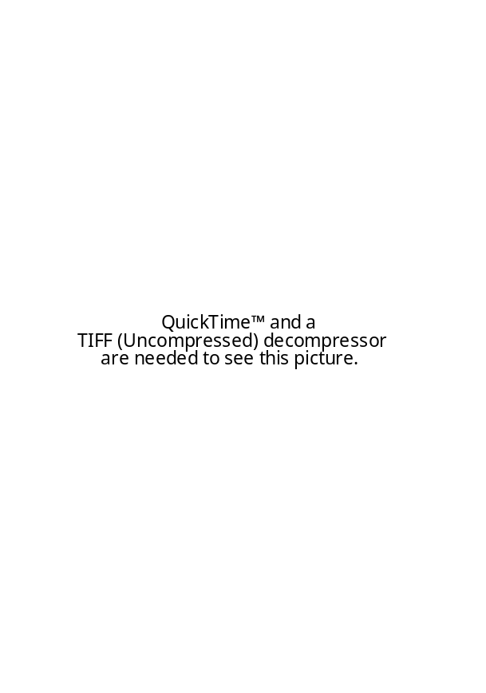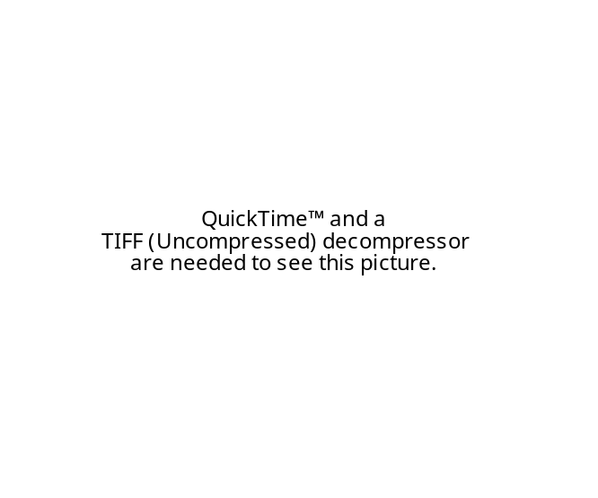
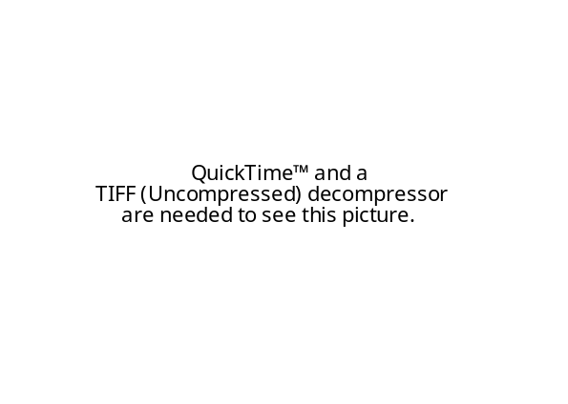

K LINK
KASSIOLA, PROFESSOR OF POLITICAL SCIENCE @ BROOKLYN COLLEGE, 04 (JOEL JAY, EXPLORATIONS IN ENVIRONMENTAL THEORY: THINKING ABOUT WHAT WE VALUE, P. 34-36)

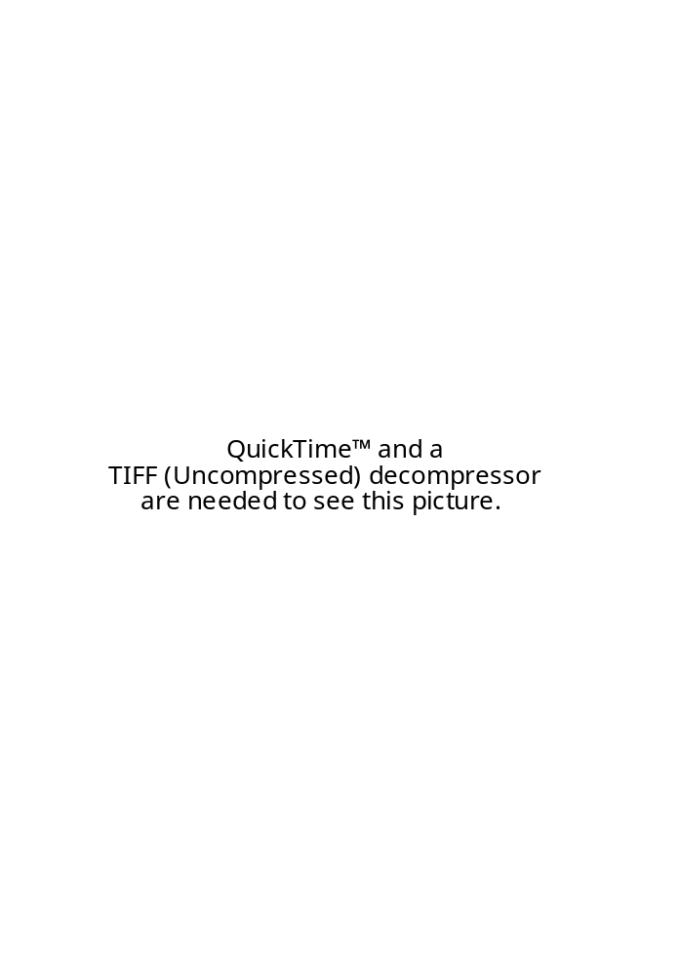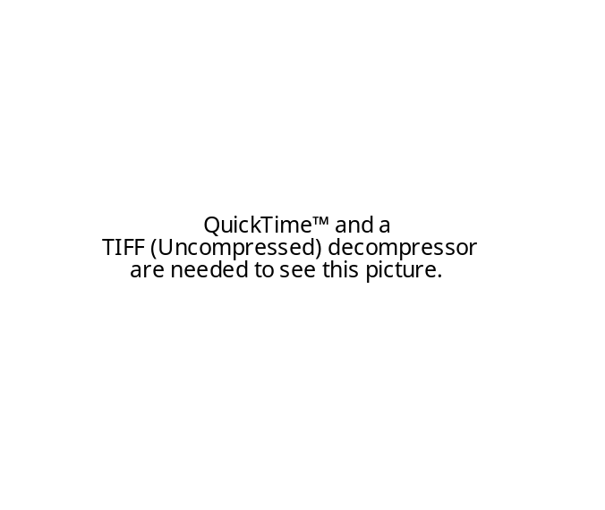
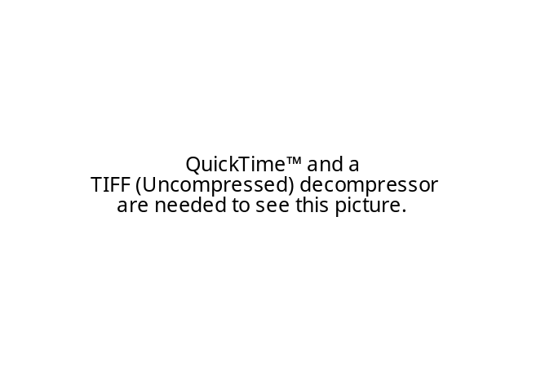[CONTINUED]
[CONTINUED]

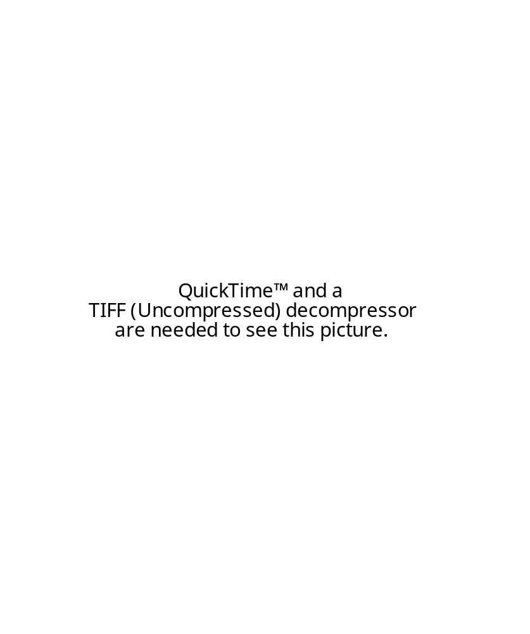
ENVIR IMPACT
MILBRATH, 04 (LESTER, EXPLORATIONS IN ENVIRONMENTAL THEORY: THINKING ABOUT WHAT WE VALUE, P. 39-40)

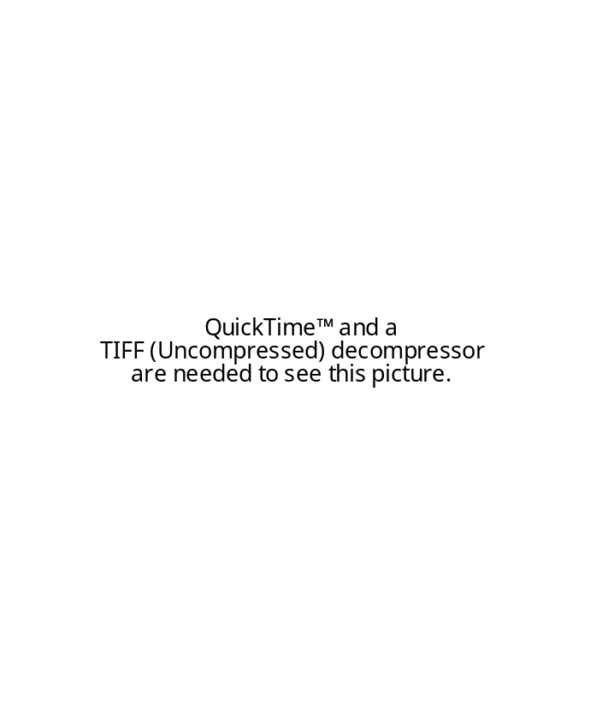
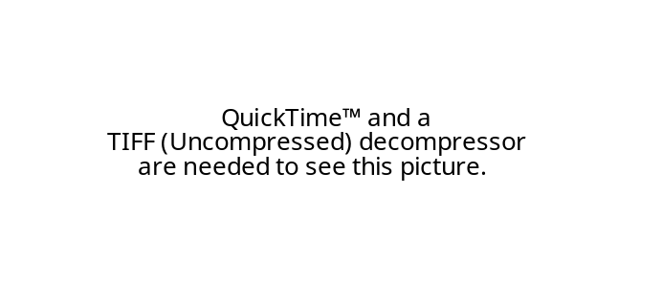
A2: PLAN SOLVES ENVIR CRISIS
MILBRATH, 04 (LESTER, EXPLORATIONS IN ENVIRONMENTAL THEORY: THINKING ABOUT WHAT WE VALUE, P. 40-41)

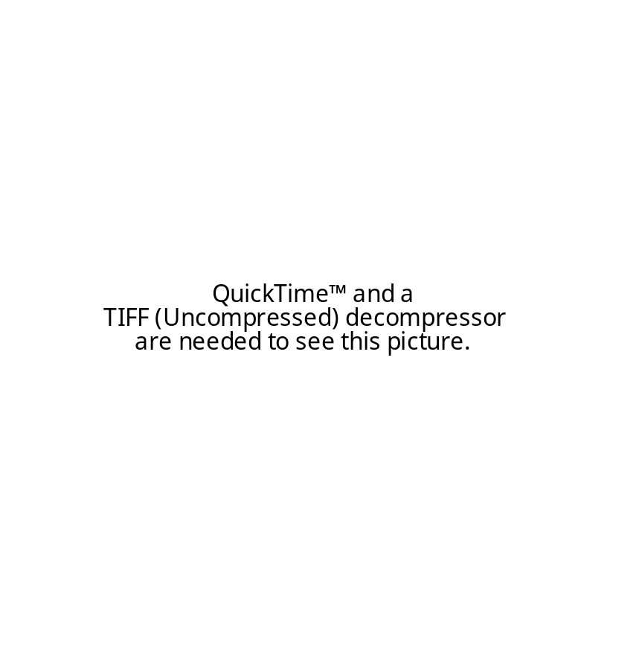

A2: CAN’T RETHINK FAST ENOUGH
MILBRATH, 04 (LESTER, EXPLORATIONS IN ENVIRONMENTAL THEORY: THINKING ABOUT WHAT WE VALUE, P. 41)

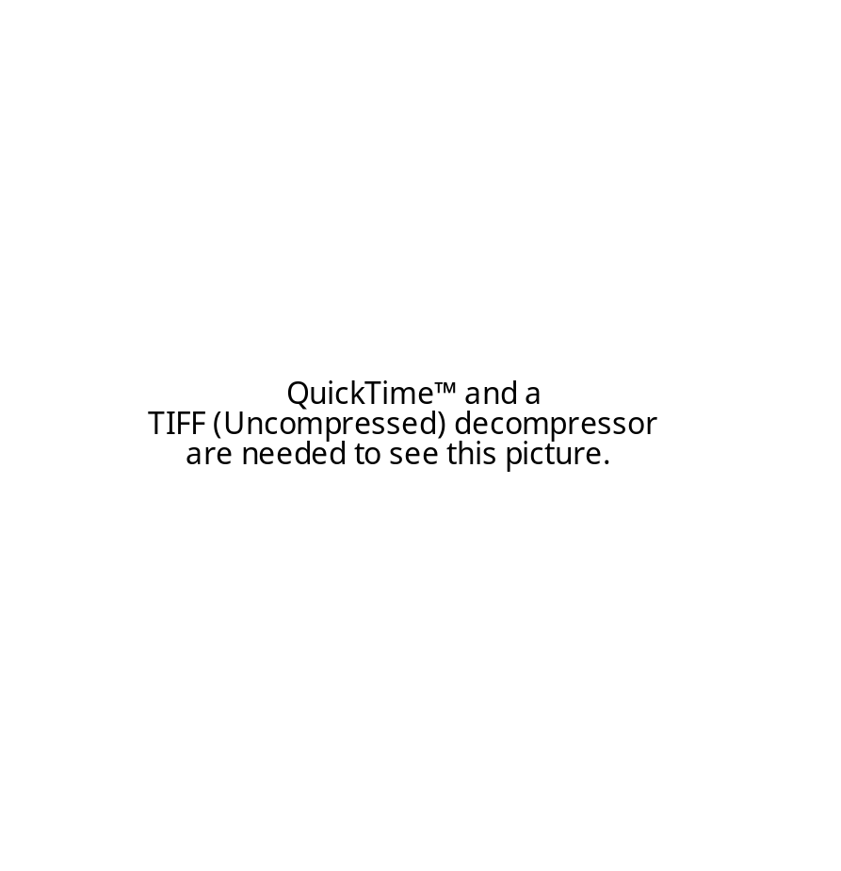

REFERENDUM CP

REFERENDUM SOLVES SOCIAL LEARNING. SOLVES CRISIS POLITICS.
MILBRATH, 04 (LESTER, EXPLORATIONS IN ENVIRONMENTAL THEORY: THINKING ABOUT WHAT WE VALUE, P. 46-48)

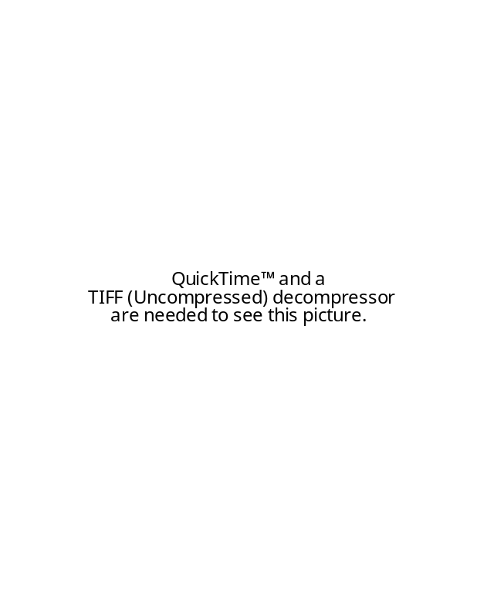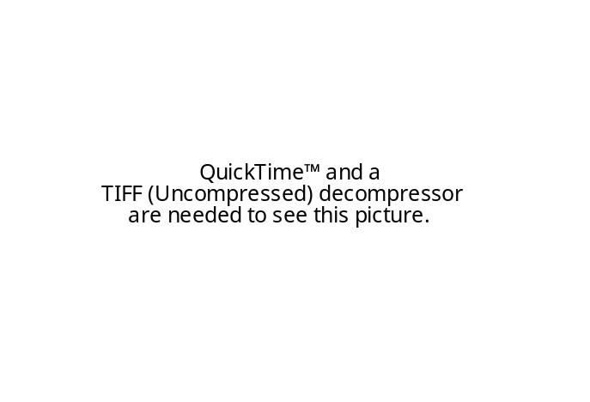
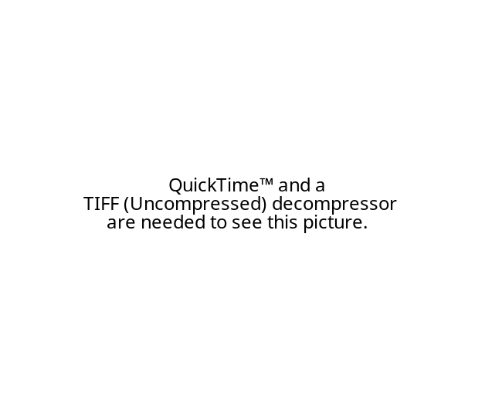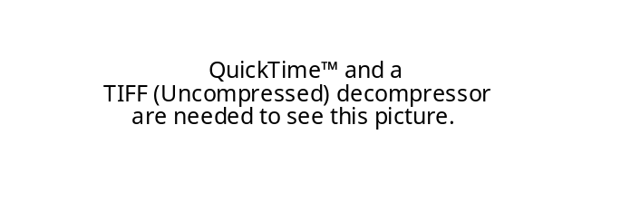
SOCIAL LEARNING SOLVES WORLD GOV.
MILBRATH, 04 (LESTER, EXPLORATIONS IN ENVIRONMENTAL THEORY: THINKING ABOUT WHAT WE VALUE, P. 48)

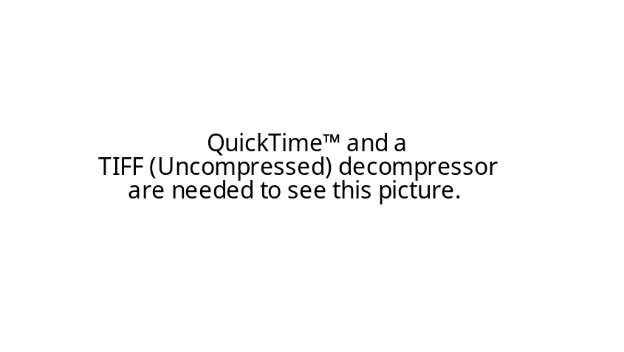

ENVIR CRISIS -> QUICK CHANGE.
MILBRATH, 04 (LESTER, EXPLORATIONS IN ENVIRONMENTAL THEORY: THINKING ABOUT WHAT WE VALUE, P. 48-49)

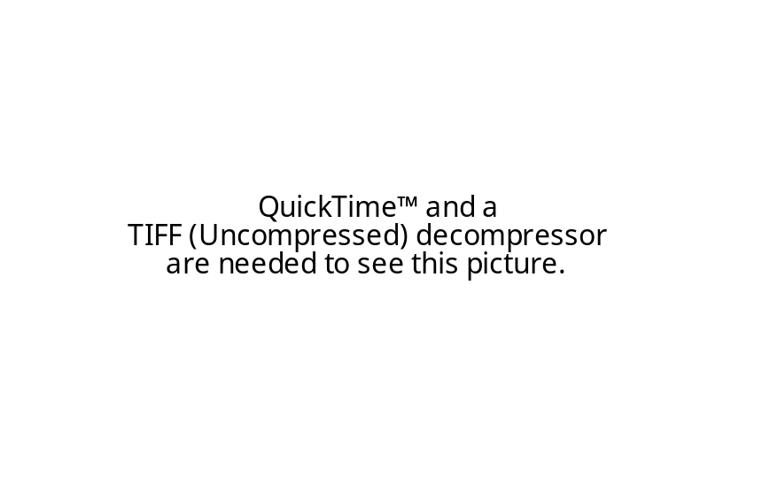
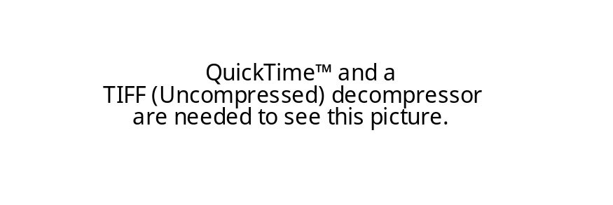

APOCALYPSE DISCOURSE GOOD
MILBRATH, 04 (LESTER, EXPLORATIONS IN ENVIRONMENTAL THEORY: THINKING ABOUT WHAT WE VALUE, P. 51)

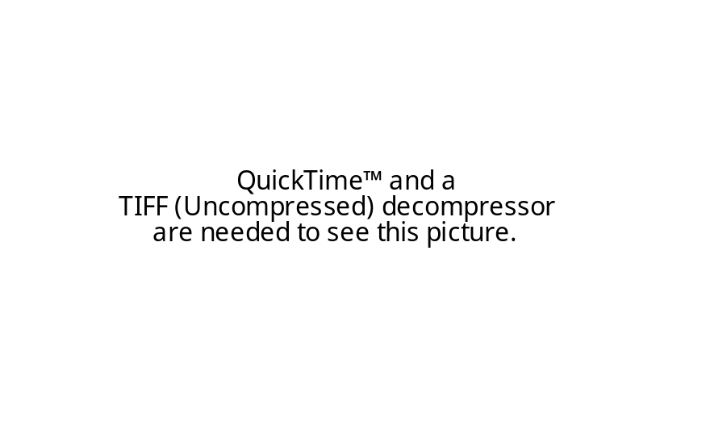

EXT TO OVERSHOOT
MCLAUGHLIN, 04 (ANDREW, EXPLORATIONS IN ENVIRONMENTAL THEORY: THINKING ABOUT WHAT WE VALUE, P. 104)

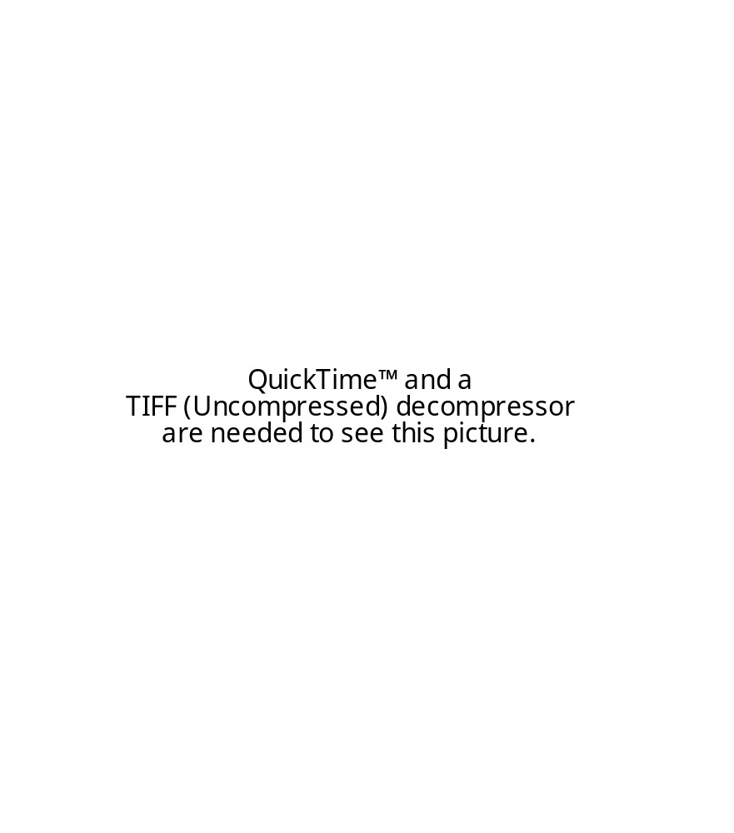

MCLAUGHLIN, 04 (ANDREW, EXPLORATIONS IN ENVIRONMENTAL THEORY: THINKING ABOUT WHAT WE VALUE, P. 112-113)

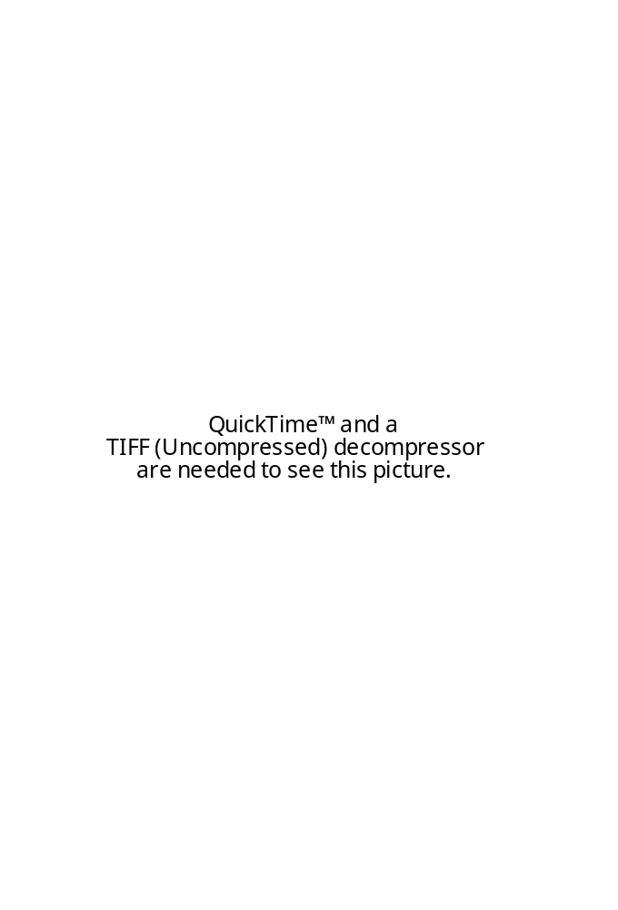
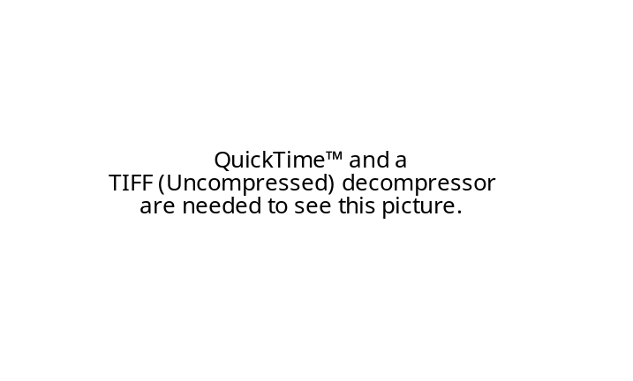
MCLAUGHLIN, 04 (ANDREW, EXPLORATIONS IN ENVIRONMENTAL THEORY: THINKING ABOUT WHAT WE VALUE, P. 113-114)


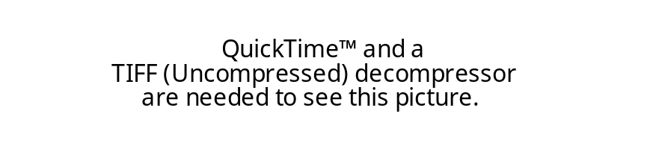

ECO-CRISIS LINK
MCLAUGHLIN, 04 (ANDREW, EXPLORATIONS IN ENVIRONMENTAL THEORY: THINKING ABOUT WHAT WE VALUE, P. 114-115)

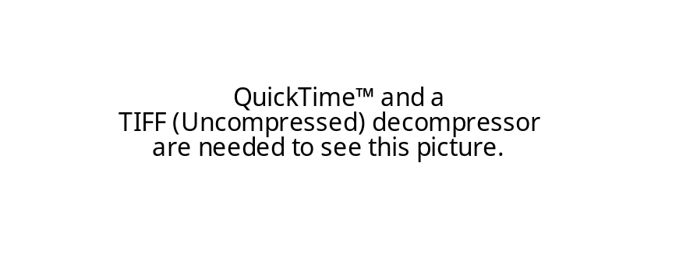
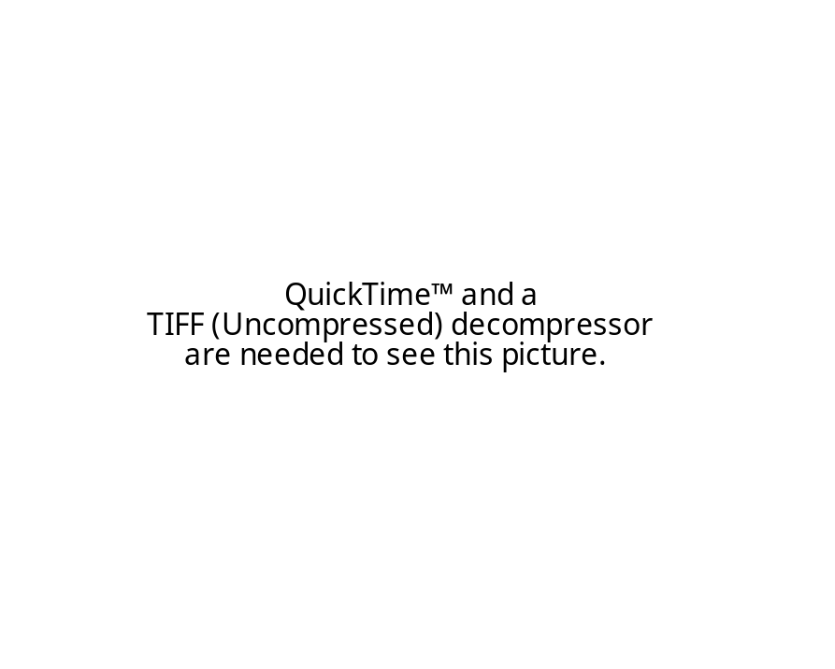
A2: FALSE CONSCIOUSNESS PREVENTS TRANSITION
MCLAUGHLIN, 04 (ANDREW, EXPLORATIONS IN ENVIRONMENTAL THEORY: THINKING ABOUT WHAT WE VALUE, P. 115)

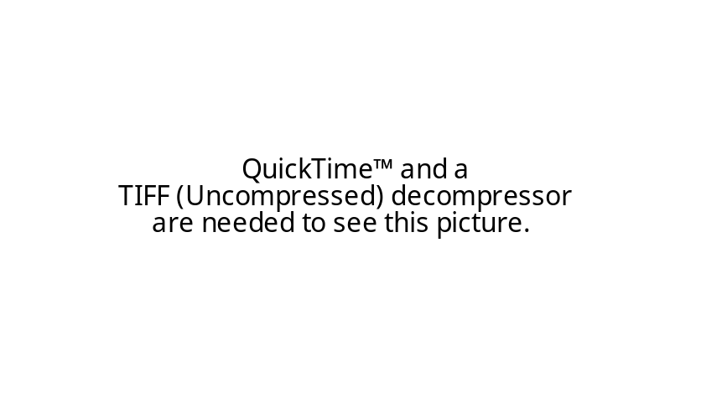

NOW IS A KEY TIME FOR GLOBAL POST-INDUSTRIAL MOVEMENTS.
TRAINER, PROFESSOR @ UNIVERSITY OF NEW SOUTH WALES, 07 (TED, THE TRANSITION IS UNDERWAY, http://ssis.arts.unsw.edu.au/tsw/D24TheTransIsUnderway.html)

At this point in time it might not seem very likely that there could be a transition from industrial-affluent-consumer society to The Simpler Way. However over the last three decades there has emerged a Global Eco-Village Movement (broadly defined) in which many people are moving to values, ways and actual settlements which more or less take the form outlined in The Alternative, Sustainable Society. (This is a society in which lifestyles are non-affluent, there are highly self-sufficient local economies, control is mostly via local participatory and cooperative arrangements, and there is a new economy containing a large non-monetary sector and without any growth.). The following extract (from Chapter 4 of What Should We Do? Build Eco-Villages!, Ted Trainer) indicates the magnitude and scope of the Movement (early in 2000). Many people are surprised and greatly encouraged to find how much is happening, at an accelerating rate. It is too early to tell whether this Movement will grow into a wholesale transformation of society, but it could and it is very important that we should work hard to bring this about.

INDUSTRIAL VALUES ARE BEING SYSTEMICALLY CHALLENGED. NOW IS KEY FOR TRANSITION.
TRAINER, PROFESSOR @ UNIVERSITY OF NEW SOUTH WALES, 07 (TED, THE TRANSITION IS UNDERWAY, http://ssis.arts.unsw.edu.au/tsw/D24TheTransIsUnderway.html)

Evidence for a paradigm shift. Over the past two decades many have argued that we are experiencing the development of a new world view or paradigm. It can be seen underlying the rise of the green parties. "Green politics a can be interpreted as a challenge to the pervasive ideology of acquisitive materialism in Western countries." (Rainbow , 1993, p. xiii.) The first Green Party, the New Zealand Values Party, contested the 1972 election on an platform rejecting some of the fundamental assumptions and values of industrial society. More recently European Green Parties, most obviously the German Greens, have seriously questioned industrialism, affluence, modern technology, centralisation and economic growth. Porritt has claimed the emergence of Green Politics as the most important political development since socialism. Bahro stated the task of the German Greens is "...to stop industrial society. In his opinion "The era of modernity has been a historical aberration." (Rainbow, 1993, p. 129.) Rainbow lists as elements in this paradigm shift the understanding that a) all things are related and that situations and problems must be seen as wholes, b) materialism, affluence, acquisition, waste, individualism, competition, centralisation, bureaucracy and technology are serious problems, c) control by elites, authorities or experts is undesirable and should be replaced by participation and people power, and d) means must be morally acceptable. He identifies this as a call for "a softer society". (Rainbow, 1993, p. 15.)

THERE’S A GLOBAL PARADIGM SHIFT TO POST-INDUSTRIAL VALUES OCCURRING NOW. TONS OF STUDIES CONFIRM.
TRAINER, PROFESSOR @ UNIVERSITY OF NEW SOUTH WALES, 07 (TED, THE TRANSITION IS UNDERWAY, http://ssis.arts.unsw.edu.au/tsw/D24TheTransIsUnderway.html)

Among the works, individuals and organisations involved in the new paradigm we can list Capra’s The Turning Point (1982), with its emphasis on the distinction between mechanical and atomistic perspectives on the one hand and organic and holistic perspectives on the other, Eisler’s The Chalice and the Blade (1990), which claimed that we are moving from "dominator" culture to "partnership" culture, Galbraith’s The Age of Uncertainty (1977), Drucker’s The Age of Discontinuity, (1969), Toffler’s The Third Wave (1981), Elgin and LeDrew’s Global Consciousness Change, (1997.), Naisbett’s Megatrends (1990), and the "New Age" and Acquarian phenomena. The fact that some of these include mystical and irrational elements is not important here; the point is that even these can be seen as part of a fundamental disenchantment with industrial-affluent society and its values and premises, and a turning to other goals, including less material and more spiritual concerns. The Deep Ecology movement, broadly defined, must be included in the list. Naess puts the paradigm shift in terms of a move from "technocentrism" to "ecocentriusm". (Naess, 1989, p. 16. See also Sessions, 1995.) Ife sees an emerging global green movement focused on sustainability, steady-state economics, decentralisation, participation, community control, local economics, self-sufficiency, cooperation, low consumption and a global perspective. (Ife, 1991.) Even in the 1970s Inglehart (1976, 1995) claimed world wide survey evidence showed that a paradigm shift from industrial-consumer values was underway, including change from concern with scarcity and growth to security and the environment, from centralisation, large scale and hierarchy to participation, and against belief in science and technology as sources of progress. Plimer (1989) comes to similar conclusions especially regarding change from belief in "unparalleled growth" to "growing sense of limits", and from concern with high living standards to concern with better quality of life. The Voluntary Simplicity movement, initiated by Elgin’s book with that title published in the early 1980s, now involves a journal and various themes to do with "downsizing your lifestyle". (Elgin,1981.) More recently Elgin (1997) argues that a new global culture has begun, claiming that 10% of Americans are now exploring Voluntary Simplicity. Birrell describes a similar shift in Sweden, in a report entitled From Growth to Sustainability. (Birrell, 1989.) Schwarz and Schwarz say "Voluntary Simplicity is one of the top trends of the nineties. By the year 2000, fifteen percent of people in their thirties and forties...will be part of the ‘simplicity’ market..." (Schwarz and Schwarz, 1998, p. 10.) "In a random survey of 800 people taken in 1995, 28% had downshifted -- voluntarily cut back income over the last five years...82% agreed that ...we buy and consume far more than we need." (p. 11.) They quote a study which found that "...one person in eight had either taken a crucial step towards downshifting or was thinking of doing so." (p. 25.) Pusey’s study of middle Australia found that there is considerable discontent with the preoccupation with greed and consumerism. (Eckersley, 1999.) Mackay finds increasing desire for a simpler less materialistic life among Australians. (Eckersley, 1999.) In 1995 a report by Young and Balance arrived at a similar conclusion for the US. High priority was put on having more time, less stress and a sense of contributing. Only 1 in 5 put high priority on more material possessions. (Eckersley, 1999.) These studies indicate ambivalence and confusion, with attraction to material prosperity but an increasing questioning of it as well. Milbrath refers to a study yielding "...solid evidence that a new paradigm is emerging. He labels this "...a New Environmental Paradigm in which consciousness of limits to growth is central." (1989, p. 118.)

THE COMING POST-INDUSTRIAL WORLDVIEW IS DEMOCRATIC.
TRAINER, PROFESSOR @ UNIVERSITY OF NEW SOUTH WALES, 07 (TED, THE TRANSITION IS UNDERWAY, http://ssis.arts.unsw.edu.au/tsw/D24TheTransIsUnderway.html)

Central within the new paradigm is the notion of participation and grass roots control. Korten talks about a rise of "people centred development". (Korten, 1990.) Edwards and Holme (1996) say, "...the emerging world order is...some form of grass-roots self-reliance and self-empowerment." Schuurman refers to "...a growing demand for a people-centred development." (Schuurman, 1993, p. 214.)

DEPRESSION ACCELERATES THE PARADIGM SHIFT.
TRAINER, PROFESSOR @ UNIVERSITY OF NEW SOUTH WALES, 07 (TED, THE TRANSITION IS UNDERWAY, http://ssis.arts.unsw.edu.au/tsw/D24TheTransIsUnderway.html)

Although a minor phenomenon at present, it can be confidently predicted that this paradigm shift will accelerate in coming years given the pace at which the globalisaztion of the economy will make it painfully obvious to more and more people that the old values and systems will not provide well for all.

ALTERNATIVE SETTLEMENTS ARE INCREASING GLOBALLY. THE INFRASTRUCTURE FOR THE TRANSITION HAS ALREADY BEEN INITIATED.
TRAINER, PROFESSOR @ UNIVERSITY OF NEW SOUTH WALES, 07 (TED, THE TRANSITION IS UNDERWAY, http://ssis.arts.unsw.edu.au/tsw/D24TheTransIsUnderway.html)

Much more impressive than the evidence of a change in world view is the growth of alternative settlements and systems. As Ife says, "At the grassroots level...increasing numbers of people in different countries are experimenting with community-based alternatives, such as local economic systems, community-based education, housing co-operatives...a community-based strategy based on principles of ecology and social justice is already emerging, as a result of the initiative of ordinary people at grass-roots level, who are turning away from mainstream structures..." (Ife, 1995, p. 99.) According to Norberg-Hodge, "Around the world, people are building communities that attempt to get away from the waste, pollution, competition, and violence of contemporary life. (Norberg-Hodge, 1996, p. 405.) The agency she has founded, the International Society for Ecology and Culture, works in Ladakh to reinforce local economies and its video Local Futures, is an inspiring illustration of what is being done in many parts of the world. The New Economic Foundation in London works to promote local economic development, with a special interest in bujilding local quality of life indicators and in establishing local currencies. Schroyer"s book Towards a World That Works (1997) documents many alternative community initiatives. "Everywhere people are waking up to the realities of their situation in a globalising economy and are beginning to recognise that their economies’ resources and socio-political participations must be regrounded in their local and regional communities." (p. 225) "Everywhere social and economic structures are re-emerging in the midst of the market system that are spontaneously generated social protections to normatively re-embed the market..." "It is no exaggeration to say that local communities everywhere are on the front lines of what might well be characterised as World War III." (p. 229.) "It is a contest between the competing goals of economic growth to maximise profits for absentee owners vs creating healthy communities that are good places for people to live." (p. 230.) "In Britain, over 1.5 million people now take regular part in a rainbow economy of community economic initiatives." (New Internationalist, 1996, p. 27.) Friberg and Hettne (1985) argue that two main groups are behind the emergence of self reliant communities, viz., those holding "post materialist" values, and those who have been marginalised, such as the unemployed and the Third World poor. In Living Lightly Schwarz and Schwarz discuss the many alternative settlements they visited on a recent world tour. They say that these people "...hope that the tiny islands of better living which they inhabit will provide examples which will eventually supplant the norms of unfettered capitalism which rule us today. Their hope is not in revolution but in persuasion by example." ( p. 2.) "What is new is that small groups of Living Lightly people are now part of an articulate and increasingly purposeful global culture which promotes values that run counter to those of the mainstream." (p. 2.) "They think the empire will eventually disintegrate...In anticipation of that collapse islands of refuge must be prepared." (p. 3.) Living Lightly people "...can only hope to prevail through their own example and the gradual erosion of the dominant system through local initiatives that exchange high living standards for a high quality of life." (p. 165.) Living Lightly people "...are in revolt against the emerging global economy and want to set up viable local alternatives." (p. 150.)

THE GLOBAL ECO-VILLAGE NETWORK CAN COORDINATE THE TRANSITION TO DECENTRALIZED SETTLEMENTS.
TRAINER, PROFESSOR @ UNIVERSITY OF NEW SOUTH WALES, 07 (TED, THE TRANSITION IS UNDERWAY, http://ssis.arts.unsw.edu.au/tsw/D24TheTransIsUnderway.html)

Many eco-villages are now functioning or are being established and a formal international organisation exists, the Global Eco-village Network, with regional branches in Europe, the USA, Asia and Oceania. Newsletters are published, conferences organised and new villages established. In 199 Global Eco-village Network published a booklet summarising 20 Ecovillages. Another booklet in 1999 describes 57 notable examples presently functioning or being developed in Europe. (Grindhdeim and Kennedy, 1999.) The 2000 edition will list over 300.

THERE’S ENOUGH EXTRA LAND WITHIN CITIES FOR URBAN AGRICULTURE.
TRAINER, PROFESSOR @ UNIVERSITY OF NEW SOUTH WALES, 07 (TED, THE TRANSITION IS UNDERWAY, http://ssis.arts.unsw.edu.au/tsw/D24TheTransIsUnderway.html)

An important element in the general alternative settlement movement is the rise of urban agriculture. The United Nation’s now acknowledges the rapid development of urban agriculture and its crucial importance in coping with the growth of Third World cities. The extensive scope for food and materials production in cities comes as a surprise to many. However there are large areas of unused land in cities, such as derelict industrial sites, let alone the parks, hospital grounds, railway edges, nature strips etc that can be used for food production. In one study of 86 American cities the area available, including vacant lots, derelict factories, land beside railways, school grounds, parks etc. was found to be almost sufficient to feed the people in those cities. (Nicholson-Lord, 1987.)

LATIN AMERICA, AFRICA, AND ASIA.
TRAINER, PROFESSOR @ UNIVERSITY OF NEW SOUTH WALES, 07 (TED, THE TRANSITION IS UNDERWAY, http://ssis.arts.unsw.edu.au/tsw/D24TheTransIsUnderway.html)

Possibly even more impressive than developments in rich countries are those in the Third World where many have long since realised that conventional development will never solve their problems. (Trainer, 1995a.) There is now a large development literature dealing with this recognition and the attempts to pioneer a "people-centred" development strategy which makes local resources available to local people to devote directly to meeting their needs via relatively simple systems and standards under their own control. (Trainer, 1995a.) The basic principle is of course not new, owing much to Gandhi, but it can be argued that we are witnessing a surge of interest in it now given the failure of conventional development. "...a new pattern of development is taking place at community and village level in rural areas of he Third World. In the spirit of self-reliance, numerous 'grassroots' groups have decided to take charge of their own development in rural villages throughout Latin America, Africa and Asia. (Schneider, 1988, p. xi.) Similar generalisations and cases are given by Galtung, (1980, p. 162), Shiva, et al, (1997), Rist, Rahnema and Esteva, (1992), Holmberg and Timberlake, (1991), Burkey, (1993), Ekins, (1992, pp. 100-108), Chopra, (1989), Lang and Hines, (1993), Ife, (1995, p. 95), Page, (1995), Craig, (1995), Higginbotham, (1995), Goldsmith, (1998), Esteva and Prakash, (1996), Amon, (1994), Korten, (1990), Human Settlements Program, (1994), Rich, (1994), Pereira and Seabrook, (199,) Marglen, (1998), Elgin and LeDrew, (1997). The magnitude of the movement is suggested by a table Brown presents indicating thousands of grassroots organisations in several countries, e.g., an estimated 12,000 organisations in India 8,000 villages in Sri Lanka , and 100,000 Christian Base Communities in Brazil. (Brown 1989, p. 157.) He describes Indian mobilisation of "...massive work teams to do everything from building road networks to draining malarial ponds...." (p. 156.) Green says "...local communities all over sub-Saharan Africa are forming self-reliance groups to eliminate hunger and save their environments by diversifying cereal, fruit and vegetable crops and building community fields, village granaries, and anti-salination structures. No one knows how many groups there are. In Kenya alone figures of 16,000 to 25,000 groups have been quoted." (1990, p. 49.) Mies and Shiva give a similar account of self-reliant village development in Maharashtra, saying that throughout India there are "... many thousands of examples of alternative practice." (1993, p. 160.) These movements "...radically reject the industrialised countries' prevailing model of capitalist-patriarchal development. ...they...want to preserve their subsistence base intact, under their own control."

ELGIN, RESEACHER WITH MORE THAN 25 YEARS EXPERIENCE IN THE SUBJECT OF PARADIGM CHANGE, 97 (DUANE WITH COLEEN LEDREW, GLOBAL CONSCIOUSNESS CHANGE: INDICATORS OF AN EMERGING PARADIGM, MAY, HTTP://WWW.NEWHORIZONS.ORG/FUTURE/ELGIN1.HTM)

Numerous trends indicate that the industrial era is on a collision course with nature -- from ozone depletion to climate change, rainforest destruction, and environmental pollution. The global ecological crisis is compounded by social, economic, and spiritual challenges that are equally daunting. Is there a countervailing set of indicators that shows that we humans may be waking up to our predicament? Is there a set of trends that shows that we are beginning to consciously organize ourselves to respond to the ecological, social, and spiritual challenges we face? The objective of this inquiry was to discover whether global culture and consciousness are significantly changing in such a way that new patterns of values and approaches to living are emerging. To discover whether this is so, we examined a number of the most comprehensive global and US surveys of the past decade. We organized this inquiry into five thematic question areas: Is the global communications revolution fostering a new global consciousness? What is the extent of humanity's global ecological awareness and concern? Is there a shift underway toward "postmodern" social values? Is a new kind of experiential or firsthand spirituality emerging? Is there a shift underway toward more sustainable ways of living? From this inquiry, we have concluded that a new global culture and consciousness have taken root and are beginning to grow in the world. This represents a shift in consciousness as distinct and momentous as that which occurred in the transition from the agricultural era to the industrial era roughly three hundred years ago. Because communications technologies are a powerful force driving the emergence of this new epoch, it would be convenient to call it the "communications era." But that name would be ill-suited since the most distinctive feature of this emerging era is not technological change, but a change in human consciousness. This change in consciousness has two primary features. First, there is a further awakening of our unique capacity to be self-reflective -- to stand back from the rush of life with greater detachment, observe the world and its workings non-judgementally. Second, from this more spacious perspective, the Earth (and even the cosmos) are seen as interconnected, living systems. Because of these two features, we are calling this emerging change in culture and consciousness the "reflective/living-systems" paradigm or perspective. Because of survey limitations, it is impossible to estimate with any accuracy the percentage of the world's population moving toward a reflective/living-systems way of life. In the US, a conservative estimate is that 20 million people -- 10 percent of adults -- are consciously exploring new ways of living that seem consistent with this paradigm. While this group is a relatively small percentage of the US population, we believe they represent an important harbinger of changes in global culture and consciousness.
ELGIN, RESEACHER WITH MORE THAN 25 YEARS EXPERIENCE IN THE SUBJECT OF PARADIGM CHANGE, 97 (DUANE WITH COLEEN LEDREW, GLOBAL CONSCIOUSNESS CHANGE: INDICATORS OF AN EMERGING PARADIGM, MAY, HTTP://WWW.NEWHORIZONS.ORG/FUTURE/ELGIN2.HTM)

In 1992, over 1600 senior scientists, including a majority of the living Nobel laureates in the sciences, signed and released a documented entitled Warning to Humanity. In it, they stated powerfully the need for fresh approaches to thinking and living. They declared that "human beings and the natural world are on a collision course . . . that may so alter the living world that it will be unable to sustain life in the manner that we know." They concluded by giving the following, simple warning to the human family: We, the undersigned senior members of the world's scientific community, hereby warn all humanity of what lies ahead. A great change in our stewardship of the earth and the life on it is required, if vast human misery is to be avoided and our global home on this planet is not to be irretrievably mutilated. 1 Although human societies have confronted major problems throughout history, the challenges of our era are unique in one crucial respect -- they now embrace the entire Earth as a whole system. Never before has humanity been on the verge of devastating the Earth's biosphere and crippling its ecological foundations for countless generations to come. Never before has the entire human family been required to work together to build a sustainable and meaningful future. Never before have so many people been called to make such sweeping changes in so little time. Albert Einstein observed that problems cannot be solved at the same level at which they are created. This insight seems profoundly relevant today as we humans need to step back and gain a whole-systems perspective if we are to respond effectively to massive ecological problems. The "ecological" challenges we face are not even purely physical. Many are social and spiritual as well. It is difficult to imagine a positive future that does not value, integrate, and balance three major ecologies: A physical ecology that is sustainable -- where we live in such a way that present generations can meet their needs without compromising the Earth's ability to support future generations. 2 A social ecology that is satisfying -- where we value rich and meaningful relationships of all kinds -- in families, neighborhoods, and communities (including the Earth -- community, with all its lifeforms). A spiritual ecology that is soulful -- where we consciously appreciate and celebrate the deep mystery and miracle of everyday life. To create a future that harmoniously integrates these three ecologies, the human family will need a new way of looking at the world -- in short, a new paradigm. What is a paradigm? Willis Harman gives a definition that we find very useful: A paradigm is "the basic way of perceiving, thinking, valuing, and doing associated with a particular vision of reality." 3 A civilization's paradigm shapes ho w we see and understand the nature of reality, our sense of self, and our feelings of social connection and purpose. Paradigms shape not only our thoughts, but our very perceptions and experience of life. When a civilization shifts from one paradigm to an other that shift goes to the very core of our lives, and represents much more than a change of ideas. Retired Canadian Ambassador James George writes about the deep nature of paradigm shifts in his book Asking for the Earth: I have been struggling to convey the idea of a paradigm shift intellectually. But . . . it is not just an idea, it is an experience; and experiences take place in the moment, in bodies with feelings. So do paradigm shifts. They first infiltrate your mind, then they grab you in the gut; only then do you "get it" and act. 4 Civilizational paradigms have persisted for at least centuries and usually millennia. At the level of human civilizations, a paradigm shift is a very rare occurrence. It has happened only a few times in human history -- specifically, during the transitions from the hunter-gatherer era to the agricultural era, from the agricultural era to the industrial era, and from the industrial era to the fast emerging communications era. Paradigms are stable and enduring ways of perceiving and relating to the world. They persist until they generate problems that cannot be solved; these problems then become the catalyst for triggering the shift to the next paradigm. 5 When we first enter a new civilizational paradigm (such as moving from the agricultural era to the industrial),we experience new freedom and creative opportunity. As we fulfill the potential of a given paradigm, however, that paradigm eventually becomes a constricting framework. Its partial or incomplete nature leads to a crisis, which in turn leads to a breakthrough into the next, more spacious paradigm. A new level of learning and creative expression ensues. As the world's senior scientists have warned, the industrial era paradigm is now generating far more problems than it is solving. The only way the human family can understand and solve these problems is by shifting to a larger paradigm that includes the entire Earth as a living system. Such a transformation seems to be underway. Peter Drucker, the well-known management expert, is just one observer who believes that the western world is undergoing a paradigm change: Every few hundred years in Western history there occurs a sharp transformation. Within a few short decades, society -- its world view, its basic values, its social and political structures, its arts, its key institutions -- rearranges itself. And the people born then cannot even imagine a world in which their grandparents lived and into which their own parents were born. We are currently living through such a transformation. 6 With the explosive growth of mass communications, a new global consciousness and culture are emerging. Already a majority of the world's people have access to television and are being profoundly influenced by the communications era. The rapidly emerging " global brain" is weaving the human family together into a new level and intensity of relationship. The communications revolution is pervasive. The combined power of the computer Internet, television networks, global satellite systems, cellular telephones, fiber optics, and many more devices has created a perceptual framework within which even those who are agrarians or industrialists in their daily work will increasingly orient themselves. As pervasive as the communications revolution is, it seems to be taking place within a larger and deeper revolution in consciousness and culture. We are living in a time of paradigm shift. What should we call the emerging paradigm? In this report, we are calling it the "reflective/ living-systems" paradigm or perspective. This name incorporates the two primary features of this perspective. The first is our growing capacity for self-reflection. Many times it has been observed that where animals "know," only humans have the capacity to "know that we know." We have the ability to observe ourselves and our world as if from a distance. Humans ca n stand back and see ourselves in the past as well as project ourselves into the future. We are not locked in, but can reflect on our situation and make fresh choices. When we can see our actions in the mirror of self-reflective knowing, we become self directing agents of our own evolution. It is this capacity for conscious, free choice that will be essential if humanity is to choose a path of communication and reconciliation to create a sustainable future. A second hallmark of the new consciousness is its "whole-systems" or "living-systems" view. For the last several hundred years in Western industrial societies, a materialistic, scientific mindset has dominated. In this view, what is "real" is the material world as perceived by our senses and organized by our intellect. The universe is seen as filled with lifeless matter and empty space. It is only natural that what is important is social status and material success. By contrast, in the emerging perspective, seemingly empty space is not empty, but filled with immense amounts of energy. Our cosmos is seen as a living, unified system. This new paradigm moves from a view of separation and isolation to one of profound wholeness and interconnection. At a fundamental level, people are viewed not as separate beings, but as intimately involved with one another in the deep web of life. If everything is intimately interconnected, then the quality and integrity of all kinds of relationships are of paramount concern. A natural expression of this paradigm is to bring into balance all the key relationships in our lives -- inner and outer, masculine and feminine, personal and global, intuitive and rational, and more. This perspective tends to bridge differences, connect people, celebrate diversity, harmonize efforts, and look for higher common ground. A reflective/living-systems orientation brings a unifying approach and offers hope in a world facing deep material, social, and spiritual fragmentation. Table 1 presents a preliminary view of the contrasts that seem to be emerging between the industrial/ materialistic paradigm and what we are calling the reflective/living-systems paradigm. Books and articles describing the possibility of a new paradigm coming into existence have been proliferating for the past 20 years. World leaders have spoken about the emergence of a new global perspective. Is a reflective/ living-systems paradigm developing in the world? That question is the focus of this study.

ELGIN, RESEACHER WITH MORE THAN 25 YEARS EXPERIENCE IN THE SUBJECT OF PARADIGM CHANGE, 97 (DUANE WITH COLEEN LEDREW, GLOBAL CONSCIOUSNESS CHANGE: INDICATORS OF AN EMERGING PARADIGM, MAY, http://www.awakeningearth.org/PDF/global_consciousness.pdf)

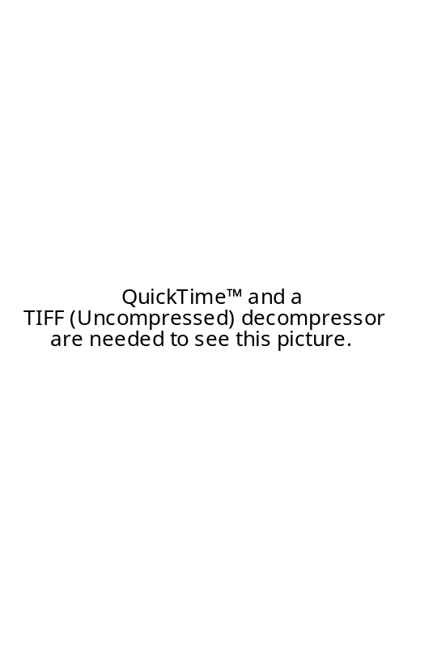

ELGIN, RESEACHER WITH MORE THAN 25 YEARS EXPERIENCE IN THE SUBJECT OF PARADIGM CHANGE, 97 (DUANE WITH COLEEN LEDREW, GLOBAL CONSCIOUSNESS CHANGE: INDICATORS OF AN EMERGING PARADIGM, MAY, http://www.awakeningearth.org/PDF/global_consciousness.pdf)


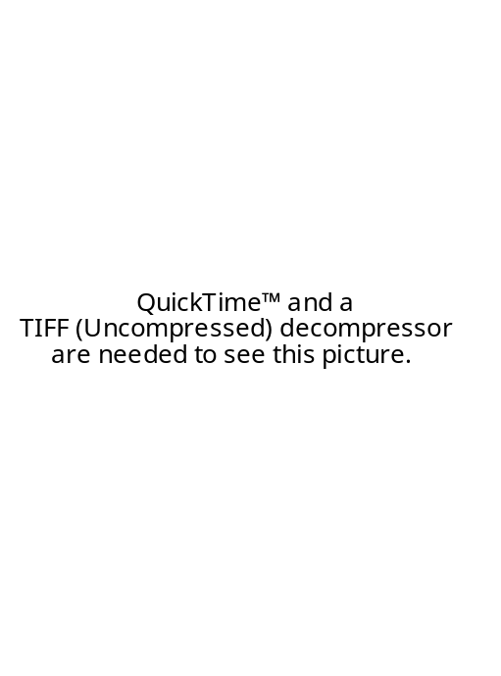
ELGIN, RESEACHER WITH MORE THAN 25 YEARS EXPERIENCE IN THE SUBJECT OF PARADIGM CHANGE, 97 (DUANE WITH COLEEN LEDREW, GLOBAL CONSCIOUSNESS CHANGE: INDICATORS OF AN EMERGING PARADIGM, MAY, http://www.awakeningearth.org/PDF/global_consciousness.pdf)


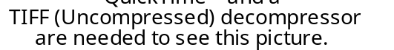

ELGIN, RESEACHER WITH MORE THAN 25 YEARS EXPERIENCE IN THE SUBJECT OF PARADIGM CHANGE, 97 (DUANE WITH COLEEN LEDREW, GLOBAL CONSCIOUSNESS CHANGE: INDICATORS OF AN EMERGING PARADIGM, MAY, http://www.awakeningearth.org/PDF/global_consciousness.pdf)

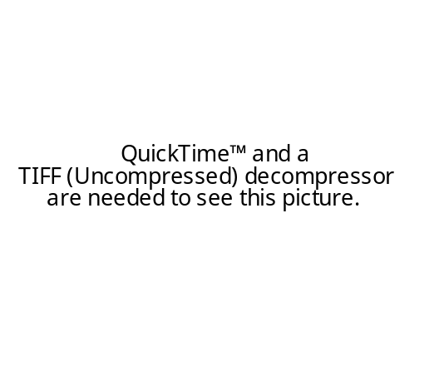

ELGIN, RESEACHER WITH MORE THAN 25 YEARS EXPERIENCE IN THE SUBJECT OF PARADIGM CHANGE, 97 (DUANE WITH COLEEN LEDREW, GLOBAL CONSCIOUSNESS CHANGE: INDICATORS OF AN EMERGING PARADIGM, MAY, http://www.awakeningearth.org/PDF/global_consciousness.pdf)

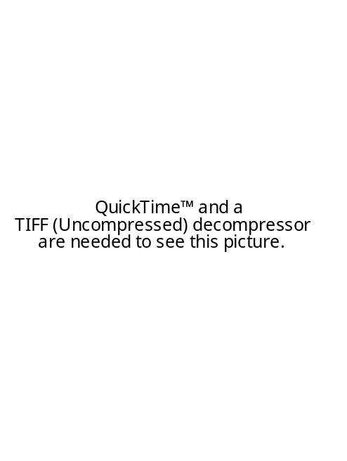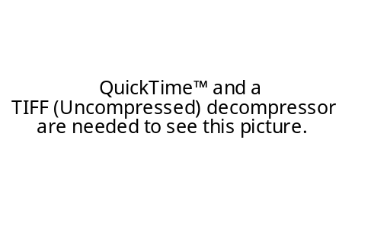
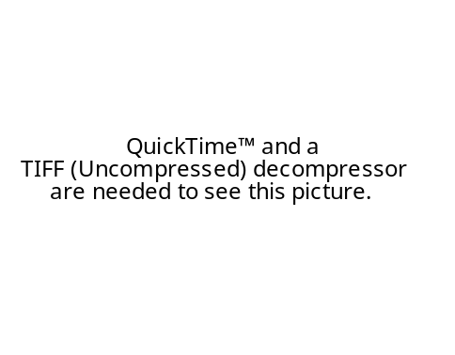
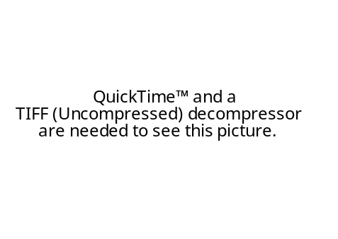

ELGIN, RESEACHER WITH MORE THAN 25 YEARS EXPERIENCE IN THE SUBJECT OF PARADIGM CHANGE, 97 (DUANE WITH COLEEN LEDREW, GLOBAL CONSCIOUSNESS CHANGE: INDICATORS OF AN EMERGING PARADIGM, MAY, http://www.awakeningearth.org/PDF/global_consciousness.pdf)

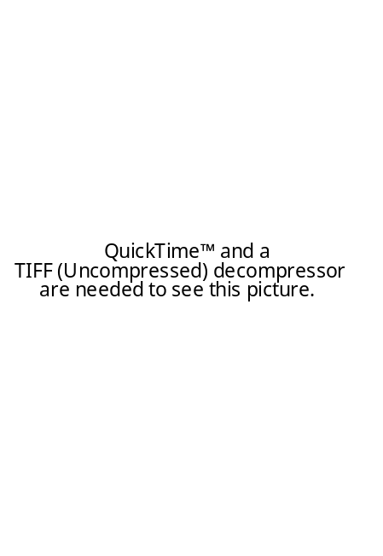
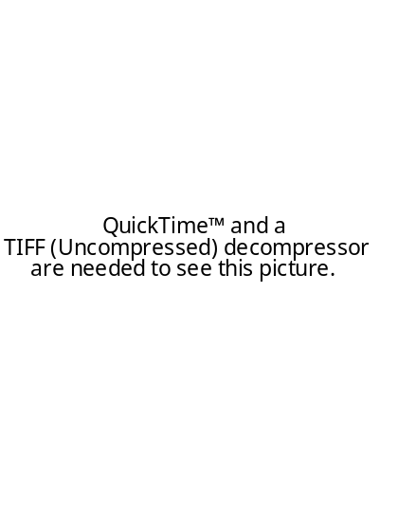
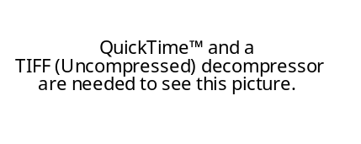
ELGIN, RESEACHER WITH MORE THAN 25 YEARS EXPERIENCE IN THE SUBJECT OF PARADIGM CHANGE, 97 (DUANE WITH COLEEN LEDREW, GLOBAL CONSCIOUSNESS CHANGE: INDICATORS OF AN EMERGING PARADIGM, MAY, http://www.awakeningearth.org/PDF/global_consciousness.pdf)

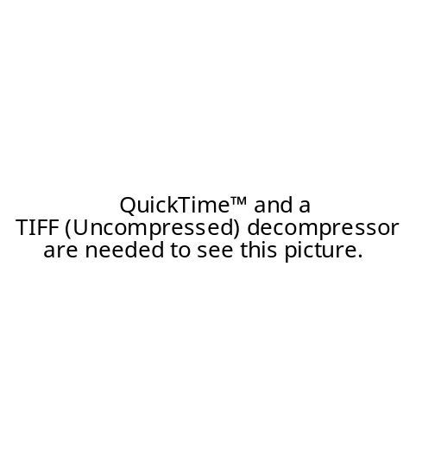
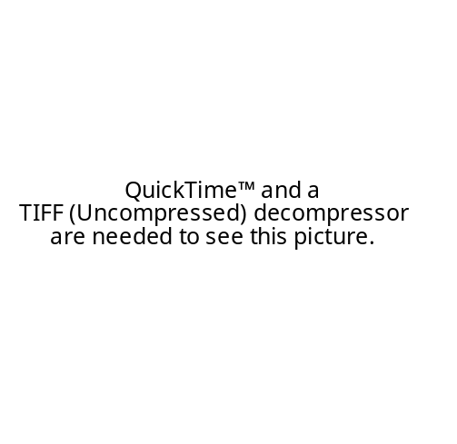

ELGIN, RESEACHER WITH MORE THAN 25 YEARS EXPERIENCE IN THE SUBJECT OF PARADIGM CHANGE, 97 (DUANE WITH COLEEN LEDREW, GLOBAL CONSCIOUSNESS CHANGE: INDICATORS OF AN EMERGING PARADIGM, MAY, http://www.awakeningearth.org/PDF/global_consciousness.pdf)

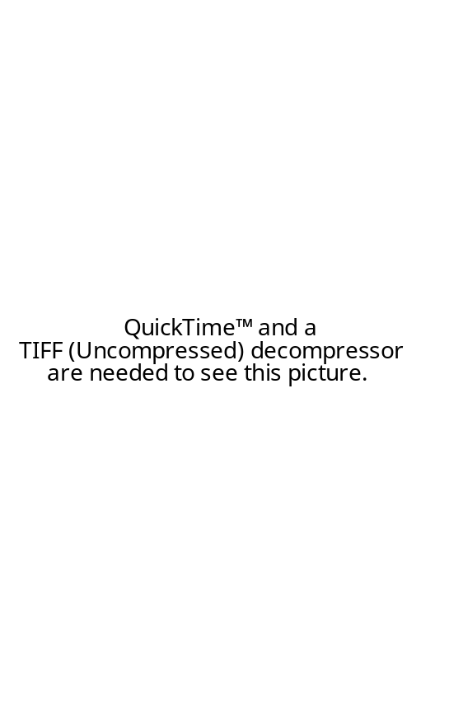
ELGIN, RESEACHER WITH MORE THAN 25 YEARS EXPERIENCE IN THE SUBJECT OF PARADIGM CHANGE, 97 (DUANE WITH COLEEN LEDREW, GLOBAL CONSCIOUSNESS CHANGE: INDICATORS OF AN EMERGING PARADIGM, MAY, http://www.awakeningearth.org/PDF/global_consciousness.pdf)

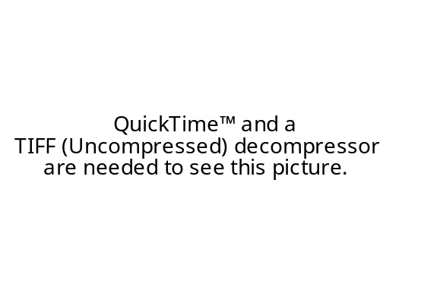
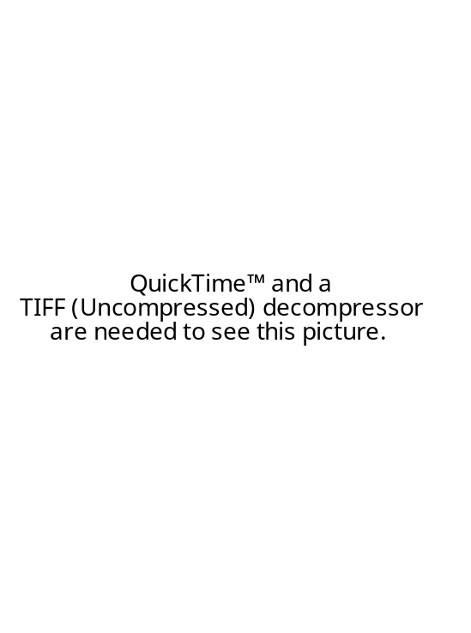
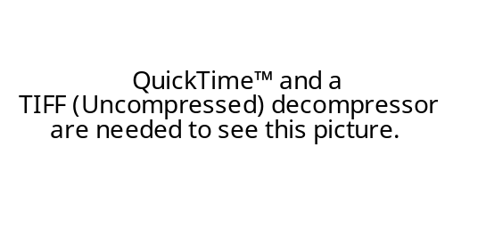
ELGIN, RESEACHER WITH MORE THAN 25 YEARS EXPERIENCE IN THE SUBJECT OF PARADIGM CHANGE, 97 (DUANE WITH COLEEN LEDREW, GLOBAL CONSCIOUSNESS CHANGE: INDICATORS OF AN EMERGING PARADIGM, MAY, http://www.awakeningearth.org/PDF/global_consciousness.pdf)

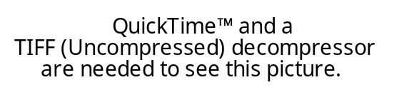
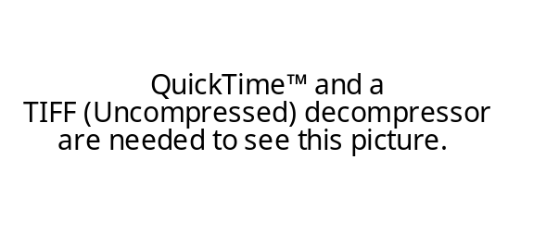
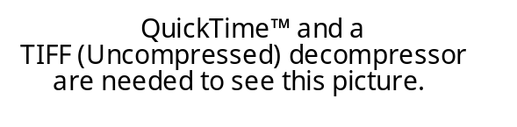

ELGIN, RESEACHER WITH MORE THAN 25 YEARS EXPERIENCE IN THE SUBJECT OF PARADIGM CHANGE, 97 (DUANE WITH COLEEN LEDREW, GLOBAL CONSCIOUSNESS CHANGE: INDICATORS OF AN EMERGING PARADIGM, MAY, http://www.awakeningearth.org/PDF/global_consciousness.pdf)

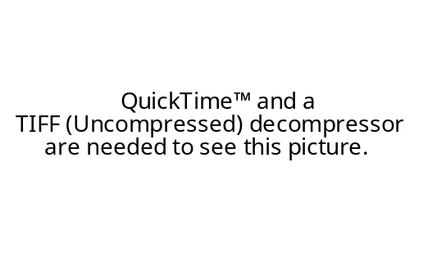
ELGIN, RESEACHER WITH MORE THAN 25 YEARS EXPERIENCE IN THE SUBJECT OF PARADIGM CHANGE, 97 (DUANE WITH COLEEN LEDREW, GLOBAL CONSCIOUSNESS CHANGE: INDICATORS OF AN EMERGING PARADIGM, MAY, http://www.awakeningearth.org/PDF/global_consciousness.pdf)

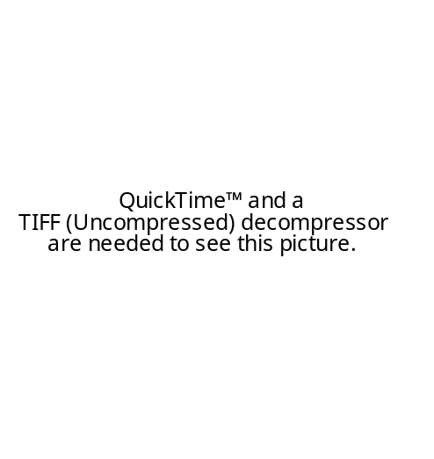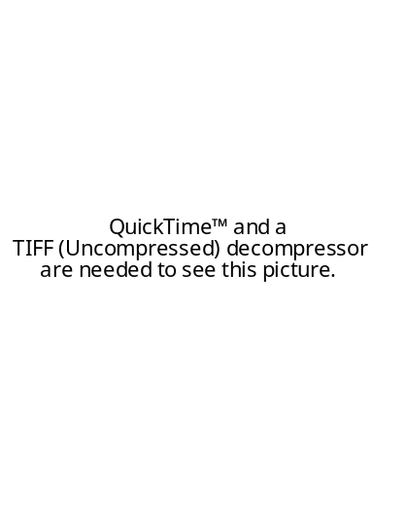
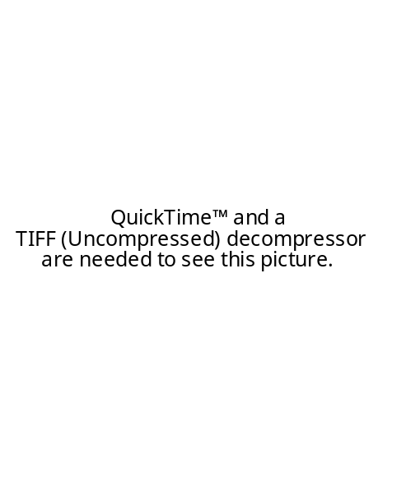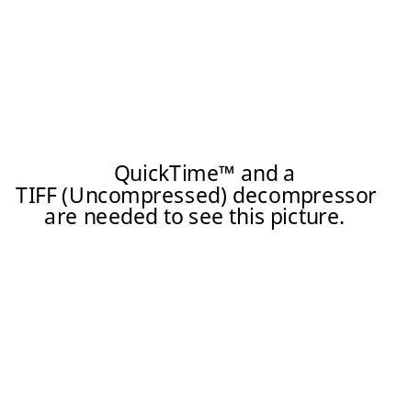

ELGIN, 01 (DUANE, GARDEN OF SIMPLICITY, YES! Magazine, WinteR,
http://www.yesmagazine.org/other/pop_print_article.asp?ID=388)

In the midst of our nation's sensational economic boom, a quiet and quite unexpected revolution in simple living is steadily transforming our society. Slowly but surely and ever-growing number of people are consciously rejecting the traditional trappings of affluence. they are choosing instead to live well within their means, achieving a life that is inwardly rich, not outwardly showy. There are many ways people are orienting their lives around this yearning for simplicity. Here are some of the diverse approaches that I see thriving in this garden of simplicity. Choiceful Simplicity- Simplicity means choosing our path through life consciously and deliberately. As a path that emphasizes freedom, simplicity also means staying focused, diving deep, and not being distracted by consumer culture. It means consiously organizing our lives so we give our true gifts to the world. Commercial Simplicity- Simplicity means that there is a growing market for products and services that sustain resources and provide lasting utility. Similarly, a new enterprise model recognizes natural ecosystems and healthy workers as important measures of productivity. Compassionate Simplicity- Simplicity means that we "choose to live simply so that others may simply live." A compassionate simplicity means following a path of reconciliation with other peoples, with other species, and with future generations. Ecological Simplicity- Simplicity means limiting our consumption to avoid destroying or depleting finite resources. It also means developing creative and sustainable alternatives like solar power and telecommuting. Elegant Simplicity- Simplicity means that the way we live our lives represents a work of unfolding artistry. An elegant simplicity is an understated yet highly pragmatic aesthetic that contrasts with the excess of consumerist lifestyles. Frugal Simplicity- Simplicity means cutting back on spending that is not truly serving our lives and practicing skillful management of our personal finances. through these practices, we can achieve greater financial independence while decreasing the impact of our consumption upon the Earth. Natural Simplicity- Simplicity means connecting with the ecology of life and balancing ur experience of the human-created environments with time in nature. We experience a deep reverence for the community of life on Earth and accept that the nonhuman life of plants and animals has its dignity and rights just as human life does. Political Simplicity- Simplicity means organizing our collective lives in ways that enable us to live more lightly on the Earth which, in turn, involves changes in nearly every area of public life - from transportation to education and media, to the design of our homes cities and workplaces. Soulful Simplicity- Simplicity means approaching life as a meditation and cultivating our experience of intimate connection with all that exists. By living simply, we can more directly awaken to the living universe that sustains us, moment by moment. Soulful simplicity is more concerned with consciously tasting life in its unadorned richness that with a particular standard or manner of material living. In cultivating a soulful connection with life, we look beyond surface appearances and bring our interior aliveness into relationships of all kinds. Uncluttered Simplicity- Simplicity means taking charge of a life that is too busy, too stressed, and too fragmented. An uncluttered simplicity means cutting back on trivial distractions, both material and nonmaterial, and focusing on essentials. As Thoreau said, "Our life is frittered away by detail... Simplify, simplify!" As with other ecosystems, this garden-scape is comprised of a rich diversity of expressions. With each conscious expression of simplicity, we contribute to the richness of our own lives and those of generations to come.
SCHWARZ AND SCHWARZ, 98 (WALTER AND DOROTHY, LIVING LIGHTLY: TRAVELS IN POST-CONSUMER SOCIETY, http://livinglightly.gn.apc.org/)

More and more people experience the world as becoming uglier, dirtier, less healthy and less just. In rich countries, people appear divided into those who work too hard to enjoy their prosperity, those who work, full-time or part-time, for pitifully low wages - and those who have no jobs at all. As a result, more individuals are becoming interested in alternatives. How can we speak of ‘living lightly’ in the Third World, where most people are poor? In India we found boundless enthusiasm for Western-style comfort and affluence, and we found people resentful that well-off travellers from a rich country should tell them not to become rich. They are right. You can’t tell someone who wants a refrigerator that they can manage with an ice-box, particularly not when you’ve always had a fridge yourself. But we found that here, too, individuals and groups had begun to question the benefits of the global economy and of so-called economic development. Since the end of the second world war, millions of rural people who were poor by industrial standards but led viable lives have become destitute, as the forests which nourished them for centuries are cut down, water supplies are drained off for industrial use or polluted, fish stocks are depleted by mechanised foreign ships, homes and lands are drowned by a gigantic new dam. ‘Development’ of this kind forces farmers off their land into cities where neither sufficient work nor adequate infrastructure awaits them. As a result, there are people in the South (as we prefer to call the Third World) who are experimenting with different approaches to development. In tune with the ideas of the Living Lightly culture in the North, they are seeking home-grown solutions. In India we visited pioneers with their own vision of what ‘development’ should mean. Not content with protesting against large dams which tend to benefit the rich, they were building small dams. We found scientists, engineers and social activists introducing equitable water distribution and organic farming into groups of villages. They were not trying to return to a primitive past; they want technology to serve the needs of living beings and of the planet. In North and South, the pioneers in this book are changing themselves. They act on the micro-level, at the grass roots. Most are practical people; some are technological wizards who invent sustainable solutions for living better with less, and who network with each other across the world by e-mail and through the Internet. They already belong to the twenty-first century. They hope that the tiny islands of better living which they inhabit will provide examples which will eventually supplant the norms of unfettered global capitalism which rule us today. Their hope is not in revolution but in persuasion by example. Small groups of Living Lightly people are now part of an articulate and increasingly purposeful global culture which promotes values that run counter to those of the mainstream. We found such groups in the USA, Europe, Australia, India and Japan, with the same aims, the same ideology - and using a similar vocabulary to describe it. The words that matter are empowerment, community, sustainability, consciousness (their word for a new awareness), and energy (their word for the spiritual power of group feeling, not sources of mechanical power). In different continents, in North and South, they envisage and practise similar solutions: eco-villages (self-reliant and convivial communities), permaculture (a more productive and sustainable way of organising homes and gardens), CSA (community-supported agriculture), LETS (trading with a local currency), co-housing (living in your own home while sharing basic facilities), and downshifting (voluntary simplicity). They rarely talk about the environment, which they often see as a luxury protected by privileged people for their own enjoyment: they are more interested in a world which allows everyone a good life. The Living Lightly people hold values which are based on a conviction that life has meaning beyond the visible and measurable. Such perennial values continue to enjoin reverence for all life, human and non-human, and therefore exclude the sort of exploitation practised in the deforestation of the Amazon region, in a motorway destroying a beauty spot, and in other profit-making exploits in the name of development. Such values reinstate notions of community, beauty in architecture, local self-reliance and living in a bioregional economy. Living Lightly pioneers believe that the emerging global market is in effect a new world empire worshipping false gods of consumerism and greed. They think the empire will eventually disintegrate, as others have. In anticipation of that collapse, islands of refuge must be prepared. Whether a world-wide financial crash or an ecological catastrophe happens or not, these experiments will serve as beacons lighting a route to the next century. The techniques of sustainable living will have been perfected and tested in readiness for a time when consumption has been uncoupled from greed and returned to its primary purpose of fulfilling need. Warnings of catastrophe can be exaggerated. Bigots and fundamentalists also talk about islands of refuge against Armageddon. But in the past a few lonely prophets of doom were proved right. The moral prophets of the Old Testament warned that a society with no communal morality was doomed, and so it proved. The new Green prophets aren’t that different. Voices like Wendell Berry’s or Gary Snyder’s in the USA or John Seymour’s in Britain are part of an unbroken tradition of prophetic writing. And their prophecies are listened to and validated by movements in ideas, linked world-wide on the Internet. There is a U-turn in what progress means.

